AI-Assisted Coding
Assignment-8.2

Roll.No:2303A52022
Batch:38

Lab 8: Test-Driven Development with AI
Course: AI Assisted Coding (23CS002PC304)
Assignment: 8.2
Topic: Generating and Working with Test Cases using Pytest

Task 1: Test-Driven Development for Even/Odd Number Validator

Task Description
The objective is to implement a function is_even(n) using a Test-Driven Development (TDD) approach with the pytest framework. We must identify edge cases (zero, negative numbers) and verify them using assertions.

Prompt
"I need to practice TDD using pytest. Generate a Python function is_even(n) and a corresponding set of pytest test functions. Ensure you test positive integers, negative integers, zero, and invalid inputs."
Code :

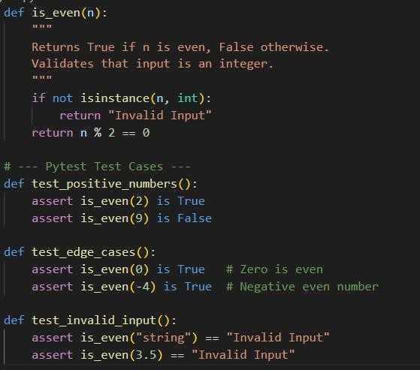

Output
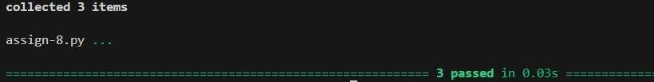

Explanation
Using pytest makes TDD cleaner. Instead of manually printing "Input | Result", we define functions starting with test_. Inside these functions, we use the assert statement. If is_even(2) returns True, the test passes silently. If it returns False, pytest would shout with a detailed error message. I separated tests into logical groups (positive, edge cases, invalid) to make debugging easier.

Task 2: Test-Driven Development for String Case Converter

Task Description
This task requires creating two functions, to_uppercase and to_lowercase. We will use pytest to handle "dirty" data—such as None values, empty strings, or numbers—ensuring the program doesn't crash.

Prompt
"Generate pytest test cases for string conversion functions to_uppercase and to_lowercase. Use assertions to verify they handle None, numbers, and empty strings safely without crashing."

Code:
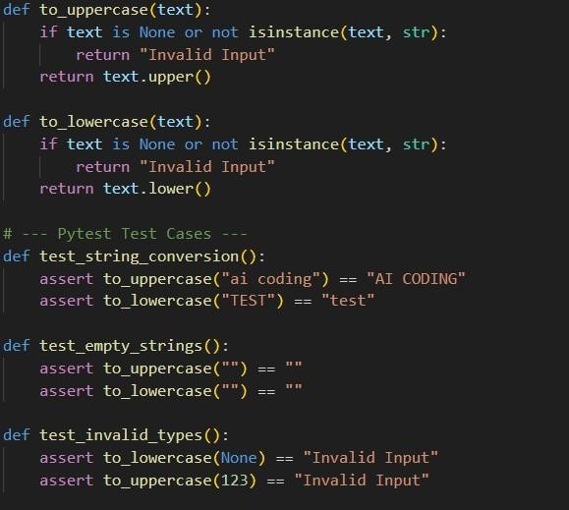

Output
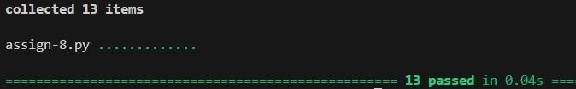

Explanation
Here, the tests act as a "contract" for the code. The test test_invalid_types specifically asserts that passing None or 123 must return "Invalid Input" rather than raising an exception. This enforces robustness. If I had written the function to just return text.upper() without checking the type first, pytest would have failed this test immediately, signaling that my code was unsafe.

Task 3: Test-Driven Development for List Sum Calculator

Task Description
We need to write a function sum_list(numbers) that calculates the total of a list. We will use pytest to verify that the function safely ignores non-numeric values.

Prompt
"Write a Python function sum_list and use pytest to verify it. The tests should check that strings inside the list are ignored and that empty lists return 0."
Code :
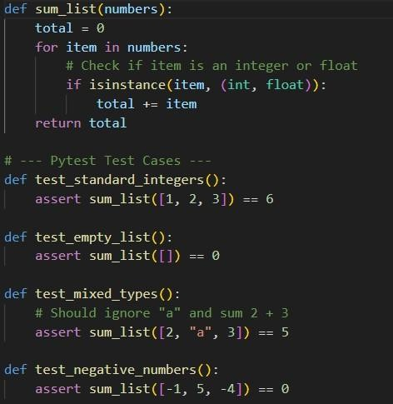

Output
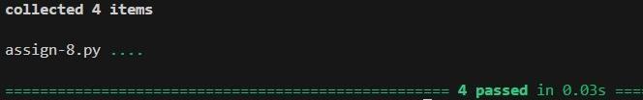

Explanation
The logic for sum_list is verified by four distinct tests. test_mixed_types is the most interesting one; it asserts that [2, "a", 3] equals 5. This confirms that our logic successfully filters out the string "a". If we used the built-in sum() function, this specific test would fail with a TypeError, guiding us to implement the manual loop with isinstance checks.

Task 4: Test Cases for Student Result Class

Task Description
This task involves Object-Oriented TDD. We will use pytest fixtures to create a fresh StudentResult instance for each test, ensuring clean state.

Prompt
"Create a StudentResult class. Use pytest fixtures to instantiate the class and write tests for adding marks, calculating averages, and determining Pass/Fail results."

Code
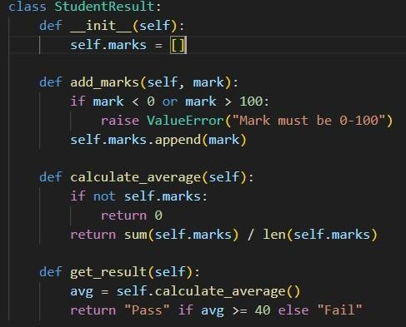
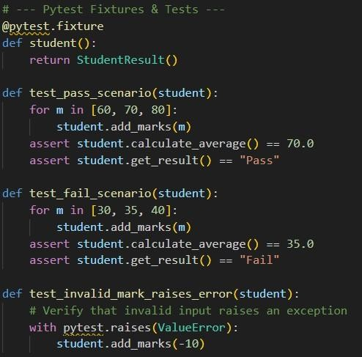

Output
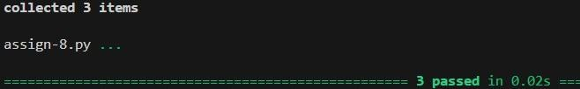

Explanation
In OOP testing, state is everything. If we reused the same student object for all tests, marks from the first test might mess up the second test. I used the @pytest.fixture decorator to create a fresh student object automatically for every test function. I also used pytest.raises(ValueError), which is a professional way to test that code correctly errors out when given bad input (like -10).

Task 5: Test-Driven Development for Username Validator

Task Description
The final task uses pytest.mark.parametrize to run the same test logic on multiple different inputs (valid and invalid usernames) efficiently.

Prompt
"Write a username validator function. Use pytest.mark.parametrize to test valid inputs ('user01') against invalid ones ('ai', 'user name', 'user@123')."
Code :

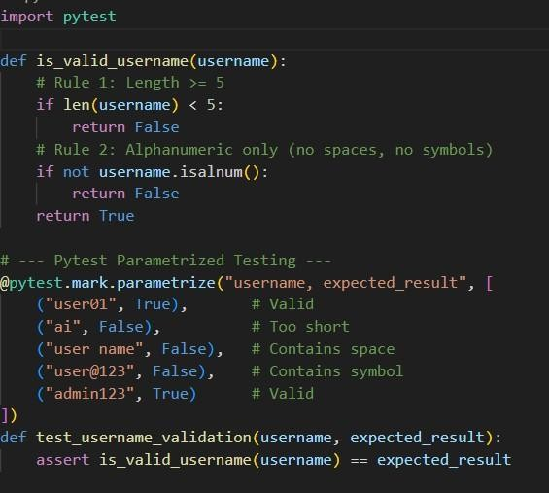

Output

Explanation
Instead of writing five separate test functions, I used @pytest.mark.parametrize. This allows us to feed a list of inputs and expected outputs into a single test function. It makes the code much cleaner and easier to expand. If we wanted to test a new case, like "super_user", we would just add one line to the list, and pytest would automatically generate a new test case for it.

