**Building BBB Kernel on Ubuntu 14.04**

1. **Install tools**

**$** apt-get install gcc-arm-linux-gnueabi

**$** apt-get install lzop

**$** apt-get install libssl-dev

1. **Download Uboot**

**$** wget [ftp://ftp.denx.de/pub/u-boot/u-boot-latest.tar.bz2](ftp://ftp.denx.de/pub/u-boot/u-boot-latest.bz2)

**$** tar -xjf u-boot-latest.tar.bz2

**$** cd u-boot-<version>

**$** make sandbox_defconfig tools-only

**$** install tools/mkimage /usr/local/bin

1. **Downloading and building the Linux Kernel**

**$** git clone git://github.com/beagleboard/kernel.git

**$** cd kernel

**$** git checkout 3.8

**$** git config --global user.email [<EMAIL>](mailto:your.email@here.com)

**$** git config --global user.name <NAME>

**$** ./patch.sh (This step may take 10 minutes or longer)

Some further preparations before the kernel is built:

**$** cp configs/beaglebone kernel/arch/arm/configs/beaglebone_defconfig

**$** wget http://arago-project.org/git/projects/?p=am33x-cm3.git\;a=blob_plain\;f=bin/am335x-pm-firmware.bin\;hb=HEAD -O kernel/firmware/am335x-pm-firmware.bin

These steps will compile the kernel and some kernel modules

$ cd kernel

$ make ARCH=arm CROSS_COMPILE=arm-linux-gnueabi- beaglebone_defconfig

$ make ARCH=arm CROSS_COMPILE=arm-linux-gnueabi- uImage dtbs

$ make ARCH=arm CROSS_COMPILE=arm-linux-gnueabi- uImage-dtb.am335x-boneblack

$ make ARCH=arm CROSS_COMPILE=arm-linux-gnueabi- modules

Tất cả output sẽ ở trong folder: …/kernel/arch/arm/boot

1. Install TFTP server

[**https://askubuntu.com/questions/201505/how-do-i-install-and-run-a-tftp-server**](https://askubuntu.com/questions/201505/how-do-i-install-and-run-a-tftp-server)

1. Install tftp on BBB

Refer file [Connect_BBB_to_internet_via_USB.docx]

1. **Copy** uImage-dtb.am335x-boneblack to /tftproot

**$** cp …/kernel/arch/arm/boot/uImage-dtb.am335x-boneblack /tftproot/

**$** mkimage -l uImage-BBB

1. Setup Ethernet Static IP for BBB
2. **Install & run DHCP on Ubuntu**

$ sudo apt-get install isc-dhcp-server

<https://www.vultr.com/docs/setting-up-a-dhcp-server-on-ubuntu>

1. Setup minicom

Refer [Setup_Serial_Debug.docx]

1. Transferring the image to the BBB via TFTP

* Press reset button on BBB, quickly press space repeatedly to stop it at the u-boot prompt

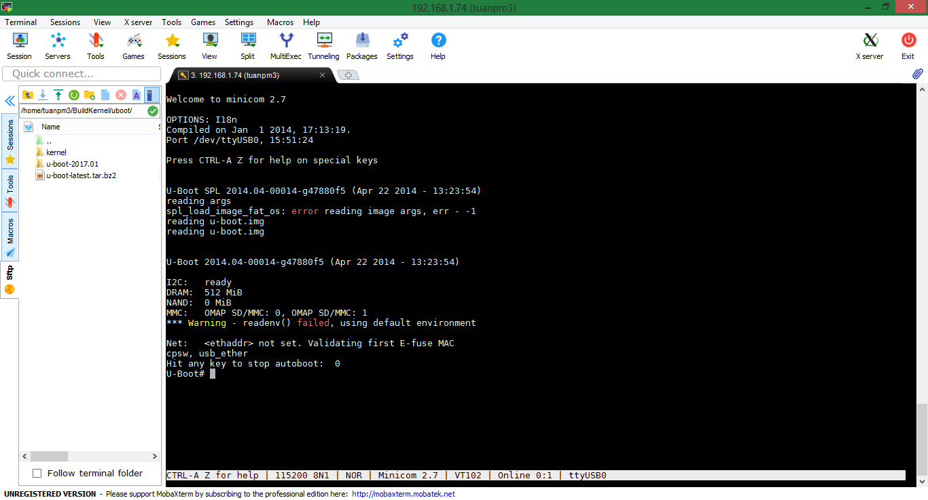

* U-Boot# setenv autoload no
* U-Boot# setenv ipaddr <board-ip> (ex: setenv ipaddr 192.168.0.1)
* U-Boot# setenv serverip <ubuntu-host-ip> (ex: setenv serverip 192.168.0.20)
* U-Boot# tftp 0x80200000 uImage-BBB

