1. **Problem**

**1.Cinema Ticket Booking System**

You are tasked with developing a simple ticket booking system for a

Local cinema. The cinema has 3 auditoriums, each showing a different movie. Each auditorium has a seating capacity of 50 seats. Your program

Should allow a user to select a movie, choose the number of tickets, and display the total cost and the remaining seats for that auditorium. Assume

the price per ticket is $12.

**2. Input:**

i. Write a function to display the available movies and ask the user to select an

auditorium by entering a corresponding number.

ii. Prompt the user to enter the number of tickets they wish to purchase.

**3. Processing:**

i. Write a function to calculate the total cost of the tickets.

ii. Manage the number of available seats. Ensure that the user cannot book more

tickets than the available seats.

iii. Update the number of seats available after each transaction.

1. **Calculate The Total Price Tickets**

**TotalPrice** = TicketPrice * SeatNumber

1. **Code and explanation when user run program.**
2. **Code**

#include <stdio.h>

#include <stdbool.h>

#include <string.h>

#define **PRICE_PER_TICKET** 12

#define **MAX_SEATS** 50

int **displayMovies**() {

    int choice;

**printf**("\nAvailable Movies\n");

**printf**("1. THE LORD OF THE RINGS: THE FELLOWSHIP OF THE RING (AUDITORIUM LEFT)\n");

**printf**("2. THE GOOOD, THE BAD AND THE UGLY (AUDITORIUM MIDDDLE)\n");

**printf**("3. THE LORD OF THE RINGS: THE TWO TOWERS (AUDITORIUM RIGHT)\n");

    while (true) {

**printf**("Enter choice (1 - 3): ");

**scanf**("%d", &choice);

        if (choice >= 1 && choice <= 3) {

            break;

        } else {

**printf**("Invalid choice! Please try again.\n");

        }

    }

    return choice - 1;

}

int **bookTickets**(int movieId, int tickets, int seats[]) {

    if (tickets > seats[movieId]) {

**printf**("Not enough seats! Only %d seats left.\n\n", seats[movieId]);

        return -1;

    }

    int cost = tickets * PRICE_PER_TICKET;

    seats[movieId] -= tickets;

**printf**("\nBooking Successful!\n");

**printf**("Tickets booked: %d\n", tickets);

**printf**("Total cost: %d\n", cost);

**printf**("Seats remaining: %d\n", seats[movieId]);

    return cost;

}

int **getNumberOfTickets**(int availableSeats) {

    if (availableSeats <= 0) {

**printf**("This movie is fully booked. Please choose another.\n");

        return -1;

    }

    int tickets;

    do {

**printf**("Enter the number of tickets: ");

**scanf**("%d", &tickets);

        if (tickets <= 0) {

**printf**("Invalid number! Enter a positive number.\n");

        } else if (tickets > availableSeats) {

**printf**("Only %d seats available.\n", availableSeats);

        }

    } while (tickets <= 0 || tickets > availableSeats);

    return tickets;

}

int **main**() {

    int seats[3] = {MAX_SEATS, MAX_SEATS, MAX_SEATS};

    char proceed[4];

    while (true) {

**printf**("Type 'yes' to continue booking or 'no' to quit: ");

**scanf**("%s", proceed);

        if (**strcmp**(proceed, "yes") == 0) {

            bool fullBooking = true;

            for (int i = 0; i < 3; i++) {

                if (seats[i] > 0) {

                    fullBooking = false;

                    break;

                }

            }

            if (fullBooking) {

**printf**("All auditoriums are fully booked!\n");

                break;

            } else {

                int chosenMovie = **displayMovies**();

                int tickets = **getNumberOfTickets**(seats[chosenMovie]);

                if (tickets == -1) {

                    continue;

                }

                int totalCost = **bookTickets**(chosenMovie, tickets, seats);

                if (totalCost != -1) {

**printf**("Total cost of your booking: %d\n", totalCost);

                }

            }

        } else if (**strcmp**(proceed, "no") == 0) {

            break;

        } else {

**printf**("Invalid input! Please enter 'yes' or 'no'.\n");

        }

    }

**printf**("Thank you for using the movie booking system!\n");

    return 0;

}

1. **Result of the program**
2. **Input:** Select the any movie in Auditorium and the number of tickets and will then give the total Price

**Output:**

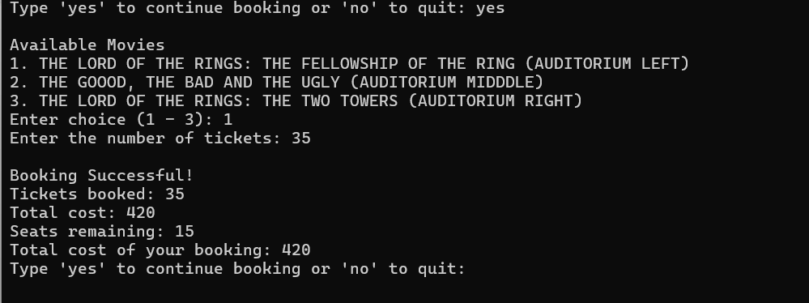

**2.Input:** If the user selects more tickets than available seats, the system will display the remaining seats and prompt the user to enter a new ticket quantity

**Output:**

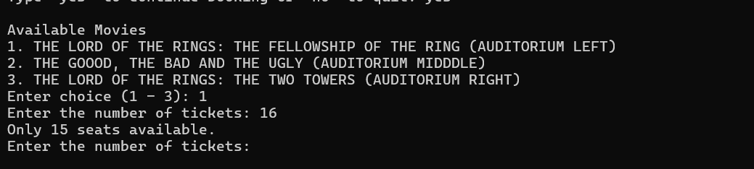

**3.Input:** If the user selects an auditorium that is fully booked, the system will prompt them to choose a different auditorium.

**Output:**

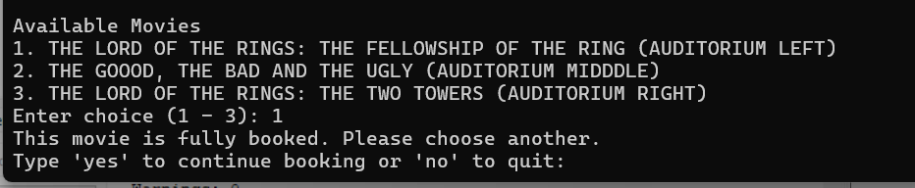

**4.Input**: If the user enters the wrong number Auditorium, the system will re-enter it

**Output:**

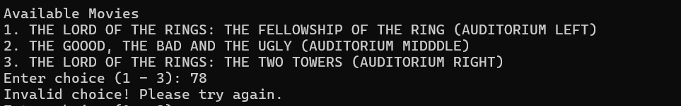

**5.Input:** If the user enters the wrong number TicketNumber, the system will re-enter i

**Output:**

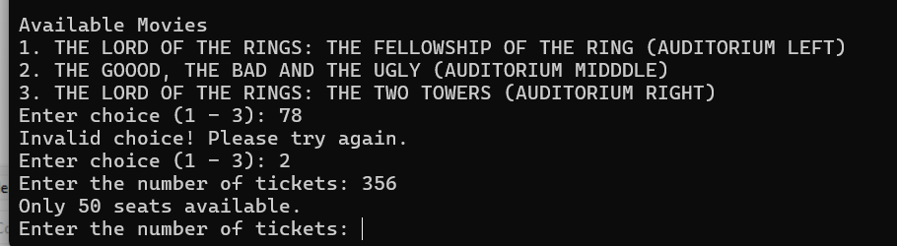

**6.Input:** If the movie viewing system is full in all auditorium, the system will ask you to come back tomorrow.

**Output:**

