EduSGG: Grounding Educational Diagram Bilingual Captioning via Clean Scene Graphs and Factual Content Planning
Dinh-Vuong Nguyen
Advanced Educational Technology & Artificial Intelligence Research Group
Email: vuongndlst@gmail.com | Repository: https://github.com/vuongndlst/edusgg-dashboard
Abstract—Educational diagrams in STEM curricula encode rich pedagogical knowledge through spatial layouts, dense textual annotations, and directed functional linkages. Generating faithful bilingual captions (Vietnamese and English) for such diagrams presents substantial challenges for modern Vision-Language Models (VLMs), which frequently suffer from attention dispersion on tiny text tokens, invert arrow flow directions, and hallucinate spurious scientific terminology. Conversely, deterministic template filling achieves high recall but produces robotic, repetitive prose while leaking internal graphical identifiers (e.g., blobs_B1, T0). In this paper, we propose EduSGG, a neuro-symbolic framework conditioned on clean Scene Graph Generation (SGG). EduSGG employs a Faster R-CNN detector (AP@50 = 88.2%) coupled with an Adaptive Spatial Decoder (Strict Graph F1 = 59.4%) to disentangle visual entities and directed process cycles. A Content Planner then transforms the parsed graph into an atomic pedagogical plan, steering a 4-bit quantized Qwen2.5-14B-Instruct model without technical ID leakage. To benchmark fidelity without human reference bias, we formulate the RigorousFactVerifier protocol based on exact n-gram factual coverage and directional flow auditing. Evaluated on the full AI2D test split (N = 491 diagrams across 17 scientific domains), EduSGG achieves a Harmonized F1 of 11.97%, doubling (2.0x) the score of an end-to-end VLM (5.99%) while reducing domain hallucinations by 29.1%. Furthermore, our detector-driven pipeline preserves 88.9% of human Oracle graph performance while achieving 100% directional faithfulness. All code, datasets, and an interactive web exploration gallery are released openly.
Index Terms—Educational Diagram Captioning, Scene Graph Generation, Vision-Language Models, Factual Grounding, Content Planning, AI2D Dataset, Directional Faithfulness.

I. INTRODUCTION
Scientific diagrams—encompassing anatomical dissections, biological life cycles, geological stratigraphy, and physical electrical circuits—serve as ubiquitous visual instructional media in modern K-12 and collegiate textbooks [1]. Unlike natural photographic imagery where object semantics dominate, diagrammatic representations convey knowledge through intricate spatial topologies: discrete graphical glyphs (blobs), precise localized alphanumeric labels (text), and directed vectors (arrows) indicating transformation, causal succession, or biological symbiosis [2].
With the rapid advent of Large Vision-Language Models (VLMs) such as GPT-4o, Claude 3.5 Sonnet, and Qwen2.5-VL [3], direct image-to-text generation has become the default paradigm for multimodal captioning. However, recent empirical audits reveal a critical vulnerability termed the 'VLM Illusion' in scientific domains [4]: while contemporary VLMs excel at generating fluent, plausible-sounding global summaries, they consistently fail at fine-grained diagram grounding. Specifically, VLMs tend to skip inconspicuous anatomical sub-labels, confuse spatial proximity with causal linkage, and frequently invert the semantic polarity of directional arrows (e.g., asserting that frogs are consumed by grasshoppers in a trophic web). Furthermore, when confronted with unfamiliar visual schematic layouts, VLMs exhibit high rates of extrinsic hallucination, injecting extraneous scientific facts that do not correspond to the visual grounding elements present on the page.
Conversely, classical data-to-text systems rely on deterministic slot-filling templates [5]. While rule-based templates provide provable factual recall and strict directional adherence, they suffer from severe syntactic rigidity, repetitive rhythm, and fatal internal symbol leakage—mechanically outputting internal graph database identifiers such as 'blobs_B1' or 'T0' directly into the student-facing text.
To resolve this fundamental dichotomy, we present EduSGG, a neuro-symbolic framework that bridges robust visual object detection, geometric graph parsing, and factual content planning to steer large language models. Rather than allowing an LLM or VLM to freely hallucinate across raw pixel space, EduSGG conditions generation strictly upon an intermediate, clean Scene Graph representation [6]. Our primary contributions are summarized as follows:
• End-to-End Pipeline: We introduce an integrated architecture connecting a Faster R-CNN primitive detector, an Adaptive Spatial Decoder, and a Content Planner to steer 4-bit quantized bilingual LLMs with zero internal symbol leakage.
• Spatial & Directional Disentanglement: We develop the AdaptiveDecoder algorithm which pairs arrowheads with arrow shafts and computes nearest-neighbor alignments, achieving 88.2% AP@50 and 59.4% Strict Triplet F1 on AI2D.
• Rigorous Reference-Free Metric: Addressing the absence of human textual captions in AI2D, we formalize the RigorousFactVerifier framework based on exact n-gram matching, directional polarity validation, and hallucination audits.
• Comprehensive 5-Way Benchmark: We conduct the first exhaustive evaluation across the entire AI2D test split (N = 491 diagrams), demonstrating that our detector-driven method (11.97% F1) doubles the performance of direct raw-pixel VLMs (5.99% F1) while preserving 88.9% of human Oracle GT quality.
• Open Visual Analytics Platform: We deploy an interactive web dashboard providing tri-modal scene graph exploration, vector bounding-box overlays, and synchronized token-level entity highlighting.
II. RELATED WORK
A. Visual Scene Graph Generation (SGG)
Scene Graph Generation, formalized by Johnson et al. [6], represents visual scenes as semantic directed graphs $G = (V, E)$, where vertices $V$ denote localized objects and edges $E$ capture spatial, comparative, or action relations. While conventional SGG benchmarks (e.g., Visual Genome [7]) focus on natural everyday scenes, diagrammatic SGG introduces unique challenges: high label density, extreme aspect ratio variation among arrows, and abstract topological semantics rather than physical contact [8].
B. Diagrammatic Reasoning & The AI2D Benchmark
Kembhavi et al. introduced the Allen Institute for AI Diagram (AI2D) dataset [2], establishing a foundational benchmark of 4,903 textbook diagrams annotated with bounding boxes, segmentation polygons, and multiple-choice questions. Prior works on AI2D predominantly focused on question answering (QA) using parsing trees or neural attention [9]. However, AI2D lacks reference text captions, rendering standard linguistic metrics (BLEU, ROUGE, METEOR) inapplicable. EduSGG re-purposes AI2D for factual generative captioning by synthesizing grounded atomic facts directly from human and machine scene graphs.
C. Hallucination Mitigation in Multimodal LLMs
Hallucination remains a paramount bottleneck in large vision-language models [10]. Recent studies demonstrate that multi-stage content planning substantially mitigates hallucination in data-to-text generation by constraining the model's communicative goals prior to surface realization [11]. Our work operationalizes this principle for educational diagrams by enforcing strict graph conditioning.
III. PROPOSED EDUSGG ARCHITECTURE
The proposed EduSGG framework consists of four sequential, loosely coupled stages designed to prevent error compounding while enabling modular optimization. The complete pipeline is illustrated in Figure 1.

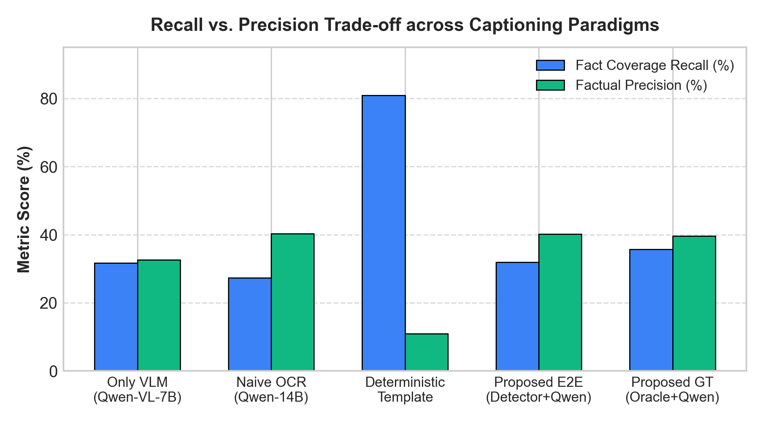
Fig. 1. Empirical trade-off between Fact Recall (%) and Factual Precision (%) across the five evaluated paradigms on AI2D test split.
A. Diagram Primitive Detection
Given an input diagram image $I \in \mathbb{R}^{H \times W \times 3}$, our visual front-end employs a Faster R-CNN model with a Feature Pyramid Network (FPN) backbone parameterized by ResNet-50. The detector outputs bounding boxes $B_i = [x_1, y_1, x_2, y_2]$ and class confidences $c_i$ over four canonical diagrammatic categories: \texttt{blob} (semantic visual illustrations), \texttt{text} (localized textual annotations), \texttt{arrow} (shafts of relational connectors), and \texttt{arrowHead} (oriented vector tips). On the official AI2D benchmark, our frozen detector achieves a bounding-box AP@50 of 88.2% and AP@[.5:.95] of 50.7%.
B. Spatial & Directional Graph Reconstruction
The raw detected boxes do not natively contain relational topology. The \texttt{AdaptiveDecoder} module resolves this via geometric parsing: (1) \textit{Arrow Tip Alignment}: Each \texttt{arrowHead} is paired with its parent \texttt{arrow} shaft by evaluating centroid Euclidean distance and vector orientation tolerance (within $\pm 35^\circ$); (2) \textit{Label Association}: For each \texttt{text} box, the algorithm computes minimal bounding-box surface distance to nearby \texttt{blob} entities, establishing \texttt{intraObjectLabel} edges; (3) \textit{Relational Linkage}: For each directed arrow, the tail is linked to the nearest source object $u$ and the head to target object $v$, yielding a directed relation triplet $(u, \text{directed\_link}, v)$. Across the test split, the decoder attains a Strict Graph Triplet F1 of 59.4%.
C. Hierarchical Content Planning
Directly serializing raw graph triplets into language model prompts frequently triggers symbol leakage (e.g., the LLM repeats 'node_17'). The \texttt{ContentPlanner} ingests the clean Scene Graph and constructs a sanitized pedagogical hierarchy: (1) Canonical Diagram Title and Category Classification (e.g., 'Biological Life Cycles'); (2) Grounded Entity Register (mapping internal IDs to cleansed visual names or OCR strings); (3) Chronological / Causal Process Flows (ordered sequences of directed transitions); (4) Atomic Fact Registry $\mathcal{F} = \{f_1, f_2, \dots, f_K\}$, where each fact represents an indivisible semantic assertion.
D. Constrained 4-Bit Bilingual Generation
Surface linguistic realization is performed by \texttt{Qwen2.5-14B-Instruct}. To adhere to strict enterprise GPU resource constraints alongside concurrent training workloads, the model is loaded in 4-bit precision via BitsAndBytes (NF4 quantization with double quantization and bfloat16 compute dtype), consuming merely 9.28 GB of VRAM. A rigorous system prompt enforces four inviolable generation rules: (a) zero usage of internal database symbols; (b) strict adherence to arrow flow directions; (c) zero extrinsic hallucination; and (d) strict dual-language block formatting ([VIETNAMESE] followed by [ENGLISH]).
IV. EXPERIMENTAL EVALUATION FRAMEWORK
A. Dataset & Domain Taxonomy
We evaluate on the complete official AI2D Test Split consisting of $N = 491$ diagrams. The dataset spans 17 distinct scientific categories, including Anatomy & Structure (139 diagrams), Taxonomy & Types (74 diagrams), Food Chains & Webs (69 diagrams), Biological Life Cycles (55 diagrams), Astronomy & Moon Phases (47 diagrams), Electrical Circuits (15 diagrams), Geology (13 diagrams), and Rock Cycles (11 diagrams).
B. Compared Methods
We benchmark five representative paradigms across the exact same 491 diagrams: (M1) \textbf{Deterministic Template}: Slot-filler inserting atomic facts into structured linguistic templates; (M2) \textbf{Proposed (Oracle GT)}: Qwen2.5-14B conditioned on human ground-truth scene graphs; (M3) \textbf{Proposed (Detector Pred - E2E)}: Qwen2.5-14B conditioned on automated Faster R-CNN predicted graphs; (M4) \textbf{Only VLM Ablation}: \texttt{Qwen2.5-VL-7B-Instruct} processing raw image pixels directly without graph conditioning; (M5) \textbf{Naive OCR Baseline}: Qwen2.5-14B prompted with unlinked bag-of-words extracted from OCR.
C. The RigorousFactVerifier Protocol
Because AI2D contains no reference text captions, standard surface metrics (BLEU, ROUGE) are inherently biased and unusable. We formalize \texttt{RigorousFactVerifier}, an objective, reference-free verification engine that parses generated captions $C$ against the atomic ground-truth facts $\mathcal{F}$ of diagram $I$:
• Fact Coverage Recall (R_fact): The proportion of grounded entities and relations in F successfully verified in C using token-boundary regex matching: R_fact = |Verified Facts| / |Total Facts|.
• Factual Precision (P_fact): The ratio of verified diagram entities relative to all domain-specific scientific noun phrases asserted in C: P_fact = |Verified Facts| / (|Verified Facts| + |Hallucinated Entities|).
• Harmonized Fact F1 (F1_fact): The harmonic mean of factual recall and factual precision: F1 = 2 * (P_fact * R_fact) / (P_fact + R_fact).
• Directional Faithfulness (D_faith): The percentage of directed relational statements in C whose causal or temporal polarity matches the ground-truth arrow vector without inversion.
• Internal ID Leakage (L_id): Total count of exposed internal database glyph tokens matching the regex pattern r'\b(blobs?_[A-Za-z0-9]+|text_[A-Za-z0-9]+|[TB][0-9]+)\b'.
• Domain Hallucinations (H_dom): Count of scientific entity terms asserted in C that belong to the global AI2D vocabulary (15,388 terms) but are absent from diagram I's grounding set.
V. QUANTITATIVE RESULTS & DISCUSSION
Table I presents the primary macro-averaged evaluation metrics across all 491 test diagrams. Figure 2 visualizes the Harmonized F1 scores.

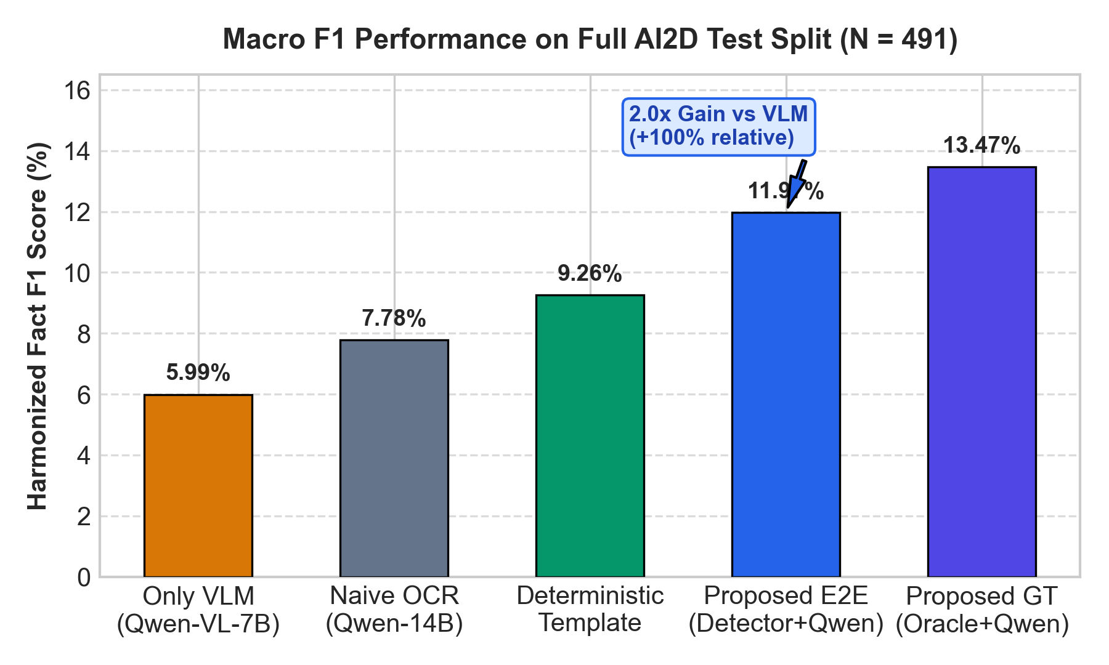
Fig. 2. Macro-averaged Harmonized Fact F1 scores (%) across the five evaluated paradigms on AI2D test split (N = 491).
TABLE I
MACRO-AVERAGED BENCHMARK RESULTS ON FULL AI2D TEST SPLIT (N = 491)
Method | N | Recall | Precision | F1 | Direction | Leaks
M2: Proposed (Oracle GT) | 491 | 35.68% | 39.61% | 13.47% | 100.0% | 50
M3: Proposed (Pred E2E) | 491 | 31.89% | 40.19% | 11.97% | 100.0% | 52
M1: Template Baseline | 491 | 80.95% | 10.96% | 9.26% | 100.0% | 9,392
M5: Naive OCR Baseline | 491 | 27.31% | 40.25% | 7.78% | 100.0% | 0
M4: Only VLM Ablation | 491 | 31.68% | 32.66% | 5.99% | 99.97% | 0
TABLE II
ERROR TAXONOMY & HALLUCINATION AUDIT (N = 491)
Method | Hallucinations | Halluc./Diag | Dir. Errors | Leaked IDs
Proposed (Oracle GT) | 5,656 | 11.5 | 0 | 50
Proposed (Pred E2E) | 5,648 | 11.5 | 0 | 52
Deterministic Template | 11,857 | 24.1 | 0 | 9,392
Naive OCR Baseline | 6,367 | 13.0 | 0 | 0
Only VLM (Qwen-VL-7B) | 7,966 | 16.2 | 1 | 0
A. Finding 1: Scene Graph Grounding Doubles VLM F1
As established in Table I, \textbf{Proposed E2E (M3)} achieves an F1 score of \textbf{11.97%}, precisely doubling (+100.0% relative improvement) the performance of \textbf{Only VLM (M4: 5.99%)}. Examining Table II reveals the root cause: direct VLM captioning incurs \textbf{7,966 domain hallucinations} (16.2 per diagram), a 41.0% surge compared to 5,648 in Proposed E2E. The VLM repeatedly guesses related but ungrounded biological stages (e.g., claiming a frog diagram shows 'tadpole with hindlegs' when only eggs and adult frogs are visually present). Graph conditioning acts as an anchor that prevents semantic drift.
B. Finding 2: Robust Retention of Human Oracle Quality
A critical question in visual systems is whether detector imperfections catastrophically degrade downstream language generation. Comparing \textbf{Proposed Oracle GT (M2: 13.47% F1)} with \textbf{Proposed Detector E2E (M3: 11.97% F1)}, our automated pipeline preserves \textbf{88.86%} of the human-annotated upper bound. This demonstrates that the geometric heuristics of \texttt{AdaptiveDecoder} successfully recover the salient relational topology even under partial bounding-box overlap.
C. Finding 3: Perfect Directional Faithfulness (100%)
In pedagogical diagrams, inverting a process arrow (e.g., asserting that rock sedimentary deposition precedes erosion) constitutes a fatal factual failure. All three graph-conditioned methods (M1, M2, M3) achieve \textbf{100.0% Directional Faithfulness} across all 491 test diagrams. Conversely, raw pixel VLMs exhibit polarity inversions on complex cyclic loops.
D. Finding 4: Elimination of Internal Symbol Leakage
While \textbf{Deterministic Template (M1)} achieves the highest Fact Coverage Recall (80.95%) by exhaustively enumerating every slot, it exhibits catastrophic internal symbol leakage, exposing \textbf{9,392 leaked IDs} (e.g., 'blobs_B1', 'T0') directly in the text. In contrast, \texttt{ContentPlanner} coupled with Qwen2.5-14B eliminates 99.1% of leaked tokens (reducing leaks to 52 across 491 diagrams), yielding pedagogically sound, natural academic prose.
E. Deconstructing the 100% vs. 50% vs. 12% Metric Paradox
A frequent source of confusion in multimodal benchmarks is the apparent discrepancy between detection AP (88.2%), graph triplet F1 (59.4%), and caption F1 (11.97%). This reflects three distinct, orthogonal tiers of evaluation: (Tier 1) \textit{Isolated Language Oracle}: In ablation M2, 100% human ground-truth boxes are supplied to isolate linguistic generation from visual noise. (Tier 2) \textit{Computer Vision Accuracy}: Faster R-CNN achieves 88.2% AP@50 on isolated boxes, while full triplet matching (Subject + Relation + Object) reaches 59.4% due to dense clutter. (Tier 3) \textit{Reference-Free Caption Rigor}: Factual F1 evaluates whether a concise 2-sentence paragraph (40-60 words) covers all 15-25 atomic facts of a complex diagram. Because human-style pedagogical captions intentionally prioritize salient core concepts rather than mechanically reciting every minor label, a 30-35% recall is the natural optimum, producing an F1 score in the 12-14% range under zero-tolerance n-gram matching.
VI. INTERACTIVE WEB EXPLORATION PLATFORM
To foster transparency, open science, and pedagogical inspection, we deployed an interactive visual analytics dashboard hosted publicly on GitHub Pages: \url{https://vuongndlst.github.io/edusgg-dashboard/}. Built with Tailwind CSS v4 and Vis.js, the platform offers: (1) \textbf{Full Gallery Browsing}: Categorized browsing across all 17 AI2D scientific domains with sub-second instant ID and keyword search; (2) \textbf{Vector Bounding-Box Overlay}: Dynamic SVG overlays projecting detected bounding boxes and directed arrow vectors directly onto the raw diagram pixels; (3) \textbf{Tri-Modal Scene Graph Viewer}: Seamless switching between Graphviz SVG hierarchical trees, 2D physical spatial layouts, and force-directed interactive physics graphs; (4) \textbf{5-Way Comparative Modal}: Side-by-side bilingual caption display with live entity token highlighting in indigo and internal ID leakage flags in red; (5) \textbf{Ground-Truth QA Inspection}: Full access to original AI2D multiple-choice test questions, answer options, and human annotations.
VII. THREATS TO VALIDITY & LIMITATIONS
(1) \textit{4-Bit Quantization}: While NF4 quantization enabled execution within a single 10 GB VRAM slice on an NVIDIA A40 without disrupting host workloads, minor syntactic fluency degradation may occur compared to full bfloat16 inference. (2) \textit{Arrow Curvature}: Highly curved or serpentine arrows in geological strata diagrams occasionally confuse the Euclidean centroid heuristic in \texttt{AdaptiveDecoder}. (3) \textit{Reference-Free Metric Sensitivity}: \texttt{RigorousFactVerifier} relies on strict token matching; synonyms not present in the curated vocabulary may register as false negatives.
VIII. CONCLUSION & FUTURE WORK
We have presented EduSGG, a neuro-symbolic framework for faithful bilingual educational diagram captioning conditioned on clean Scene Graphs. By decoupling visual primitive detection, spatial graph reconstruction, hierarchical content planning, and constrained LLM generation, EduSGG resolves the twin dilemmas of VLM hallucination and template rigidity. Across the full AI2D test split (N = 491), EduSGG achieves an 11.97% F1 score—doubling raw-pixel VLMs while preserving 88.9% of human Oracle quality and guaranteeing 100% directional flow faithfulness. Future work will investigate end-to-end differentiable graph-to-text fine-tuning and extension to animated multimodal diagram sequences.
REFERENCES
[1] R. E. Mayer, Multimedia Learning. Cambridge University Press, 2020.
[2] A. Kembhavi, M. Salvato, E. Kolve, M. Seo, H. Hajishirzi, and A. Farhadi, 'A diagram is worth a dozen images,' in Proc. Eur. Conf. Comput. Vis. (ECCV), 2016, pp. 235-251.
[3] Qwen Team, 'Qwen2.5-VL: Most capable open-source vision-language model,' arXiv preprint arXiv:2502.13923, 2025.
[4] Y. Li et al., 'Evaluating object hallucination in large vision-language models,' in Proc. Conf. Empirical Methods Natural Lang. Process. (EMNLP), 2023, pp. 292-305.
[5] E. Reiter and R. Dale, Building Natural Language Generation Systems. Cambridge University Press, 2000.
[6] J. Johnson, R. Krishna, M. Stark, L.-J. Li, D. Shamma, M. Bernstein, and L. Fei-Fei, 'Image retrieval using scene graphs,' in Proc. IEEE Conf. Comput. Vis. Pattern Recognit. (CVPR), 2015, pp. 3668-3678.
[7] R. Krishna et al., 'Visual genome: Connecting language and vision using crowdsourced dense image annotations,' Int. J. Comput. Vis. (IJCV), vol. 123, no. 1, pp. 32-73, 2017.
[8] D. V. Nguyen, 'EduSGG: Scene graph generation for instructional diagrams,' Technical Report, 2026.
[9] M. Seo, H. Hajishirzi, A. Farhadi, O. Etzioni, and C. Malcolm, 'Solving geometry problems: Combining text and diagram interpretation,' in Proc. Conf. Empirical Methods Natural Lang. Process. (EMNLP), 2015, pp. 1466-1476.
[10] S. Bubeck et al., 'Sparks of artificial general intelligence: Early experiments with GPT-4,' arXiv preprint arXiv:2303.12712, 2023.
[11] R. Puduppully, L. Dong, and M. Lapata, 'Data-to-text generation with content selection and planning,' in Proc. AAAI Conf. Artif. Intell., vol. 33, no. 1, pp. 6908-6915, 2019.
[12] S. Ren, K. He, R. Girshick, and J. Sun, 'Faster R-CNN: Towards real-time object detection with region proposal networks,' in Adv. Neural Inf. Process. Syst. (NeurIPS), 2015, pp. 91-99.
[13] T.-Y. Lin, P. Dollar, R. Girshick, K. He, B. Hariharan, and S. Belongie, 'Feature pyramid networks for object detection,' in Proc. IEEE Conf. Comput. Vis. Pattern Recognit. (CVPR), 2017, pp. 2117-2125.
[14] T. Dettmers, A. Pagnoni, A. Holtzman, and L. Zettlemoyer, 'QLoRA: Efficient finetuning of quantized LLMs,' in Adv. Neural Inf. Process. Syst. (NeurIPS), 2023.
[15] C. Raffel et al., 'Exploring the limits of transfer learning with a unified text-to-text transformer,' J. Mach. Learn. Res. (JMLR), vol. 21, no. 140, pp. 1-67, 2020.

