Exercise 14: Mongoose

Objective
In this exercise, you’ll learn about Mongoose, which is a popular Object Data Modeling (ODM) library for MongoDB and Node.js. It provides a straightforward, schema-based solution to model your application data. It includes built-in type casting, validation, query building, business logic hooks, and more, out of the box.

Exercise
- Init node-mongoose app with Express framework
- Install Mongoose via npm (Node Package Manager)
- Code is used to declare url and database of Mongo
const mongoose = require('mongoose');
mongoose.connect('mongodb://localhost/my_database', { useNewUrlParser: true, useUnifiedTopology: true });
- New models folder and new article.js file in this folder
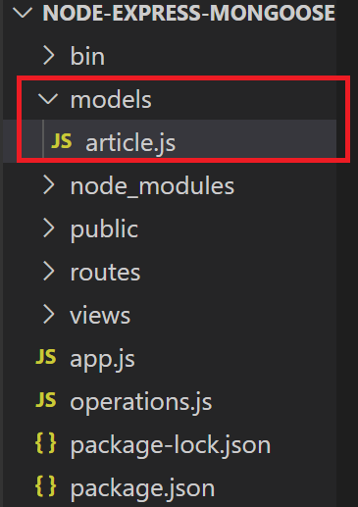
- Add code in article.js (models folder) as below
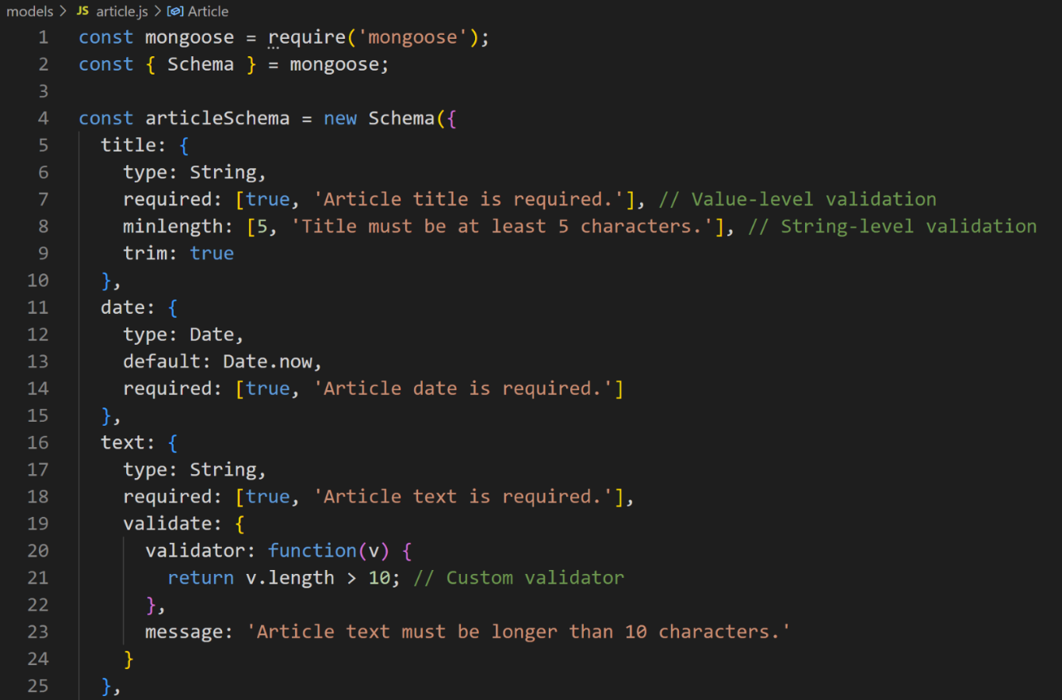

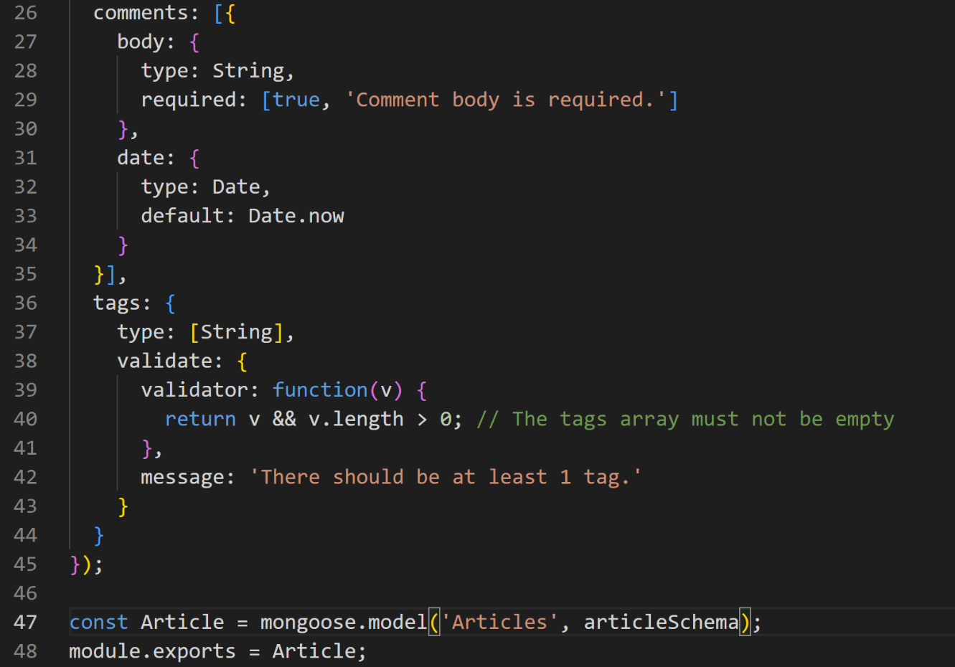
- Add code in app.js file as below

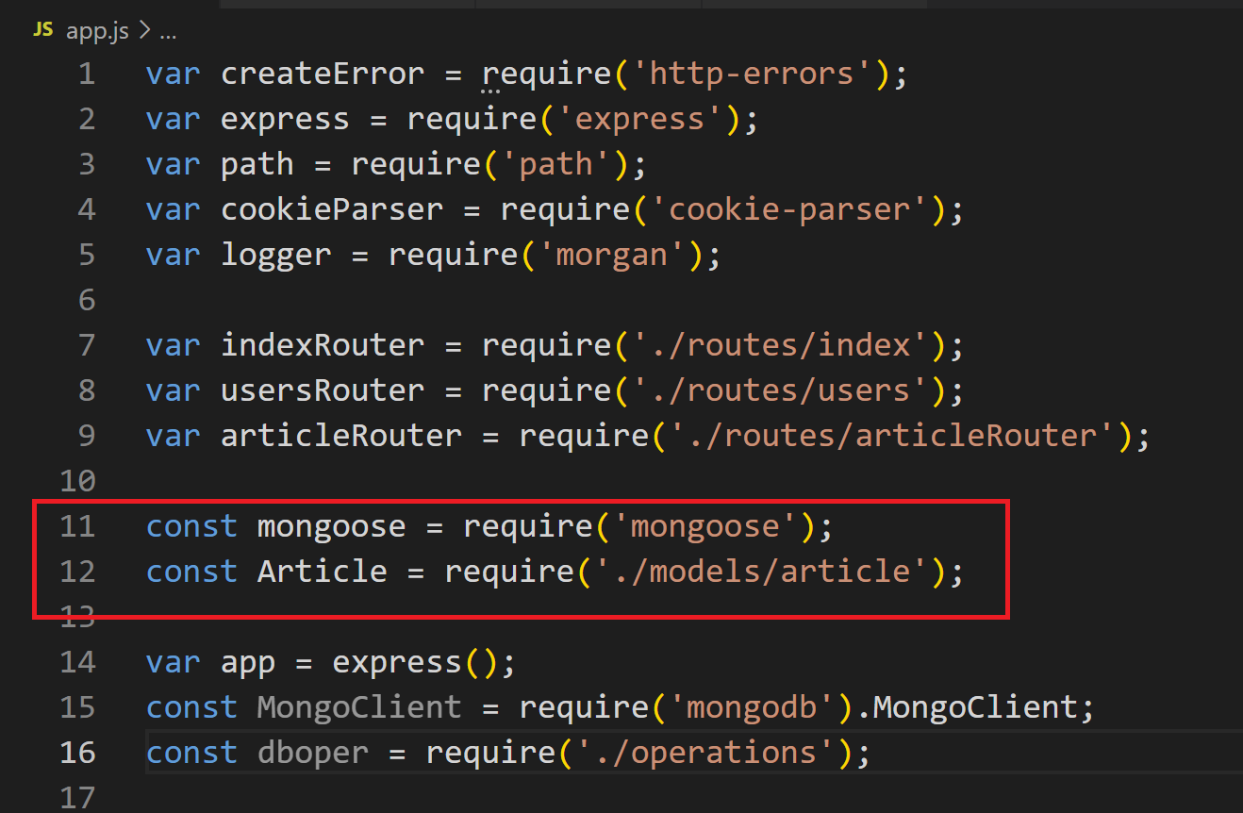
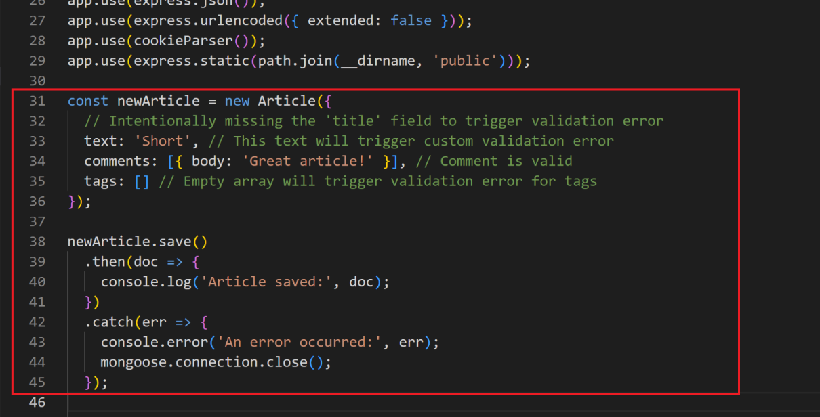
- Result with validation error

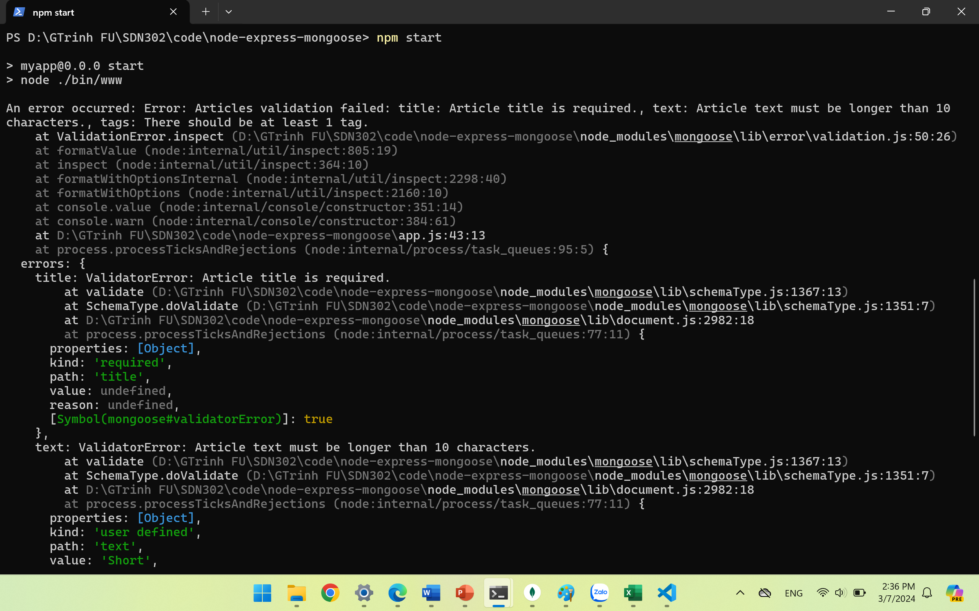
- Change new test
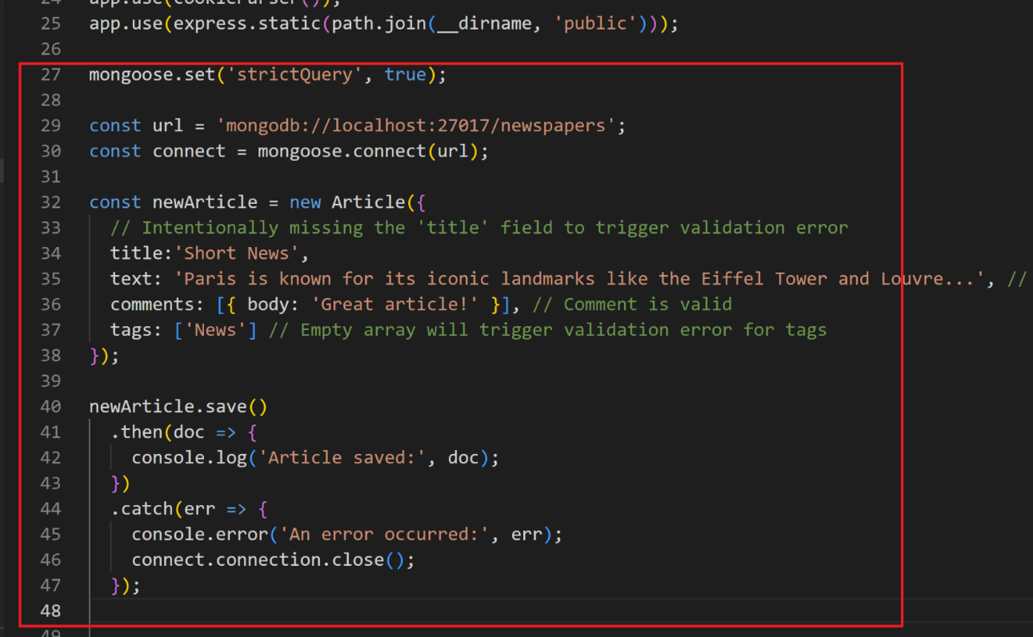
- Insert database successfully

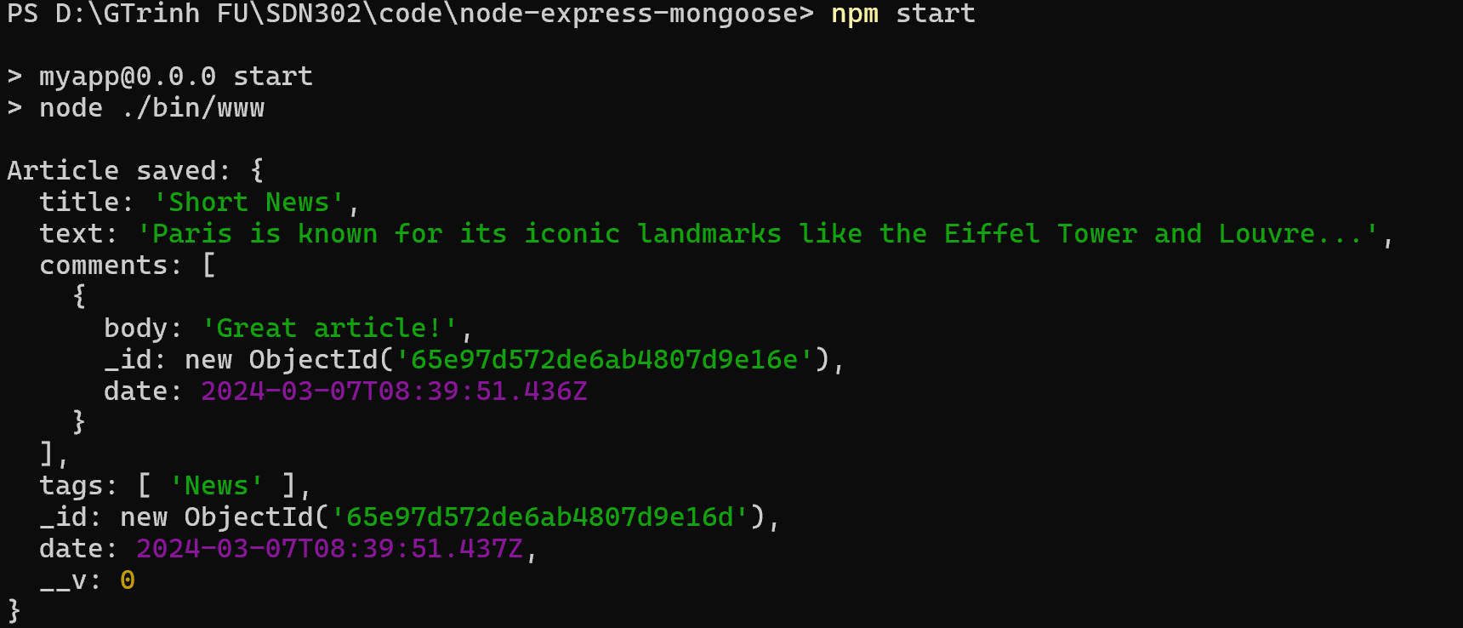

Conclusion
This is a very basic introduction to get you started with Mongoose. There's a lot more to explore, including middleware (pre and post hooks), advanced querying, aggregation, etc. Mongoose's official documentation is a great resource to learn more.

