Exercise 20: Cookies

Objective
In this exercise, you wil learn about cookies that are small pieces of data stored on the client-side, typically by web browsers, and sent to the server with every request made by the client. They play a crucial role in web development for managing state, sessions, and personalizing user experiences.

Exercise
- Install cookie-parser": "~1.4.4" and "bcrypt": "^5.1.1"
- Create authentication folder
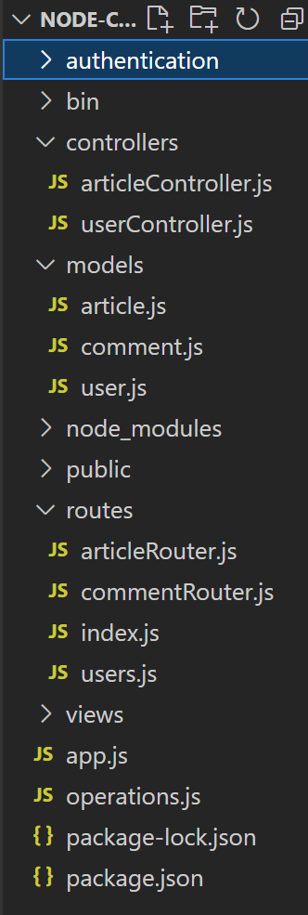
- Create auth.js in authentication folder
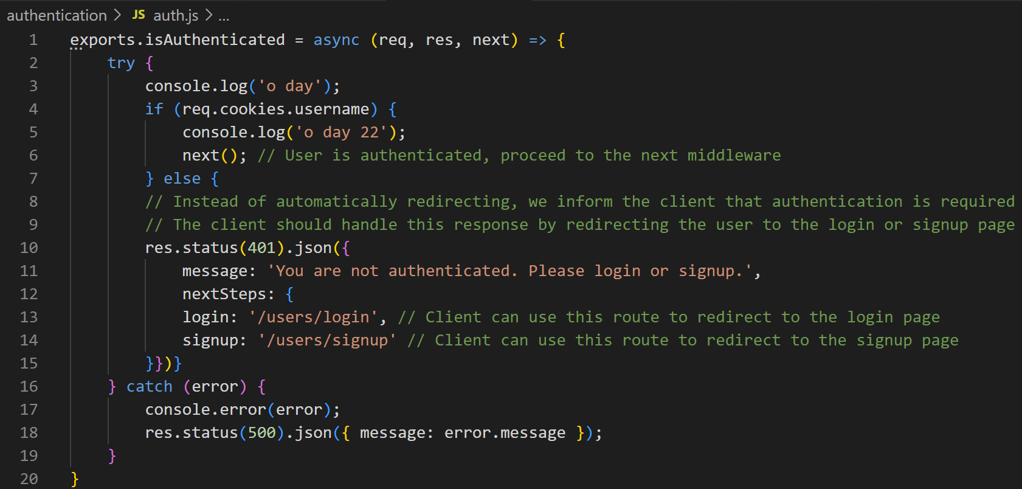

- Modify articleRouter.js to authenticat
- Modify articleRouter.js to authenticate
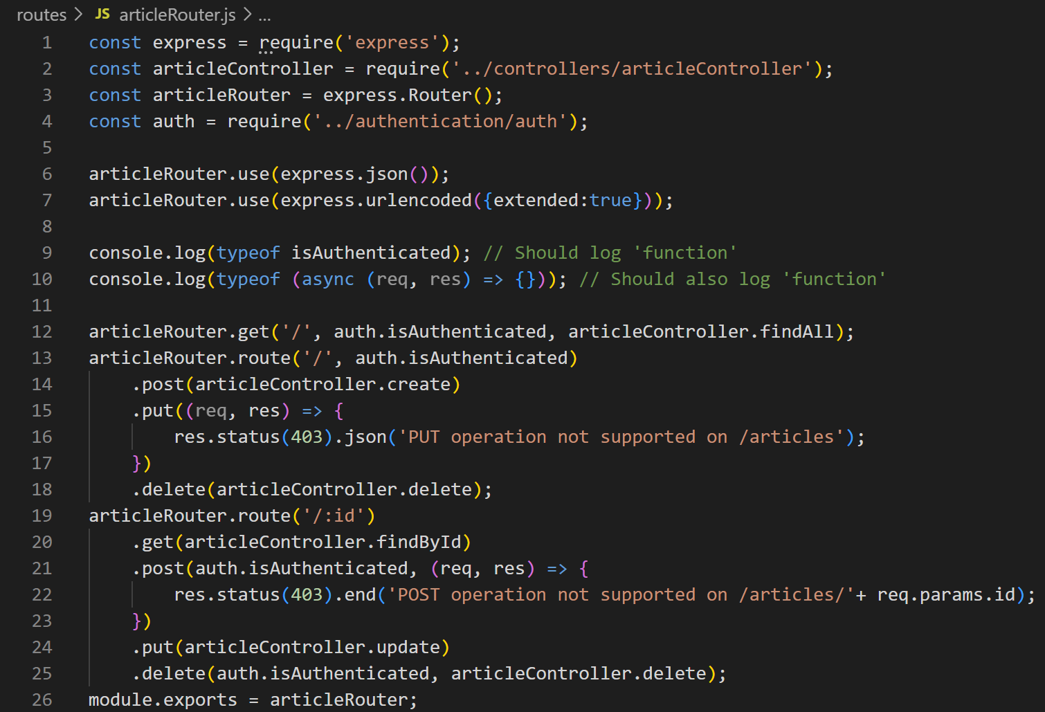
- Test with Postman
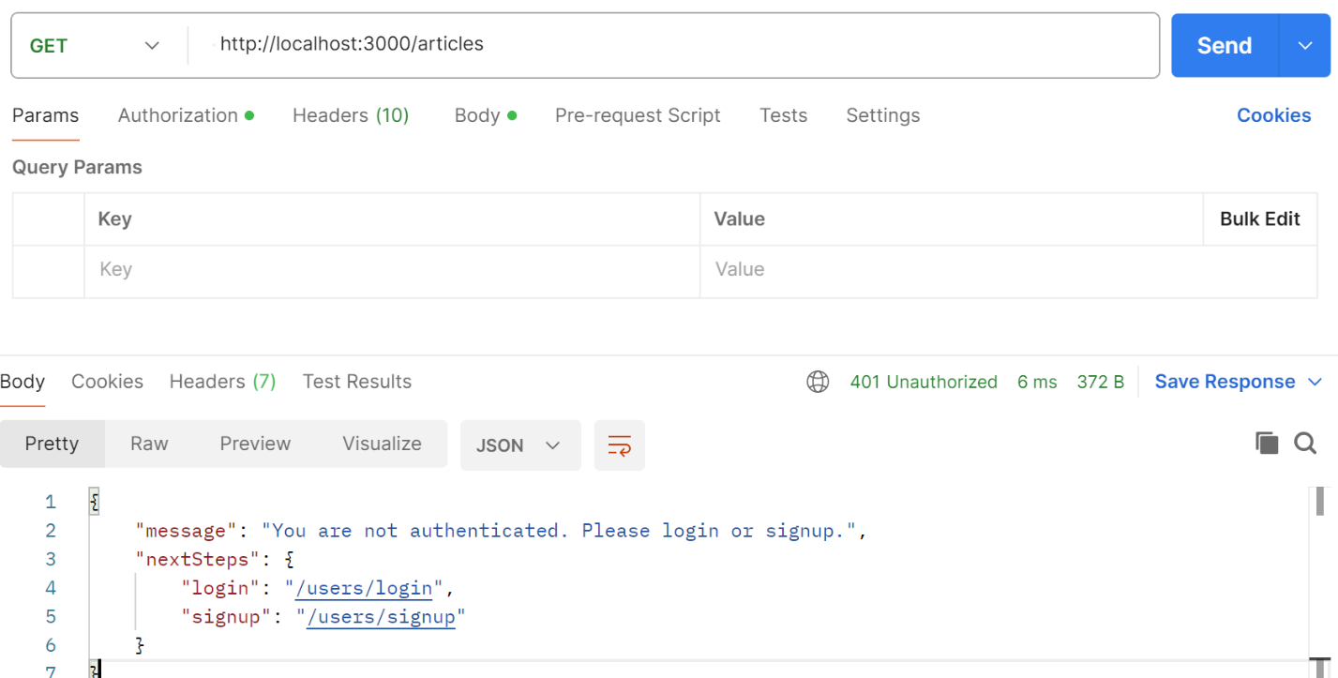

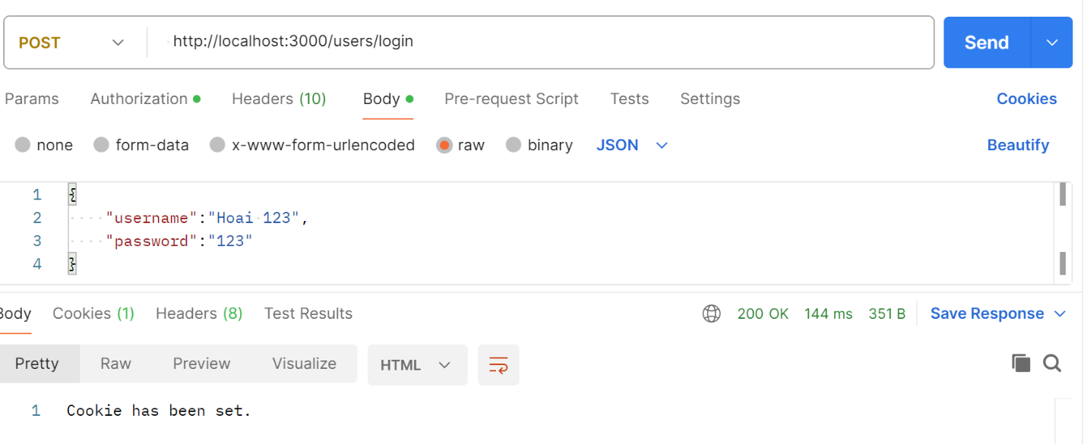
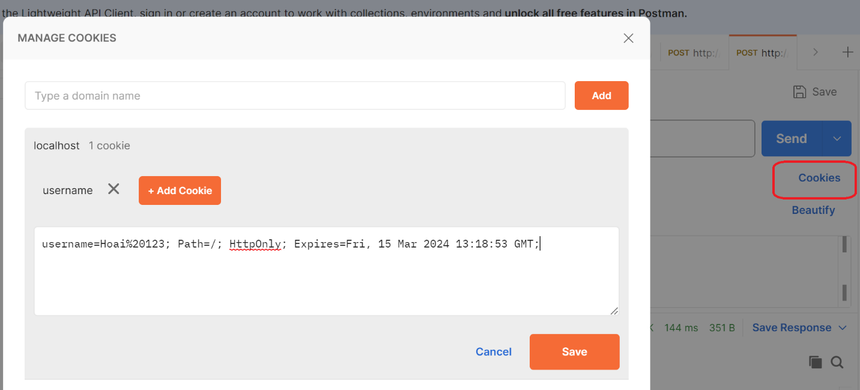

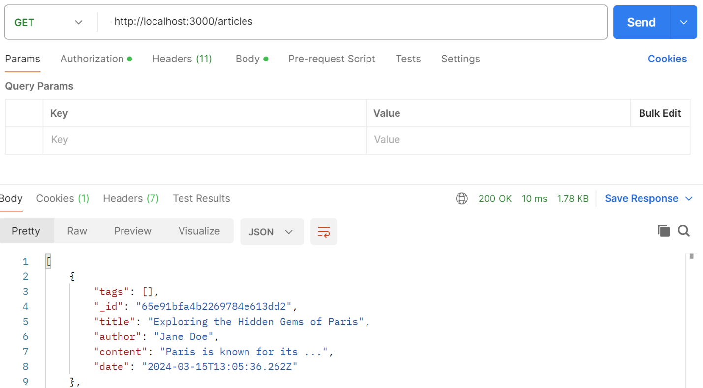

Conclusion
Conclusion, Cookies are a fundamental part of web development, offering a range of functionalities from enhancing user experience through personalization and session management to supporting security measures. Understanding how to effectively use and manage cookies is essential for web developers.

