Exercise 21: Session

Objective
In this exercise, you’ll learn about store sessions in MongoDB using a session store like connect-mongo with Express.js.

Exercise
- Rename node-cookies to node-session and open it
- Install "express-session": "^1.18.0", "connect-mongo": "^5.1.0"
- Create folder config and new sessionConfig.js file
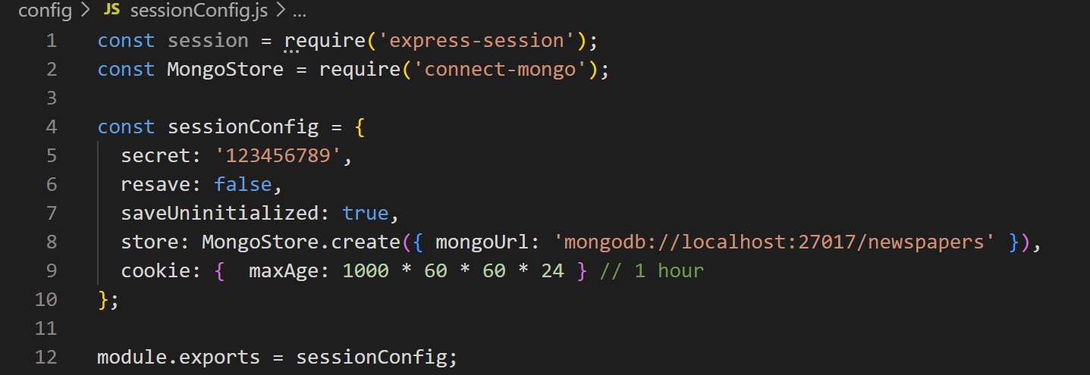
- Do this code with auth.js file in authentication folder
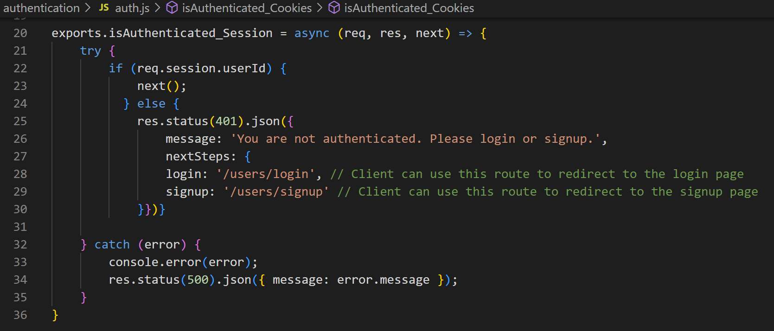

- Modify articleRouter.js to authenticate
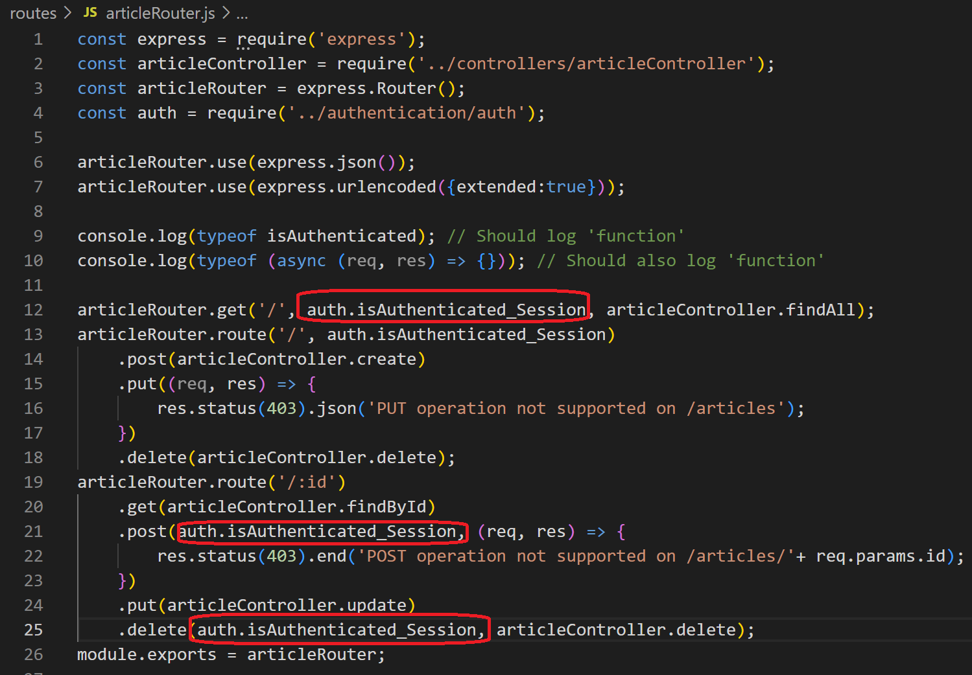
- Modify app.js to call configSession
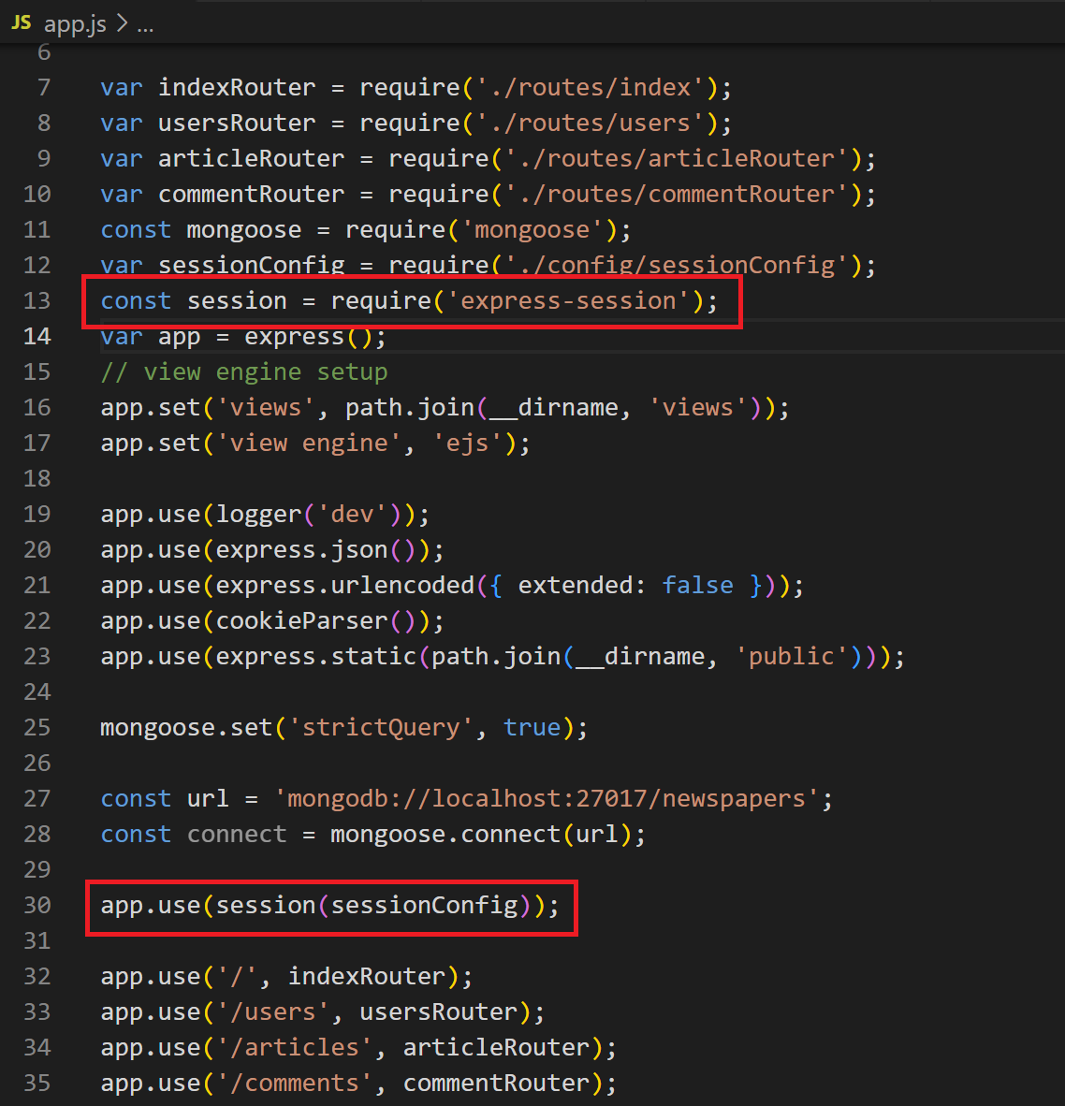
- Test with Postman
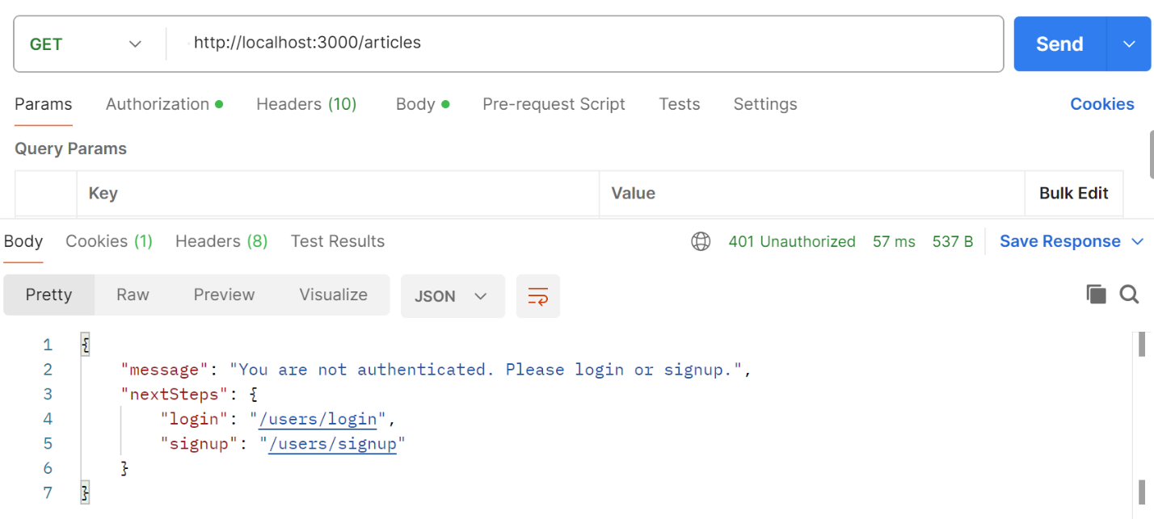
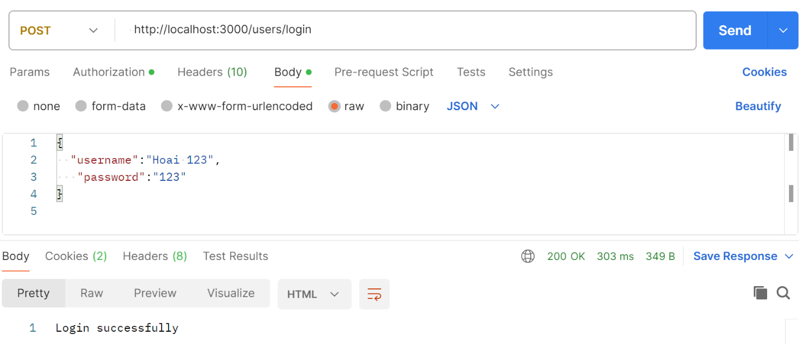
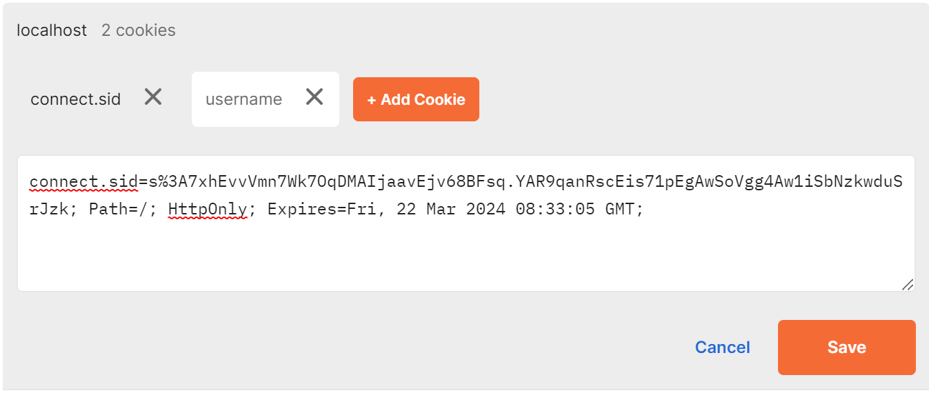

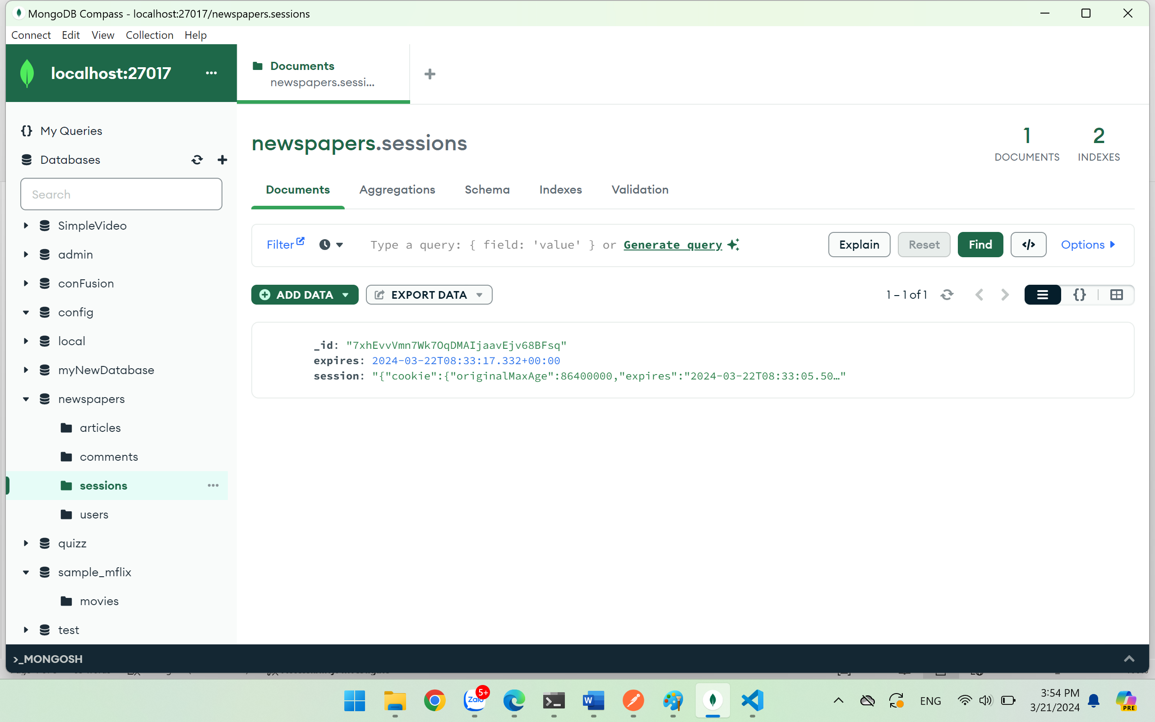
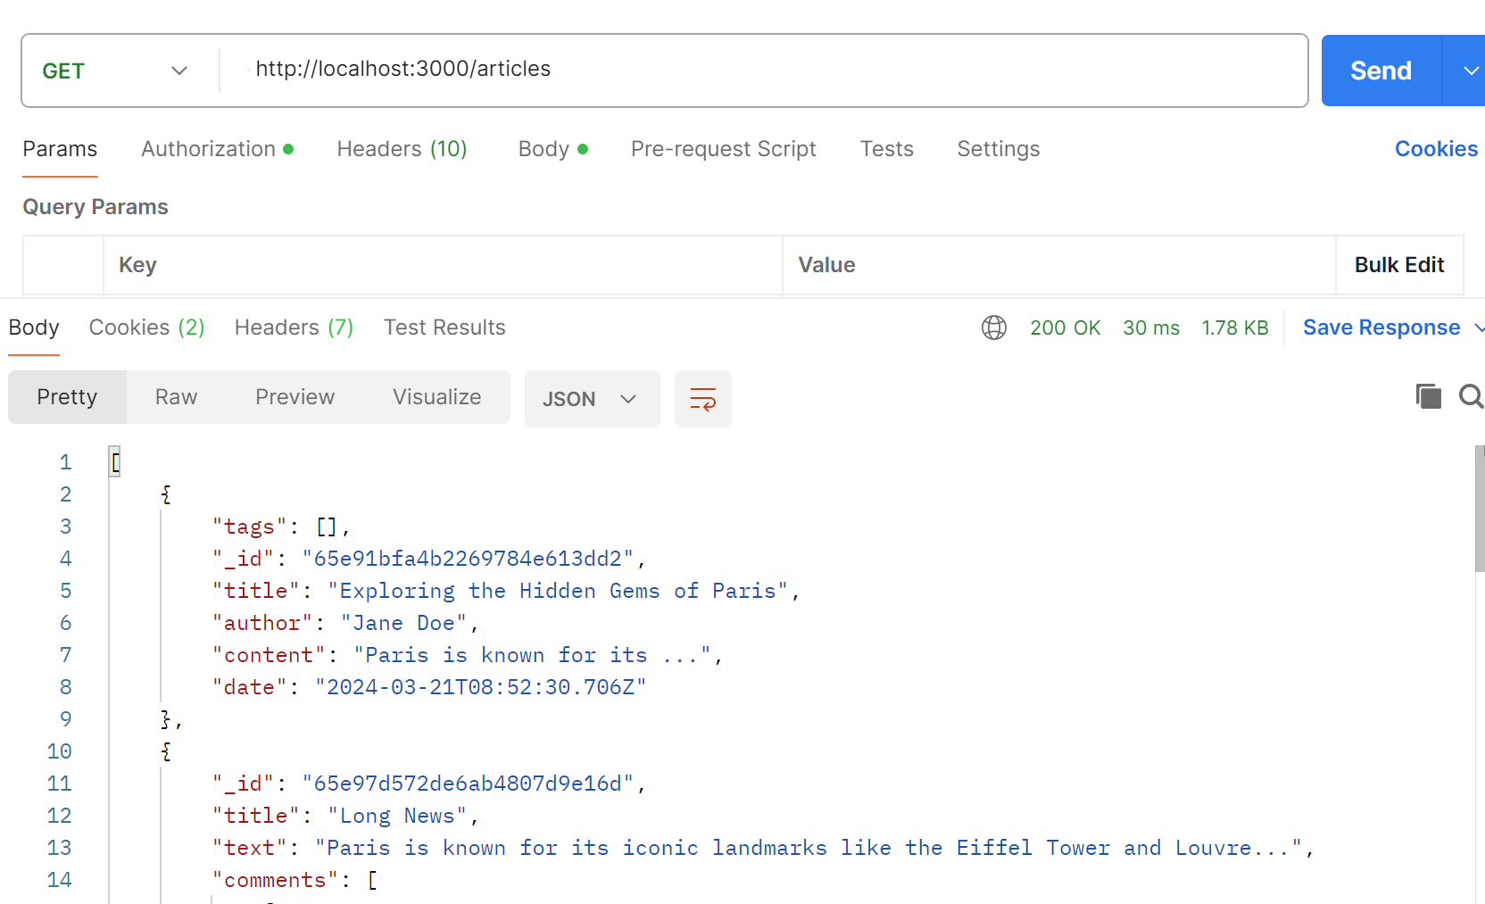

Conclusion
After doing this exercise, you are able to improve code organization, maintainability, and scalability basing on MVC patter.

