Exercise 23: Passport JWT

Objective
In this exercise, you’ll learn about the Passport JWT (JSON Web Token) strategy that is specifically used for authenticating with a JSON Web Token. It is a means to transmit information between parties in a compact, URL-safe way. When using the Passport JWT strategy, the server generates a token that certifies the user's identity and sends it to the client. The client then includes this token in the HTTP header of subsequent requests for authentication.

Exercise
- Rename node-session to node-jwt and open it
- Install "jsonwebtoken": "^9.0.2"
- Create folder config and new jwtConfig.js file
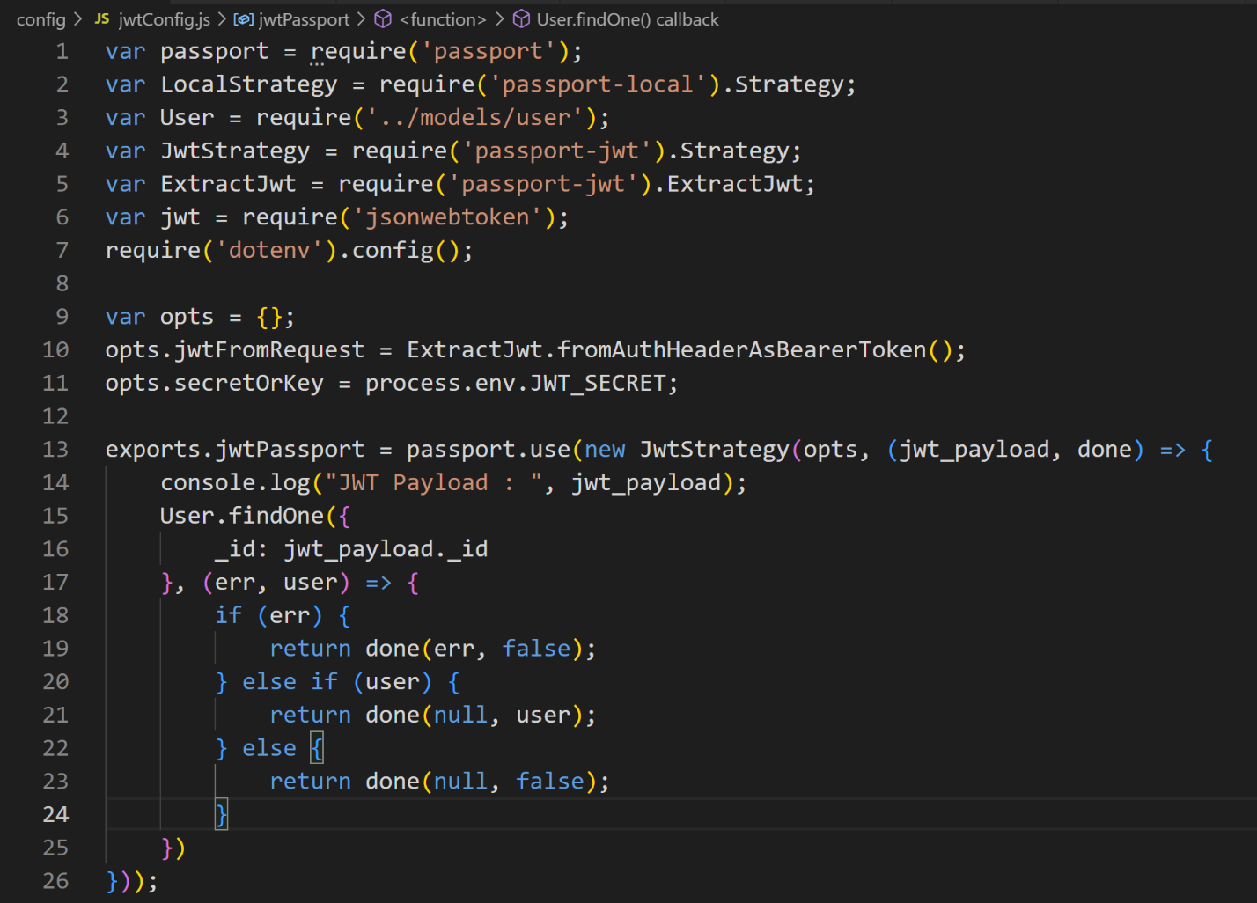

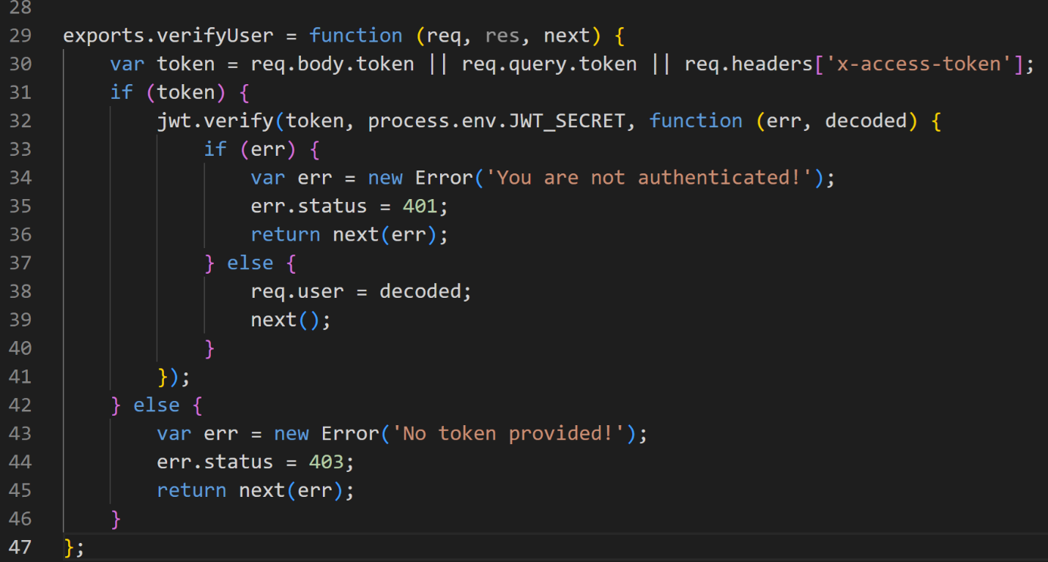
- Do this code with userRouter.js file in authentication folder
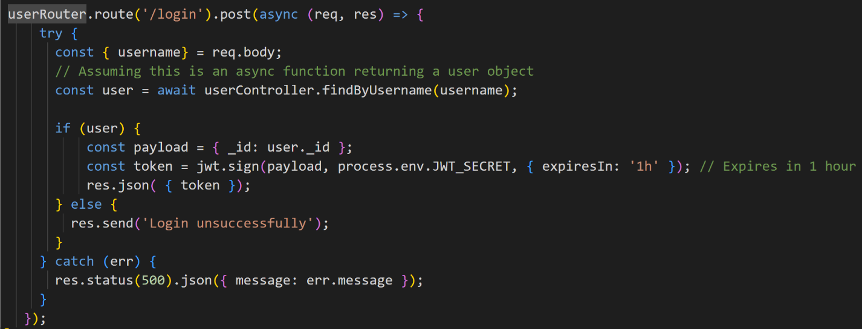

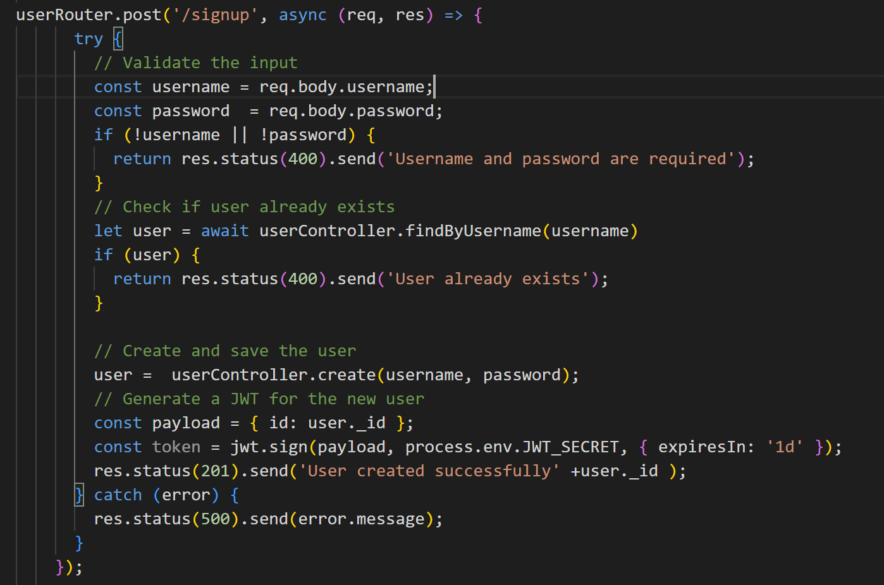
- Modify articleRouter.js to authenticate
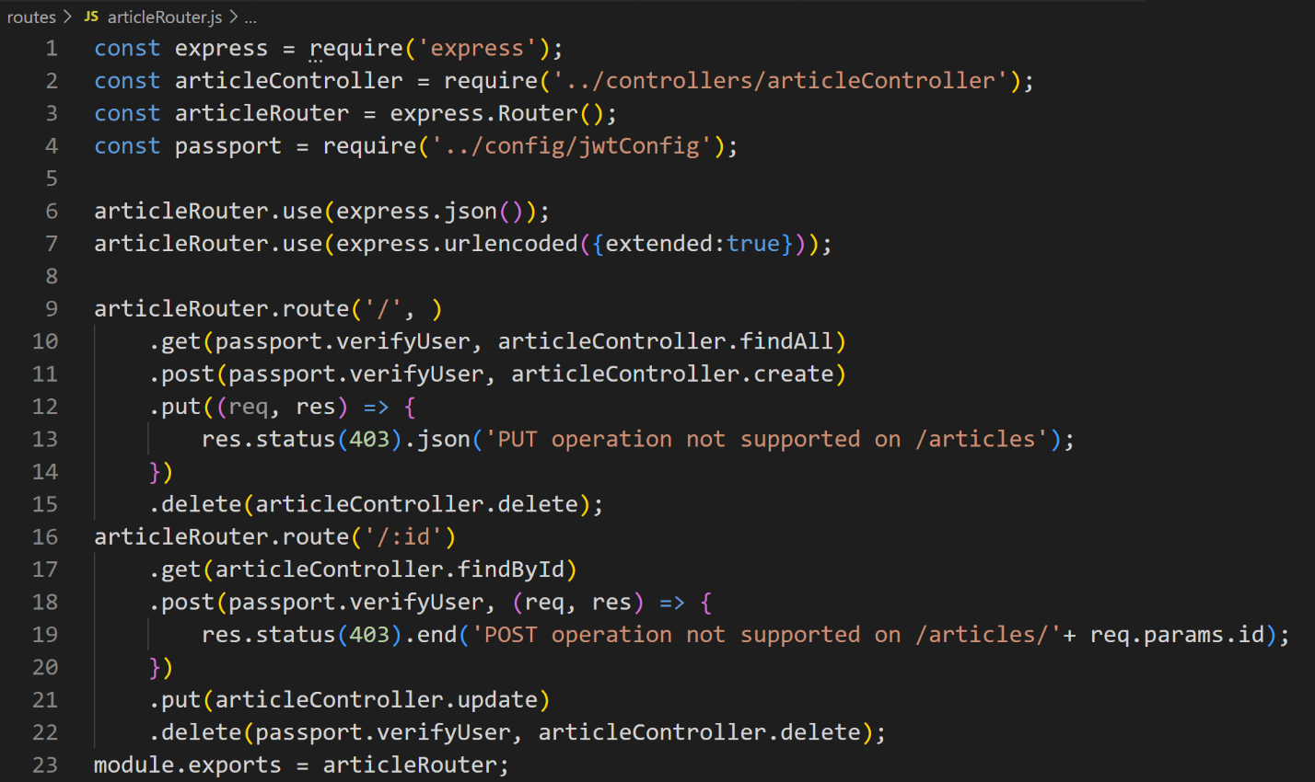
- Test with Postman

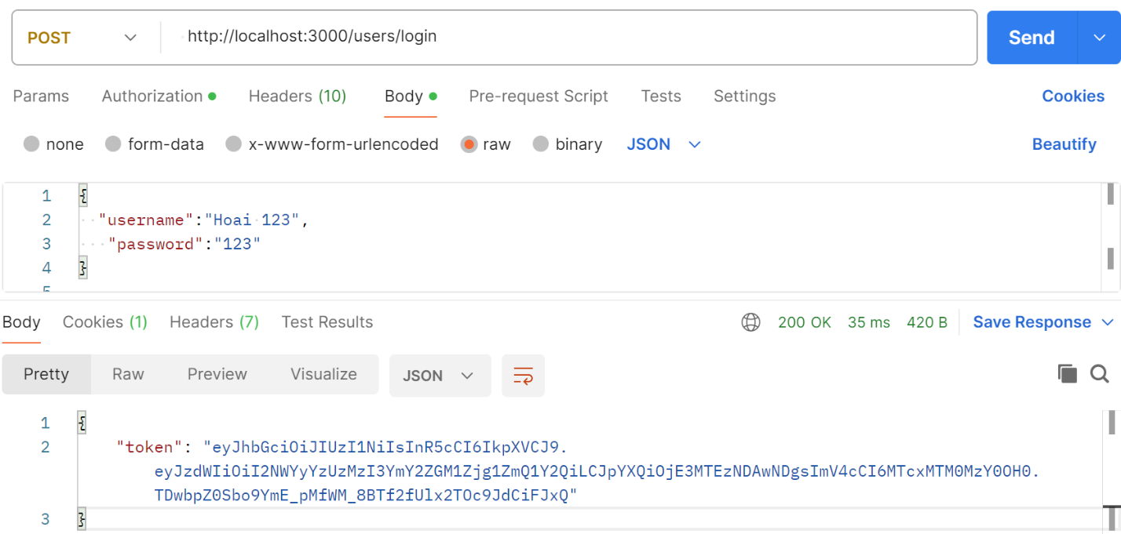
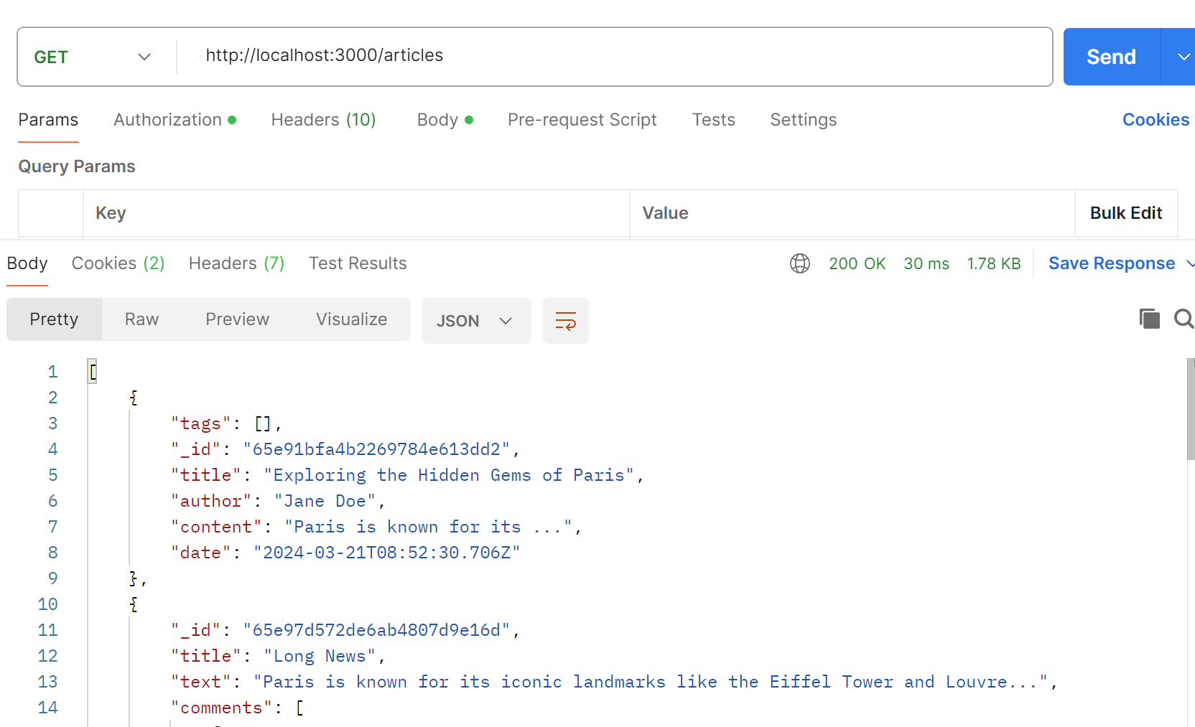

Conclusion
After doing this exercise, you are able to use JWT passport for authenticating.

