Exercise 26: OAUTH (Part 1)

Objective
In this exercise, you’ll learn about the OAuth 1.0 protocol and utilizing a library that supports OAuth 1.0 authentication. OAuth 1.0 is a protocol for third-party authentication, allowing users to grant your application access to their information on another service without exposing their credentials.

Exercise
- Copy node-https app and rename https-facebook
- Change code in app.js
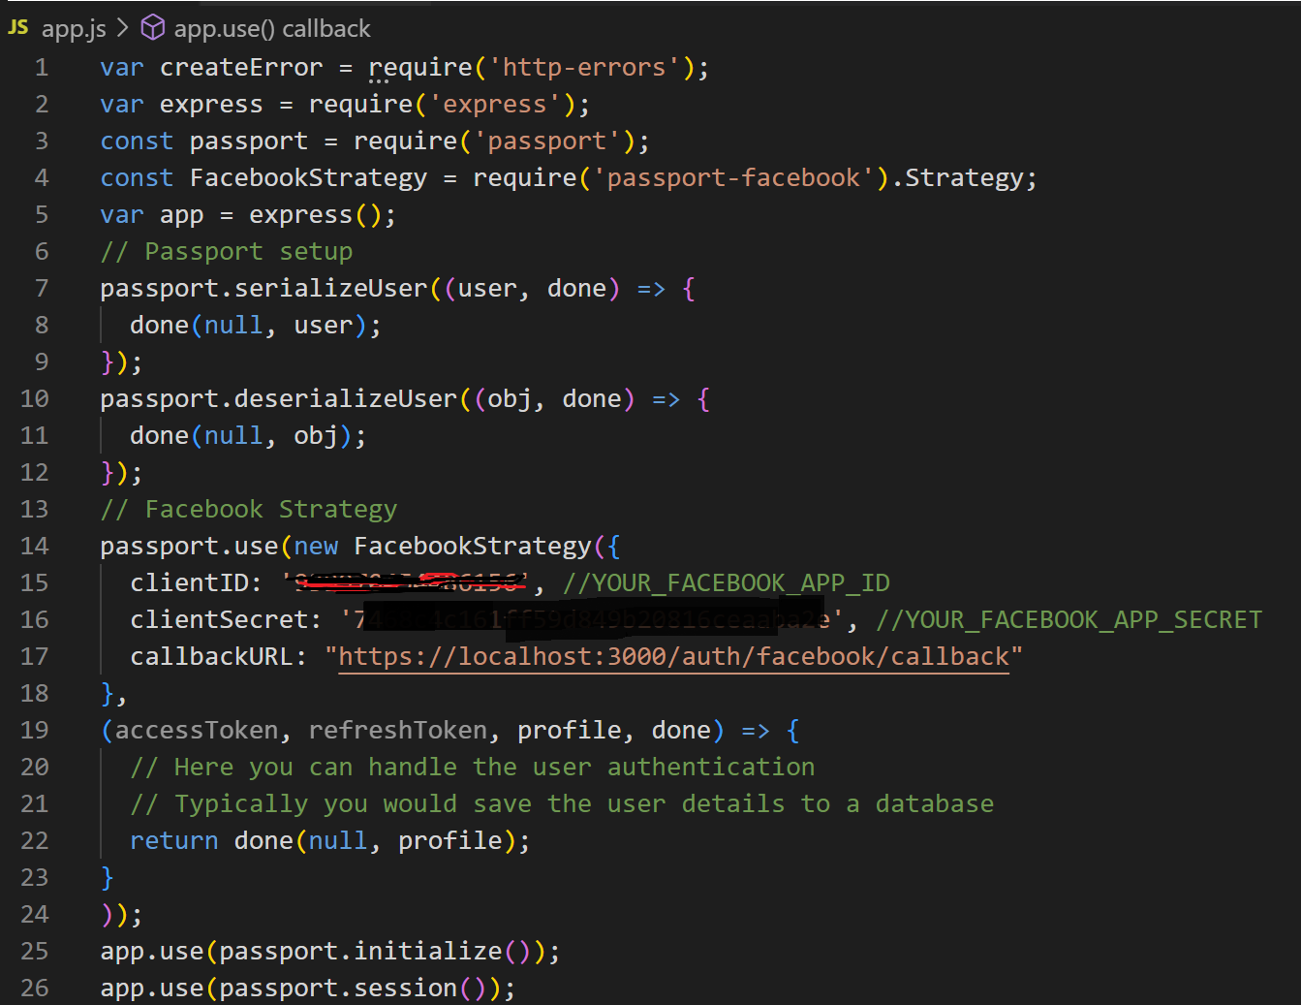
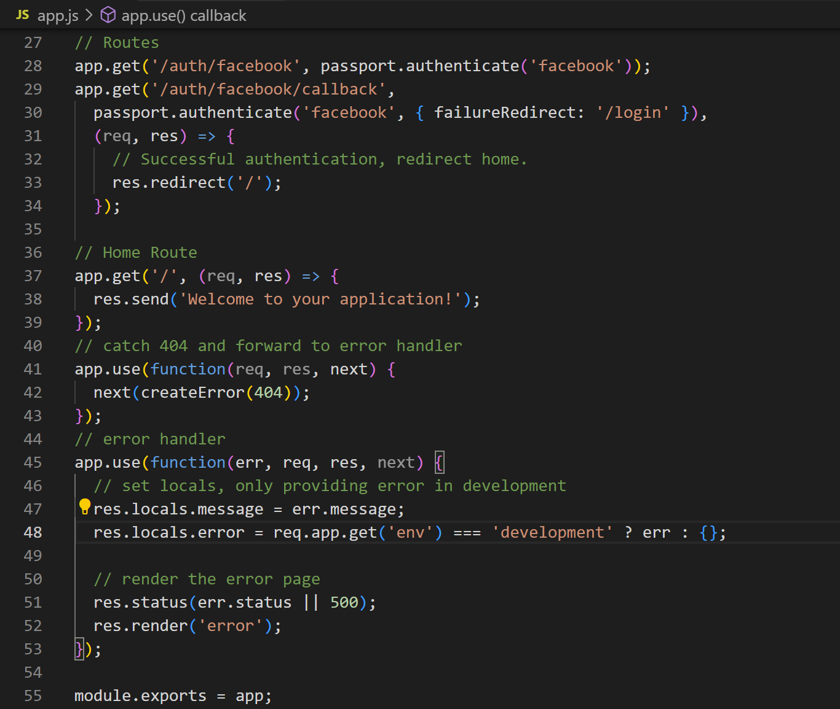
- Test with browser with url https://localhost:3000/auth/facebook
Successful login
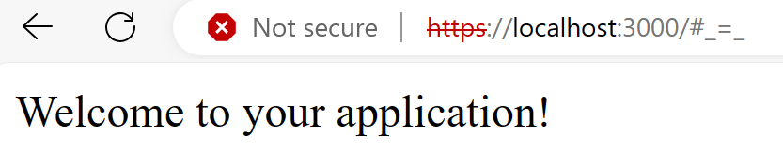
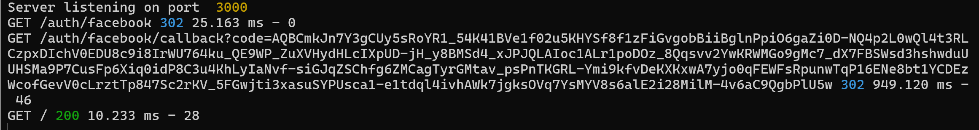

Conclusion
After doing this exercise, OAuth 1.0 requires careful handling of cryptographic signatures and tokens. While more complex than OAuth 2.0, it provides a secure method for authenticating and authorizing requests. Using a library like oauth in Node.js can greatly simplify the process, allowing you to focus on the logic and features of your application. Always ensure to secure your consumer keys and secrets, as well as tokens and secrets obtained during the OAuth flow.

