S N E W S

SNews
  - Android news reader with security-checking workflows
Software Product & Technical Report | 2025 project • 2026 documentation edition
Repository: snews-android • Android source: source/ • Product: SNews
Product | SNews
Platform | Android
Project period | March–May 2025 (project documentation)
Authors | Trần Hoàng Minh Vương · Nguyễn Việt Tín
Document language | English
Publication repository | snews-android (planned GitHub release)
ANALYSIS • ARCHITECTURE • PRODUCT DESIGN • VALIDATION

Executive summary
SNews is an Android mobile application conceived to combine accessible news consumption with practical security-awareness tools. The product brings together categorized articles, search, saved content, account-related features, user reports, and an interface for checking potentially suspicious digital objects. Its distinctive proposition is to place security evaluation alongside everyday reading rather than requiring users to switch to a separate specialist tool.
The implementation comprises a single Kotlin Android Gradle module built with Jetpack Compose, Navigation Compose, ViewModels and repository classes. Firebase Authentication and Cloud Firestore support account and application data; the source also includes a Hacker News RSS reader, article translation using ML Kit, Cloudinary image upload and VirusTotal URL/file analysis. No Flask administration application is present in the supplied archive. All statements about active behavior in this report are based on static source review rather than a successful Android build or live cloud test.
The principal user journeys are implemented at screen and repository level: sign-in and sign-up, feed and article detail, search, comments and reactions, bookmarks, community reports, scanner screens, history and settings. Several elements remain incomplete or need correction, including social login callbacks, the bank-account check action, notification ownership, scanner error classification and service credential handling. The report explicitly distinguishes implemented pathways from validated release behavior.
Documentation basis — Source reviewed: user-supplied SNews Android ZIP (single :app module, November 2026 review). Test level: static inspection and archive integrity only; Android build, instrumented tests and Firebase rules were not available for validation.

Contents
01 | Product context and rationale
02 | Users, needs and product journeys
03 | Functional design
04 | System architecture and technology
05 | Information model and data lifecycle
06 | Interaction design and accessibility
07 | Security and privacy posture
08 | Development, deployment and operation
09 | Verification strategy and findings
10 | Limitations and development roadmap
11 | Conclusion

01 Product context and rationale

The problem
Digital information consumption and security decisions often occur in the same session: a user reads an article, follows a link, evaluates an unfamiliar domain or receives a suspicious phone number. A conventional news reader optimizes discovery and reading, whereas a stand-alone scanning tool focuses on risk signals. SNews explores their intersection through a single Android experience.

Product intent
The product aims to shorten the path between encountering questionable information and requesting an additional safety check. The intended value is convenience and awareness, not a guarantee that a URL, file, IP address or phone number is safe. A third-party detection result is a risk indicator and must be interpreted with care.

Scope boundary
This release includes an Android client only. The 2025 design proposed a supporting administrative experience, but no separate admin panel, Flask service or Firebase Security Rules file is supplied in this source archive. Consequently, moderation and administrative access must not be represented as a verified deployed feature.

02 Users, needs and product journeys

Primary audience
The principal user is a mobile reader who wants concise access to news and a straightforward way to examine suspicious digital artifacts encountered during browsing or messaging. The interface emphasizes a low learning curve: discover a story, open it, save it, then access a dedicated safety-checking area when needed.

Reader journey
A reader begins on the home screen, browses highlighted news, chooses a category or searches a topic, and opens a detail view. Related actions may include reactions, bookmarking, sharing and checking a potentially suspicious link. The design material also presents a reporting form in which the user selects a report category, describes the event and submits evidence where appropriate.

Administrative journey
The product design identifies administrator responsibilities such as content publication, report moderation and user administration. The received code implements a reader-facing Android client and access to a reports collection; it does not include a separately deployable administration console or a server-side role-enforcement package. Such workflows are design context, not demonstrated components of this release.

03 Functional design

News experience
The app contains HomeScreen, NewsScreen, AllNewsScreen, NewsDetailScreen and AllBookmarkScreen, connected through MainActivity navigation. NewsRepository reads the Firestore posts collection, while NewsSocialRepository handles reactions, comments, sharing records and bookmarks. RssRepository retrieves an external The Hacker News feed, and TranslationManager translates HTML text with ML Kit. These code paths demonstrate implementation intent but still require device-level tests for completeness and resilience.

Security checks
ScanScreen and ScanViewModel connect URL and file submissions to VirusTotal v3 endpoints and request analysis results; ScanRepository records scan_history entries in Firestore. ScanPhoneAndCardScreen uses a different workflow for phone-number lookups: ScanPhoneCardRepository checks the malicous_phone and reports collections. The bank-account option is visible in the screen but its submit callback contains no lookup implementation. A missing or zero detection count is not proof of safety, and file uploads to VirusTotal raise privacy considerations.

Community reporting
ReportScreen, ReportDataScreen and ReportDetailScreen represent the community-reporting experience. ReportRepository submits records to Firestore and attempts to upload an attached image via CloudinaryUploader. It also retrieves user reports and report statistics. Access policies and moderation behavior cannot be verified from the Android source alone, because Firebase Security Rules and a separate admin service were not included.

User account and preferences
FirebaseAuthService supports email/password registration and sign-in; additional Google, Facebook and Apple buttons are shown, but their navigation callbacks in MainActivity are empty. SettingsScreen and ThemeViewModel provide display preferences, while NotificationRepository reads and updates notification documents. NotificationSettingsViewModel currently holds changes in memory and includes TODO markers for persistence. Offline reading and multi-factor authentication have not been established by the supplied code.

04 System architecture and technology

Android client
The supplied app/build.gradle.kts defines namespace/applicationId com.example.securescan, compileSdk 35, targetSdk 35, minSdk 24, versionName 1.0 and Java source/target compatibility 11. The project has one Android module, :app, and uses Jetpack Compose. API 24 means Android 7.0 or later, correcting the earlier API 26 assumption. These are inspected build settings, not evidence of build success.

Application building blocks
The implementation follows a pragmatic Compose + ViewModel + Repository structure: MainActivity defines the navigation graph; UI screens consume ViewModels; data repositories interact with Firestore, Firebase Authentication, external RSS and scanning services. Dependencies also declare Firebase Realtime Database and Storage, but declaration alone does not prove those services are used by a given feature. The design is a single Android client with managed cloud services, not a verified microservices system.

Cloud and external integrations
Firebase Authentication and Cloud Firestore are directly referenced in source; VirusTotal is invoked through Retrofit from ScanViewModel and Cloudinary is used by ReportRepository via CloudinaryUploader. The Hacker News RSS feed is consumed by RssRepository. These integrations are not equivalent to independent backend services included in the source. Service credentials, rules, network availability and usage quotas are external requirements for working deployment.

Engineering implications
The code separates several state and data concerns, but critical production work remains. The original source contained a live-looking VirusTotal API key in ScanViewModel and Cloudinary identifiers in CloudinaryUploader. The accompanying public-release snapshot removes these values from committed source and reads local build-time properties instead. Such properties are still extractable from an APK; a server-side proxy is recommended where API credentials require secrecy.
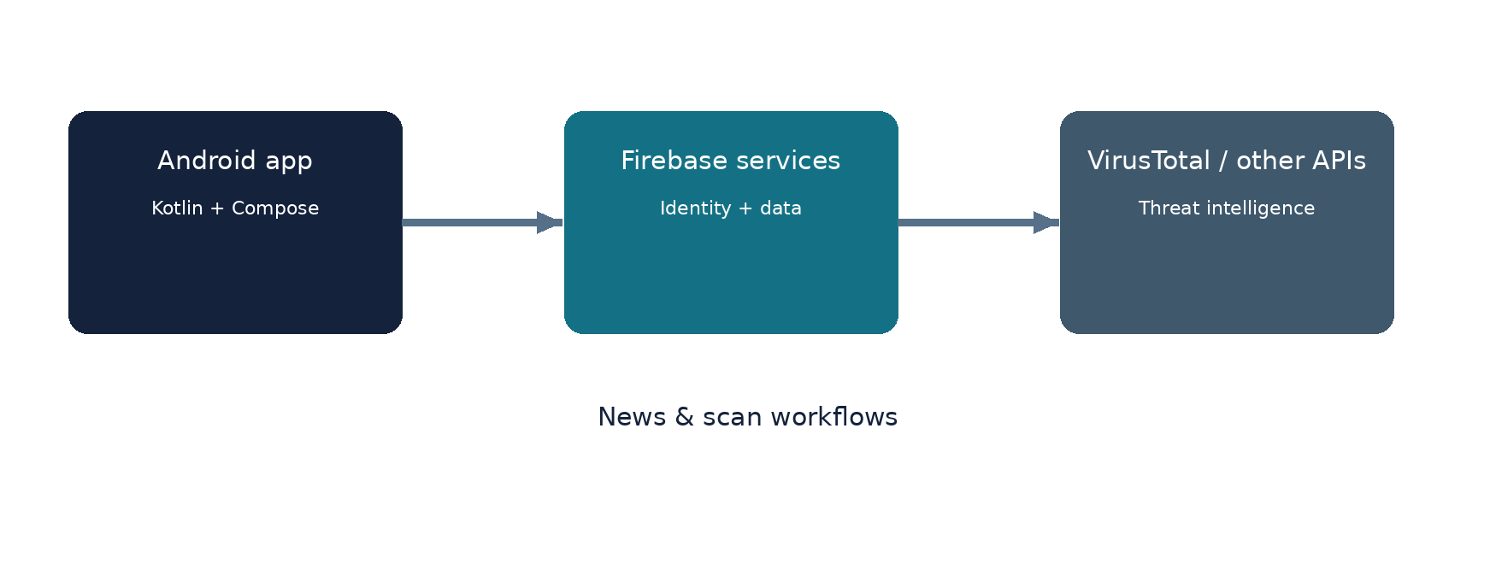
Figure 1. Product architecture (logical overview)

05 Information model and data lifecycle

Document-oriented data
The application uses Firestore collections called posts, comments, reactions, shares, bookmarks, reports, users, notifications and scan_history. ScanPhoneCardRepository also queries a collection named malicous_phone (spelling retained from code). These names are verifiable in repository classes; their real records, indexes and database security rules are not bundled. The report treats these classes as the observable data access model, not as an audited production database schema.

Ownership and relations
The reader identity anchors bookmarks, posts interactions, reports and scan history. News items have descriptive metadata and may be referenced by comments, reactions and shares. For integrity and privacy, write operations should validate the authenticated user and enforce ownership or role-aware access in Firebase Security Rules, not only in UI conditions.

Data minimization
Security-related inputs can include personal phone numbers, URLs with private tokens and files containing confidential material. Storage and transmission should be minimized, disclosed to users and protected according to the actual third-party service terms. Scan history and submitted reports should have explicit retention and deletion policies.

06 Interaction design and accessibility

Navigation model
The interface screenshots depict a bottom navigation bar, card-based content and dedicated scanning entry points. The visual system uses blue as a primary cue for primary actions and a distinct result treatment for a safety classification. Separating content consumption from risk checking helps keep the interface understandable.

Feedback and interpretation
A scan outcome is only an external service signal. ScanViewModel formats scan counts and uses a regular expression to recover the malicious count for its local classification. The current implementation can default an unparsed count to zero, which risks a misleading neutral classification. The product should distinguish clean, unknown, incomplete and failed checks and avoid implying a guarantee of safety.

Inclusive interaction
Readable contrast, scalable text, sufficiently large touch targets and descriptive labels are especially valuable for a mixed audience. Dark mode is visible in the original screenshots. Accessibility compliance would require an independent audit rather than an assertion based solely on appearance.
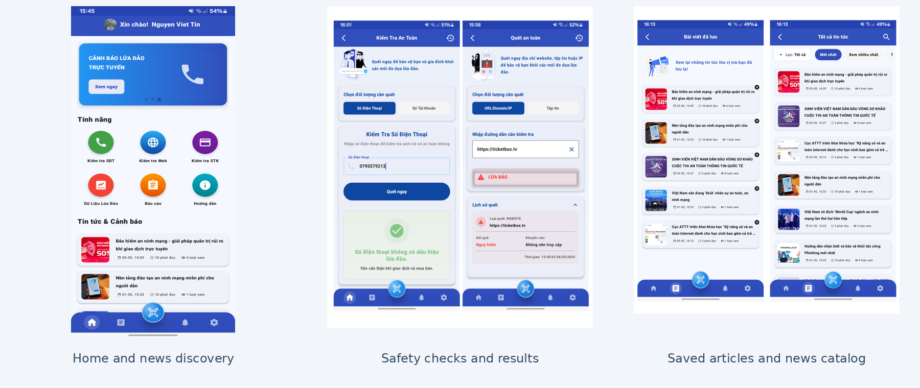
Figure 2. Original UI evidence: home, checking, and news views

07 Security and privacy posture

Trust boundaries
Authentication uses FirebaseAuthService, while data access is performed directly from the Android client. The repository does not include Firebase Security Rules, so server-enforced per-user isolation and moderator privileges have not been verified. NotificationRepository fetches notifications without an explicit current-user filter, and its bulk update targets all unread documents returned by the collection query; this requires a concrete access-control review.

API and file handling
The uploaded source embeds a VirusTotal key in an Android ViewModel. It must be considered exposed, revoked/rotated, and excluded from public Git history. The packaged source uses an uncommitted local configuration mechanism, but credentials built into a mobile client are still recoverable. File uploads and Cloudinary image submissions also transfer user-selected data to external providers; consent, disclosure, quotas and safe error states must be addressed before production deployment.

Security verification status
The reviewed materials include the Android source files and build configuration, but not the Firebase project rules/export or a reproducible test run. Source inspection identified an incomplete bank-account scan callback, empty social sign-in actions, notification-query ownership concerns, a hard-coded credential in the original archive and only starter sample tests. These observations support a targeted improvement plan, not a claim of successful security certification.

08 Development, deployment and operation

Development environment
This is an Android Studio/Gradle project with settings.gradle.kts defining one :app module. The Android Gradle Plugin version catalog is 8.8.1 and Kotlin is 2.0.0, with Java source/target compatibility 11; Gradle itself requires a compatible runtime JDK, commonly JDK 17 for this plugin generation. Firebase configuration and API credentials are environment-specific prerequisites. The source package contains wrapper scripts and wrapper JAR.

Build process
Open source/ in Android Studio, install Android SDK Platform 35, create a local Firebase project configuration at app/google-services.json, and provide local service settings using local.properties.example. Sync Gradle and build :app:assembleDebug. No Android SDK/complete cloud test environment was available in this review, so the build outcome is explicitly unverified. The supplied public-release copy replaces only credential-bearing configuration references and documents that modification.

Release considerations
The distributable snapshot excludes app/google-services.json, .idea workspace metadata, local.properties and signing secrets. It replaces the embedded VirusTotal key and Cloudinary identifiers with BuildConfig values populated from local.properties during local builds, while preserving the original feature flow. This is safer for Git publishing, but does not secure runtime secrets inside a distributed APK. Production deployment should introduce secure service-side mediation for sensitive scanning credentials.

09 Verification strategy and findings

Evidence-based assessment
Static source inspection confirms screen declarations, navigation destinations, ViewModel calls, Firestore collection access, RSS parsing, user report flows and Retrofit scanning integration. It also confirms a placeholder bank-account action, empty third-party sign-in callbacks, unpersisted notification settings and starter sample tests only. This is code-level evidence; there is no claim that authentication, scanning accuracy, push notifications or offline reading passed live tests.

Test approach
The recommended validation matrix covers Firebase authentication, Firestore read/write permission boundaries, news/search/reactions/bookmarks, report images and moderation, notification isolation, URL/file scan success/failure/timeout/rate-limit states, phone checks and the incomplete bank-account tab. Each case should be tested on a real/emulated Android device at multiple supported API levels and with controlled Firebase accounts.

Acceptance evidence
Each test should record the build revision, device/API level, prerequisites, expected outcome and actual result, ideally with logs and screenshots. Performance claims such as a sub-three-second response, support for more than one thousand concurrent users or 99.9% uptime require measured load and availability data; none is supplied here.

10 Limitations and development roadmap

Current limitations
Current limitations include an incomplete bank-account scan action; social login buttons without handler implementations; notification settings lacking persistence; notification queries that require ownership filtering; error/result ambiguity in the scanner; absent Firebase Security Rules from the archive; and exposure of an API credential in the original source. The supplied package includes no separate administrator application or verified offline cache. None of these limitations is hidden by the product narrative.

Near-term priorities
Priorities are to rotate the exposed VirusTotal key, move privileged scanning calls behind a trusted backend, define and test Firebase Security Rules, correct notification ownership handling, complete or remove non-functional buttons, clarify scanner unknown/error outcomes, and validate phone-number report matching. The next milestone is a clean reproducible Android build with integration and UI test evidence.

Long-term opportunities
Once the core product is stable, potential extensions include stronger content search, personalized article discovery, local caching, richer safety explanations, better notifications, accessibility improvements and additional vetted threat-intelligence providers. AI-assisted features should only be added with clear evaluation criteria, privacy boundaries and user-facing transparency.

11 Conclusion

Product outcome
SNews is a substantial Android application implementation with news browsing, Firestore-backed social interactions, reports, RSS content and security-checking workflows represented in source. Its educational product value is the combination of reading and risk awareness. The correct release characterization is a functioning-intent codebase requiring configuration and further testing, not a proven safe or production-ready security product.

Engineering perspective
The system uses a single Android client with layered ViewModel and repository code, hosted Firebase services and external VirusTotal/Cloudinary/RSS integrations. Static review found opportunities to strengthen secret management, trust boundaries, notification filtering, error handling and automated tests. These are actionable software-engineering outcomes supported by the supplied implementation.

Documentation position
This report is an original, stand-alone description of SNews grounded in the supplied Android source archive and design context. Source paths in the implementation appendix make the primary technical claims traceable; operational statements are limited to the evidence available without an Android device, Firebase credentials or live API tests.

Evidence and verification matrix
Area | Evidence available | Status
Android build and navigation | app/build.gradle.kts; MainActivity.kt | Verified in source; runtime not tested
News, search, RSS and translation | NewsRepository.kt; RssRepository.kt; TranslationManager.kt | Implemented in source
Reactions, comments, bookmarks | NewsSocialRepository.kt; NewsViewModel.kt | Implemented in source
URL and file scanning | ScanViewModel.kt; VirusTotalApiService.kt | API integration in source; needs credentials/tests
Phone / bank-account checks | ScanPhoneCardRepository.kt; ScanPhoneAndCardScreen.kt | Phone lookup implemented; bank action incomplete
Authentication and notifications | FirebaseAuthService.kt; NotificationRepository.kt | Email auth implemented; notification isolation unverified
Admin console, security rules, build tests | Not supplied in Android ZIP / only sample tests | Not verified / absent
This matrix summarizes code-level evidence from the supplied Android ZIP. “Implemented in source” means a class or interaction pathway exists; it does not mean the scenario has passed a runtime test.

References and source notes
[1] Project archive: “Building a News-Reading Application with Security Mechanisms,” SNews project report, May 2025 (user-supplied source).
[2] SNews source archive (Kotlin Android project, supplied for this documentation edition, November 2026); historical source repository: https://github.com/vuongthm/snews; documentation edition: snews-android
[3] Android build configuration: source/app/build.gradle.kts and source/gradle/libs.versions.toml.
[4] Android Developers, Guide to App Architecture: https://developer.android.com/topic/architecture
[5] IEEE Professional Communication Society, Write Effective Reports: https://procomm.ieee.org/communication-resources-for-engineers/written-reports/write-effective-reports/
[6] VirusTotal documentation: https://docs.virustotal.com/ (reference for interpretation and service constraints).

Implementation evidence | Source appendix
Source layout: source/app/src/main/java/com/example/securescan/

A. Implementation map
The single-module Gradle project starts at app/src/main/java/com/example/securescan/MainActivity.kt. Its Compose NavHost connects authentication, news, saved articles, reports, URL/file scanning, phone/account checks, notifications, RSS and preferences. Supporting ViewModels bridge screen state and repository operations.

B. News and community data
NewsRepository.kt maps the posts collection to news flows. NewsSocialRepository.kt accesses comments, reactions, bookmarks and shares and includes Firestore transactions for post interactions. RssRepository.kt parses the The Hacker News RSS feed; TranslationManager.kt uses ML Kit translation while traversing article HTML.

C. Threat-checking boundary
ScanViewModel.kt invokes VirusTotal v3 URL, file and analysis endpoints declared in VirusTotalApiService.kt. ScanRepository.kt saves scan_history documents. ScanPhoneCardRepository.kt checks phone numbers in malicous_phone and reports. ScanPhoneAndCardScreen.kt contains an empty submit handler for bank-account checking. These are distinct risk-signal sources, not a comprehensive device-protection engine.

D. Accounts, reports and notifications
FirebaseAuthService.kt handles email/password registration and sign-in. ReportRepository.kt stores reports and uploads attached images via CloudinaryUploader.kt. NotificationRepository.kt currently reads the collection without user-specific filtering and marks unread records in a batch; Firebase rules are required to enforce ownership. The archive has no independent admin dashboard.

E. Release and verification boundary
The distributable source removes concrete service identifiers and replaces embedded settings with BuildConfig variables fed from ignored local.properties. The uploaded project had a hard-coded VirusTotal key and a Google Services configuration: the associated credential should be rotated before sharing publicly. Source-level inspection is not a passed debug build, security assessment or validation of malware detection effectiveness.

