 TRAN VIET VUONG
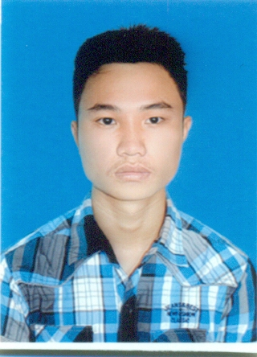

PERSONAL DETAILS

- Name Tran Viet Vuong
- Nationality Vietnamese
- Date of Birth August, 31th, 1995
- Sex Male
- Marital status Single
- Phone No. 01666432971
- Email vuongtvse03854@fpt.edu.vn
- Adress: To 4, thon Binh Tinh, xa Binh Minh, huyen Thang Binh, tinh Quang Nam

EDUCATIONAL BACKGROUND

- Software enginnering – FPT University – Vietnam

CERTIFICATE AND AWARD
- None

PROFESSIONAL SUMMARY
- Cooperative and able to perform within a team-oriented atmosphere.
- Have a serious and strict working manner.
- Hard working, eager to learn.
- Hobbies: play football, game, read book and going out with my friend.

SOFTWARE
- Database:
- Programming Languages: C, C++, JavaScript, Html, Css.
- Programming Tools: Netbean 8.3, DEV CPP, PHP Designer 8.0
- App server / Middleware:
- Framework: Bootstrap, JQuery , JDK 6u23 or more
- Configuration Management tools:
- Browsers: IE 8 9 10, Firefox 18, chrome 20 or higher
- OOAD/OOP: Object Oriented Programming (OOP), MVC

HARDWARE

HP Pavilion g4 – Core i5

OPERATING SYSTEMS

Windows

PROFESSIONAL EXPERIENCE

2015/2 – 3/2015
C++ Course: Developing Console Application to manage student information.

Project: FPT Assignment

Customer: Teacher

Assignment Description:
Team size: 1
Assignment size: 1 week

Responsibilities: Developer

Technologies Used:
Hardware environment
• Laptop HP Pavilion g4 Core i5, RAM 4Gb
Software environment
• .NET framework 3.5
Development tools
• DEV C 4.9

Programming Language:
- C++

2015/9 – 2015/10

SWE Course: Make an application to Help people pass A1 certification exam.

Project: FPT_Project

Customer: teacher

Project Description:
Some people needs a software application can help them try to learn and test before take an exam.

Domain:
Team size: 5
Project size: 2 month

Responsibilities: Project manager, main coder.

Technologies Used:
Hardware environment
• Laptop HP Pavilion g4 Core i5, RAM 4Gb
Software environment
• JDK 7.3
Development tools
• NetBeans 8.3
Programming Language:
- JAVA

