Final Project– SPI-Based Dual-Mode ALU/MAC Design

Due date: 課堂討論

基本方案(80%):
Mode1: 利用SPI介面將ALU之指令與data(總共可送8組)傳送至暫存器(cmd, a, b)以供ALU做後續運算。SPI傳輸完畢後，ALU可由”aluop_st1”這個pulse訊號來啟動8筆指令的運算，並將執行結果儲存至輸出(out)暫存器做後為後續check。
Mode 2: 利用SPI介面將MAC之input data(A總共八筆B0-B7；C0-C7)傳送至暫存器以供MAC做後續運算。SPI傳輸完畢後，MAC可由”aluop_st2”這個pulse訊號來啟動Serial-8的MAC運算，並將每筆MAC執行結果儲存至輸出(out)暫存器做後為後續check。

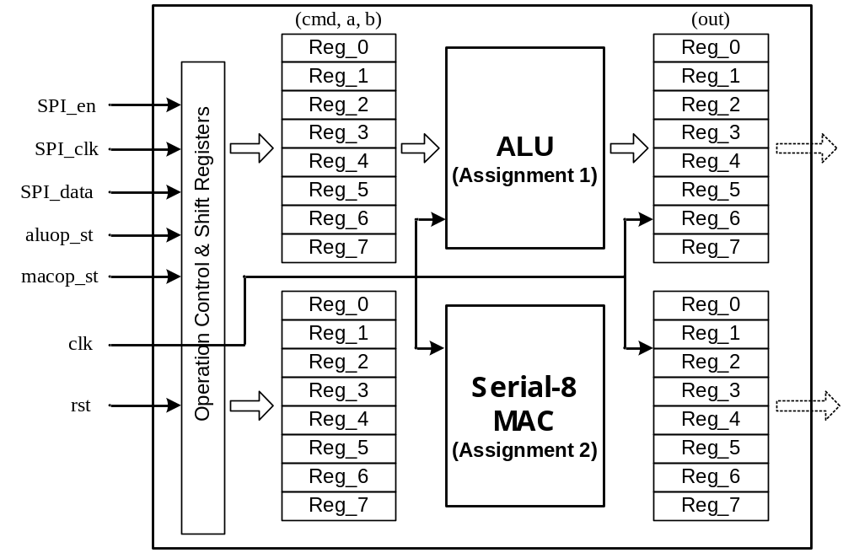

- SPI contents:
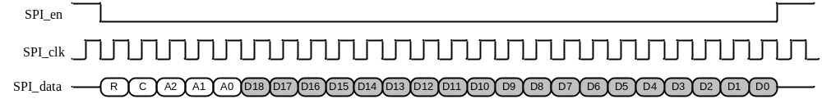

Timing specification:
SPI_clk → 1 MHz ; clk → 20 MHz
In Mode 1:
Control portion:
C→ 設為”0” ; R→ Reserved for future applications
Data portion:
[D18:D16] → cmd (3-bit); [D15:D8] → a (8-bit); [D7:D0]→b (8-bit)
Address portion:
[A2:A0]→ Addresses for Reg_0 to Reg_7 (from “000” to “111”) (3-bit)
e.g. “000” : (cmd0, a0, b0) stored to Reg_0
“001” : (cmd1, a1, b1) stored to Reg_1 and etc.
Operations:
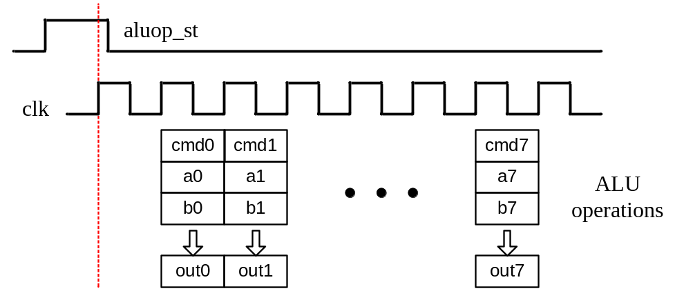
In Mode 2:
Control portion:
C→ 設為”1” ; R→ Reserved for future applications
Data portion:
D18→ Round or Floor; [D17,D16] → trun (2-bit); [D15:D8] → B0,B1,…,B7 (8-bit); [D7:D0]→ C0,C1,…,C7 (8-bit)
Address portion:
[A2:A0]→ Addresses for Reg_0 to Reg_7 (from “000” to “111”) (3-bit)
e.g. “000” : (R/F, trun0, B0, C0) stored to Reg_0
“001” : (R/F, trun1, B1, C1) stored to Reg_1 and etc.
Operations:
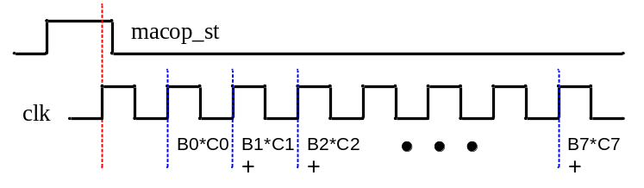

B0*C0→Reg0, B0*C0+ B1*C1→Reg1, B0*C0+ B1*C1+ B2*C2→Reg2, 以此類推
trun(2-bit: 00~11): suitable truncated number of LSB bits for MAC results
- 加強方案(20%):
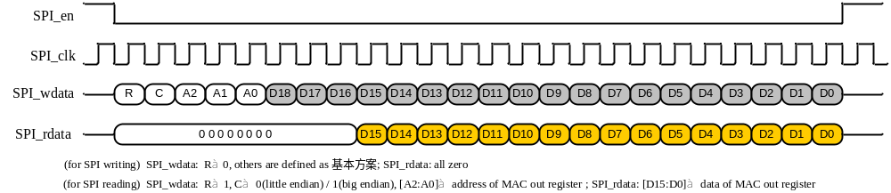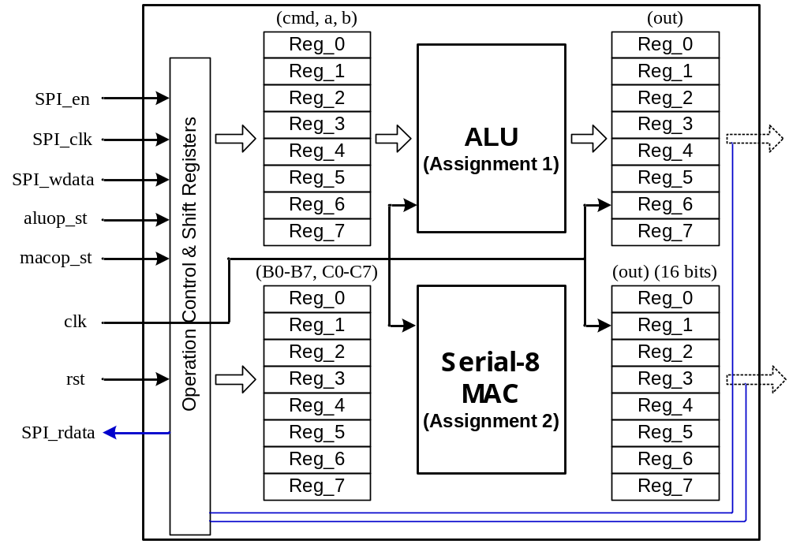

- 加強方案(20%):
