Assignment 3 & 4– SPI-Based ALU Processor Design

Due date: 課堂討論

功能: 利用SPI介面(Serial Peripheral Interfacing)將ALU之指令與data(總共可送8組)傳送至暫存器(cmd, a, b)以供ALU做後續運算。SPI傳輸完畢後，ALU可由”aluop_st”這個pulse訊號來啟動8筆指令的運算，並將執行結果儲存至輸出(out)暫存器做後為後續check。

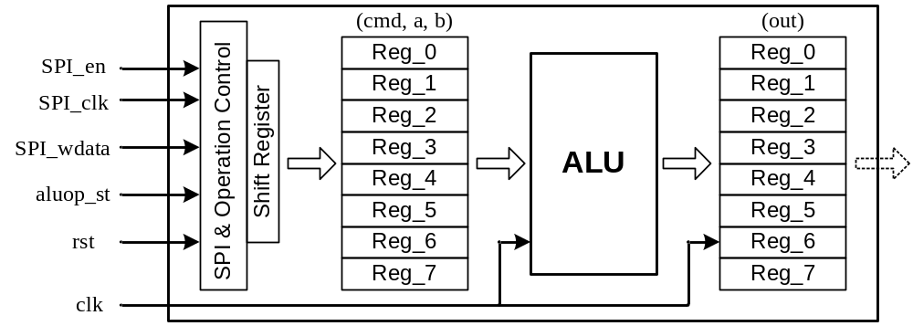

ALU contents: (The same with Assignment 1)
Top cell name (module name) | Top
Port | Port name | Bit-width | 描述
Input port | a | 8 | 輸入為加數/減數
Input port | b | 8 | 輸入為被加數/被減數
Input port | Cmd  >> Sel | 3 | Sel= 0 → a+b (9-bit)  Sel= 1 → a-b (9-bit)  Sel= 2 → a&b (8-bit)  Sel= 3 → a|b (8-bit)  Sel= 4 → a^b (8-bit)  Sel= 5 → a/2 + 4b (11-bit)  Sel= 6 → 3(a+b) (11-bit)  Sel= 7 → 6a + b/4 (11-bit)
Output port | out | 8 | 輸出結果
- SPI contents:

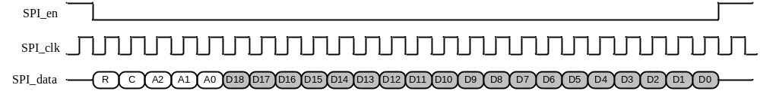

Data portion:
[D18:D16] → cmd (3-bit); [D15:D8] → a (8-bit); [D7:D0]→b (8-bit)

Address portion:
[A2:A0]→ Addresses for Reg_0 to Reg_7 (from “000” to “111”) (3-bit)
e.g. “000” : (cmd0, a0, b0) stored to Reg_0
“001” : (cmd1, a1, b1) stored to Reg_1 and etc.

Control portion:
C→ Reserved for future applications
R→ Reserved for future applications

Timing specification:

SPI_clk → 1 MHz (low-speed SPI clock)
clk → 20 MHz (relatively high-speed internal operation clock)
rst → Async. reset

