**Bank Record Generation**

Assignment 2: To write a program that parses and processes bank data from a file.

**Output Snapshots:**

**Snapshot 1**: Positive scenario to display first 25 bank records.

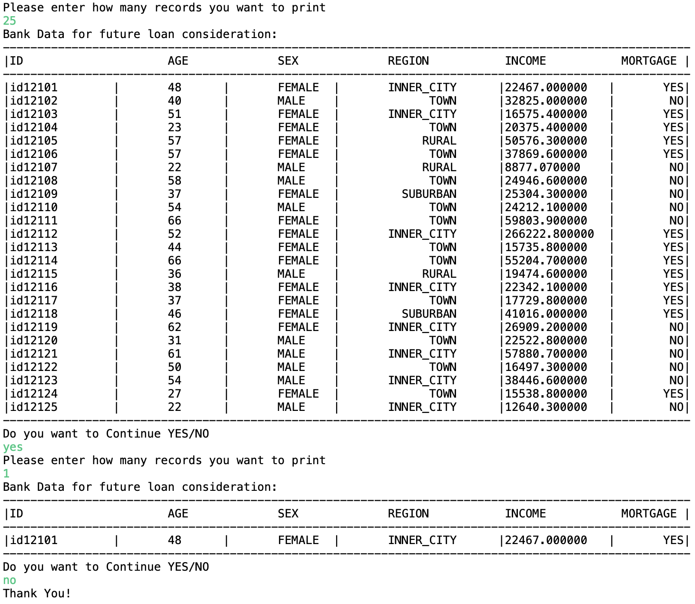

**Snapshot 2:** Positive scenario: to display bank records and exit.

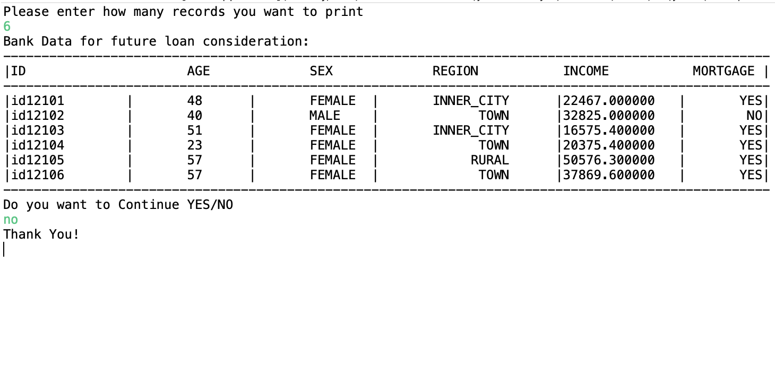

**Snapshot 3**: Negative Scenario: To display file not found exception

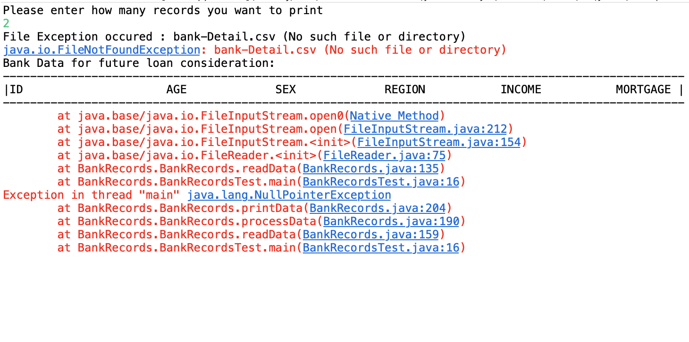

**Source code:**

**File 1:** Client.java

**package** BankRecords;

//Abstract class Client.java

**public** **abstract** **class** Client {

//Defining abstract method

//Method to read data from csv file

**public** **abstract** **void** readData();

//Method to process data from csv file

**public** **abstract** **void** processData();

//Method to print process data from csv file

**public** **abstract** **void** printData();

}

**File 2:** BankRecords.java

**package** BankRecords;

**import** java.io.BufferedReader;

**import** java.io.File;

**import** java.io.FileNotFoundException;

**import** java.io.FileReader;

**import** java.util.ArrayList;

**import** java.util.Arrays;

**import** java.util.List;

**public** **class** BankRecords **extends** Client {

//default constructor

**public** BankRecords() {}

**int** noOfRec;

//parameterized constructor initializing number of record to display

**public** BankRecords(**int** noOfRecords)

{

**this**.noOfRec= noOfRecords;

}

// defining all data elements

String id,sex,region,married,car,save_act,current_act, mortgage, pep;

ArrayList<List<String>> arrList = **new** ArrayList<>();

BankRecords recObj[] = **new** BankRecords[570];

**int** age,children,index=0;

**double** income;

//Method to read bank data

**public** **void** readData()

{

//try block to read bank data

**try**

{

File file = **new** File("bank-Detail.csv");

BufferedReader br = **new** BufferedReader(**new** FileReader(file));

String line;

//reading file line by line

**while**((line=br.readLine())!= **null**)

{

arrList.add(Arrays.*asList*(line.split(",")));

index++;

//increases capacity of BankRecords class array if equals to 590

**if**(index== recObj.length)

incrementArrCapacity();

}

br.close();

}

**catch**(FileNotFoundException fileEx)

{

System.***out***.println("File Exception occured : "+ fileEx.getMessage());

fileEx.printStackTrace();

}

**catch**(Exception ex)

{

System.***out***.println("Exception occured : "+ ex.getMessage());

ex.printStackTrace();

}

processData();

}

//method to increase array capacity

**public** **void** incrementArrCapacity()

{

recObj = Arrays.*copyOf*(recObj, recObj.length+10);

}

//Method to process the data from csv file

**public** **void** processData()

{

**int** rec=0;

**for**(List<String> recData: arrList)

{

recObj[rec]= **new** BankRecords();

recObj[rec].setId(recData.get(0));

recObj[rec].setAge(Integer.*parseInt*((recData.get(1))));

recObj[rec].setSex(recData.get(2));

recObj[rec].setRegion(recData.get(3));

recObj[rec].setIncome(Double.*parseDouble*(recData.get(4)));

recObj[rec].setMarried(recData.get(5));

recObj[rec].setChildren(Integer.*parseInt*(recData.get(6)));

recObj[rec].setCar(recData.get(7));

recObj[rec].setSave_act(recData.get(8));

recObj[rec].setCurrent_act(recData.get(9));

recObj[rec].setMortgage(recData.get(10));

recObj[rec].setPep(recData.get(11));

rec++;

}

printData();

}

//Method to print the bank data

**public** **void** printData()

{

System.***out***.println("Bank Data for future loan consideration:");

System.***out***.println("----------------------------------------------------------------------------------------------------");

System.***out***.println("|ID\t\t\tAGE\t\tSEX\t\tREGION\t\t INCOME\t\t MORTGAGE |");

System.***out***.println("----------------------------------------------------------------------------------------------------");

String finalRec;

//loop to display record

**for**(**int** i=0;i< noOfRec;i++)

{

finalRec =String.*format*("|%s\t|\t%d\t|\t%s\t|\t%10s\t|%f\t|%10s|",recObj[i].getId(),recObj[i].getAge(),recObj[i].getSex(),

recObj[i].getRegion(),recObj[i].getIncome(),recObj[i].getMortgage());

System.***out***.println(finalRec);

}

System.***out***.println("----------------------------------------------------------------------------------------------------");

}

//setters to set bank data elements

**public** **void** setId(String id) {

**this**.id = id;

}

**public** **void** setSex(String sex) {

**this**.sex = sex;

}

**public** **void** setRegion(String region) {

**this**.region = region;

}

**public** **void** setMarried(String married) {

**this**.married = married;

}

**public** **void** setCar(String car) {

**this**.car = car;

}

**public** **void** setSave_act(String save_act) {

**this**.save_act = save_act;

}

**public** **void** setCurrent_act(String current_act) {

**this**.current_act = current_act;

}

**public** **void** setMortgage(String mortgage) {

**this**.mortgage = mortgage;

}

**public** **void** setPep(String pep) {

**this**.pep = pep;

}

**public** **void** setAge(**int** age) {

**this**.age = age;

}

**public** **void** setChildren(**int** children) {

**this**.children = children;

}

**public** **void** setIncome(**double** income) {

**this**.income = income;

}

//getters to get all bank data elements

**public** String getId() {

**return** id;

}

**public** String getSex() {

**return** sex;

}

**public** String getRegion() {

**return** region;

}

**public** String getMarried() {

**return** married;

}

**public** String getCar() {

**return** car;

}

**public** String getSave_act() {

**return** save_act;

}

**public** String getCurrent_act() {

**return** current_act;

}

**public** String getMortgage() {

**return** mortgage;

}

**public** String getPep() {

**return** pep;

}

**public** **int** getAge() {

**return** age;

}

**public** **int** getChildren() {

**return** children;

}

**public** **double** getIncome() {

**return** income;

}

}

**File 3**: BankRecordsTest.java

**package** BankRecords;

**import** java.util.Scanner;

**public** **class** BankRecordsTest {

**public** **static** **void** main(String[] args)**throws** Exception {

// **TODO** Auto-generated method stub

Scanner sc=**new** Scanner(System.***in***);

**int** noOfRec;

String isContinue;

**do** {

System.***out***.println("Please enter how many records you want to print");

noOfRec= sc.nextInt();

BankRecords bankRec = **new** BankRecords(noOfRec);

//calling readData method which will read BankRececords.csv file

bankRec.readData();

System.***out***.println("Do you want to Continue YES/NO");

isContinue =sc.next();

**if**(isContinue.compareTo("yes")==0 || isContinue.compareTo("no")==0)

{

**if**(isContinue.compareTo("no")==0)

{

System.***out***.println("Thank You!");

**break**;

}

}

**else**

{

System.***out***.println("Incorrect input");

System.***out***.println("Do you want to Continue YES/NO");

isContinue =sc.next().toLowerCase();

}

}**while**(isContinue.compareTo("yes")==0);

//initializing BankRecords class

sc.close();

}

}