APTOS 2019 Data Analysis Report
  - ENGG2112 final project | Role A data engineering | 7 October 2026

Scope and main findings
All 3,662 labelled retinal images matched their files and decoded successfully. Identical-image groups with conflicting grades accounted for 62 records; provisional exclusion left 3,600 images for splitting and preprocessing. Similar-image review remains outstanding, so the split cannot yet support a claim of leakage-free evaluation.
The revised project predicts five diagnosis grades from fundus photographs, replacing the proposal's binary target. This report analyses the downloaded APTOS 2019 labelled training data [1]; competition test data are outside its scope.

Labels and class distribution
The CSV has two columns: id_code links each row to a PNG filename, and diagnosis supplies the target grade. All 3,662 IDs are unique, with no missing IDs or labels and no grades outside 0 to 4. No age or patient identifier column is present.
Grade and label | Images | Share
0 No DR | 1,805 | 49.29%
1 Mild | 370 | 10.10%
2 Moderate | 999 | 27.28%
3 Severe | 193 | 5.27%
4 Proliferative DR | 295 | 8.06%

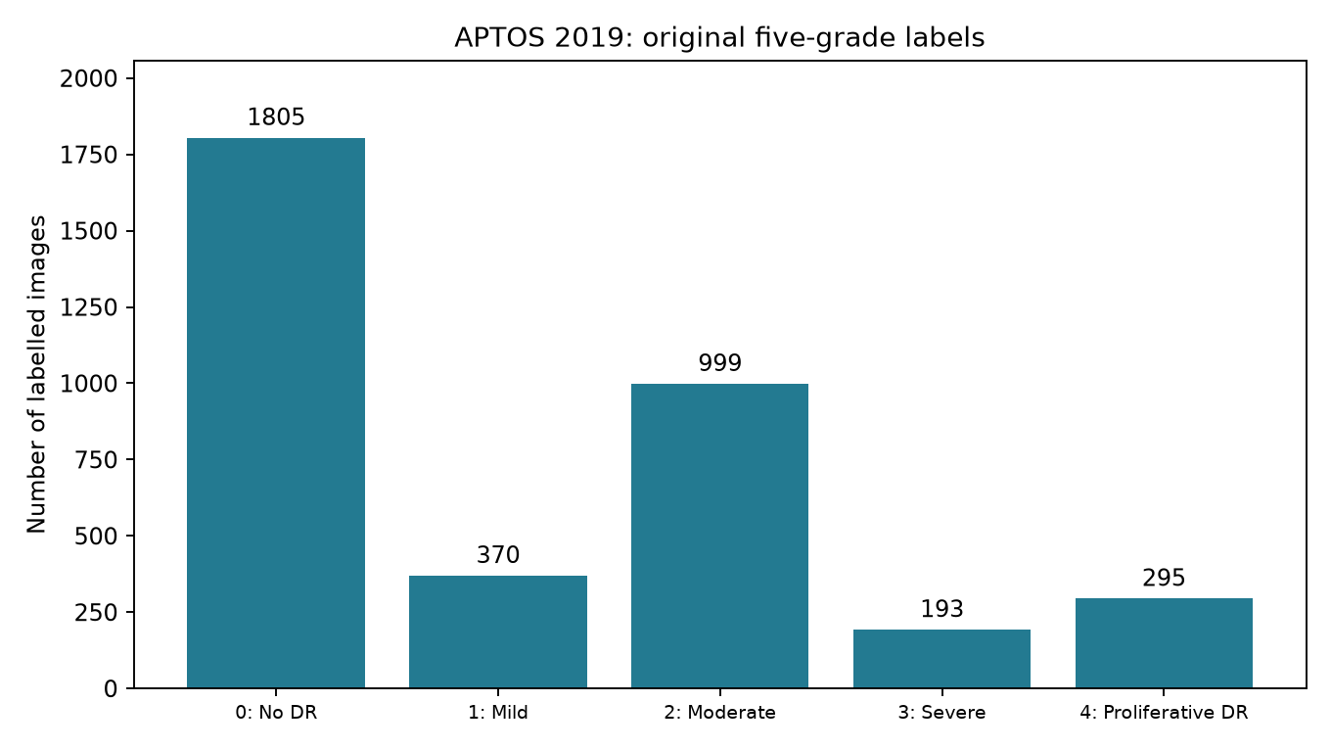
Figure 1 Original label distribution measured from train.csv [2].
Grade 0 contains 1,805 images versus 193 in grade 3, a 9.35 to 1 ratio. Always predicting grade 0 would score 49.29% on these original labels. This descriptive baseline shows why overall accuracy alone would be insufficient; class-specific results are needed. It is not a measured model result.

Image integrity and duplicate findings
The audit checked filenames, verified PNG integrity, fully decoded each file, and computed SHA-256 hashes of file bytes and decoded RGB pixels with dimensions. Pixel hashes identify exact content matches even when PNG encodings differ. These automated checks assess file consistency; they do not establish clinical image quality or label correctness.
Audit measure | Result
Labelled records and matching PNG files | 3,662 / 3,662
Missing or unreadable images | 0 / 0
Extra PNG files without a label row | 0
Exact pixel duplicate groups | 123
Records in exact duplicate groups | 251
Groups with conflicting grades | 30
Records provisionally excluded for conflicting grades | 62
Remaining records before manual review | 3,600
Similar-image candidate pairs requiring review | 4,096

Counts refer to image records, not unique patients. The 251 duplicate-group records include the 62 conflicting records. They are not 251 additional copies. Original files and grades have been retained; no grade was guessed or corrected. Exclusion removes 1.69% of the original records and may change the sample composition.
A 64-bit difference hash generated the similarity review list using a Hamming distance of at most 2, excluding exact pixel matches. The 4,096 pairs are candidates, not confirmed duplicates or patients. This heuristic can produce false matches and miss related images. No manual review decisions have yet been incorporated into the split.

Original image dimensions
Dimension in pixels | Minimum | Median | Maximum
Width | 474 | 2,144 | 4,288
Height | 358 | 1,536 | 2,848

All 3,662 images were recorded as RGB. Width and height statistics are marginal summaries; the minimum width and height need not belong to the same image. Variable source dimensions require a consistent model input transform. A fixed resolution also discards detail, so visual readability of a thumbnail cannot establish preservation of small retinal features.

Provisional dataset split
The split retains all five grades and groups identical decoded images together. Records with conflicting grades are excluded from the current manifest. The remaining 3,600 records form 3,504 exact-image groups; these groups are not patient identifiers. Same-grade duplicates are retained within one split, which may still weight repeated content more heavily.
The target proportions are approximately 70% training, 15% validation and 15% testing. The script evaluates 256 GroupShuffleSplit candidates for each holdout step and selects by sample-size and per-grade proportional error, without model scores. It first selects the test set with seed 2112, then validation from the remainder with seed 2113.
Grade | Original | Excluded | Train | Validation | Test
0 | 1805 | 4 | 1258 | 270 | 273
1 | 370 | 10 | 253 | 54 | 53
2 | 999 | 23 | 684 | 148 | 144
3 | 193 | 13 | 127 | 26 | 27
4 | 295 | 12 | 199 | 40 | 44
Total | 3,662 | 62 | 2,521 | 538 | 541

The actual proportions of eligible records are 70.03%, 14.94% and 15.03%. Checks found zero exact pixel-group overlap across splits and no repeated image IDs in the manifest. These checks do not establish patient-level independence. Confirmed related-image groups must be incorporated and the reviewed split frozen before final model evaluation.

Preprocessing baseline
All 3,600 eligible images were converted to RGB, resized with aspect-preserving LANCZOS interpolation, and padded with black to 224 by 224 pixels. The outputs were saved separately as PNG files. All processed files were subsequently decoded and checked for RGB mode, output dimensions, and agreement with the source labels and split assignments.
Automatic black-border cropping is disabled. No random augmentation, oversampling or model-specific normalization has been applied. Pixel values remain unsigned 8-bit values from 0 to 255. The model teammate must apply the selected model's normalization consistently, and restrict training augmentation or balancing to the training set.
The 224-pixel resolution is a computationally manageable starting point, not an experimentally established optimum. The team still needs to compare input choices using training and validation data. Test performance must not determine preprocessing or other model choices.

Limitations and remaining work
Final evaluation remains provisional because the similarity candidates and conflicting labels have not been manually resolved. The available CSV cannot verify patient-level separation or support age-subgroup analysis. Successful image decoding is not evidence that images are clinically gradable. This work has not trained a classifier or measured diagnostic performance, generalisation to another dataset, or clinical benefit.
Before final submission, the team should document duplicate-review decisions, reconsider the effect of retaining repeated images, confirm the five-grade target and model input requirements, and freeze the reviewed split. The project background still needs disease-specific primary references and a justified connection to the intended application. Evaluation should report performance across all grades and explain the effect of class imbalance.

Files for the model teammate
All paths below are relative to the local project folder D:\engg2112-final report. The teammate should use the same reviewed manifest rather than create an independent random split.
- artifacts/splits/split_manifest.csv records the image ID, grade, assigned split, group ID and pixel hash. The current version is provisional.
- data/processed_224_v1/ contains prepared images, processed_manifest.csv and preprocessing_config.json. Read the configuration before applying model transforms.
- artifacts/audit/ contains the image inventory, duplicate and conflict lists, candidate pairs, aggregate tables and figures.
- src/, notebooks/01_data_audit.ipynb, requirements-lock.txt and README.md provide the executable workflow, learning notebook, dependency versions and instructions.
Reproduction order: audit_data, split_data, then preprocess, each run as a module with the project Python environment. Use a new output directory for a different preprocessing version. Six automated tests passed during setup, and all eight Notebook code cells executed successfully. Input hashes recorded with the audit, split and preprocessing configuration were rechecked during this export.

Sources and reproducibility records
[1] APTOS 2019 Blindness Detection. Kaggle competition data page. https://www.kaggle.com/competitions/aptos2019-blindness-detection/data
[2] Local train.csv and artifacts/audit/audit_summary.json, image_inventory.csv and near_duplicate_candidates.csv. Audit run 7 October 2026. All descriptive data counts and dimensions in this report were computed locally.
[3] artifacts/splits/split_summary.json and split_manifest.csv; data/processed_224_v1/preprocessing_config.json and processed_manifest.csv. Methods are implemented in src/audit_data.py, src/split_data.py and src/preprocess.py.

AI assistance
Codex generated the initial pipeline and this report using the local results. The student must review the code and reasoning, document modifications and checks, and retain the relevant full prompts and outputs for the course AI-use appendix. The existing docs/AI_ASSISTANCE.md is a starting record, not the complete appendix.

