**[VPUB]**

**DEPLOYMENT DOCUMENT**

|  |  |
| --- | --- |
| Ngày | [dd/mm/yyyy] |
| Phiên bản | [x.x] |
| Tình trạng | [Đã duyệt/Đang duyệt/Chưa duyệt] |
| Tác giả | [Phạm Ngọc Vũ, Developer] |
| Người xem xét | [Tên Nhân Viên, Chức vụ] |
| Người duyệt | [Tên Nhân Viên, Chức vụ] |

DANH MỤC TỪ VIẾT TẮT

|  |  |
| --- | --- |
| Từ viết tắt | Từ đầy đủ |
|  |  |
|  |  |
|  |  |
|  |  |

Mục lục

1 Server 1

1.1 Setup Bitvise SSH Client 1

1.2 Setup default for Centos 2

1.3 Setup httpd and MySQL 2

1.3.1 Httpd 2

1.3.2 MySQL 2

1.4 Setup tomcat 3

1.4.1 Source Tomcat 3

1.4.2 Setup service tomcat: 4

1.5 Setup AccessControlService 4

1.5.1 Install VLC 4

1.5.2 Setup AccessControlService 4

# Server

## Setup Bitvise SSH Client

* Download: <https://www.bitvise.com/ssh-client-download>

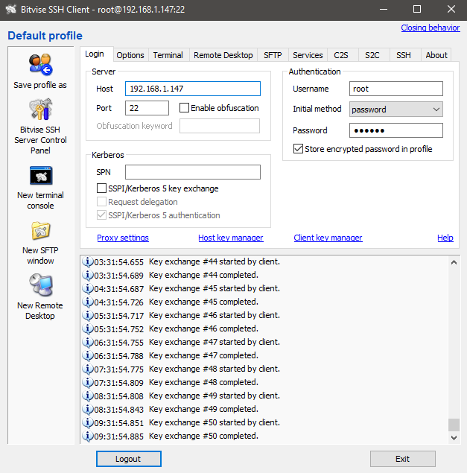

* Server:
  + Host: Server Address
  + Port: default **22**
  + Username: administrator provided
  + Password: administrator provided
* Run **New terminal console** to execute commands (**#** is commands in this document, **don’t** type **#** in commands)

## Setup default for Centos

* Set DNS: edit file **/etc/resolv.conf** add **nameserver 8.8.8.8**
* Update server: **# yum update**
* Disable the service
  + Selinux: **/etc/selinux** edit file **config** set **SELINUX=disabled**
  + Iptable:
    - **# chkconfig iptables off**
    - **# service iptables stop**
  + Ip6table:
    - **# chkconfig ip6tables off**
    - **# service ip6tables stop**
* Install NTP (Network Time Protocol): auto update date time
  + **# yum install ntp**
  + **# ntpdate pool.ntp.org**
  + **# chkconfig ntpd on**
* Setup Java(JDK)
  + **# mkdir /usr/java**
  + **# cd /usr/java**
  + Copy file **jdk-7u25-linux-x64.tar.gz** to **/usr/java**
  + **# tar -xvf jdk-7u25-linux-x64.tar.gz**
* Reboot server: **reboot**

## Setup httpd and MySQL

### Httpd

* **# yum install httpd**
* **# chkconfig httpd on**
* **# service httpd restart**

### MySQL

* Install
  + **# yum install mysql-server mysql**
* Setup
  + Boot with OS
    - **# chkconfig mysqld on**
  + Restart MySQL
    - **#service mysqld restart**
* Setup new password or forget password
  + **# mysqld_safe**
  + **# mysql -u root**
  + **# use mysql;**
  + **# UPDATE mysql.user SET Password=PASSWORD('[new_password]') WHERE User='root';**
  + **# flush privileges;**
* Permission
  + **# mysql -u root –p**
  + **Enter password**
  + **# use mysql;**
  + **# GRANT ALL ON *.* TO 'root'@'[ip_client]' IDENTIFIED BY '[password]' WITH GRANT OPTION;**
  + **# flush privileges;**
    - * **[ip_client]**: **'%'** is all
  + **# exit**
* Restore database by **Navicat**
* Setup **Scheduler** for **MySQL** by **Navicat Query**: **SET GLOBAL event_scheduler = ON;**

## Setup tomcat

### Source Tomcat

* Copy file source (**[file_name].tar.gz**) to **/usr**
  + **# cd /usr**
  + **# tar -xvf [file_name].tar.gz**
* Edit **port** for tomcat:
  + Enter folder **/usr/tomcat-sworld/conf**
  + Edit file **server.xml**



* Edit database for tomcat: check file **hibernate.cfg.xml**

### Setup service tomcat:

* Copy file **tomcat** to **/etc/rc.d/init.d**
* Setup Permission **775** for file **tomcat**: **# chmod 775 /etc/rc.d/init.d/tomcat**
* Start tomcat with OS: **# chkconfig --add tomcat**
* Commands:
  + **Run**: **# service tomcat start**
  + **View log** tomcat: **# tail -f /usr/tomcat-sworld/logs/catalina.out**
  + **Stop**: **# service tomcat stop**
* Deploy:
  + Build in eclipse => *.war
  + Upload file *.war to folder webapps (stop server before upload)
  + Start server
  + Test server: open browser: [server_address]:[port]/sworldwebservice/sworld/auth/login/admin/123

## Setup AccessControlService

### Install VLC

* **# rpm -Uvh http://download.fedoraproject.org/pub/epel/6/x86_64/epel-release-6-8.noarch.rpm**
* **# rpm -Uvh http://li.nux.ro/download/nux/dextop/el6/x86_64/nux-dextop-release-0-2.el6.nux.noarch.rpm**
* **# yum info vlc**
* **# yum install vlc**

### Setup AccessControlService

* **# mkdir /usr/AccessControlService**
* Copy file **AccessControlService.jar** to **/usr/AccessControlService**
* Copy folder **AccessControlService_lib** to **/usr/AccessControlService**
* Run with OS: enter folder **/etc/rc.d** edit file **rc.local**

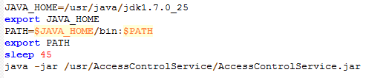

* Copy file **config.xml** to **/**
* Description for file **config.xml**
  + **TimeInspectionServer**: time check server (**milliseconds**)
  + **TimeInspectionCamera**: time check camera (**milliseconds**)
  + **TimeOpenDoor**: time delay after open the door (**milliseconds**)
  + **JavaWebService**: link to web service server
  + **User**: user name login to web service server
  + **Password**: password login to web service server
  + **UseAccessControl**: is use module **sAccess** (**true**/**false**)
  + **UseTimekeeping**: is use module **sTimekeeping** (**true**/**false**)
  + **PortReader**: port listening to **UDP** reader (MCR-02)
  + **Number**: number port listening form **PortReader** to **PortReader + Number**
  + **Mode**: for module **sAccess** (**12121212** is **Sai Gon Pearl**)
  + **NumberOfCamera**: number camera for **sTimekeeping**
  + **CameraAddress1**: 1st camera IP address
  + **CameraAddress2**: 2nd camera IP address
  + **ReaderForCamera1**: IP address of the reader use **CameraAddress1**, spaces between reader
  + **ReaderForCamera2**: IP address of the reader use **CameraAddress2**, spaces between reader