Anh Vu
August 22, 2021
Foundations of Programming Python
Assignment 07

Files and Exceptions in Python

Introduction
In this Module, we discover the uses of Files and Exceptions. For the assignment this week, we will again post our files to GitHub repository and perform a peer review via GitHub.

Exception Handling
Exception handling makes your code more robust and helps prevent potential failures that would cause your program to stop in an uncontrolled manner.

When exception occurs, Python will normally stop and generate an error message. These exceptions can be handled using the try statement. Since the try block raises an error, the except block will be executed.

You can use the else keyword to define a block of code to be executed if no errors were raised:

The finally block, if specified, will be executed regardless if the try block raises an error or not

Reference articles:
https://www.w3schools.com/python/python_try_except.asp

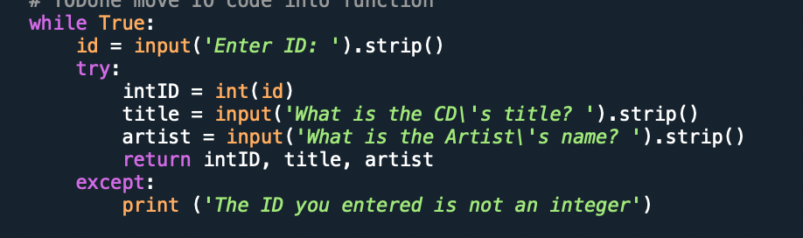
Figure 1: Error handling example

Pickling in Python

Pickling is a way to convert a python object (list, dict, etc.) into a character stream. The idea is that this character stream contains all the information necessary to reconstruct the object in another python script. Python pickle module is used for serializing and de-serializing a Python object structure. Any object in Python can be pickled so that it can be saved on disk. What pickle does is that it “serializes” the object first before writing it to file.

The Python pickle module basically consists of four methods:
pickle.dump(obj, file, protocol=None, *, fix_imports=True, buffer_callback=None)
pickle.dumps(obj, protocol=None, *, fix_imports=True, buffer_callback=None)
pickle.load(file, *, fix_imports=True, encoding="ASCII", errors="strict", buffers=None)
pickle.loads(bytes_object, *, fix_imports=True, encoding="ASCII", errors="strict", buffers=None)

You should not use pickles if you want to use data across different programming languages, pickle is not recommended. Its protocol is specific to Python, thus, cross-language compatibility is not guaranteed.

Reference articles:
https://realpython.com/python-pickle-module/
https://www.datacamp.com/community/tutorials/pickle-python-tutorial

Assignment
Upload in GitHub: https://github.com/vuquanh/Assignment_06.git

Codes:
try:
objFile = open(file_name, 'r')
for line in objFile:
data = line.strip().split(',')
dicRow = {'ID': int(data[0]), 'Title': data[1], 'Artist': data[2]}
table.append(dicRow)
objFile.close()
except:
print ('No such file')
Listing 1: Code to check if there is such file

while True:
id = input('Enter ID: ').strip()
try:
intID = int(id)
title = input('What is the CD\'s title? ').strip()
artist = input('What is the Artist\'s name? ').strip()
return intID, title, artist
except:
print ('The ID you entered is not an integer')
Listing 2: Code to check if ID input is an integer

File Running

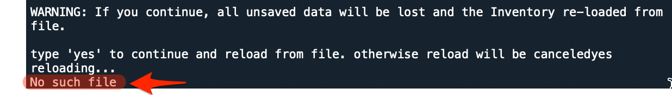
Figure 2: Error Handling when No file to read

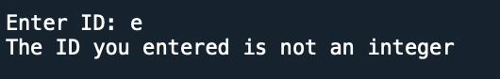
Figure 3: Error Handling when ID is not integer

Summary

In this assignment we discovered more about Error Handling value. It is very good concept to know so that we don’t create codes that might cause the program to terminate or cause any confusion to clients

Appendix

Listing CDInventory.py

#------------------------------------------#
# Title: CDInventory.py
# Desc: Working with files and exception.
# Change Log: (Who, When, What)
# DBiesinger, 2030-Jan-01, Created File
# AnhVu, 2021-Aug-12, Added Code
# AnhVu, 2021-Aug-22, Added Code for Error Handling
# AnhVu, 2021-Aug-22, Added Code to save Binary
#------------------------------------------#

import pickle

# -- DATA -- #
strChoice = '' # User input
lstTbl = [] # list of lists to hold data
dicRow = {} # list of data row
strFileName = 'CDInventory.dat' # data storage file
objFile = None # file object

# -- PROCESSING -- #
class DataProcessor:
# TODone add functions for processing here
@staticmethod
def additem (strID, strTitle, stArtist):
"""Function to add new data to the table

Args:
strID: ID number for the new record
strTitle: Title of the new record
stArtist: Artist name of the new record

Returns:
None.
"""
# TODone move processing code into function
intID = int(strID)
dicRow = {'ID': intID, 'Title': strTitle, 'Artist': stArtist}
lstTbl.append(dicRow)

@staticmethod
def removeitem (intIDDel):
"""Function to allow users to remove item from the table

Args:
intIDdel: the ID number of the record user want to delete

Returns:
None.
"""
# TODone move processing code into function
intRowNr = -1
blnCDRemoved = False
for row in lstTbl:
intRowNr += 1
if row['ID'] == intIDDel:
del lstTbl[intRowNr]
blnCDRemoved = True
break
if blnCDRemoved:
print('The CD was removed')
else:
print('Could not find this CD!')

@staticmethod
def savedata (data, fileName):
"""Function to allow users to save data to the table

Args:
None.

Returns:
None.
"""
objFile = open(strFileName, 'wb')
objFile.write (pickle.dumps(lstTbl))
objFile.close()

class FileProcessor:
"""Processing the data to and from text file"""

@staticmethod
def read_file(file_name):
"""Function to manage data ingestion from file to a list of dictionaries

Reads the data from file identified by file_name into a 2D table
(list of dicts) table one line in the file represents one dictionary row in table.

Args:
file_name (string): name of file used to read the data from
table (list of dict): 2D data structure (list of dicts) that holds the data during runtime

Returns:
None.
"""
try:
objFile = open(file_name, 'rb')
data = objFile.read ()
objFile.close()
return pickle.loads (data)
except:
print ('No such file')

@staticmethod
def write_file(file_name, table):
# TODOne Add code here
# TODOne add docstring
"""Function to manage writing data from user input to file

For each row in the table, a datarow is a dictionary

Args:
file_name (string): name of file used to read the data from
table (list of dict): 2D data structure (list of dicts) that holds the data during runtime

Returns:
None.
"""

objFile = open(file_name, 'a')
for row in table:
datarow = '{}{}{}'.format (row['ID'],row['Title'],row['Artist'])
objFile.write (datarow)
objFile.close()

# -- PRESENTATION (Input/Output) -- #

class IO:
"""Handling Input / Output"""

@staticmethod
def print_menu():
"""Displays a menu of choices to the user

Args:
None.

Returns:
None.
"""

print('Menu\n\n[l] load Inventory from file\n[a] Add CD\n[i] Display Current Inventory')
print('[d] delete CD from Inventory\n[s] Save Inventory to file\n[x] exit\n')

@staticmethod
def menu_choice():
"""Gets user input for menu selection

Args:
None.

Returns:
choice (string): a lower case sting of the users input out of the choices l, a, i, d, s or x

"""
choice = ' '
while choice not in ['l', 'a', 'i', 'd', 's', 'x']:
choice = input('Which operation would you like to perform? [l, a, i, d, s or x]: ').lower().strip()
print() # Add extra space for layout
return choice

@staticmethod
def show_inventory(table):
"""Displays current inventory table

Args:
table (list of dict): 2D data structure (list of dicts) that holds the data during runtime.

Returns:
None.

"""
print('======= The Current Inventory: =======')
print('ID\tCD Title (by: Artist)\n')
for row in table:
print('{}\t{} (by:{})'.format(*row.values()))
print('======================================')

# TODOne add I/O functions as needed
@staticmethod
def userinput ():
"""Function to ask user for input of new records

Args:
None.

Returns:
id: ID number for the new record
title: Title name for new record
artist: Artist name of the new record
"""
# TODone move IO code into function
while True:
id = input('Enter ID: ').strip()
try:
intID = int(id)
title = input('What is the CD\'s title? ').strip()
artist = input('What is the Artist\'s name? ').strip()
return intID, title, artist
except:
print ('The ID you entered is not an integer')

# 1. When program starts, read in the currently saved Inventory
lstTbl = FileProcessor.read_file(strFileName)
if lstTbl is None:
lstTbl = []

# 2. start main loop
while True:
# 2.1 Display Menu to user and get choice
IO.print_menu()
strChoice = IO.menu_choice()

# 3. Process menu selection
# 3.1 process exit first
if strChoice == 'x':
break
# 3.2 process load inventory
if strChoice == 'l':
print('WARNING: If you continue, all unsaved data will be lost and the Inventory re-loaded from file.')
strYesNo = input('type \'yes\' to continue and reload from file. otherwise reload will be canceled')
if strYesNo.lower() == 'yes':
print('reloading...')
lstTbl = FileProcessor.read_file(strFileName)
IO.show_inventory(lstTbl)
else:
input('canceling... Inventory data NOT reloaded. Press [ENTER] to continue to the menu.')
IO.show_inventory(lstTbl)
continue # start loop back at top.

# 3.3 process add a CD
elif strChoice == 'a':
# 3.3.1 Ask user for new ID, CD Title and Artist
# TODO move IO code into function
#strID = input('Enter ID: ').strip()
#strTitle = input('What is the CD\'s title? ').strip()
#stArtist = input('What is the Artist\'s name? ').strip()
strID, strTitle, stArtist = IO.userinput()

# 3.3.2 Add item to the table
# TODO move processing code into function
#intID = int(strID)
#dicRow = {'ID': intID, 'Title': strTitle, 'Artist': stArtist}
#lstTbl.append(dicRow)
#IO.show_inventory(lstTbl)
DataProcessor.additem(strID, strTitle, stArtist)
IO.show_inventory(lstTbl)
continue # start loop back at top.

# 3.4 process display current inventory
elif strChoice == 'i':
IO.show_inventory(lstTbl)
continue # start loop back at top.

# 3.5 process delete a CD
elif strChoice == 'd':
# 3.5.1 get Userinput for which CD to delete
# 3.5.1.1 display Inventory to user
IO.show_inventory(lstTbl)
# 3.5.1.2 ask user which ID to remove
intIDDel = int(input('Which ID would you like to delete? ').strip())
# 3.5.2 search thru table and delete CD
# TODOne move processing code into function
DataProcessor.removeitem (intIDDel)
IO.show_inventory(lstTbl)
continue # start loop back at top.

# 3.6 process save inventory to file
elif strChoice == 's':
# 3.6.1 Display current inventory and ask user for confirmation to save
IO.show_inventory(lstTbl)
strYesNo = input('Save this inventory to file? [y/n] ').strip().lower()
# 3.6.2 Process choice
if strYesNo == 'y':
# 3.6.2.1 save data
# TODOne move processing code into function
DataProcessor.savedata (lstTbl, strFileName)
else:
input('The inventory was NOT saved to file. Press [ENTER] to return to the menu.')
continue # start loop back at top.

# 3.7 catch-all should not be possible, as user choice gets vetted in IO, but to be save:
else:
print('General Error')

