Anh Vu
August 29, 2021
Foundations of Programming Python
Assignment 08

Objects and Classes in Python

Introduction
In this Module, we discover the uses of Objects and Classes. For the assignment this week, we will again post our files to GitHub repository and perform a peer review via GitHub.

Classes
Object oriented programming (OOP) paradigm is built around the idea of having objects that belong to a particular type. In a sense, the type is what explains us the object.
Everything in Python is an object of a type such as integers, lists, dictionaries, functions and so on. We define a type of object using classes.
Classes possess the following information:
- Data attributes: What is needed to create an instance of a class
- Methods (i.e. procedural attributes): How we interact with instances of a class.

class Cat:
color = ''
def __init__(self, cat_color):
self.color = cat_color

def print_color(self):
print('My color is {}'.format(self.color))

def jump(self, how_height):
print('Im jumping {}'.format(how_height))

A = Cat('brown')
B = Cat('black')

A.print_color()
B.print_color()

A.jump('1m')
B.jump('2m')

Figure 1: Class example

Class and Objects:
I was confused by the difference between class and object. I understand now class is a template for objects. A class defines object properties including a valid range of values, and a default value. A class also describes object behavior. An object is a member or an "instance" of a class. An object has a state in which all of its properties have values that you either explicitly define or that are defined by default settings.
This subtle conceptual difference between classes and objects shows why there is a tendency to want to use them interchangeably.

Class Constructor:
Constructors are generally used for instantiating an object. The task of constructors is to initialize(assign values) to the data members of the class when an object of the class is created. In Python the __init__() method is called the constructor and is always called when an object is created.

class TrackInfo :
position = None
title = ''
length = ''
def __init__(self, position, title, length):
self.position = int(position)
self.title = title
self.length = length

# -- PRESENTATION (Input/Output) -- #
track1 = TrackInfo (1, 'Bad', 'MJ')
track2 = TrackInfo (2, 'OK', 'Blah')

print ('The track is', track1.position, track1.title, track1.length)
Figure 2: Lab 08_B and the use of class constructor
Keyword “self”
The self parameter is a reference to the current instance of the class, and is used to access variables that belongs to the class. It does not have to be named self , you can call it whatever you like, but it has to be the first parameter of any function in the class.

Assignment
Upload in GitHub: https://github.com/vuquanh/Assignment08.git

Codes:
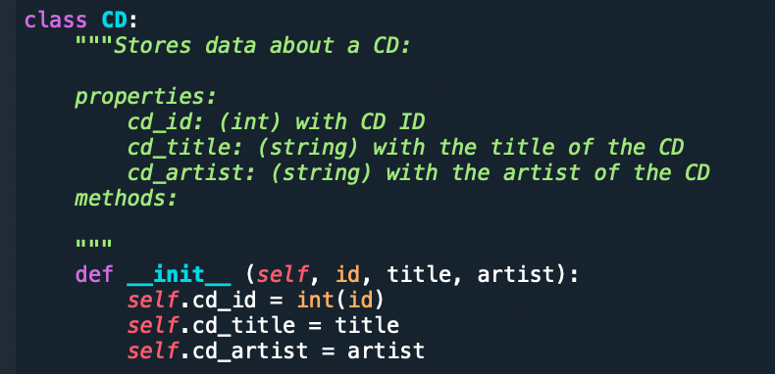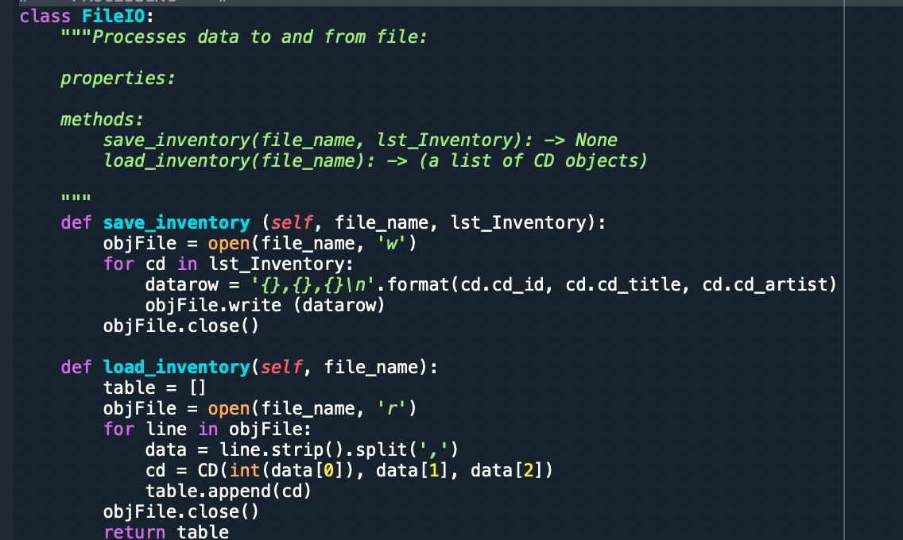

File Running

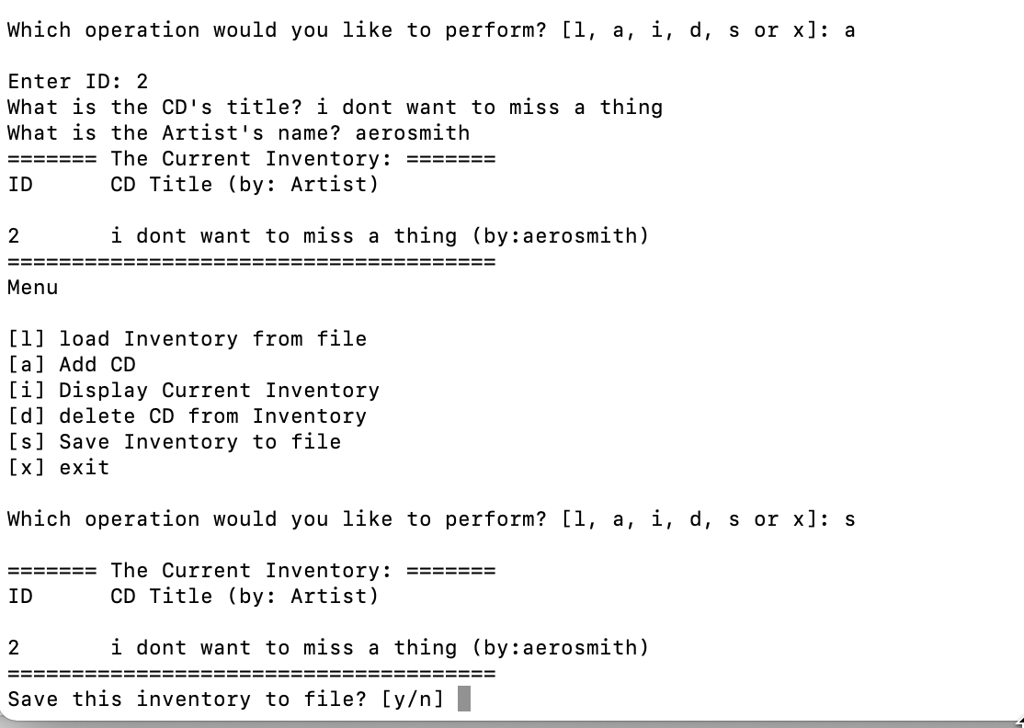
Figure 3- Running in Terminal

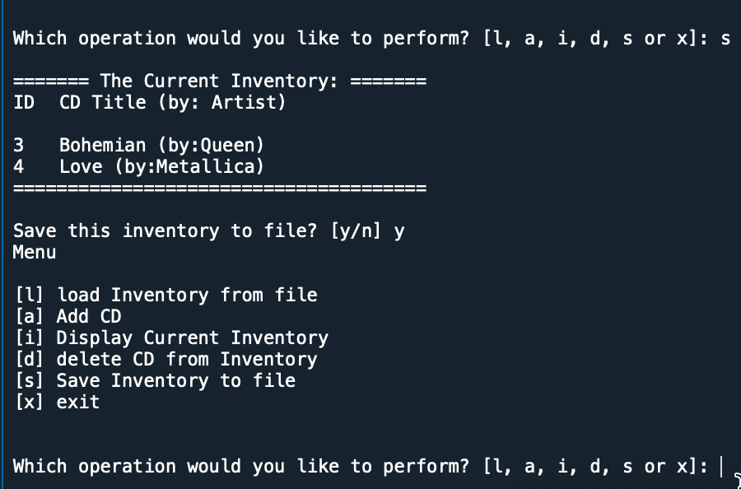
Figure 4: Running in Spyder IDE

Appendix

Listing CD_Inventory.py

#------------------------------------------#
# Title: CD_Inventory.py
# Desc: Assignnment 08 - Working with classes
# Change Log: (Who, When, What)
# DBiesinger, 2030-Jan-01, created file
# DBiesinger, 2030-Jan-01, added pseudocode to complete assignment 08
# AnhV, 2021-Aug-30, added code
#------------------------------------------#

# -- DATA -- #
strFileName = 'cdInventory.txt'
lstOfCDObjects = []

class CD:
"""Stores data about a CD:

properties:
cd_id: (int) with CD ID
cd_title: (string) with the title of the CD
cd_artist: (string) with the artist of the CD
methods:

"""
def __init__ (self, id, title, artist):
self.cd_id = int(id)
self.cd_title = title
self.cd_artist = artist

# -- PROCESSING -- #
class FileIO:
"""Processes data to and from file:

properties:

methods:
save_inventory(file_name, lst_Inventory): -> None
load_inventory(file_name): -> (a list of CD objects)

"""
def save_inventory (self, file_name, lst_Inventory):
objFile = open(file_name, 'w')
for cd in lst_Inventory:
datarow = '{},{},{}\n'.format(cd.cd_id, cd.cd_title, cd.cd_artist)
objFile.write (datarow)
objFile.close()

def load_inventory(self, file_name):
table = []
objFile = open(file_name, 'r')
for line in objFile:
data = line.strip().split(',')
cd = CD(int(data[0]), data[1], data[2])
table.append(cd)
objFile.close()
return table

# -- PRESENTATION (Input/Output) -- #
class IO:
def print_menu(self):
"""Displays a menu of choices to the user

Args:
None.

Returns:
None.
"""

print('Menu\n\n[l] load Inventory from file\n[a] Add CD\n[i] Display Current Inventory')
print('[d] delete CD from Inventory\n[s] Save Inventory to file\n[x] exit\n')

def menu_choice(self):
"""Gets user input for menu selection

Args:
None.

Returns:
choice (string): a lower case sting of the users input out of the choices l, a, i, d, s or x

"""
choice = ' '
while choice not in ['l', 'a', 'i', 'd', 's', 'x']:
choice = input('Which operation would you like to perform? [l, a, i, d, s or x]: ').lower().strip()
print() # Add extra space for layout
return choice

def show_inventory(self, table):
"""Displays current inventory table

Args:
table (list of dict): 2D data structure (list of dicts) that holds the data during runtime.

Returns:
None.

"""
print('======= The Current Inventory: =======')
print('ID\tCD Title (by: Artist)\n')
for cd in table:
print('{}\t{} (by:{})'.format(cd.cd_id, cd.cd_title, cd.cd_artist))
print('======================================')

def userinput (self):
"""Function to ask user for input of new records

Args:
None.

Returns:
id: ID number for the new record
title: Title name for new record
artist: Artist name of the new record
"""
id = input('Enter ID: ').strip()
title = input('What is the CD\'s title? ').strip()
artist = input('What is the Artist\'s name? ').strip()
return id, title, artist

# -- PROCESSING -- #
class DataProcessor:
@staticmethod
def additem (strID, strTitle, strArtist):
"""Function to add new data to the table

Args:
strID: ID number for the new record
strTitle: Title of the new record
stArtist: Artist name of the new record

Returns:
None.
"""
cd = CD(int(strID), strTitle, strArtist)
lstOfCDObjects.append(cd)

@staticmethod
def removeitem (intIDDel):
"""Function to allow users to remove item from the table

Args:
intIDdel: the ID number of the record user want to delete

Returns:
None.
"""
intRowNr = -1
blnCDRemoved = False
for cd in lstOfCDObjects:
intRowNr += 1
if cd.cd_id == intIDDel:
del lstOfCDObjects[intRowNr]
blnCDRemoved = True
break
if blnCDRemoved:
print('The CD was removed')
else:
print('Could not find this CD!')

# -- Main Body of Script -- #
ioObj = IO()
fileIOObj = FileIO()

while True:
# 2.1 Display Menu to user and get choice
ioObj.print_menu()
strChoice = ioObj.menu_choice()

# 3. Process menu selection
# 3.1 process exit first
if strChoice == 'x':
break
# 3.2 process load inventory
if strChoice == 'l':
print('WARNING: If you continue, all unsaved data will be lost and the Inventory re-loaded from file.')
strYesNo = input('type \'yes\' to continue and reload from file. otherwise reload will be canceled')
if strYesNo.lower() == 'yes':
print('reloading...')
lstOfCDObjects = fileIOObj.load_inventory(strFileName)
ioObj.show_inventory(lstOfCDObjects)
else:
input('canceling... Inventory data NOT reloaded. Press [ENTER] to continue to the menu.')
ioObj.show_inventory(lstOfCDObjects)
continue # start loop back at top.

# 3.3 process add a CD
elif strChoice == 'a':
strID, strTitle, stArtist = ioObj.userinput()
DataProcessor.additem(strID, strTitle, stArtist)
ioObj.show_inventory(lstOfCDObjects)
continue # start loop back at top.

# 3.4 process display current inventory
elif strChoice == 'i':
ioObj.show_inventory(lstTbl)
continue # start loop back at top.

# 3.5 process delete a CD
elif strChoice == 'd':
ioObj.show_inventory(lstOfCDObjects)
intIDDel = int(input('Which ID would you like to delete? ').strip())
DataProcessor.removeitem (intIDDel)
ioObj.show_inventory(lstOfCDObjects)
continue # start loop back at top.

# 3.6 process save inventory to file
elif strChoice == 's':
ioObj.show_inventory(lstOfCDObjects)
strYesNo = input('Save this inventory to file? [y/n] ').strip().lower()
if strYesNo == 'y':
fileIOObj.save_inventory (strFileName, lstOfCDObjects)
else:
input('The inventory was NOT saved to file. Press [ENTER] to return to the menu.')
continue # start loop back at top.

# 3.7 catch-all should not be possible, as user choice gets vetted in IO, but to be save:
else:
print('General Error')

