Anh Vu
August 7, 2021
Foundations of Programming Python
Assignment 05

List and Dictionaries in Python

Introduction
In this Module, we continue to discover the uses of List and Dictionaries. We also covered the basics of Separations of concerns programming pattern, error handling, functions and script template. For the assignment this week, we will post our files to GitHub repository and perform a peer review via GitHub.

Dictionaries

Dictionaries are used to store data values in {key: value} pairs. They are written in curly brackets {}. All store data in a sequence and can be accessed by an index.

The difference between list and dictionary: A list is an ordered sequence of objects while dictionaries are unordered sets. Dictionaries are assessed via keys, not via their position as in list.

#define variables
choice = '' #user input
lstTabl = [] #list of lists to hold data
lstRow = [] #list of data row
strfileName = 'CDInventory1.txt'
objFile = None

# create the inventory table using dictionary
dict1 = {'Artist': 'Run Rig', 'Title': 'The Big Wheel'}
dict2 = {'Artist': 'Michael Jackson', 'Title': 'Bad'}
lstdict = [dict1, dict2]

# print out the menu
print ('Write or Read file data')
print ('[a] add data to list')
print ('[w] to write data to file')
print ('[r] to read data from file')
print ('[d] display data')
print ('[exit] to quit')
while True:
choice = input ('a,w,r,d,or exit: ').lower()

# ask user to input data
if choice == 'a':
Artist = input ('Enter the artist name: ')
Title = input ('Enter the CD Title: ')
dict3 = {'Artist': Artist, 'Title': Title}
# add data to list
lstdict.append(dict3)
pass

# write data to file
elif choice == 'w':
for row in (lstdict):
print (row)
Artist1 = row ['Artist']
Title1 = row ['Title']
objFile = open ('CDInventory1.txt', 'a')
objFile.write (Artist1 + '\n')
objFile.write (Title1 + '\n')
objFile.close ()
pass

# read data from file
elif choice == 'r':
objFile = open (r'CDInventory1.txt', 'r')
content = objFile.read ()
print (content)
objFile.close()

# display data
elif choice == 'd':
for row in (lstdict):
print (row)
pass

#exit
elif choice == 'exit':
break
Figure 1 - Lab 05-B: Using dictionaries

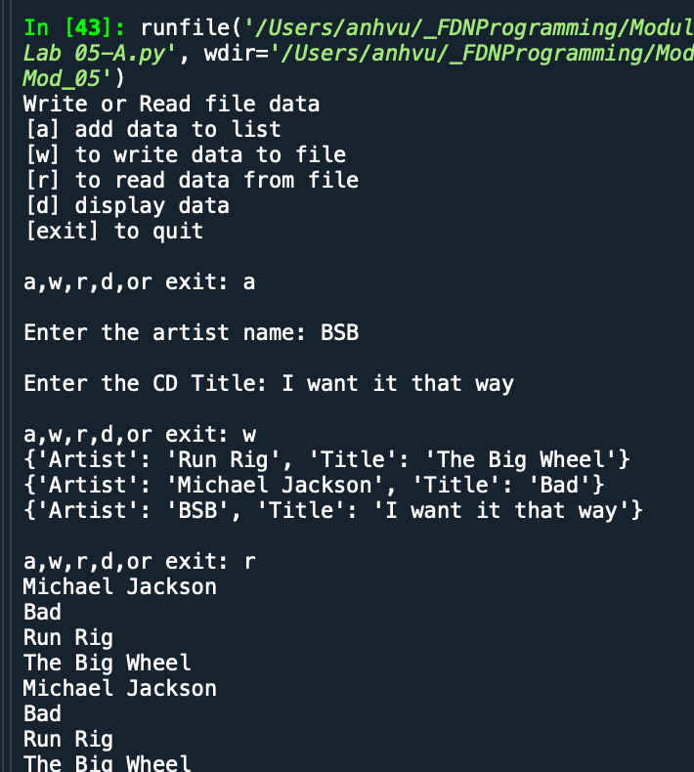
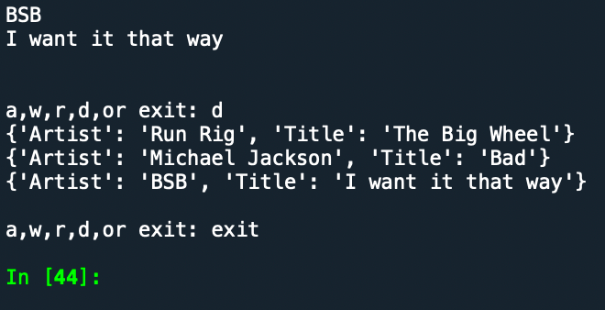
Figure 2 - Code run for Lab 05 - B

Separations of Concerns
Separation of Concerns (SoC) is a design concept to separate a computer program into distinct sections and each section addresses a separate concern. It normally has 3 parts: Data, Processing and Presentation.
(See Figure 3 below)

Functions
You can use function to organize your code. Functions allow users to group a set of statements and make them accessible via a given name. In Python, functions must be defined before they can be called.

Script Template
Script template is useful. For example, in our case, without script, we normally have to delete header that Spyder put in the editor and recreate the header. A script template can provide our expected header and some pseudocode in it that could reduce the time and repetition.
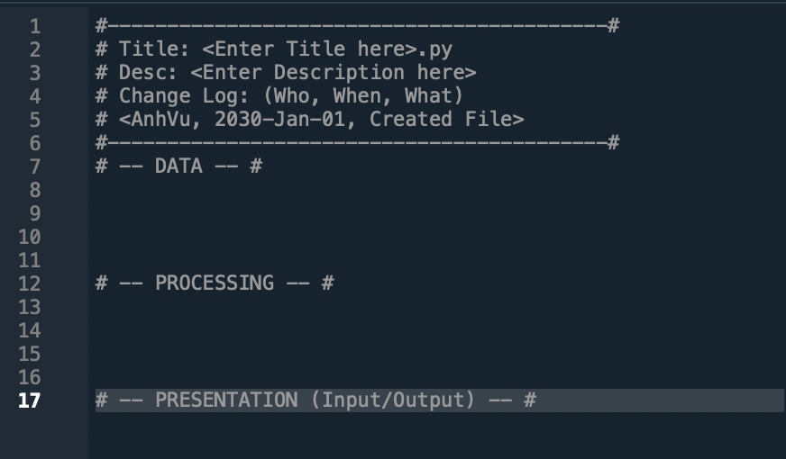
Figure 3: New template in Spyder

Structure Error Handling

To avoid the error when you script execution gets aborted or worse, the program gets crashed by this error, the structure error handing can tell user about the error and keep the program running. The ZeroDivisionError is an example of how the Try-Except can help to bypass this error.

GitHub
GitHub is a website and cloud-based service that you could store and manage your code, as well as track and control changes to your code. GitHub’s mascot is an Octocat!

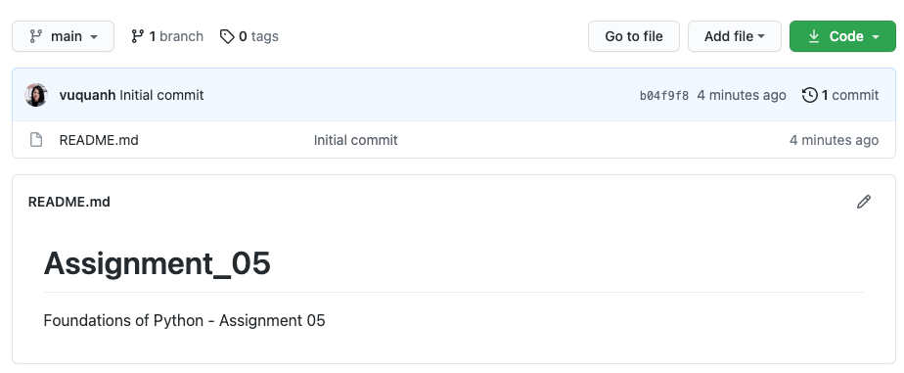
Figure 4: Created account in GitHub and ready to upload the first repository

Assignment

Steps:
- Review the code template
- Adjust the order of steps. Add new ones if needed
- Use separation of concerns
- Review the code for each section and add codes for TODO
- Run the code for each section before moving onto the next one.
- Check the whole code and txt file

Codes:

# Declare variables

strChoice = '' # User input
lstdict = [] # list of lists to hold data
dict3 = {} # list of data row
strFileName = 'CDInventory.txt' # data storage file
objFile = None # file object

# Get user Input
print('The Magic CD Inventory\n')
while True:
# 1. Display menu allowing the user to choose:
print ('[l] Load Inventory from file')
print ('[a] Add CD\n[i] Display Current Inventory')
print ('[d] Delete CD from Inventory')
print ('[s] Save Inventory to file')
print ('[x] Exit')
strChoice = input('l, a, i, d, s or x: ').lower() # convert choice to lower case at time of input

# 1. Load inventory if the user chooses so
if strChoice == 'l':
f = open ('CDInventory.txt', 'r')
i = 0
l = f.readlines ()
while i < len(l) - 1:
ID = l[i]
Artist = l[i+1]
Title = l[i+2]
dict = {'ID':ID, 'Artist':Artist, 'Title': Title}
lstdict.append (dict)
i = i + 3
f.close ()
pass

# 2. Add CD if the user chooses so
elif strChoice == 'a':
strID = input('Enter an ID: ')
strTitle = input('Enter the CD\'s Title: ')
strArtist = input('Enter the Artist\'s Name: ')
intID = int(strID)
dict3 = {'ID': strID, 'Title': strTitle, 'Artist': strArtist}
lstdict.append(dict3)
pass

# 3. Display the current data to the user each time the user wants to display the data
elif strChoice == 'i':
print('ID, CD Title, Artist')
for row in (lstdict):
print(row)
pass

# 4. Deleting an entry if user chooses to do so
elif strChoice == 'd':
removeTitle = input ('Enter Title to be removed: ')
for row in lstdict:
Title1 =row ['Title']
if Title1 == removeTitle:
lstdict.remove (row)
print ('New inventory is: ','\n',lstdict)
pass

# 5. Save the data to a text file CDInventory.txt if the user chooses so
elif strChoice == 's':
for row in lstdict:
print (row)
ID1 = row ['ID']
ID1 = ID1.replace('\n', '')
Artist1 = row ['Artist']
Artist1 = Artist1.replace('\n', '')
Title1 = row ['Title']
Title1 = Title.replace('\n', '')
objFile = open(strFileName, 'a')
objFile.write(ID1 + '\n')
objFile.write (Artist1 + '\n')
objFile.write (Title1 + '\n')
objFile.close()
pass

# 6. Exit the program if the user cxhooses so
elif strChoice == 'x':
break

else:
print('Please choose either l, a, i, d, s or x!')

File Running

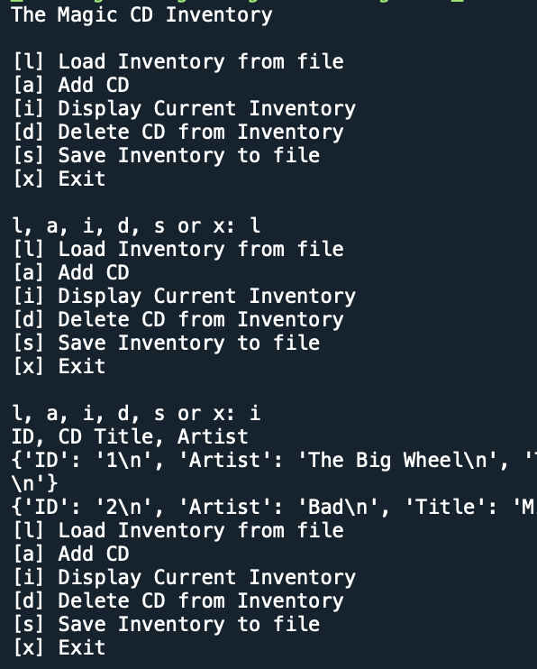

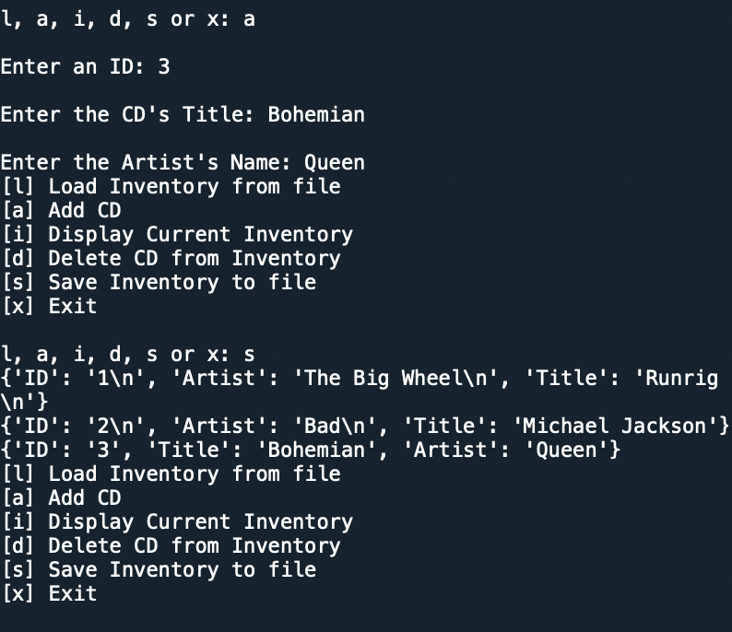

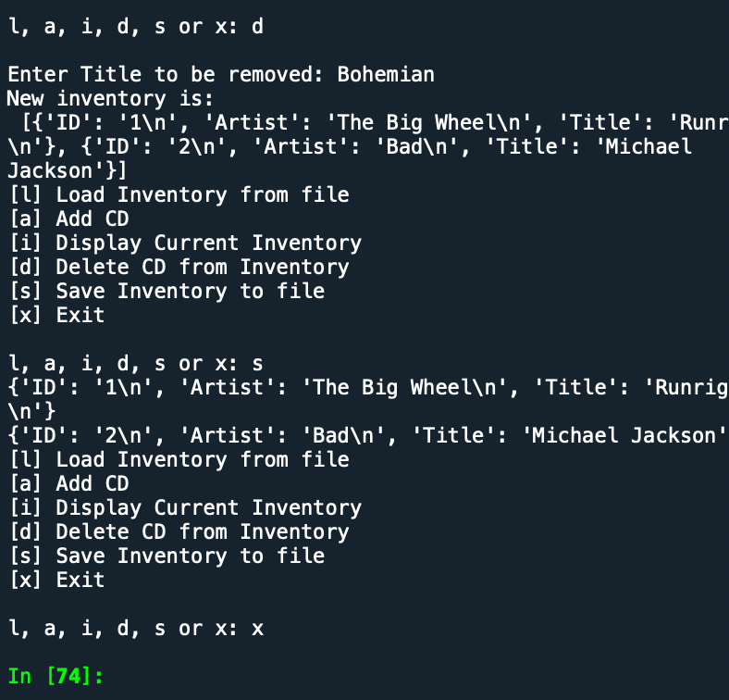
Figure 5: Code run for the assignment

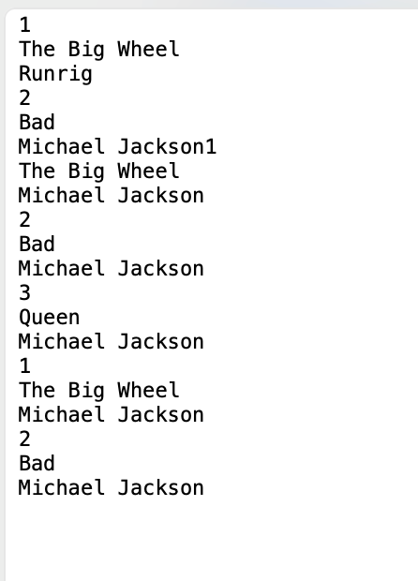
Figure 6: File Inventory.txt
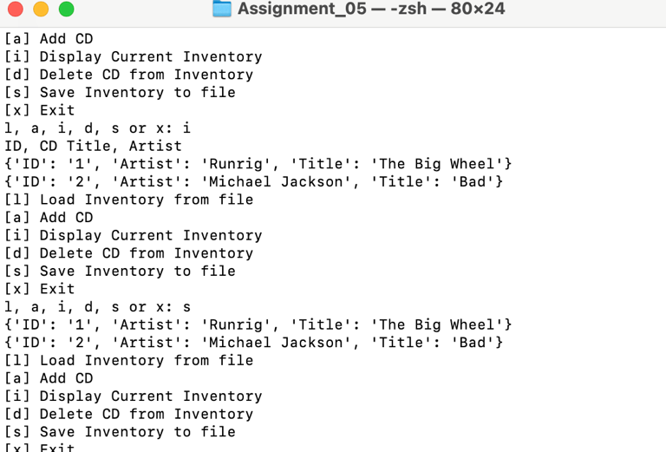
Figure 7: File Run in Terminal

Summary

In this assignment we discovered more about Dictionaries. This is the first time we use GitHub repository to upload our work. We were able to write more complexed code, write to file, open from file, delete entry and display entry.

Appendix

Listing CDInventory.py

#------------------------------------------#
# Title: CDInventory.py
# Desc: Starter Script for Assignment 05
# Change Log: (Who, When, What)
# DBiesinger, 2030-Jan-01, Created File
# AnhVu, 2021-Aug-06, Added Code
#------------------------------------------#

# Declare variables

strChoice = '' # User input
lstdict = [] # list of lists to hold data
dict3 = {} # list of data row
strFileName = 'CDInventory.txt' # data storage file
objFile = None # file object

# Get user Input
print('The Magic CD Inventory\n')
while True:
# 1. Display menu allowing the user to choose:
print ('[l] Load Inventory from file')
print ('[a] Add CD\n[i] Display Current Inventory')
print ('[d] Delete CD from Inventory')
print ('[s] Save Inventory to file')
print ('[x] Exit')
strChoice = input('l, a, i, d, s or x: ').lower() # convert choice to lower case at time of input

# 1. Load inventory if the user chooses so
if strChoice == 'l':
f = open ('CDInventory.txt', 'r')
i = 0
l = f.readlines ()
while i < len(l) - 1:
ID = l[i]
ID = ID.replace('\n', '')
Title = l[i+1]
Title = Title.replace('\n', '')
Artist= l[i+2]
Artist= Artist.replace('\n', '')
dict = {'ID':ID, 'Artist':Artist, 'Title': Title}
lstdict.append (dict)
i = i + 3
f.close ()
pass

# 2. Add CD if the user chooses so
elif strChoice == 'a':
strID = input('Enter an ID: ')
strTitle = input('Enter the CD\'s Title: ')
strArtist = input('Enter the Artist\'s Name: ')
intID = int(strID)
dict3 = {'ID': strID, 'Title': strTitle, 'Artist': strArtist}
lstdict.append(dict3)
pass

# 3. Display the current data to the user each time the user wants to display the data
elif strChoice == 'i':
print('ID, CD Title, Artist')
for row in (lstdict):
print(row)
pass

# 4. Deleting an entry if user chooses to do so
elif strChoice == 'd':
removeTitle = input ('Enter Title to be removed: ')
for row in lstdict:
Title1 =row ['Title']
if Title1 == removeTitle:
lstdict.remove (row)
print ('New inventory is: ','\n',lstdict)
pass

# 5. Save the data to a text file CDInventory.txt if the user chooses so
elif strChoice == 's':
for row in lstdict:
print (row)
ID1 = row ['ID']
Artist1 = row ['Artist']
Title1 = row ['Title']
objFile = open(strFileName, 'a')
objFile.write(ID1 + '\n')
objFile.write (Artist1 + '\n')
objFile.write (Title1 + '\n')
objFile.close()
pass

# 6. Exit the program if the user cxhooses so
elif strChoice == 'x':
break

else:
print('Please choose either l, a, i, d, s or x!')

