Anh Vu
August 15, 2021
Foundations of Programming Python
Assignment 06

Functions, Attributes and Return Values in Python

Introduction
In this Module, we continue to discover the uses of Functions, Atrributes and Return Values. For the assignment this week, we will again post our files to GitHub repository and perform a peer review via GitHub.

Functions

A function is a block of code which only runs when it is called. We can pass data, known as parameters/ arguments into a function. A function can return data as result.

In Lab06-A example below, the output is the same with Listing 2 but we replaced with attributes and return values. This way, function can be called anywhere in the code.

# -- DATA -- #
intNumA = None
intNumB = None

# -- PROCESSING -- #
# process the data
def getSum (intNumA, intNumB):
return intNumA + intNumB

def getDif (intNumA, intNumB):
return intNumA - intNumB

def getPro (intNumA, intNumB):
return intNumA * intNumB

def getQuo (intNumA, intNumB):
return intNumA / intNumB

# -- PRESENTATION (Input/Output) -- #
# get user input data
print ('Basic Math script. Calculating the Sum, Difference, Product and Quotient of two numbers. ')
intNumA = int (input('Please enter the 1st Number: '))
intNumB = int (input ('Please enter the 2nd Number: '))

# display the result
print ('This script calculated using the Numbers', intNumA, 'and', intNumB)
print ('The result are: \n')
print ('Sum :\t\t', getSum (intNumA, intNumB),'\nDifference:\t', getDif(intNumA, intNumB))
print ('Product :\t', getPro (intNumA, intNumB), '\nQuotient:\t', getQuo(intNumA, intNumB))

Figure 1 – Lab 06 - A

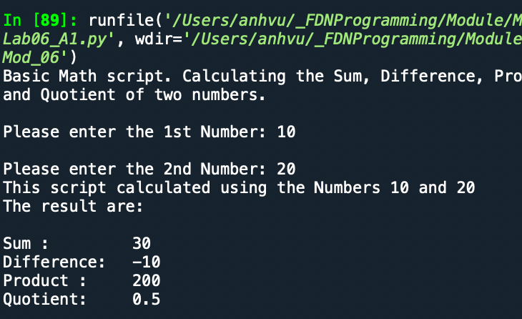
Figure 2 – Output is the same

Functions with Multiple Return Values

# -- DATA -- #
intNumA = None
intNumB = None

# -- PROCESSING -- #
# process the data
def calculation (a, b):
return (a + b, a - b, a * b, a / b)

# -- PRESENTATION (Input/Output) -- #
# get user input data
print ('Basic Math script. Calculating the Sum, Difference, Product and Quotient of two numbers. ')
intNumA = int (input('Please enter the 1st Number: '))
intNumB = int (input ('Please enter the 2nd Number: '))

# display the result
print ('This script calculated using the Numbers', intNumA, 'and', intNumB)
print ('The result are: ', calculation(intNumA, intNumB))

Figure 3: Lab 06 – B
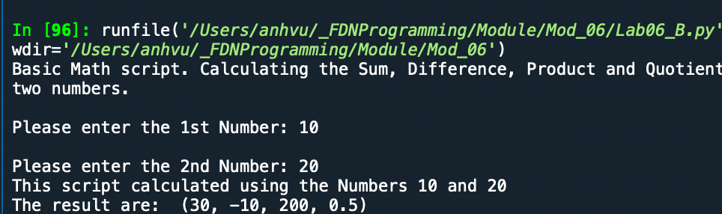
Figure 4: This function returns all four calculation results at the same time.

Variables Scope:
A variable is only available from inside the region it is created. This is called scope.
- Local Scope: A variable created inside a function belongs to the local scope of that function, and can only be used inside that function.
- Global Scope: A variable created in the main body of the Python code is a global variable and belongs to the global scope.
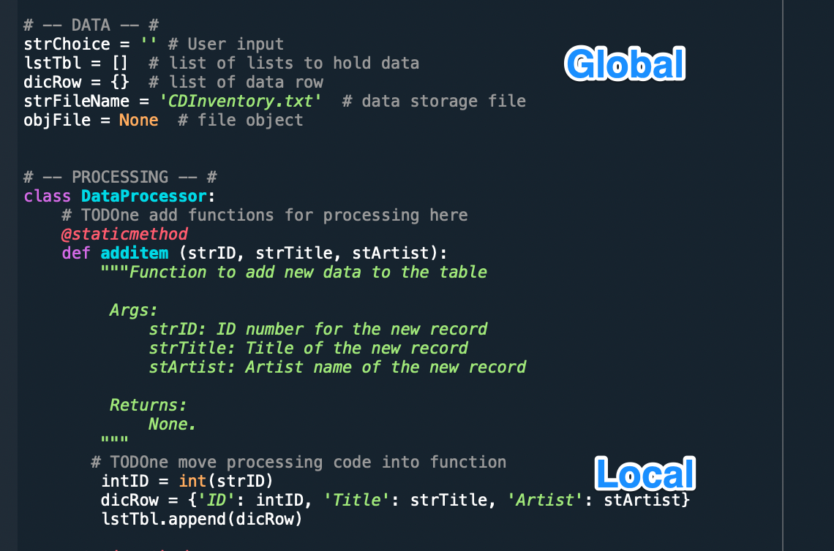
Figure 5 - Example of Global and Local Scope variables

Docstrings:
Docstrings are the string literals that appear right after the definition of a function, method, class, or module. It is helpful for the coders and reviewers to understand what those do.

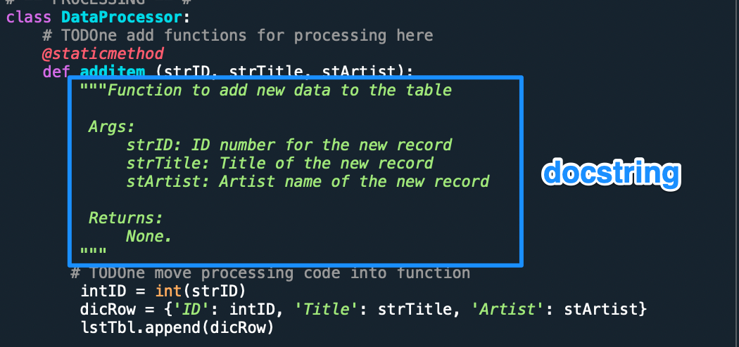
Figure 6: Example of a docstring

Assignment
Upload in GitHub: https://github.com/vuquanh/Assignment_05.git

Codes:
# -- DATA -- #
strChoice = '' # User input
lstTbl = [] # list of lists to hold data
dicRow = {} # list of data row
strFileName = 'CDInventory.txt' # data storage file
objFile = None # file object

# -- PROCESSING -- #
class DataProcessor:
# TODOne add functions for processing here
@staticmethod
def additem (strID, strTitle, stArtist):
"""Function to add new data to the table

Args:
strID: ID number for the new record
strTitle: Title of the new record
stArtist: Artist name of the new record

Returns:
None.
"""
# TODOne move processing code into function
intID = int(strID)
dicRow = {'ID': intID, 'Title': strTitle, 'Artist': stArtist}
lstTbl.append(dicRow)

@staticmethod
def removeitem (intIDDel):
"""Function to allow users to remove item from the table

Args:
intIDdel: the ID number of the record user want to delete

Returns:
None.
"""
# TODO move processing code into function
intRowNr = -1
blnCDRemoved = False
for row in lstTbl:
intRowNr += 1
if row['ID'] == intIDDel:
del lstTbl[intRowNr]
blnCDRemoved = True
break
if blnCDRemoved:
print('The CD was removed')
else:
print('Could not find this CD!')

@staticmethod
def savedata ():
"""Function to allow users to save data to the table

Args:
None.

Returns:
None.
"""
objFile = open(strFileName, 'w')
for row in lstTbl:
lstValues = list(row.values())
lstValues[0] = str(lstValues[0])
objFile.write(','.join(lstValues) + '\n')
objFile.close()
pass

class FileProcessor:
"""Processing the data to and from text file"""

@staticmethod
def read_file(file_name, table):
"""Function to manage data ingestion from file to a list of dictionaries

Reads the data from file identified by file_name into a 2D table
(list of dicts) table one line in the file represents one dictionary row in table.

Args:
file_name (string): name of file used to read the data from
table (list of dict): 2D data structure (list of dicts) that holds the data during runtime

Returns:
None.
"""
table.clear() # this clears existing data and allows to load data from file
objFile = open(file_name, 'r')
for line in objFile:
data = line.strip().split(',')
dicRow = {'ID': int(data[0]), 'Title': data[1], 'Artist': data[2]}
table.append(dicRow)
objFile.close()

@staticmethod
def write_file(file_name, table):
# TODOne Add code here
# TODOne add docstring
"""Function to manage writing data from user input to file

For each row in the table, a datarow is a dictionary

Args:
file_name (string): name of file used to read the data from
table (list of dict): 2D data structure (list of dicts) that holds the data during runtime

Returns:
None.
"""

objFile = open(file_name, 'a')
for row in table:
datarow = '{}{}{}'.format (row['ID'],row['Title'],row['Artist'])
objFile.write (datarow)
objFile.close()
pass

# -- PRESENTATION (Input/Output) -- #

class IO:
"""Handling Input / Output"""

@staticmethod
def print_menu():
"""Displays a menu of choices to the user

Args:
None.

Returns:
None.
"""

print('Menu\n\n[l] load Inventory from file\n[a] Add CD\n[i] Display Current Inventory')
print('[d] delete CD from Inventory\n[s] Save Inventory to file\n[x] exit\n')

@staticmethod
def menu_choice():
"""Gets user input for menu selection

Args:
None.

Returns:
choice (string): a lower case sting of the users input out of the choices l, a, i, d, s or x

"""
choice = ' '
while choice not in ['l', 'a', 'i', 'd', 's', 'x']:
choice = input('Which operation would you like to perform? [l, a, i, d, s or x]: ').lower().strip()
print() # Add extra space for layout
return choice

@staticmethod
def show_inventory(table):
"""Displays current inventory table

Args:
table (list of dict): 2D data structure (list of dicts) that holds the data during runtime.

Returns:
None.

"""
print('======= The Current Inventory: =======')
print('ID\tCD Title (by: Artist)\n')
for row in table:
print('{}\t{} (by:{})'.format(*row.values()))
print('======================================')

# TODOne add I/O functions as needed
@staticmethod
def userinput ():
"""Function to ask user for input of new records

Args:
None.

Returns:
id: ID number for the new record
title: Title name for new record
artist: Artist name of the new record
"""
# TODOne move IO code into function
id = input('Enter ID: ').strip()
title = input('What is the CD\'s title? ').strip()
artist = input('What is the Artist\'s name? ').strip()
return id, title, artist

# 1. When program starts, read in the currently saved Inventory
FileProcessor.read_file(strFileName, lstTbl)

# 2. start main loop
while True:
# 2.1 Display Menu to user and get choice
IO.print_menu()
strChoice = IO.menu_choice()

# 3. Process menu selection
# 3.1 process exit first
if strChoice == 'x':
break
# 3.2 process load inventory
if strChoice == 'l':
print('WARNING: If you continue, all unsaved data will be lost and the Inventory re-loaded from file.')
strYesNo = input('type \'yes\' to continue and reload from file. otherwise reload will be canceled')
if strYesNo.lower() == 'yes':
print('reloading...')
FileProcessor.read_file(strFileName, lstTbl)
IO.show_inventory(lstTbl)
else:
input('canceling... Inventory data NOT reloaded. Press [ENTER] to continue to the menu.')
IO.show_inventory(lstTbl)
continue # start loop back at top.

# 3.3 process add a CD
elif strChoice == 'a':
# 3.3.1 Ask user for new ID, CD Title and Artist
# TODO move IO code into function
#strID = input('Enter ID: ').strip()
#strTitle = input('What is the CD\'s title? ').strip()
#stArtist = input('What is the Artist\'s name? ').strip()
strID, strTitle, stArtist = IO.userinput()

# 3.3.2 Add item to the table
# TODO move processing code into function
#intID = int(strID)
#dicRow = {'ID': intID, 'Title': strTitle, 'Artist': stArtist}
#lstTbl.append(dicRow)
#IO.show_inventory(lstTbl)
DataProcessor.additem(strID, strTitle, stArtist)
IO.show_inventory(lstTbl)
continue # start loop back at top.

# 3.4 process display current inventory
elif strChoice == 'i':
IO.show_inventory(lstTbl)
continue # start loop back at top.

# 3.5 process delete a CD
elif strChoice == 'd':
# 3.5.1 get Userinput for which CD to delete
# 3.5.1.1 display Inventory to user
IO.show_inventory(lstTbl)
# 3.5.1.2 ask user which ID to remove
intIDDel = int(input('Which ID would you like to delete? ').strip())
# 3.5.2 search thru table and delete CD
# TODOne move processing code into function
DataProcessor.removeitem (intIDDel)
IO.show_inventory(lstTbl)
continue # start loop back at top.

# 3.6 process save inventory to file
elif strChoice == 's':
# 3.6.1 Display current inventory and ask user for confirmation to save
IO.show_inventory(lstTbl)
strYesNo = input('Save this inventory to file? [y/n] ').strip().lower()
# 3.6.2 Process choice
if strYesNo == 'y':
# 3.6.2.1 save data
# TODOne move processing code into function
DataProcessor.savedata ()
else:
input('The inventory was NOT saved to file. Press [ENTER] to return to the menu.')
continue # start loop back at top.

# 3.7 catch-all should not be possible, as user choice gets vetted in IO, but to be save:
else:
print('General Error')

File Running

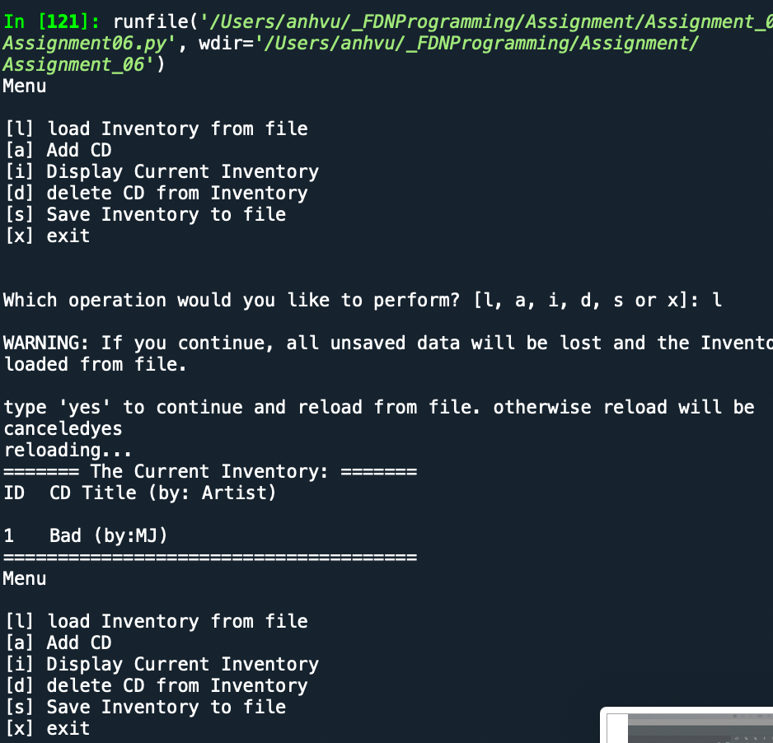

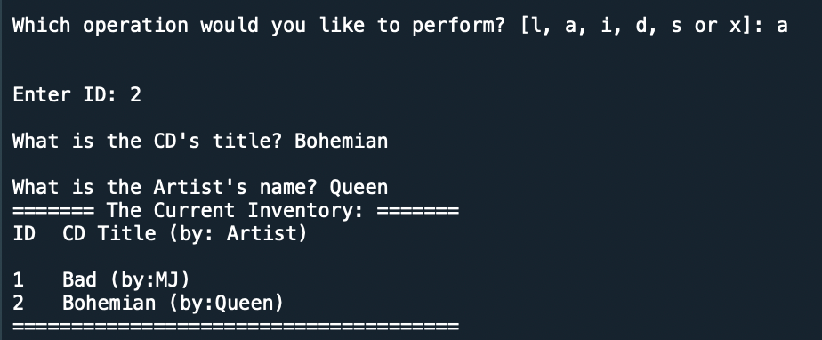

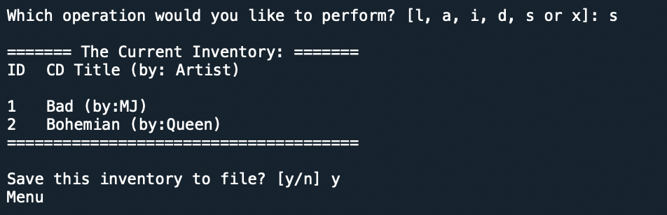

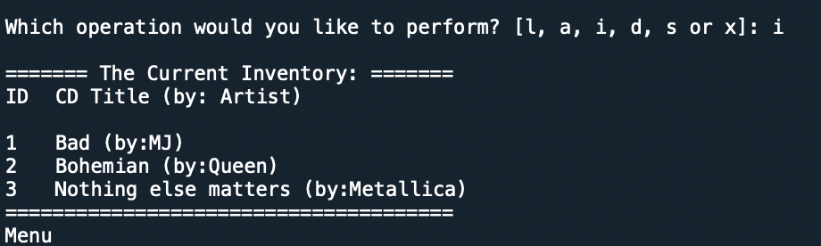

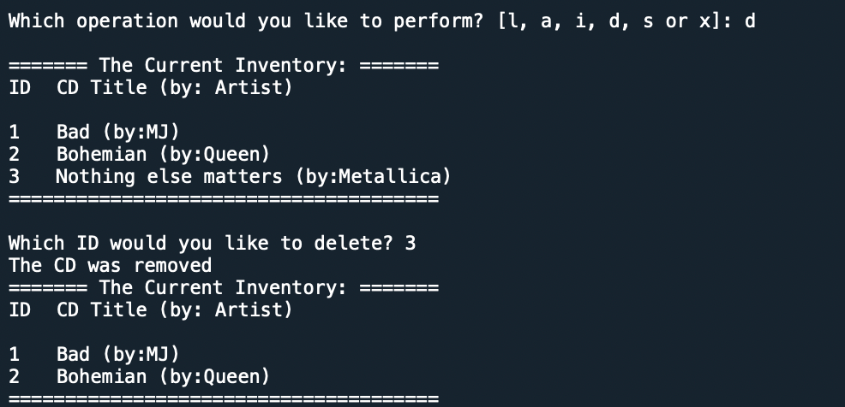
Figure 7: Code run as expected

Summary

In this assignment we discovered more about Functions and return value. The assignment we learned how to modify other’s codes and use docstrings to make the codes clear to understand.

Appendix

Listing CDInventory.py

#------------------------------------------#
# Title: CDInventory.py
# Desc: Starter Script for Assignment 05
# Change Log: (Who, When, What)
# DBiesinger, 2030-Jan-01, Created File
# AnhVu, 2021-Aug-06, Added Code
#------------------------------------------#

# Declare variables

strChoice = '' # User input
lstdict = [] # list of lists to hold data
dict3 = {} # list of data row
strFileName = 'CDInventory.txt' # data storage file
objFile = None # file object

# Get user Input
print('The Magic CD Inventory\n')
while True:
# 1. Display menu allowing the user to choose:
print ('[l] Load Inventory from file')
print ('[a] Add CD\n[i] Display Current Inventory')
print ('[d] Delete CD from Inventory')
print ('[s] Save Inventory to file')
print ('[x] Exit')
strChoice = input('l, a, i, d, s or x: ').lower() # convert choice to lower case at time of input

# 1. Load inventory if the user chooses so
if strChoice == 'l':
f = open ('CDInventory.txt', 'r')
i = 0
l = f.readlines ()
while i < len(l) - 1:
ID = l[i]
ID = ID.replace('\n', '')
Title = l[i+1]
Title = Title.replace('\n', '')
Artist= l[i+2]
Artist= Artist.replace('\n', '')
dict = {'ID':ID, 'Artist':Artist, 'Title': Title}
lstdict.append (dict)
i = i + 3
f.close ()
pass

# 2. Add CD if the user chooses so
elif strChoice == 'a':
strID = input('Enter an ID: ')
strTitle = input('Enter the CD\'s Title: ')
strArtist = input('Enter the Artist\'s Name: ')
intID = int(strID)
dict3 = {'ID': strID, 'Title': strTitle, 'Artist': strArtist}
lstdict.append(dict3)
pass

# 3. Display the current data to the user each time the user wants to display the data
elif strChoice == 'i':
print('ID, CD Title, Artist')
for row in (lstdict):
print(row)
pass

# 4. Deleting an entry if user chooses to do so
elif strChoice == 'd':
removeTitle = input ('Enter Title to be removed: ')
for row in lstdict:
Title1 =row ['Title']
if Title1 == removeTitle:
lstdict.remove (row)
print ('New inventory is: ','\n',lstdict)
pass

# 5. Save the data to a text file CDInventory.txt if the user chooses so
elif strChoice == 's':
for row in lstdict:
print (row)
ID1 = row ['ID']
Artist1 = row ['Artist']
Title1 = row ['Title']
objFile = open(strFileName, 'a')
objFile.write(ID1 + '\n')
objFile.write (Artist1 + '\n')
objFile.write (Title1 + '\n')
objFile.close()
pass

# 6. Exit the program if the user cxhooses so
elif strChoice == 'x':
break

else:
print('Please choose either l, a, i, d, s or x!')

Appendix

Listing CDInventory.py

#------------------------------------------#
# Title: Assignment06.py
# Desc: Working with classes and functions.
# Change Log: (Who, When, What)
# DBiesinger, 2030-Jan-01, Created File
# AnhVu, 2021-Aug-12, Added Code
#------------------------------------------#

# -- DATA -- #
strChoice = '' # User input
lstTbl = [] # list of lists to hold data
dicRow = {} # list of data row
strFileName = 'CDInventory.txt' # data storage file
objFile = None # file object

# -- PROCESSING -- #
class DataProcessor:
# TODOne add functions for processing here
@staticmethod
def additem (strID, strTitle, stArtist):
"""Function to add new data to the table

Args:
strID: ID number for the new record
strTitle: Title of the new record
stArtist: Artist name of the new record

Returns:
None.
"""
# TODOne move processing code into function
intID = int(strID)
dicRow = {'ID': intID, 'Title': strTitle, 'Artist': stArtist}
lstTbl.append(dicRow)

@staticmethod
def removeitem (intIDDel):
"""Function to allow users to remove item from the table

Args:
intIDdel: the ID number of the record user want to delete

Returns:
None.
"""
# TODO move processing code into function
intRowNr = -1
blnCDRemoved = False
for row in lstTbl:
intRowNr += 1
if row['ID'] == intIDDel:
del lstTbl[intRowNr]
blnCDRemoved = True
break
if blnCDRemoved:
print('The CD was removed')
else:
print('Could not find this CD!')

@staticmethod
def savedata ():
"""Function to allow users to save data to the table

Args:
None.

Returns:
None.
"""
objFile = open(strFileName, 'w')
for row in lstTbl:
lstValues = list(row.values())
lstValues[0] = str(lstValues[0])
objFile.write(','.join(lstValues) + '\n')
objFile.close()
pass

class FileProcessor:
"""Processing the data to and from text file"""

@staticmethod
def read_file(file_name, table):
"""Function to manage data ingestion from file to a list of dictionaries

Reads the data from file identified by file_name into a 2D table
(list of dicts) table one line in the file represents one dictionary row in table.

Args:
file_name (string): name of file used to read the data from
table (list of dict): 2D data structure (list of dicts) that holds the data during runtime

Returns:
None.
"""
table.clear() # this clears existing data and allows to load data from file
objFile = open(file_name, 'r')
for line in objFile:
data = line.strip().split(',')
dicRow = {'ID': int(data[0]), 'Title': data[1], 'Artist': data[2]}
table.append(dicRow)
objFile.close()

@staticmethod
def write_file(file_name, table):
# TODOne Add code here
# TODOne add docstring
"""Function to manage writing data from user input to file

For each row in the table, a datarow is a dictionary

Args:
file_name (string): name of file used to read the data from
table (list of dict): 2D data structure (list of dicts) that holds the data during runtime

Returns:
None.
"""

objFile = open(file_name, 'a')
for row in table:
datarow = '{}{}{}'.format (row['ID'],row['Title'],row['Artist'])
objFile.write (datarow)
objFile.close()
pass

# -- PRESENTATION (Input/Output) -- #

class IO:
"""Handling Input / Output"""

@staticmethod
def print_menu():
"""Displays a menu of choices to the user

Args:
None.

Returns:
None.
"""

print('Menu\n\n[l] load Inventory from file\n[a] Add CD\n[i] Display Current Inventory')
print('[d] delete CD from Inventory\n[s] Save Inventory to file\n[x] exit\n')

@staticmethod
def menu_choice():
"""Gets user input for menu selection

Args:
None.

Returns:
choice (string): a lower case sting of the users input out of the choices l, a, i, d, s or x

"""
choice = ' '
while choice not in ['l', 'a', 'i', 'd', 's', 'x']:
choice = input('Which operation would you like to perform? [l, a, i, d, s or x]: ').lower().strip()
print() # Add extra space for layout
return choice

@staticmethod
def show_inventory(table):
"""Displays current inventory table

Args:
table (list of dict): 2D data structure (list of dicts) that holds the data during runtime.

Returns:
None.

"""
print('======= The Current Inventory: =======')
print('ID\tCD Title (by: Artist)\n')
for row in table:
print('{}\t{} (by:{})'.format(*row.values()))
print('======================================')

# TODOne add I/O functions as needed
@staticmethod
def userinput ():
"""Function to ask user for input of new records

Args:
None.

Returns:
id: ID number for the new record
title: Title name for new record
artist: Artist name of the new record
"""
# TODOne move IO code into function
id = input('Enter ID: ').strip()
title = input('What is the CD\'s title? ').strip()
artist = input('What is the Artist\'s name? ').strip()
return id, title, artist

# 1. When program starts, read in the currently saved Inventory
FileProcessor.read_file(strFileName, lstTbl)

# 2. start main loop
while True:
# 2.1 Display Menu to user and get choice
IO.print_menu()
strChoice = IO.menu_choice()

# 3. Process menu selection
# 3.1 process exit first
if strChoice == 'x':
break
# 3.2 process load inventory
if strChoice == 'l':
print('WARNING: If you continue, all unsaved data will be lost and the Inventory re-loaded from file.')
strYesNo = input('type \'yes\' to continue and reload from file. otherwise reload will be canceled')
if strYesNo.lower() == 'yes':
print('reloading...')
FileProcessor.read_file(strFileName, lstTbl)
IO.show_inventory(lstTbl)
else:
input('canceling... Inventory data NOT reloaded. Press [ENTER] to continue to the menu.')
IO.show_inventory(lstTbl)
continue # start loop back at top.

# 3.3 process add a CD
elif strChoice == 'a':
# 3.3.1 Ask user for new ID, CD Title and Artist
# TODO move IO code into function
#strID = input('Enter ID: ').strip()
#strTitle = input('What is the CD\'s title? ').strip()
#stArtist = input('What is the Artist\'s name? ').strip()
strID, strTitle, stArtist = IO.userinput()

# 3.3.2 Add item to the table
# TODO move processing code into function
#intID = int(strID)
#dicRow = {'ID': intID, 'Title': strTitle, 'Artist': stArtist}
#lstTbl.append(dicRow)
#IO.show_inventory(lstTbl)
DataProcessor.additem(strID, strTitle, stArtist)
IO.show_inventory(lstTbl)
continue # start loop back at top.

# 3.4 process display current inventory
elif strChoice == 'i':
IO.show_inventory(lstTbl)
continue # start loop back at top.

# 3.5 process delete a CD
elif strChoice == 'd':
# 3.5.1 get Userinput for which CD to delete
# 3.5.1.1 display Inventory to user
IO.show_inventory(lstTbl)
# 3.5.1.2 ask user which ID to remove
intIDDel = int(input('Which ID would you like to delete? ').strip())
# 3.5.2 search thru table and delete CD
# TODOne move processing code into function
DataProcessor.removeitem (intIDDel)
IO.show_inventory(lstTbl)
continue # start loop back at top.

# 3.6 process save inventory to file
elif strChoice == 's':
# 3.6.1 Display current inventory and ask user for confirmation to save
IO.show_inventory(lstTbl)
strYesNo = input('Save this inventory to file? [y/n] ').strip().lower()
# 3.6.2 Process choice
if strYesNo == 'y':
# 3.6.2.1 save data
# TODOne move processing code into function
DataProcessor.savedata ()
else:
input('The inventory was NOT saved to file. Press [ENTER] to return to the menu.')
continue # start loop back at top.

# 3.7 catch-all should not be possible, as user choice gets vetted in IO, but to be save:
else:
print('General Error')

