Webots E-puck Trash Can Project

Vural Erdogan
School of Computer Science,
University of Hertfordshire, College Lane,
Hatfield, Hertfordshire, AL10 9AB,
United Kingdom
ve17aae@herts.ac.uk

Abstract—In this project, we programmed a prototype of an autonomous e-puck robot that clean environment by using a searching and scanning method.
Keywords—e-puck; braitenberg; autonomous vehicles; trash can solution.

Introduction
Developing technology enables us to create various applications such as autonomous vehicles. Autonomous vehicles have the potential to develop the ideal methods to contribute a wide range of engineering disciplines. One of famous example of these vehicles is “Braitenberg vehicles” introduced by Valentino Braitenberg in 1986 [1]. Braitenberg vehicles have simple structure and functions such as avoiding the source or tending to the source. Valentino Braitenberg explained these behaviours by relating psychology in his studies. Afterwards, the e-puck robot was invented as a differential wheeled mobile robot for micro-engineering education by Michael Bonani and Francesco Mondada in 2009 [2]. Due to its simple design and multi-functional features such as utilising colour camera, accelerometer, microphones, loudspeaker, sensors and actuators led to being popular for educational purposes, research areas and industry.
In this project, we attempt to program a prototype of an autonomous e-puck with a trash can solution which applies to clean environment automatically.

Method

Environment and Libraries
While beginning to code our project, we used “Webots Software” that possesses continuous simulation feature with many robot applications. Also, the software was designed for real-world applications due to its resemblance to real-world parameters. First, we created a rectangular area with a black line in the middle of it. The wall in the environment was creating noise that confused robot behaviours. We reduced the height of these walls from “1” to “0.001”. As a result, the robot could be moved more consistent. In addition, we utilised from the noises to produce random searching method. The low noise signals contributed to altering e-puck’s direction randomly. After choosing e-puck, we imported “Differential Wheels” and actuators’ library. These enabled the all the sensors and actuators for programming.

Sensors and Actuators
Secondly, we decided to code with Python throughout the project. With Python, the robot should be avoided from obstacles. For avoiding obstacles, we used line sensors “ps1, ps2, ps3, ps6, ps7, ps8”. The first sensors belong to the right side the last sensors ps6, ps7 and ps8 belong to the left side. The values of the sensors were increasing while recognising the obstacles. Therefore, the robot has been programmed to increase the wheels’ speed when it detects an obstacle. If there is an obstacle on the left side, it increases left wheel’s speed and changes turning the direction of the right wheel. Also, we used the same method for ground sensors. When they detect the black elliptic line in the area, the values of the ground sensors were decreasing instead of increasing. We applied the same technique with opposite of conditions. As a result, our robots have gained avoiding feature from obstacles and the line.
Moreover, we used encoders to scan its surrounding while stopping. The encoders were ticking 159 times for a turn [3]. We preferred to the method which is “scan first then search it”. Also, we decided that while searching, the e-puck should be repeated scanning action occasionally so that the method of scanning was happening every 19,000 right encoder ticks and after completing each task. When it reaches 19,000, it turns 730 ticks, which is approximately 8 second, and scans 180° degrees and it can be adjusted depends on the environment.

Trash and Trash Can
We added five balls to the environment to symbolise trash, trash can, and obstacle. Two yellow, one red, and two green balls have been determined respectively. Lifting trash has been symbolised turning LED on, and for throwing away the bin has been symbolised LED off.

Camera
The colour camera of e-puck enabled for image recognition possessing 40x10 (width and height) sizes. We obtained colour values of pixels, which are red, green and blue, and in order to obtain yellow values, red and green should be 255 and blue should be 0. Therefore, we were able to compare red, yellow and green values conveniently while programming pixel values. The critical point is that we obtained values from only one pixel, which is the centre of the camera image (20x5). That contributed us to detect trash and bin rapidly from away.

States and Process
We applied states for calling functions such as “led off”, “led on”, “foundbin”, “foundtrash”, “searchtrash”, “searchbin”.
The e-puck was scanning its surrounding for detecting a trash that is represented a yellow ball. If it detects a trash, the e-puck focuses the target and only moves forward. If it does not find anything while scanning, “searchtrash” method is called and begins searching for trash. Steps of searching are same just as scanning; if it detects, it focuses again and move forward. When it comes close to trash, it actives the first LED turns on and begins for searching the trash can, a red ball. After finding the trash can, it repeats the same action and searches for a yellow ball.

Conclusion and Discussion
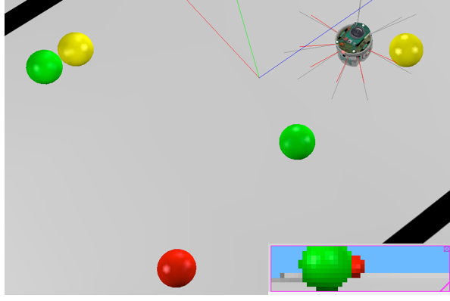
The robot searching and scanning approach achieved the purposes such as automatic searching, finding targets, avoiding the black line and obstacles while searching, enabling LED and doing actions in a sequence. However, it illustrated insufficient features such as clashing the obstacles which position is between the e-puck and the target while focusing the target (e.g. shown in Figure 1). We could not use avoiding the obstacle function while focusing due to losing the position of the target. To solve this problem, “Blob Search” method may be implemented for this method [4]. We tried to solve this problem by increasing height of the camera pixel, which was checking middle of the image, that enabled us to detect closer targets. Nevertheless, it extended the time of searching due to “close search method”. Therefore, choosing the camera pixel determines the distance of the target-e-puck. In Figure 2, we symbolised it 40x30 camera view, with a yellow ball which is in the middle of height, 15. If the user would like to search it for long distances, should get the middle pixel of the image. On the other hand, if the user would like the e-puck to search targets without crashing, should choose higher heights pixel of the image. The scanning process is also might be adjusted to the environment. If the user would like the e-puck to scan the whole environment, which also extends the time, should determine the ticks around 1400. Furthermore, the users are able to set the frequency of scanning process by increasing or decreasing the tick condition which was 19,000.
Another point is that green obstacles were difficult to detect when compared the other colours by the distance sensors. Due to the infra-red feature of the sensors, the diffusion codes should be used for the solution or increasing red value of the green object may solve this issue. Otherwise, the colour issue causes the e-puck to crash the green balls sometimes.

Figure 2: The pixel height range of e-puck’s camera view.

Consequently, even though the searching and scanning method is not as ideal as blob search, it might be applied for the applications.

References

[1] “Vehicles: Experiments in Synthetic Psychology - Valentino Braitenberg - Google Kitaplar.” [Online]. Available: https://books.google.co.uk/books?hl=tr&lr=&id=7KkUAT_q_sQC&oi=fnd&pg=PR9&dq=braitenberg+vehicles&ots=l_cujtMSZa&sig=ca-9zdh152vcSdO80MOCoYoxQq8&redir_esc=y#v=onepage&q=braitenberg vehicles&f=false. [Accessed: 13-Dec-2017].
[2] F. Mondada et al., “The e-puck , a Robot Designed for Education in Engineering,” Robotics, vol. 1, no. 1, pp. 59–65, 2006.
[3] “Webots documentation: Using the e-puck robot.” [Online]. Available: https://www.cyberbotics.com/doc/guide/using-the-e-puck-robot?version=remidhum:reference_proto. [Accessed: 15-Dec-2017].
[4] M. L. Walters, “AI and Robotics Applications.” Lecture: 7COM32 "Robotic Vision", University of Hertfordshire, 2017.
Figure 1: Locking to target and the e-puck’s camera view.

