- How many network connections are available by default on this system?
The virtual machine has one network connection available, which is the Intel(R)82574L Gigabit connection.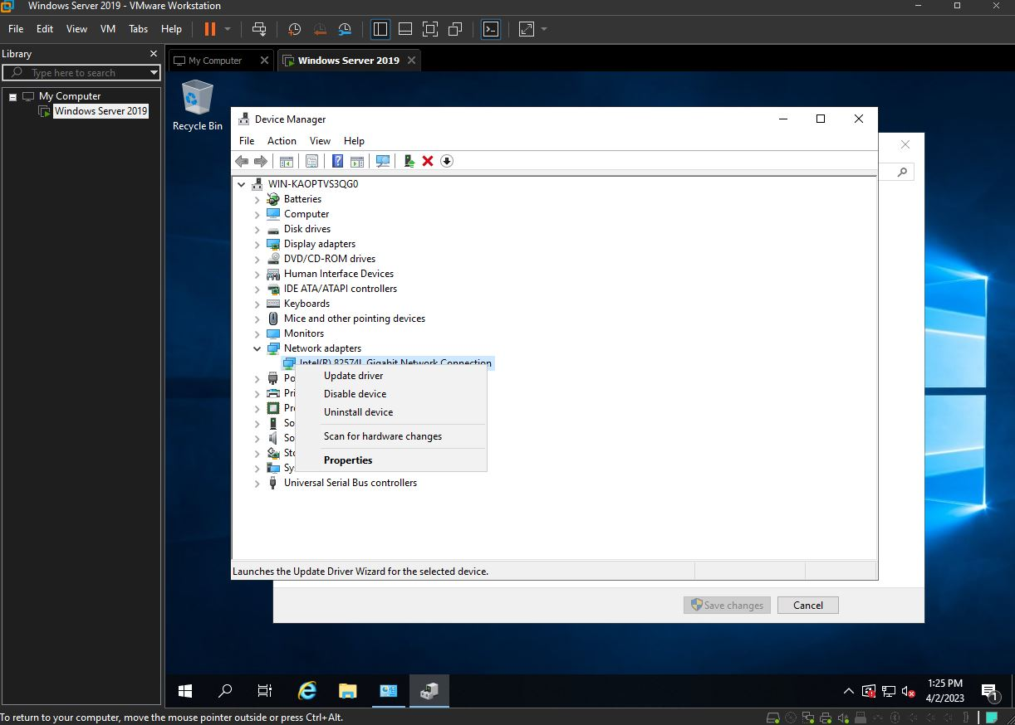
- Which ones are used by the operating system to connect to the host?
The operating system uses the virtual NAT connection adapter to connect to the host system.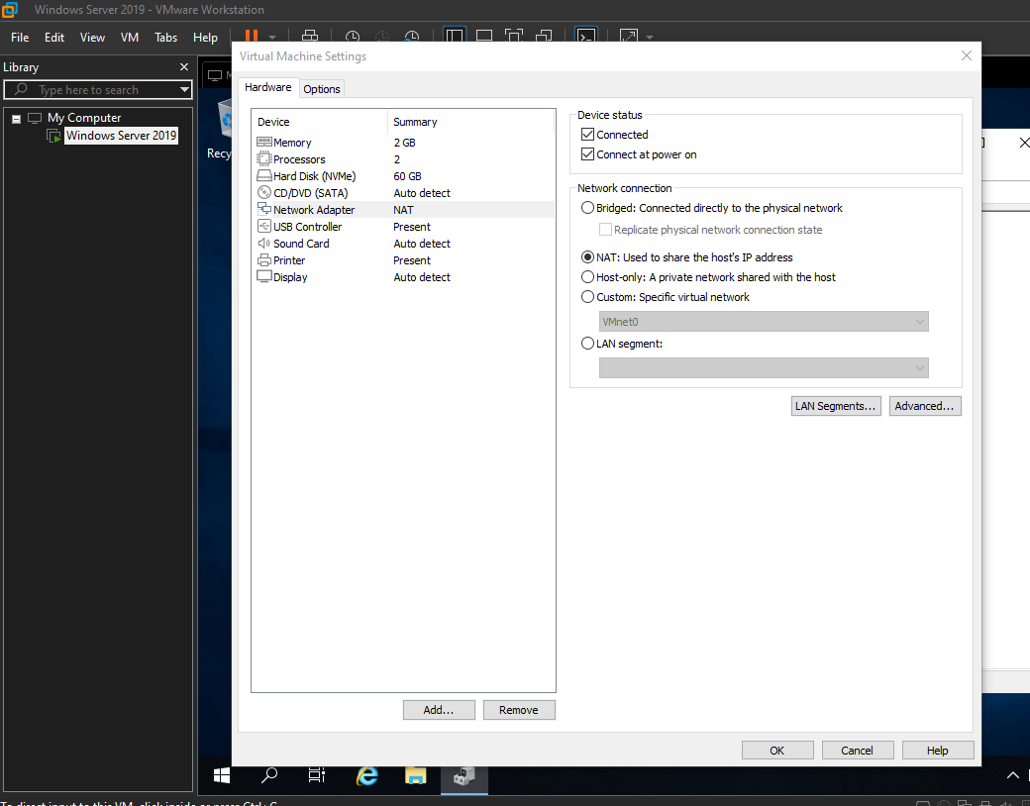
- What is the difference between the host system and the virtualized system?
The host system is the physical computer or server on which the virtualization software is installed, while the virtualized system is a software-based system running within the virtualization software. The host system provides the hardware resources, such as CPU, memory, and storage, while the virtualized system uses these resources to run its own operating system and applications.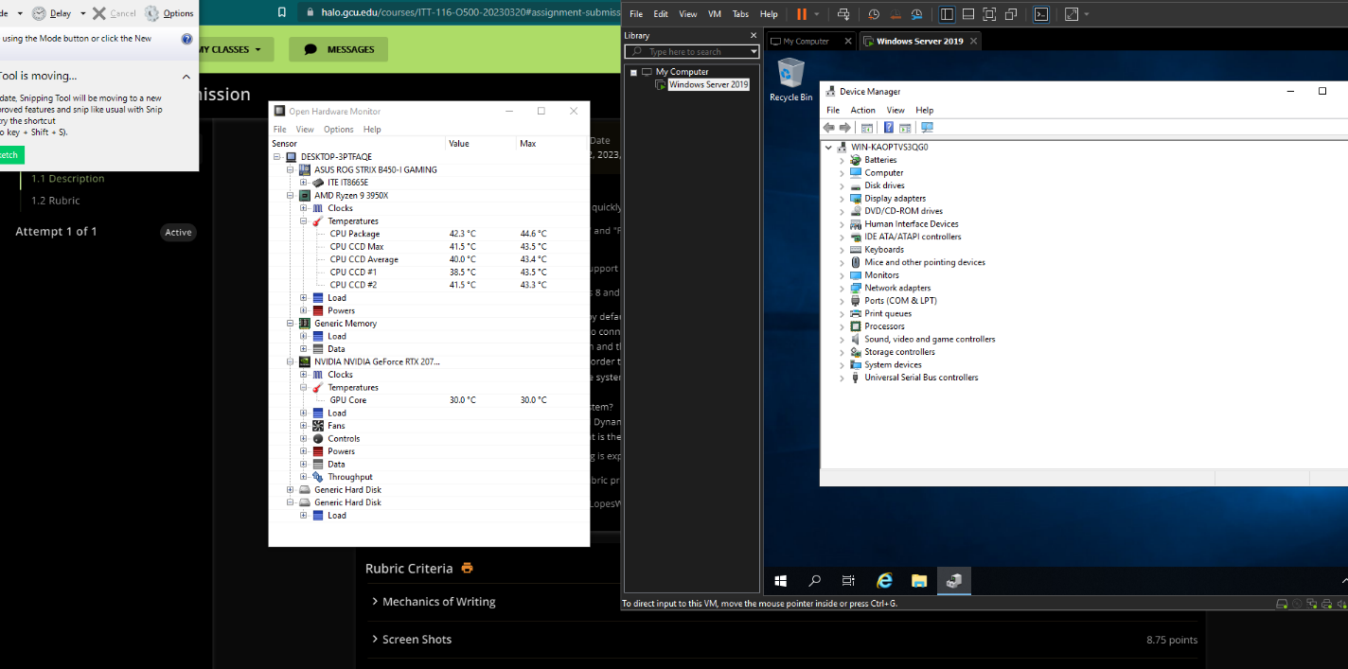
- If you need to isolate this virtualized system in order to create an air-gapped system, what might you do?
To isolate the virtualized system, one approach could be to disable the network adapter of the virtual machine, which would prevent it from connecting to any network or communicating with the host system. Another option could be to use a virtualization solution that supports creating isolated virtual networks, such as VMware vSphere or Microsoft Hyper-V, and configure the virtual machine to use a separate, isolated network.
- What is the Internet Protocol (IP) address of the system?
The IP address of the system can be obtained by running the ipconfig command in the Windows command prompt. In this case, the IP address of the virtual machine is 192.168.72.2
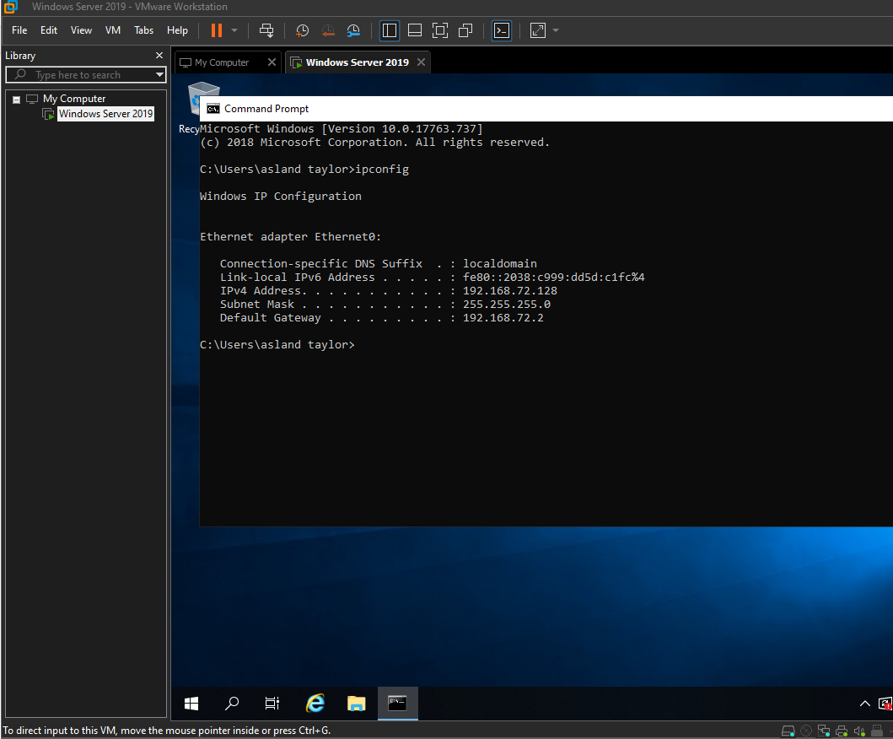
- What is the IP address of the host system?
The IP address of the host system can also be obtained by running the IPconfig command, this time on the host system. In this case, the IP address of the host system is 172.16.0.1
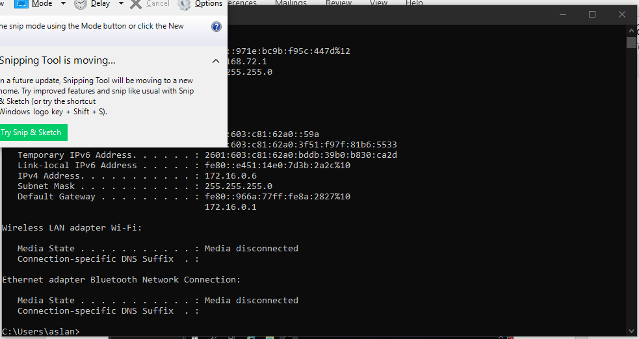
- What are the other address details for each system?
In addition to the IP addresses, each system also has a subnet mask, which determines the range of IP addresses that are part of the same network segment, and a default gateway, which is the IP address of the device that provides access to other networks. In this case, the subnet mask for both systems is 255.255.255.0, and the default gateway for the virtual machine is 192.168.72.2, which is the IP address of the VirtualBox NAT gateway. 
- Explain what a Domain Name Server (DNS) and Dynamic Host Configuration Protocol (DHCP) are.
A Domain Name Server is a network service that translates domain names into IP addresses. When you type a domain name into a web browser, the DNS server is responsible for finding the IP address associated with that domain name and directing the browser to the correct website. DNS is an essential component of the internet infrastructure and allows users to access websites and services using human-readable domain names rather than numeric IP addresses (Buckbee, M. (2022, January 19).
A Dynamic Host Configuration Protocol is a network protocol that allows devices to automatically obtain an IP address and other network configuration information, such as subnet mask, default gateway, and DNS server addresses. DHCP simplifies network administration by automatically assigning IP addresses and reducing the likelihood of conflicts between devices (Brain, M., Chandler, N., & Crawford, S. (2000, April 1)).
- Identify the MAC address for each system. What is the MAC address?
The MAC address is a unique identifier assigned to network interfaces for communications on the physical network. Every device on a network has a unique MAC address assigned by the manufacturer. The MAC address is used to identify devices on the network and is used in the process of communicating with other devices.
00-50-56-C0-00-08 is the MAC address for my VMware machine. In general, the MAC address can be found by looking at the network interface settings of the device, either through the operating system or using specialized network tools. You can type in Ipconfig/all in CMD and find the physical address for a network which is the MAC address (What is a MAC address and how do I find it? April 2nd, 2023)

Resources
Brain, M., Chandler, N., & Crawford, S. (2000, April 1). How domain name servers work. HowStuffWorks. Retrieved April 2, 2023, from https://computer.howstuffworks.com/dns.htm
Buckbee, M. (2022, January 19). What is a domain controller, when is it needed + set up. Varonis. Retrieved April 2, 2023, from https://www.varonis.com/blog/domain-controller
What is a MAC address and how do I find it? - whatismyipaddress. (n.d.). Retrieved April 2, 2023, from https://whatismyipaddress.com/mac-address

