IF ELSE- ASSIGNMENT

QUES-1

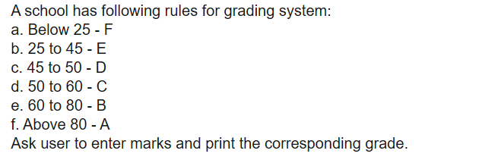

QUES-2

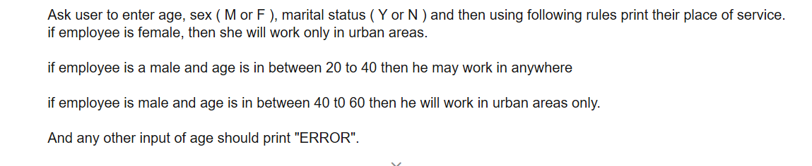

QUES-3



QUES-4

