**“LAKBAY CEBU: CEBU TOURIST GUIDE WITH DIALECT TRANSLATOR”**

A Capstone Project

Submitted to the Faculty of the

College of Engineering and Technology

Universidad de Manila

In Partial Fulfillment

of the Requirements of the Degree

Bachelor of Science in Information Technology

**SEAN PHILIP P. CRUZ**

**JOHN VINCENT M. DANTES**

**MARY KRIS E. LAPUZ**

**ELAINE R. MANALO**

**ROME MARTELL E. MAPILI**

January 2019

**College of Engineering and Technology**

**APPROVAL SHEET**

This capstone entitled “**LAKBAY CEBU: CEBU TOURIST GUIDE WITH DIALECT TRANSLATOR”** prepared and submitted by **SEAN PHILIP P. CRUZ, JOHN VINCENT M. DANTES, MARY KRIS E. LAPUZ, ELAINE R. MANALO** and **ROME MARTELL E. MAPILI** has been reviewed and recommended as partial fulfillment of the requirements for the degree of Bachelor of Science in Information Technology.

**RYAN B. AZUR**

*Research Adviser*

Accepted and approved by the panel of examiners following a successful Oral Defense on February 14, 2019 with a grade of __________.

**PANEL 1**

*Panelist*

**PANEL 2**

*Panelist*

**PANEL 3**

*Chairperson*

Accepted and approved in partial fulfillment of the requirements for the degree of Bachelor of Science in Information Technology.

**ELMERITO D. PINEDA, MBA-IS**

*Dean, College of Engineering and Technology*

Date: __________

**Certificate of Originality**

I/We hereby declare that the research paper entitled:

**“LAKBAY CEBU: CEBU TOURIST GUIDE WITH DIALECT TRANSLATOR”**

is my/our own work and that, to the best of my/our knowledge and belief, it contains no material previously published or written by another person nor material to which to a substantial extent has been accepted for award of any other degree or diploma of a university or other institute of higher learning, except where due acknowledgement is made in the text.

I/We also declare that the intellectual content of this thesis is the product of my/our work, even though I/we may have received assistance from others on style, presentation and language expression.

**SEAN PHILIP P. CRUZ JOHN VINCENT M. DANTES**

*Proponent’s Signature**Proponent’s Signature*

**MARY KRIS E. LAPUZ ELAINE R. MANALO**

*Proponent’s Signature**Proponent’s Signature*

**ROME MARTELL E. MAPILI**

*Proponent’s Signature*

**Date of Completion: ___________**

**Attested by:**

**RYAN B. AZUR, MBA-IS** **Date of Completion: ___________**

*Research Adviser’s Signature*

**ACKNOWLEDGMENT**

**SEAN PHILIP P. CRUZ**

**JOHN VINCENT M. DANTES**

**MARY KRIS E. LAPUZ**

**ELAINE R. MANALO**

**ROME MARTELL E. MAPILI**

**TABLE OF CONTENTS**

**Page**

TITLE PAGE……………………………………………………………………… i

APPROVAL SHEET……………………………………………………………… ii

CERTIFICATE OF ORIGINALITY……………………………………………... iii

ACKNOWLEDGMENT.......................................................................................... iv ABSTRACT............................................................................................................. v

TABLE OF CONTENTS……………………………………………………....…. vi

LIST OF TABLES................................................................................................... viii

LIST OF FIGURES.................................................................................................. ix

LIST OF APPENDICES.......................................................................................... x

INTRODUCTION.................................................................................................... 1

Project Context…..……………………………………………………....... 2

Project Description……............................................................................... 3 Objectives of the Project............................................................................... 4

Scope and Limitation of the Project.............................................................. 5

Significance of the Project............................................................................ 6

REVIEW OF RELATED LITERATURE AND STUDIES..................................... 7

Related Literature…………………………………………………………. 7

Related Studies…………………………………………………………….. 15

Synthesis…………………………………………………………………... 20

Conceptual Framework………………………………………………..…… 21

TECHNICAL BACKGROUND……………………............................................... 24

Technical Definition of Terms…………………………………….………. 24

Technologies to be Used…………….…………………………………….. 27

Functionality of the Project.…………………...…………………………... 27

METHODOLOGY................................................................................................... 29

Requirements Specifications..…………………………………………….. 29

Design……………………………………………………………………... 40 Development..……………………………………………………………... 47

Test Plan…….……………………………………………………………... 50

Evaluation Plan…...………………………………………………………... 54

Test and Evaluation Results ………...……………………………………... 59

SUMMARY OF FINDINGS, CONCLUSIONS, AND RECOMMENDATIONS.. 65

Summary of Findings……………......…………………………………….. 65 Conclusions………………………......……………………………………. 66

Recommendations….……………......……………………………………...67

IMPLEMENTATION PLAN................................................................................... 68

Project Implementation Checklist...……………………………………….. 68

Implementation Contingency.……………………………………………... 69 Infrastructure/Deployment….……………………………………………... 69

**LIST OF TABLES**

|  |  |  |
| --- | --- | --- |
| Table |  | Page |
| 1 | Gantt Chart of the Project …………………………………………….... | 32 |
| 2 | Software Requirements………… ……………………........................... | 33 |
| 3 | Likert Scale….. ……………………….……........................................... | 46 |
| 4 | Scoring System of the Evaluation………………………….………….. | 57 |
| 5 | Summarized Test Results ……………………........................................ | 60 |
| 6 | Evaluation Results from IT Experts ……………………........................ | 61 |
| 7 | Evaluation Results from End-users ……………………......................... | 62 |
| 8 | Overall Summary of Evaluation by Criteria ……………………............ | 63 |

**LIST OF FIGURES**

|  |  |  |
| --- | --- | --- |
| Figure |  | Page |
| 1 | Conceptual Framework of the Study....................................................... | 21 |
| 2 | Functional Decomposition Diagram.…………...................................... | 29 |
| 3 | Program Flowchart….............................................................................. | 35 |
| 4 | Use Case………….…………………………………………................. | 37 |
| 5 | IPO……………….................................................................................. | 38 |
| 6 | Development Process Diagram...……………........................................ | 39 |
| 7 | Splash Screen…………………………………….................................. | 41 |
| 8 | On boarding Screen…………………………………………................. | 41 |
| 9 | On boarding Screen..……………………………………...................... | 42 |
| 10 | On boarding Screen ………………………….……….………..…….. | 42 |
| 11 | Home Screen........................................................................................... | 43 |
| 12 | App Drawer............................................................................................. | 43 |
| 13 | Activity Page….…………………………………………………….… | 44 |
| 14 | E-Route Page...….……………………………………………………... | 44 |
| 15 | Translator Page……………..………...................................................... | 45 |
| 16 | Dictionary Page,.….………………........................................................ | 47 |
| 17 | Deployment Diagram…………………………………………………. | 49 |
| 18 | Infrastructure Diagram………………………………………………… | 70 |

**LIST OF APPENDICES**

1. Summary Of Test Results
2. Summary Of Evaluation Results
3. Data Matrix
4. Source Code
5. Sample Reports
6. Program Flowchart
7. Sequence Diagram
8. Activity Diagram
9. Budgetary Estimate
10. Endorsement And Request Letter
11. Assignment Of English Critic
12. Assignment Of Technical Critic
13. Assignment Of Statistician
14. Certificate Of English Editing
15. Certificate Of Technical Editing
16. Certificate Of Statistical Analysis
17. Routing Slip Of Final Manuscript
18. Brochure
19. User’s Manual
20. Curriculum Vitae

**Chapter I**

**INTRODUCTION**

The study focuses in the “Queen City of the South” Cebu City Philippines containing its six cities; Cebu, Danao, Lapu-Lapu, Mandaue, Toledo and Talisay; and its 47 smaller towns. Cebu has more than kept pace with the nation’s progress. Today the island province leads in traditional and non-traditional exports and has the highest economic growth rate anywhere in the country. Likewise, recent indications pointed out that Cebu has become the country’s favorite tourist destination. In contrast to the bustling metropolis, the rest of Cebu’s 167 islets and islands are lined with idyllic white sandy beaches and pristine clear waters. Cebu has gained wide popularity for fantastic diving grounds evidenced by the proliferation of resorts which offer luxurious accommodations, excellent dive facilities and the services of competent dive masters and dive guides. Cebu’s strategic location makes it ideal for those who wish to travel to the other islands and provinces by plan, boat or bus.

According to the founders of Lonely Planet Cebu (2018) is the hub around which the Visayas revolve. It is the most densely populated island in the Philippines and is second only to Luzon in its strategic and economic importance to the country. This is

one of the most prosperous regions in the country – the 2016 growth rate was 8.8%, considerably higher than the national average.

While developing the mobile application, the proponents investigated that Cebu City have regulations and implications to traffic congestion regarding with the Public Utility Jeepneys (PUJs) route. Tourists encounter the problem of transportation while travelling to Cebu City.

As stated by (John Daryl D. Arnado et all, 2017) the Cebu City government regulates and implements its PUJ operations and traffic congestion. It also examined the traffic ordinances implemented by the local government. The study measured assessed the volume of PUJs plying on various designated city routes, it effects on the city’s traffic congestion and its effectiveness of traffic management. A data mining technique was employed through secondary data collection on the volume PUJ from the offices of the Cebu City Traffic Operations Management (CITOM) and the Land Transportation Office Regional office No.7 (LTO7). A survey was also conducted to CITOM Officials and PUJ commuters and drivers. The findings revealed a declining numbers of PUJs and are heavily regulated in their specific routes. Research respondents perceived that traffic management and implementation are not effective. Most of them are not satisfied on the government’s action in solving the traffic problems in the city. They believed that the local government put heavy teeth over the PUJs management as a public transport system whereas private vehicles are loosely

managed since the city ordinance is loose on it. This implies that the traffic ordinance is vague and not updated for the problem. In conclusion, the volume of PUJs is not the critical contributor to traffic congestion; it is how effective the ordinance is implemented. Ultimately, strict and effective implementation of traffic rules and regulations of Cebu city’s transport system are the areas requiring immediate attention to end perennial problem of traffic congestion in Cebu City.

The proponents proposed an application that will help tourists move freely and access efficient road transport within their location and destination using the E-Route feature. Within the feature the tourists will be able to find their current location and select their desired destination. The tourist will get the PUJ zip code and route as a result.

Today’s apps for language translation try to accomplish the same thing. While not as accurate or instantaneous, the application is nevertheless useful and greatly improved because the application also have a tourist spots that can guide a tourist to know where they will go in a particular place. Having a tourist spot guide will help many tourists about the place they wanted to go. This will help many people in Cebu and the tourist that visiting the province to communicate much more effectively also to help local and foreign tourists guide them through the beautiful places of Cebu. The proponents also include a dictionary module that is consists of two translations such as Filipino to Cebuano and English to Cebuano. It will help the local and foreign tourists of Cebu ease their mind in understanding the language in Cebu either their mother tongue is Filipino or

English. The application also offered a mobile translator that has two functions which is the speech-to-text and text-to-speech language. It will help the users to translate a dialect such as English to Cebuano, English to Filipino, Cebuano to English and Cebuano to Filipino.

The mobile application programming interface (APIs) make it easy to build apps, and this provides an excellent way to exploit and demonstrate computational linguistics research, perhaps not used as much as it could. Developing this kind of project is a must because many people love to travel around the world, by having such application it will help the traveler to maximize their travel experience because they will be informed by the place they will going and they can easily communicate with a foreign language by using the app. There is a saying that “The country’s tourism potential is not yet maximized, hence the need to promote the Philippines as a tourist destination haven.” By Joseph Ace Durano.

**Project Context**

Tourism is a dynamic and competitive industry that requires the ability to adapt constantly to customers’ changing needs and desires, as the customer’s satisfaction, safety and enjoyment are particularly the focus of tourism businesses. The proposed study aims to promote tourism not only Cebu City but the country also Philippines. As specified according to the research with the booming tourism of Cebu, the proponents planned to enhance the travel experience of a foreign and local tourist through a virtual

guide application. Introducing the tourist spots: spots that are non-popular and popular that are ready to be discovered in Cebu City, the application will convince more tourists

to visit and travel to Cebu City with the assurance of benefits using the proposed application. The project specifically features Cebu City but the application itself is not limited to local citizen to further endorse the culture to foreign users.

**Project Description**

The project will be consist of three major part such as Speech Translator, Dictionary and Tourist Spot Guide through E-Route Navigation, this will help the tourism industry because nowadays the travel industry is one of the fastest growing economic sectors hence, many developing economies like Philippines put tourism industry in the national agenda. The system will acquire information on tourist attractions, visibility on the part of the tourist attractions in the province as seeing a mobile site increases the top-of-mind presence and popularity. ; By the current procedure as stated above the process is manual so our team decided to develop an app that will make it more efficient and on-the-go. This will help many tourists to know the place they are going better because there will be a description of a place in the app and they can communicate much more easily with the Cebuanos because the application have an speech translator.

**Objectives of the Project**

The proposed project aims to develop “Lakbay Cebu: Cebu Tourist Guide with Dialect Translator” to let the local and foreign tourists travel in Cebu City with the assistance of a tour guide application.

Specifically it aims to:

1. Create a mobile application for visitors of the Cebu City that has these Features:
2. Top tourist Spots and Activities on the Cebu City.
3. E-Route Navigation through Cebu City.
4. Dictionary of the Dialect of Cebuanos.
5. Mobile translation with speech-to-text and text-to-speech translation
6. Test and evaluate user acceptance on the developed application “Lakbay Cebu: Cebu Tourist Guide with Dialect Translator” in terms of:
7. Functionality;
8. Content;
9. Design;
10. Test and evaluate the importance of developed application in terms of:
    1. Discover Module
    2. Activity Module
    3. E-Route Module
    4. Translator Module
    5. Dictionary Module

**Scope and Limitations of the Project**

1. Discovery Module – In this module, the user will be able to navigate top tourist spots with detailed information like description, location, contact numbers provided and map with Google assistance.
2. Activities Module – In this module, the user can work on categories in the activity like falls, mountains, beaches, festivals, foods and music with its detailed information.
3. E-Route Module – In this module, the user’s location can be located through GPS navigation and be able to find jeepney route, code.
4. Dictionary Module – In this module, the user can search and find meaning with Cebuano dialect into English.
5. Translator Module – In this module, the user will be able to translate speech to text, text to speech with English to Visayan, Tagalog.

**Limitations**

1. The application will only run on Android devices.
2. The application needs internet connection for function usability.
3. The application doesn’t have a booking module (i.e hotel, transportation)

**Significance of the Project**

The significance of the project is to help many citizens and non-citizens to communicate easily to Cebuanos and help them travel blithely in the city of Cebu. The following will benefit the project:

**Tourist.** For the tourist the application will help them travel in Cebu city with a handful guide that will translate, communicate and navigate for the user’s tour.

**Cebu Tourism.** For the Cebu tourism the proposed project will help promote Cebu City that focuses in endorsing places and culture.

**Department of Tourism/ Tourist.** For the Department of Tourism the proposed project will not only support Cebu City tourism but the Philippines also.

**Future Researcher.** For the researcher the project will help them because this project will be guide them or it will help them to have some ideas of how to develop a speech

translator with tourist spot guide. They will also gain benefits by using some ideas of our research like how our team develops the project step by step and by knowing what software did our team used to develop the project. The study will also give them the idea of software and hardware should be used in developing this kind of project.

The beneficiaries of the project are the citizen of Cebu and the non-citizen of Cebu. They will be benefited because a tourist can maximize their travel experience in Cebu because they can easily communicate with Cebuanos and there are tourist spot that can guide them in the wonderful places in Cebu. It can also help some non-citizen of Cebu to learn

some Visayan language by using the dictionary of the app and it will encourage them to travel in Cebu by knowing the wonderful place of the province.

**CHAPTER II**

**REVIEW OF RELATED LITERATURE AND STUDIES**

**Introduction**

**Related Literature**

This chapter discusses literature written by different authors and other researchers’ conducted studies that correlates to the proposed study. This section contains related gathered information from different sources such as websites and books.

Conceptual framework of the Project and Technical definition of terms is also covered in this chapter.

**Related Literature**

**A Malay Dialect Translation and Synthesis System: Proposal and Preliminary System.** According to Research Gate (2012) Malay is a language from the Austronesian family. Malay is the official language in Malaysia, Indonesia, Singapore, and Brunei. However, Malay spoken in different countries and even within a country

itself might vary in terms of pronunciation and vocabulary from one place to another. The Malay dialects in Malaysia can be grouped according to the states of the country. In this

paper, we propose the architecture of a Malay dialect translation and synthesis system, that given a sentence in standard Malay, it translates and synthesizes an utterance in the dialect requested. The system consists of 3 modules, dialect translation system, dialect G2P system, and speech synthesis system

The outcome from this study is two folds. From linguistic viewpoint, it will help us understanding and appreciating the interesting differences in the Malay dialect in Malaysia, which is important to help preserve the dialect and culture in it. Secondly, the proposed system will be useful for people who like to learn a particular dialect or it can

be used in places that require this facility. At this stage, we have completed the standard Malay system, and this paper presents our work so far.

**Speech-Enabled Hybrid Multilingual Translation (2014).** As mentioned by Research Gate (2014) this study presents architecture and a prototype for speech-to-speech translation on Android devices, based on GF (Grammatical Framework). From the user’s point of view, the advantage is that the system works off-line and yet has a lean size; it also gives, as a bonus, grammatical information useful for language learners. From the developer’s point of view, the advantage is the open architecture that permits the customization of the system to new languages and for special purposes. Thus the architecture can be used for controlled-language-like translators that deliver very high

quality, which is the traditional strength of GF. However, this paper focuses on a general-purpose system that allows arbitrary input. It covers eight languages.

**Interactive Mobile Based Tour Guide.** As indicated by Research Gate (2013) this paper presents the work carried out in developing an interactive mobile tour guide application to replace the traditional tour guide booklet. Main features of the application are; virtual tour of important places located, voice based information provider, location identifier and a map based path selection function to select the best path to a specified destination within the premises. The application was developed based on the Android platform, and delivered as a mobile application. Main goal of this project is to help the tourists to travel on their own and take full advantage of the visit without missing the main attractions.

**A location-based services and Google maps-based information master system for tour guiding (2016).** This paper aims to develop a location-based services supported Dr.What-Info system, i.e. a master multi-agent system on what the information is, using Google maps and an image recognition technology as a tourism information provider and as a route planner for tourists. Users can have great fun during vacation travels through an easy-to-use interface, integrating smartphone GPS function, a QR/Bar code reader and easy access to a cloud database, to find all of the required web services. In particular, given an archeological site in New Taipei City, Taiwan, for testing purposes, the

presented system is demonstrated not only as a provider of information on popular tourist attractions, but also as a high performance GPS navigation device to guide users toward their desired destinations. The complete system developments, displays, and corresponding experiments and comparisons show that the research results demonstrate performance superiority over a number of previous studies.

**Multilingual Speech Synthesis System (2012).** The technology of converting a text document into speech signals is called speech synthesis. The broader definition of the term includes record-playback speech synthesis, where prerecorded voices are simply played back on demand. It also covers speech synthesis by filing and editing, which stores in advance the words or phrases of recorded speech and joins them in a designated order for playback. A typical application of the former is a message response system in answering machines, and that of the latter is an automated announcement system at railway stations, which announces the destinations of arriving trains (by embedding the recorded speech of destinations into that of carrier sentences).

**Translating the tourist gaze: from heritage and ‘culture’ to actual encounter (2012).** This paper covers two main areas. The first area is an analysis of the various facets of heritage, cultural tourism and tourist encounter with other cultures in terms of culture-bound tourist gaze, a simplified, generalized and necessarily distorted model of ‘the Other’. The model of perception is culture itself, and is discussed in terms of 3 macro

levels: heritage; the practices and traditions of a people; and the system of internal values and beliefs that both form the model of reality and guide it. Secondly, the paper focuses on translation and Outsider interpretation. It reveals how little emphasis is given either to translator language or to cultural competence, and focuses on the problems of mediating for the culture-bound tourist gaze.

**Related Studies**

**Aikuma (2014).** Proliferating smartphones and mobile software offer linguists a scalable, networked recording device. This paper describes Aikuma, a mobile app that is designed to put the key language documentation tasks of recording, respeaking, and translating in the hands of a speech community. After motivating the approach we describe the system and briefly report on its use in field tests.

**Smart Audio Tour Guide System using TTS (2017).** The global positioning system (GPS)-enabled mobile phones provide the location-based tourist guide applications for indoor or outdoor environment. In this paper, we develop the location-based audio tour guide system using speech synthesis provided by the server-based text-to-speech (TTS) engine. The mobile audio guide travel application provides real-time tour information in multilingual versions at the major tourist attractions. The developed audio tour guide system is consisted of the tour guide service system, the wiki-based tourist information

collection system, the tour information DB, the server-based TTS engine, and Android and IOS mobile apps.

The developed tourist guide system is very helpful for tourists and enhancing self-guided tours of outdoor locations. The audio tour guide services also provide safe and comfortable route and path guidance for pedestrians and handicapped or elderly people.

One of the essential components for an audio guide system is the geo tagging tour information. We are building the location-based tour information DB and photos for smart audio tour guide in the major walking tourist spots in Jeju and Seoul.

**Android Mobile Phone based Syntactic Analysis System to Support English-Myanmar Translation for Tourists (2014).** Nowadays, the language barrier among tourists was one of the major difficulties when travelling. The tourists can rely on mobile phone for travelling purposes. Mobile phone is necessary part of the people’s life. Mobile language translation system is used for a better travelling guide. So, this system is proposed as the syntactic analysis system to support English, Myanmar translation for tourists guide. The proposed system is also implemented on the android operated mobile phones because the android platform makes it easier for travellers to get and use applications on their mobile phones. The entire system is implemented by using Android SDK, SQLite and Java-based Android API.

**Android Travel Mate Application using Real Time OCR (2013).** Proposed system that can extract a text from the image, the extracted text is translated into a specific language. This application is useful for Tourists and travelers to understand the native country language. They simply use their mobile camera, simply click the image of the signboards, menus etc. The OCR engine used in the system extracts the text from the image. Tourist and Travelers simply use their Android phone camera for clicking the image.

**English Text to Multilingual Speech Translator Using Android (2011).** As stated by Research Gate (2011) This paper aims at providing design and development solution of an Android application whose objective is to provide a solution to overcome the barrier of languages by implementing text to speech conversion in different languages. The Android application developed text to speech conversion to facilitate the translation of English language text into speech output in different languages. We have also proposed few improvements which can further advance this system to include more target audiences so as to make it more beneficial and useful. The proposed English Text to Multilingual Speech Translator using Android (T2MSTA) aims at providing assistance to

the people lacking the power of speech or non-native speakers like people who do not share a common language.

**Problems & Suggestions for Android City Tour Guide System Based on Web Services for Mumbai (2015).** Mobile performs the important role in today’s lifestyle of human being. All the convenient things are done through the mobile applications and the development of different application has been increasing day by day. In such applications, location dependent systems have been detected as an important application. We propose architecture of “Android city tour guide system based on Web service for Mumbai” that is able to provide tourism information to the mobile users for Mumbai city conveniently. The article can realize to query information for hotel, scenery, restaurant, traffic, schools.

**Android city tour guide system based on Web service (2012).** The combination of the smart phone and the Internet service is the trend of the future information development and software applications. Mobile phones are the most commonly used communication tools. Using mobile phones to obtain information is not only quick, but also more convenient shortcut to improve people's lives. In the paper, we propose the software development architecture based on Web services. This framework introduces the three-layer architecture of Web development into mobile phone software development. Based on the three-layer architecture, the android based city tour guide

system is developed. The android based city guide system can realize to query information for hotel, scenery, restaurant, traffic and so on. The android based city guide system has more practical significance.

**Electronic tour guide for Android mobile platform with multimedia travel book (2012).** In this paper, a new system for positioning and multimedia reporting, named electronic tour guide, is presented. The mobile device of the system communicates with the server, from which it receives electronic tourist maps, and the GPS satellites. Each location on the map with predetermined irregular shape avoids overlap with other areas and thus it increases the accuracy of the visited location. The device is guiding the tourist using the coordinates received from the GPS signals and the objects that are preloaded as electronic maps. The main functions of the system are: (a) it is displaying the content according to user's movement, position and preferred selections; (b) it generates reports for guiding using existing date stored from the server, the current position, the previous movement and the paid services; (c) it reports and prepares the multimedia travel book based on the paid services; (d) it prepares the daily trip report from images, text and audio files downloaded from server or recorded by user; (e) it submits the recorded data for future individual, group or public usage.

**Traveler Acceptance of an App-Based Mobile Tour Guide (2013).** This study aims to identify antecedents and determinants affecting travelers’ technological

acceptance of an app-based mobile tour guide (AMTG). Informativeness (IF) and entertainment (EN) are amended as antecedents apart from performance expectancy (PE), effort expectancy (EE), social influence (SI), and facilitating conditions (FC) suggested by the unified theory of acceptance and use of technology model. The empirical results

were obtained in a sample of 205 travelers visiting Macau. Structural equation modeling is used to evaluate the relationships among the antecedents and determinants of the proposed model. The results indicate that IF and EN have direct effects on PE and EE. All factors except EN have significant effects on the behavioral intention of a traveler to use an AMTG. The results of this study provide implications for travel app designers and service providers to formulate business strategies to encourage travelers to adopt the AMTGs**.**

**Tour guide robot using wireless based localization (2013).** This paper details the design and implementation of a tour guide robot. This robot makes use of a ZigBee wireless network to locate itself in the tour area using a weighted centroid technique. Most popular technologies like GPS based localization do not work well in the indoor environment that the tour guide robot would operate in. The ZigBee-based solution works better in this type of environment plus the individual ZigBee nodes can be used for building monitoring applications (such as temperature and smoke detection) as well. The weighted centroid method is not the only method of localization but it is the simplest. Other competing methods like trilateration and triangulation are more prone to error as

they require accurate distance measurements that an indoor environment with its myriad of reflective surfaces cannot provide. The implementation that this paper presents was able to achieve a desirable level of accuracy. The best case in the trials was a 0.61 m margin of error, and the average case was 2.38 m.

**Synthesis**

In the study of all gathered data and literature helps to create a related system.

Other existing mobile application, had some features where people can only locate places, unlike the advancement of the proposed app (Cebu City Guide with Dialect

Translator) offers users to interact and communicate with Cebuanos through speech text translator.

**Conceptual Framework of the Project**

**INPUT PROCESS OUTPUT**

**Waterfall Model**

1. Planning
2. Requirement Analysis
3. Designing
4. Coding
5. Testing
6. Debugging

**Lakbay Cebu: Cebu Tourist Guide with Dialect Translator**

**Knowledge Requirement**

1. Google Cloud Platform
2. Java Programming

**Software Requirement**

1. Android Studio
2. Google Cloud Platform

**Hardware Requirement**

1. Laptop

* 2.53GHz Processor
* 8 GB RAM

1. Mobile Phone

**EVALUATION**

*Figure 1.* Conceptual Framework of the Proposed Project “Lakbay Cebu: Cebu Tourist Guide with Dialect Translator”

The requirements stated in the conceptual framework should be followed accordingly; the first knowledge requirement is Google Cloud Platform for API and Java

for Programming Language, the software requirements is Android Studio for the intergraded development environment (IDE) and Google Cloud Platform for API and Services and for the hardware requirement is Laptop and mobile phones to make the next

Step the Process. In this part the model will be use is Waterfall Model; after the entire process is done the finished mobile application will be called Cebu City Guide with Dialect Translator. Then it will be evaluated to see the mobile applications is

**CHAPTER III**

**TECHINICAL BACKGROUND**

**Technical Definition of Terms**

The technical definition of terms provides the user a better understanding of the system and the terminologies applied in the project. The following are composed of conceptual definitions as used in the system:

**Android Studio.** Android Studio is the official integrated development environment (IDE) for Android application development. It is based on the IntelliJ IDEA,

a Java integrated development environment for software, and incorporates its code editing and developer tools.

**Google Cloud Platform.** Offered by Google, is a suite of cloud computing services that runs on the same infrastructure that Google uses internally for its end-user

products, such as Google Search and YouTube. Alongside a set of management tools, it provides a series of modular cloud services including computing, data storage, data

analytics and machine learning. Registration requires a credit card or bank account details.

**Adobe XD.** Is the all-in-one UX/UI solution for designing websites, mobile apps, and more Design, prototype, share.

**Adobe Illustrator.** Is a software application for creating drawings, illustrations, and artwork using a Windows or MacOS computer.

**Technologies to be Used**

The device used for the development of the software is a laptop with 8GB RAM, Intel Core i5-4300u processor with a graphics processing unit of AMD Radeon 8750M and a 500GB hard-drive, this is, however, not a requirement since any other device that can run the following software: Android Studio, Google Cloud Platform, Adobe Illustrator and Experience Design (XD can be used to develop the software. Adobe Illustrator and Adobe XD were used to create and enhance the software’s interface design and presentation. Android Studio and Google Cloud Platform were used in order to develop and test the software; using Java as the programming language and Firebase Database Query for the back-end database of the system.

**Functionality of the Software Project**

The application “Lakbay Cebu: Cebu Tourist Guide with Dialect Translator” is proposed to support Cebu City and Philippine tourism, therefore the study is proficient to tourists to have this application.

**CHAPTER IV**

**METHODOLOGY**

As it is indicated in the title, this chapter includes the research methodology of the dissertation. In more details, in this part the author outlines the research strategy, the research method, the research approach, the methods of data collection, the selection of the sample, the research process, the type of data analysis, the ethical considerations and the research limitations of the project.

**Requirements Specifications**

The requirements specifications include the operational, technical, and schedule feasibilities. These are feasibility studies conducted in order to assess the practicality of the project. This is where the different kinds of requirements needed to use the software were specified. This also aimed to evaluate the project’s potential for success.

**Operational feasibility.** The operational feasibility discusses how well the proposed software solves problems and how it satisfies the requirements identified during the software development. The assessment includes how it was integrated into an environment that does a manual procedure compared to how it should function.

***Functional decomposition diagram.*** The functional decomposition

diagram, as illustrated in Figure 2, is a form of analysis that dissects a complex process to show its individual elements. This shows an organization’s current flow of data through a

system’s process. This is a hierarchy chart taken in the act of breaking down the function of a device, process, or system into its basic components. Since Lakbay Cebu does not

rely on the process of an existing company nor does it use the process of one as basis, represented on its FDD is the general breakdown of its functions.

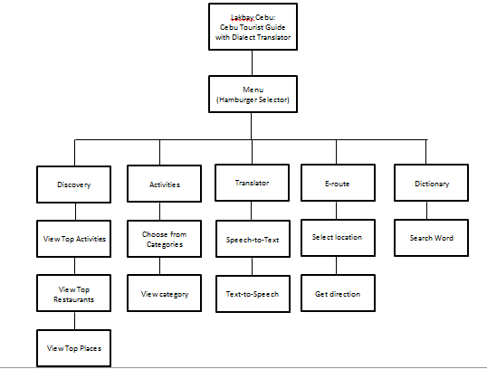

*Figure 2.* Functional Decomposition Diagram of the Proposed Project “Lakbay Cebu:

Cebu Tourist Guide with Dialect Translator”

Lakbay Cebu functions as a virtual tour guide that features Cebu City. Users can browse places and activities through the hamburger menu. They can also translate dialect via speech-to-text and text-to-speech. A feature where user can find their destination route and a dictionary for searching words.

**Process Model (Flowchart)**

*Figure 3.* Program Flowchart of the Proposed Project “Lakbay Cebu: Cebu Tourist Guide with Dialect Translator”

The diagram shown above is the flow of the application. As shown if the user open the application it will show the logo, it means the app is loading but if the phone the user is using does not have an internet connection the app will not redirect him/her to the homepage of the app. If the phone has an internet connection the app will redirect him/her to the homepage and other category. After is the tourist spot, if the user taps the tourist spot the user will see a two categories inside, such as land and water , if the user

choose the category then the app will show him/her all the wonderful spots according to what category he chose. Next process is translation. Translation has a two category, speech to text or text to speech, after choosing one of those the user have to choose again if what language he/she wants to translate like Filipino to Visayan, English to Visayan and vice versa. The next one is Dictionary. In dictionary the user only need to input what Visayan word does he/she want to know and dictionary will provide the meaning to it. Following is about us there the user can see who the one who developed the application is.

**Technical feasibility.** This section is the complete study of the project in terms of input, processes, output, fields, programs and procedures. It is a very effective tool for

long term planning and trouble shooting. The technical feasibility study should most essentially support the financial information of an organization.

***Compatibility checking.*** The proponents will make use of software that will have almost no compatibility problems even if used in other devices or computers in order to avoid tedious checking every time a change is made. Either way, the compatibility check that will be conducted includes testing the software used using different hardware, interchanging in between, in order to identify whether there is a compatibility problem or none. The proponents will also make use of different hardware similar to what is used in order to test whether the software will work using that

particular hardware or not. Furthermore, the proposed software is specifically designed as a cross-platform application.

***Relevance of the technologies.*** Windows 10 is the OS used for the development of the software for the reason that it serves as a good support for Android Studio. The latter is the integrated development environment (IDE) used to build applications for Android operating system. The programming language used is Java because of its rich set of core features.

The hardware used for the development of the software is a laptop with 8GB RAM, Intel core i5-4300u with a graphics processing unit of AMD Radeon 8750M and a 500GB hard drive, these are, however, not a requirement since any other device that can run the following software: Android Studio, Android Studio emulator, Adobe Photoshop and Experience Design can be used to develop the software. Adobe Experience Design was used for the interactive software prototype because it supports

vector designs and wire framing. Adobe Photoshop and Adobe Illustrator were used to create and enhance the interface design and presentation of the software. Firebase Database Query was used for the back-end database of the system.

**Schedule feasibility.**This part discussed and portrays the timetable of the project, whether it is completed on time or not. The period on how long would it take to develop

the software was estimated through the use of a Gantt chart. This part also evaluated whether the time it took to complete the program was within a reasonable bound.

***Gantt chart.*** The Gantt chart showing all of the tasks to be done as the project progresses is shown below. The tasks included are divided in rows and the columns include the month and year. Inside the main body of table are lines which are used to signify the span of time before a task is completed.

Table 1

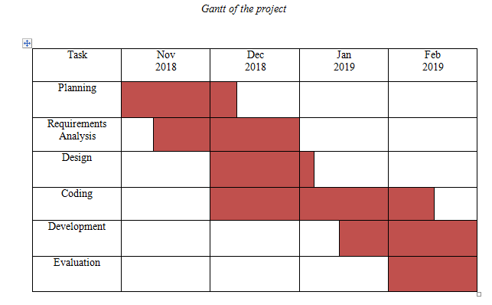*Gantt Chart of the Project*

The first task in the chart shown above is the planning phase, where the preparation and preliminary research for the project is performed. It usually takes a short

period of time in order to be done. The following task is the analysis, where the functionality, requirements and the feasibility of the project have been analyzed. This task takes roughly a week or more in order to be done, depending on the scope of the software to be developed. The Design phase refers to the designing and prototyping of the software. It began while the analysis phase was being conducted. This was done to provide the software a user-friendly interface. The development phase began succeeding

the design phase to test how well the interface works in the actual software. The testing and debugging phase occurs as the development goes. Upon development and testing, evaluation is performed.

**Use Case Diagram**

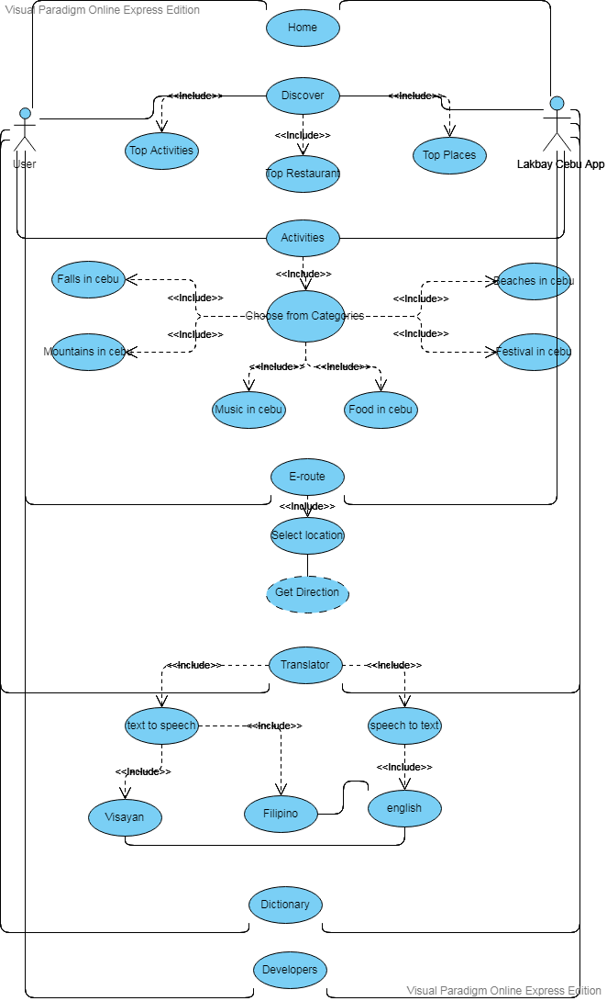

*Figure 4.* Use Case of the Proposed Project “Lakbay Cebu: Cebu Tourist Guide with

Dialect Translator”

**Requirements modeling.** This section discusses the tasks that determined the needs or conditions required for the development of the project. Specifically, it provided

a model and description of the IPO or Input-Process-Output of the software, and discussed its performance and control requirements as well.

***Input.*** The input section of the software is where all the data coming from the user were entered into the software. In Lakbay Cebu, it needs the user’s e-mail address and password to be able to register or retrieve the user’s account.

***Process.*** This part of the cycle shows how the input from the user was processed. This is the part where the specified command has been verified and processed, then executed. Upon input, the application will then validate the user’s account for registration or log in.

***Output.*** The output is the last part of the cycle; this is where all the inputs by the user are then converted as an output after being processed. Upon validation, the accounted will then be logged in.

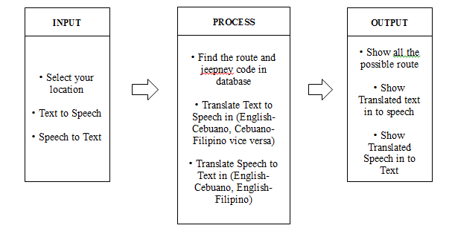

*Figure 5.* IPO of “Lakbay Cebu: Cebu Tourist Guide with Dialect Translator”

The figure illustrates the IPO of the proposed project where the first module requires the user to select location to find the route and jeepney code. Once the required action is done, the user can view the entire possible route. In the second module, the user can select text to speech to translate English to Cebuano, Cebuano to Filipino vice versa. After the selection, user will have the speech as the result of translated text. In the last module, the user can select speech to text that translates English to Cebuano, Cebuano to Filipino. Afterwards, the user speech is translated in to text.

**Development**

This part will tackle the interaction of user and the application by using the use case diagram that will show everything what happens inside the system.

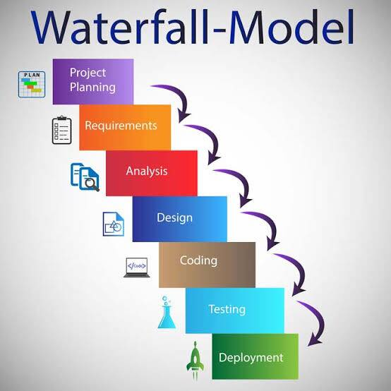**Development Process.**

*Figure 6.* Development Process Diagram of the Proposed Project “Lakbay Cebu: Cebu Tourist Guide with Dialect Translator”

The figure illustrates the development process of Lakbay Cebu. The proponents

**Project Planning** - This is where all the brainstorming begins, members decide on what will be the project, what is the name, the profit after its deployment and the pros and cons.

**Requirements** - Is where the members define what are the requirements of the system that will be produced.

**Analysis** - the process of breaking a complex topic or substance into smaller parts in order to gain a better understanding of it.

**Design** - Is where the designing of the User Interface/User Experience takes place

**Coding** - Is where all the modules are coded and programmed logically, this is where the main functions of the system is produced.

**Testing** - testing is where the system is produced and is ready for debugging, and patching takes place, also the end users will provide a feedback and the recommendations will be done before the system is deployed.

**Deployment** - it is where the system is ready for public use, the development never stops because of the rapid changes in technology. The developers will still provide support and will continue to receive feedback and recommendations.

**Hardware Requirements.**

In developing the mobile application, we used laptops that will be able to run the software indicated in software requirements. The laptop must have a 2.53 GHz processor

and at least 8 GB RAM for the development of the system to go smoothly and prevent hardware requirements problems that might delay the development of the mobile application. And mobile phones for testing the application.

**Risk assessment/analysis.** Risk assessment analysis is the review of all the possible risks associated with a particular event or action that might occur as the software was being developed. It is applied to most forms of study or any action where risks are present and may be analyzed on a quantitative and qualitative basis.

Software and hardware specifications limit is one factor that affects the development of the software. The software includes a database, thus, there is a need for a sufficient amount of storage space. The developers therefore made use of cloud computing

**Design**

This part showcases the design of the software, providing screenshots of the software’s interface and functions.

**Output and user-interface design.** This section provided screenshots of the software’s user interface and the different outputs of the functions or features it has.

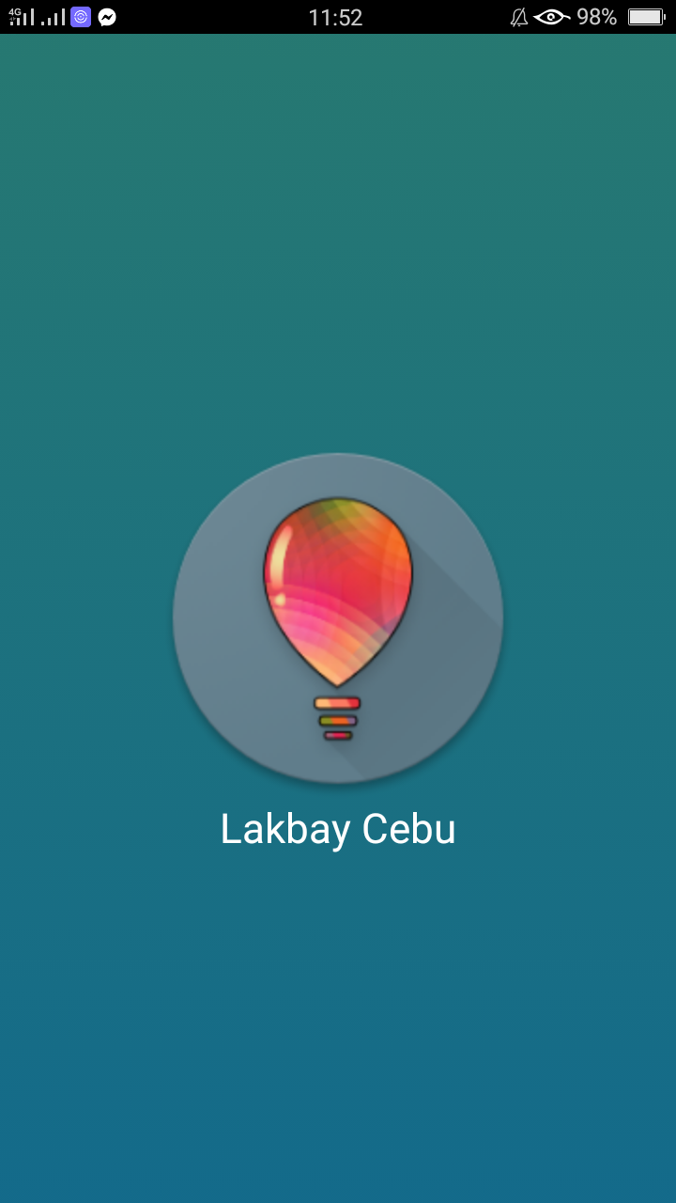

*Figure 7. Splash Screen*

The figure shows the user interface of the loading page after the application is being selected.

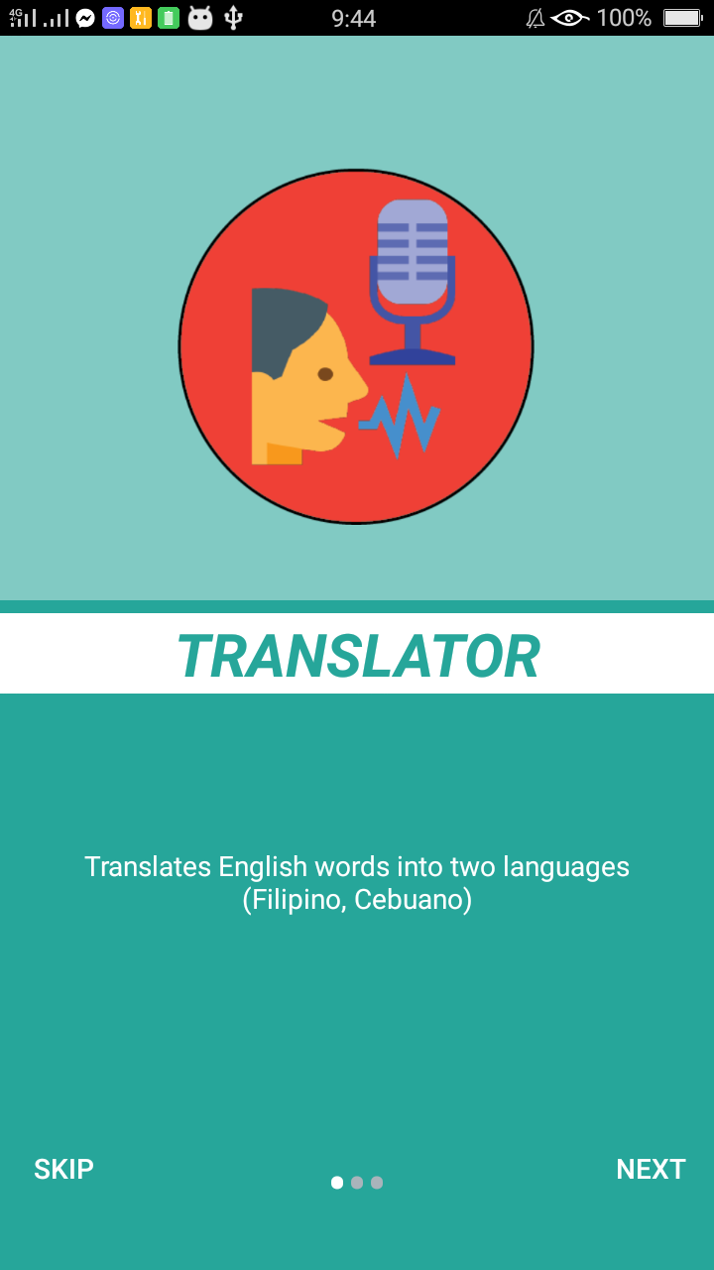

*Figure 8. On boarding Screen*

The figure shows the user interface of the on boarding page where the user can view the introduction of the application: translator that translates English into Cebuano or Tagalog.

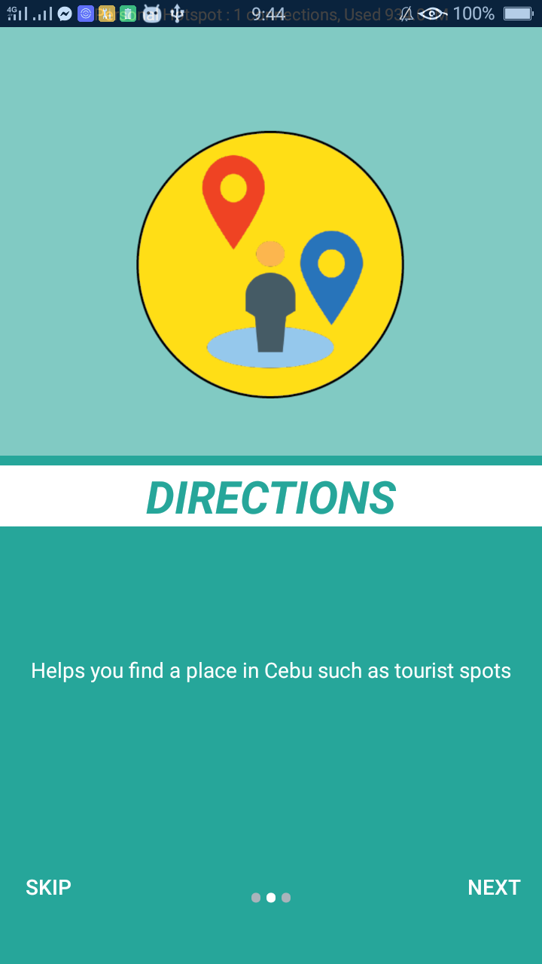

*Figure 9. On boarding Screen*

The figure shows the user interface of the on boarding page where the user can view the introduction of the application: Directions that will guide the user by travelling into their destination.

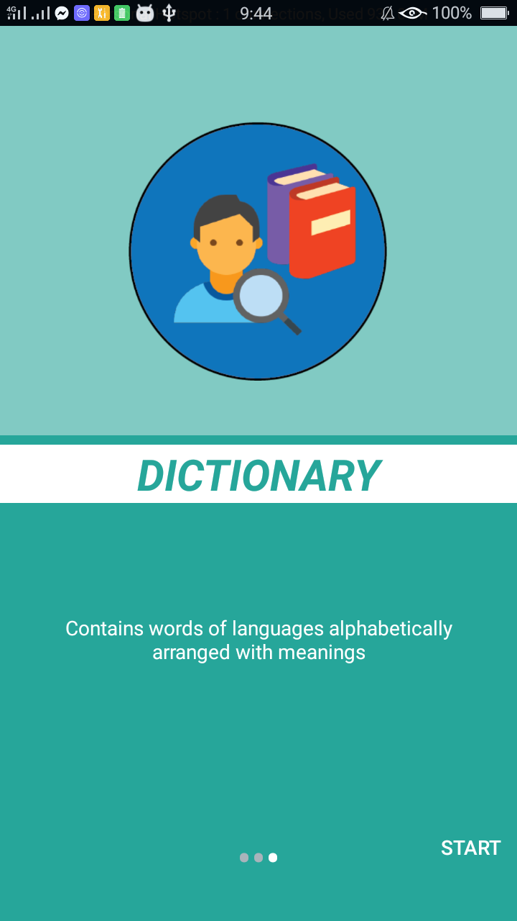

*Figure 10. On boarding Screen*

The figure shows the user interface of the on boarding page where the user can view the introduction of the application: dictionary that specifically made for Cebuano dialect to help the tourists.

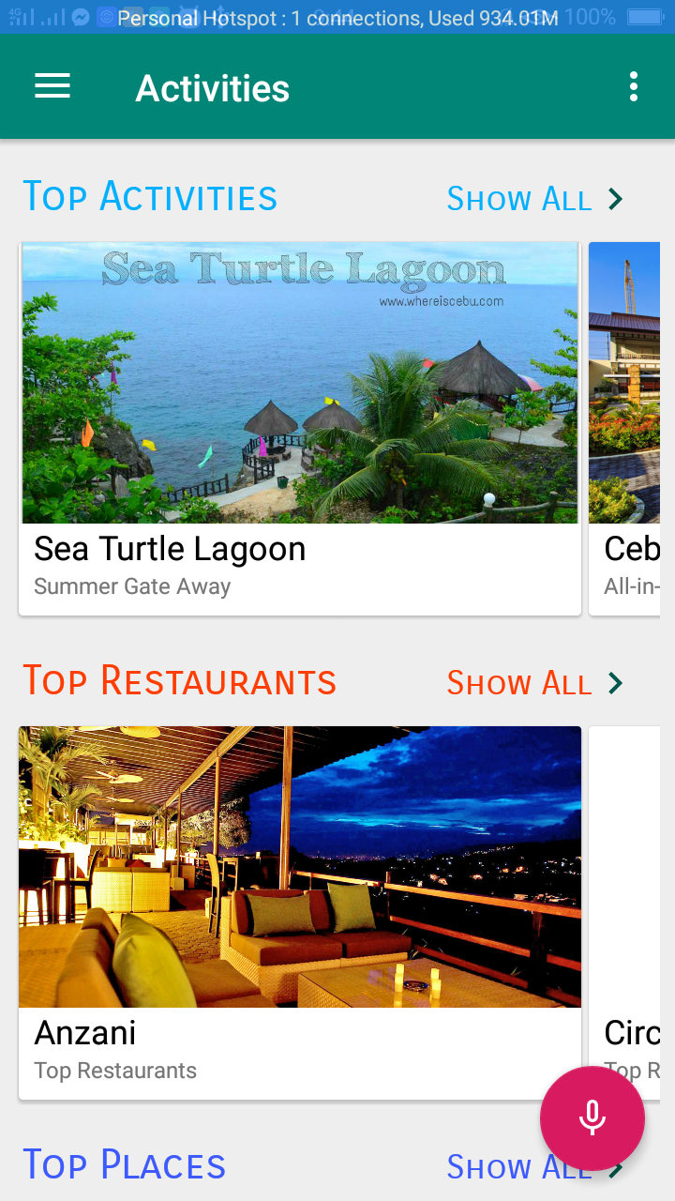

*Figure 11. Home Screen*

The figure shows the user interface of the home page where the user can view all the top and recommended places in Cebu City with the detailed information and a google map feature to help the user find the place immediately.

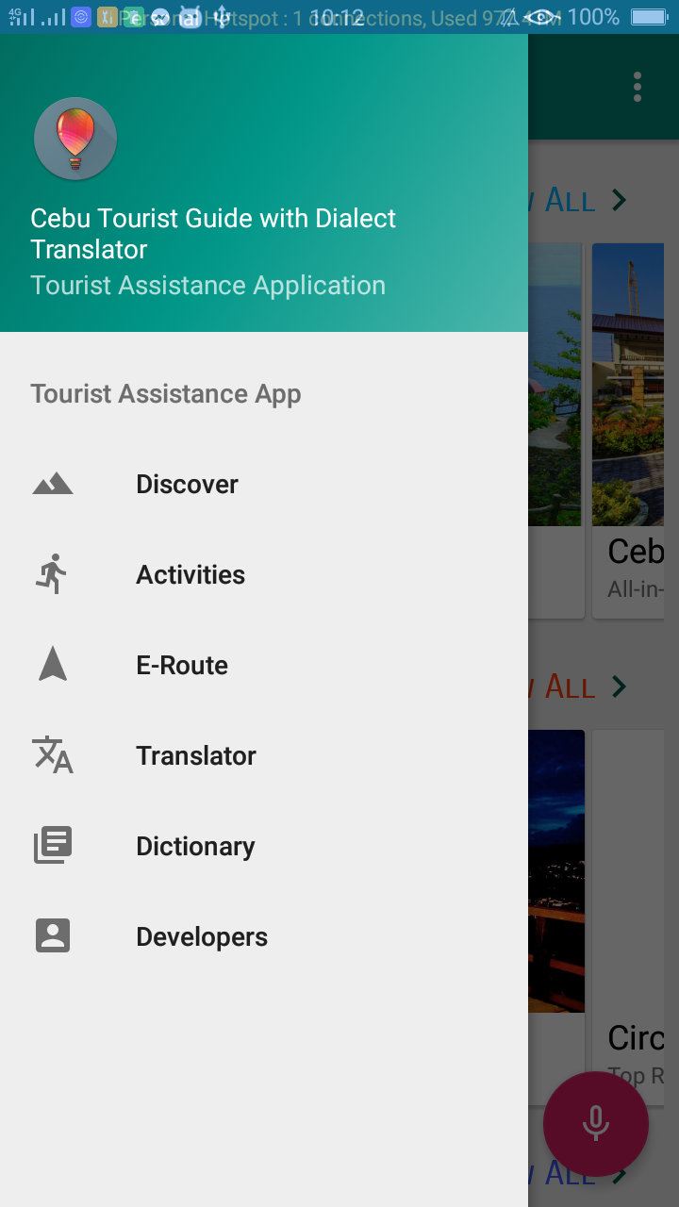

*Figure 12.Menu Screen*

The figure shows the user interface of the on menu page where the user can navigate which feature is needed.

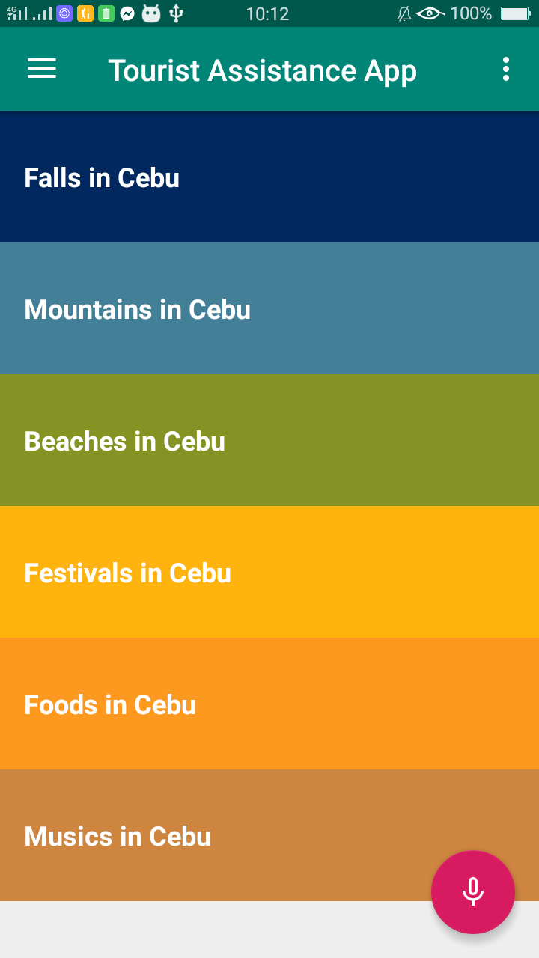

*Figure 13. Activity Module Screen*

The figure shows the user interface of the on activities page where the user can view all the tourist spots located in Cebu City including the important information and a suggested link to view all the details regarding on a certain spot.

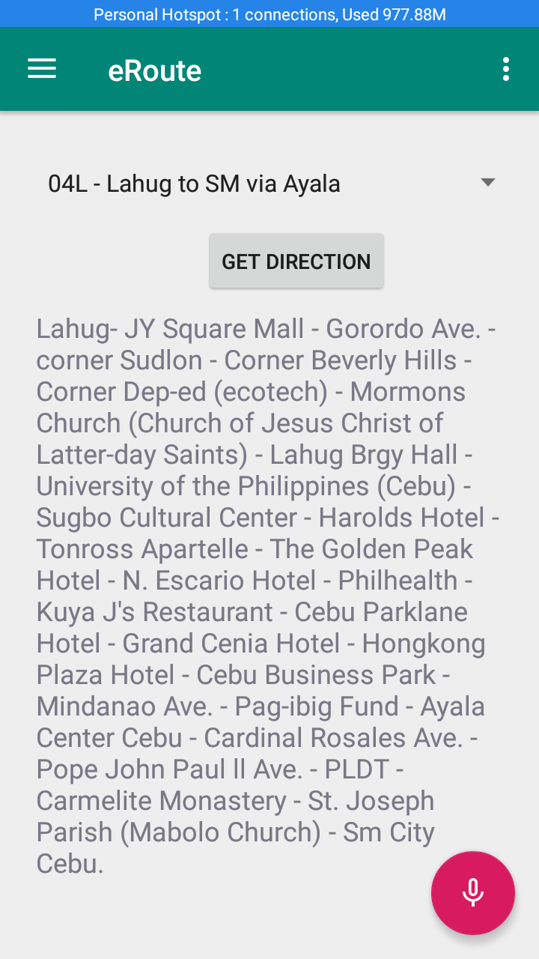

*Figure 14. E-Route Module Screen*

The figure shows the user interface of the on E-Route page where the user can select a destination and a get direction button will be selected to see the PUJ route.

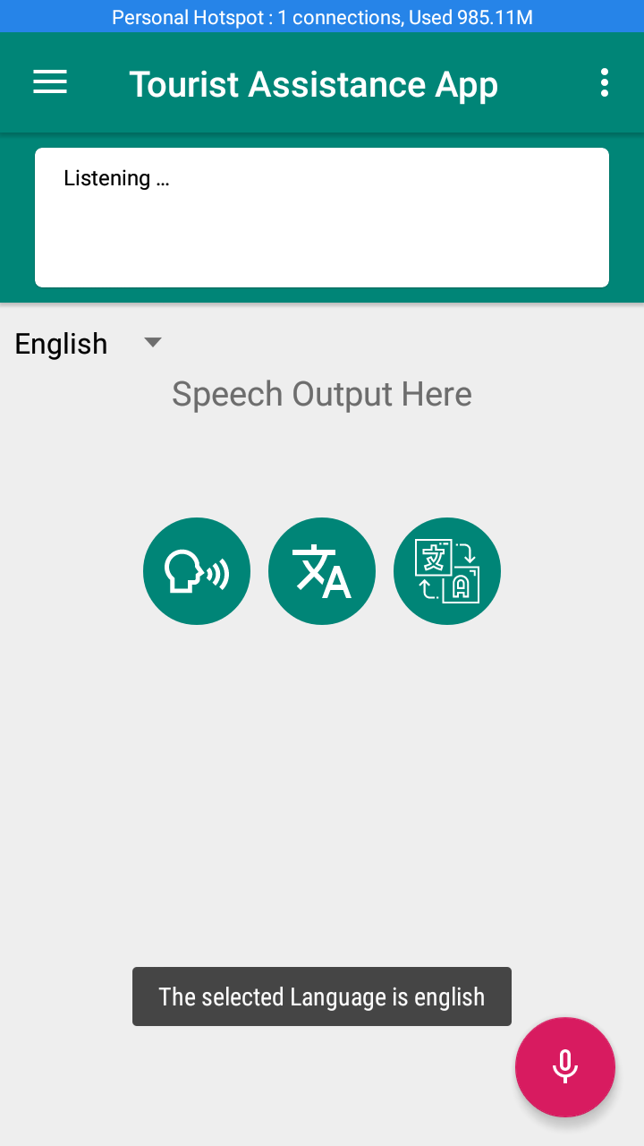

*Figure 15. Translator Module Screen*

The figure shows the user interface of the translator page where the user will be able to translate speech to text, text to speech with English to Visayan, Tagalog.

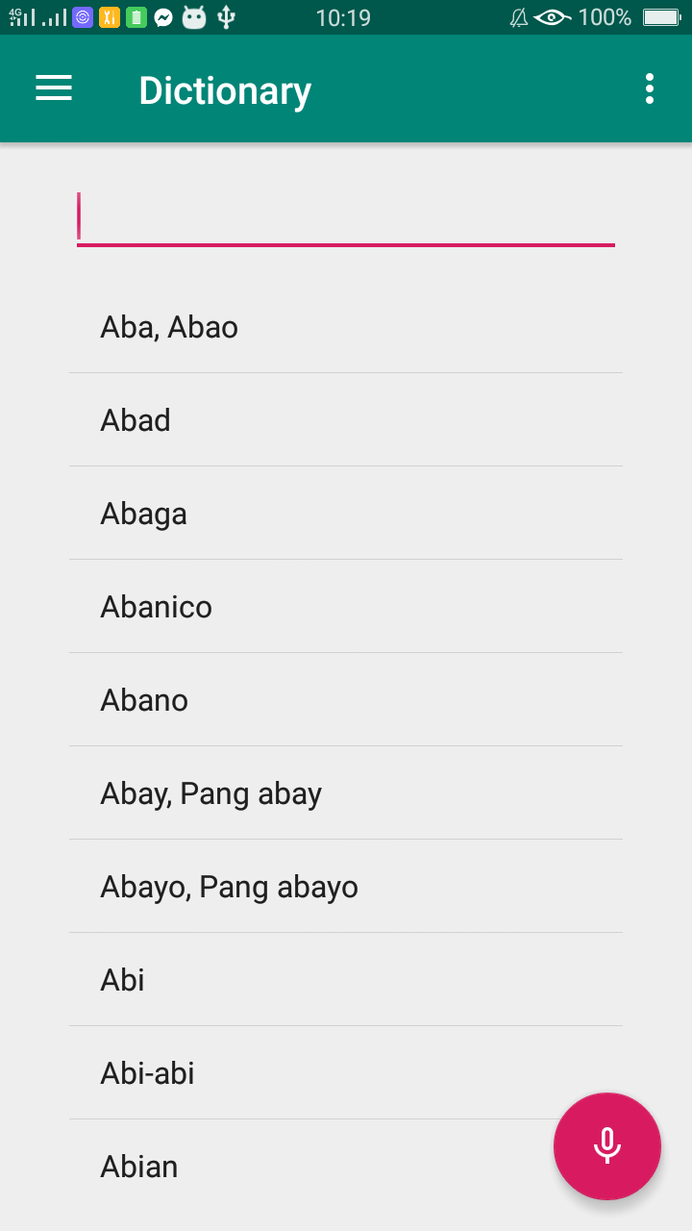

*Figure 16. Dictionary Module Screen*

The figure shows the user interface of the dictionary page where the user can search and find meaning with Cebuano dialect into English.

**Data design.** The information domain model developed during analysis phase is transformed into data structures needed for implementing the software. The data objects, attributes, and relationships depicted in entity relationship diagrams and the information stored in data dictionary provide a base for data design activity.

**System architecture.** The system architecture diagram enables you to graphically model the applications of a system, and the externals that they interface with and data stores that they use or provide information to.

***Security.*** This is where the provided sufficient security for user accounts is shown.

**Development**

This section discusses the development of the project using software and hardware in order to have a successful study.

**Software specification.** The proponents developed the application using Android Studio as the integrated development environment. Android Studio Em was the Android emulator used to test their project within a safe, virtual environment. Prototyping was done in Adobe Experience Design, and the user interface was developed with Adobe Photoshop and Adobe Illustrator.

**Hardware specification.** The device used for the development of the software is a laptop with 8GB RAM, Intel Core i5-4300u with a graphics processing unit of AMD Radeon 8750M and a 500GB hard-drive. The application will work on Android Operating System (OS) ver. 5.0 or higher with at least 2GB of RAM.

**Program specification.** “Lakbay Cebu: Cebu Tourist Guide with Dialect Translator” is specified for promoting tourism and providing assistance for tourists in Cebu City. After the application being selected, users are prompted to a splash screen where the logo and title are displayed. An on-boarding page is also showed as an overview to what the application offers. The Home page is where the top recommended places are featured. An application side menu bar is provided for the users to use for navigating between screens. The categories of activities in Cebu City are listed. The E-Route section provides location and destination route for users. A feature where in users can translate dialect through speech-to-text and text-to-speech usage. Furthermore, a dictionary is provided for users to find meaning that focuses on Cebu City dialect.

**Programming environment.** This section discusses the software used in developing the project.

***Front end.*** Adobe Photoshop and Adobe Illustrator are used for the development of the graphical user interface.

***Back end.*** Android Studio is the integrated development environment (IDE) used in building and developing the application, utilizing Java as the programming language. Firebase Database Query is used for the web-based database.

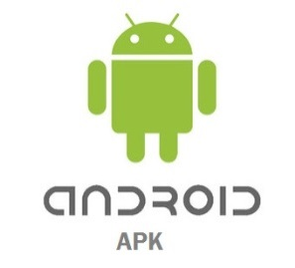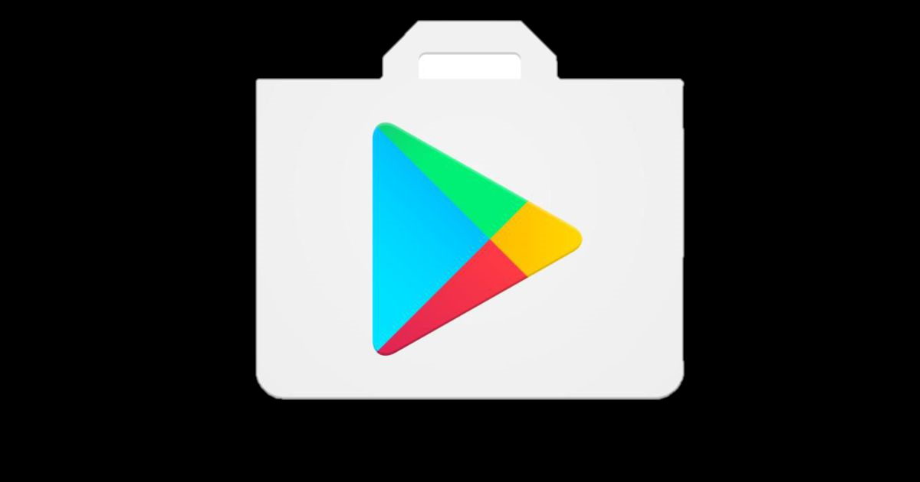

IDE

Android Application

Package

Google Play

Lakbay Cebu Application

End-user



*Figure 17.* Deployment Diagram of “Lakbay Cebu: Cebu Tourist Guide with Dialect Translator”

Specification lays out functional and non-functional requirements, and it may include a set of use cases that describe user interactions that the software must provide.

Table 2

*Software Requirements*

|  |  |
| --- | --- |
| **Software** | **Description** |
| Related image | Android Studio – This software is used for coding and building the application |
| Image result for google cloud platform | Google Cloud Platform – This platform is to use its services such as API, cloud computing services etc. |

**Test Plan**

This section discusses the analysis of testing the application to identify and try to find the errors in the application and able to address it for improvement of the overall quality of the software application. This section also includes breakdowns of the step by step procedures of testing conducted by the developers to identify the acceptability of the project. This section determines whether the application is prepared for future use. Testing the application if it is running correctly and buttons are functioning properly.

**Test data.** Compatibility, Conformance, and Functional Testing are used for Lakbay Cebu. Compatibility testing ensures that the application is compatible with various Android versions and screen sizes. Conformance testing is based on the standards of the Android Core App Quality Guidelines: visual design and user interaction; functionality; compatibility, performance and stability; and adherence of the application through Google Play. Functional testing ensures that the application has all the required functionality that is specified within its functional requirements.

**Verification, validation and testing.** This is the method of evaluating the conditions imposed at the start and the specification requirements for the application. The

researchers conducted testing to determine whether the application meets its objectives and functions to target users.

***Conformance testing.*** The researchers used conformance testing to verify the efficiency of the application based on the standards of the Android Core App Quality Guidelines. This determines whether the application meets the standard for visual design and user interactions, functionality, performance and stability, and readiness to be published on Google Play.

***Compatibility testing.*** The compatibility testing was used by the researchers to ensure compatibility of the application with different Android versions. Testers ran the application in Android smart phones with versions 5.0 (Lollipop), 6.0 (Marshmallow), 7.0 (Nougat), and 8.0 (Oreo). The screen resolution and screen sizes were also tested by installing the application in devices of different sizes.

***Functionality testing.*** Functional testing was used by the proponents to identify whether the application has met all the required functionality that is specified within its functional requirements.

**Test conditions.** The activities listed below were executed on the application. Tests were performed on the developed application to verify whether it is functioning well and meets its expected outcome.

1. Run the application and test to see if the functions are performing properly.
2. Validate whether all the mandatory fields are working as required.
3. Validate whether each button is working according to its corresponding function.
4. Verify whether navigations are working properly.
5. Test the visual design and user interaction of the application.
6. Test the compatibility, performance, and stability of the application.
7. Determine whether the application is qualified to be uploaded on Google Play.
8. Verify whether the application is compatible with Android OS 5.0 Lollipop up to 8.0 Oreo.
9. Verify whether the application display is suitable across different screen resolutions.

Preliminary testing was done in accordance to the test case scenarios for orderly testing. The proponents examined expected result to see whether the output was accomplished.

For the final testing of the system, the researchers accomplished the following activities:

* 1. Conformance testing for the test case scenario of the application testing.
  2. Compatibility testing for the assurance of the compatibility of the application in Android platforms.
  3. Functional testing for the affirmation of appropriate application functionality.

**Test criteria.** This section discussed the standards against which test procedures and outcomes were compared.

Test Case Objectives for Conformance Testing:

1. To check if the application conforms to the Android core app quality guidelines
2. To ensure that the visual design and interaction patterns of the application adhere to the Android standards and are appropriate for the users
3. To ensure that the application provides expected functional behavior for the user’s convenience
4. To guarantee that the application provides the performance, stability and responsiveness expected by users
5. To ensure that the application is ready to be deployed on Google Play

Test Case Objectives for Compatibility Testing:

1. To check the performance and stability of the application in various Android versions
2. To check the visual quality of the application across different screen resolutions

**Evaluation Plan**

This section discussed the developers’ plans for the evaluation of the application to ensure that the evaluation is made possible. The developers sought out for testers to evaluate the software to determine whether it is suitable for use by means of evaluation instrument based on Mobile Application Rating Scale (MARS). The testers are ten (20) IT Experts, and thirty (30) Cebuano Android users.

**Evaluation data.** The developers used different smartphones with different Android versions during the evaluation period and used provided evaluation sheet from the research adviser to ensure its standard based on the criteria of Mobile Application Rating Scale. The participating evaluation respondents were ten (20) IT Experts, and thirty (30) Cebuano Android users.

1. Engagement
2. Entertainment
3. Interest
4. Customization
5. Interactivity
6. Target Group
7. Functionality
8. Performance
9. Ease of Use
10. Navigation
11. Gestural Design

3. Aesthetics

a. Layout

b. Graphics

c. Visual Appeal

4. Information

a. Accuracy of App Description (in Play Store)

b. Goals

c. Quality of Information

d. Quantity of Information

e. Visual Information

**Statistical treatment of data.** The gathered data were presented and calculated using statistical computations. The mean and the standard deviation were computed. These are the formulas that were used to compute the result:

Weighted Mean

The formula is:

X = Σ

Where X = Weighted mean

Σ means “summation of”

X = Score proper weight

N = total number of respondents

The formula is to compute the weighted mean of the scores given by the users and IT personnel. X is weighted mean, Σ represents the summation of the total of, X represents as score proper weight from the survey. N represents as the total number of respondents. To get the weighted mean, the formula is total score divided by total number of respondents.

Standard Deviation

The formula is:

S = **√**Σ(x – x) ²

N

Where the S = the standard deviation

Σ means “summation of”

X = each value in the data set.

X = mean of all values in data set

N = number of all values in data set

The formula is to compute the standard deviation of the scores given by the users and IT personnel. S is the Standard deviation, Σ represents as the summation of the total of, X represents the value of each data set. X represents of all the values in data set, N represents as number of all values in data set. To get the standard deviation, the summation of the value of data set subtracted to all values in data set raised to 2, the answer will be divided by the number of all the values in data set and get its square root.

**Likert Scale.** The researchers used Likert scale that is commonly involved in research that employs questionnaires. It used fixed choice response formats and are designed to measure attitudes or opinions.

Table 3

*Likert Scale*

|  |  |
| --- | --- |
| **LIKERT SCALE** | |
| **Range** | **Interpretation** |
| 4.75– 6.00 | Excellent |
| 3.26 – 4.00 | Good |
| 2.51 – 3.25 | Average |
| 1.76 – 2.50 | Fair |
| 1.00 – 1.75 | Poor |

Table 1 displays the basis of scores during the survey. If the score ranges 4.75 up to 6.00 it is “Excellent”, if it is 3.26 up to 4.00 it is “Good”, if it is 2.51 up to 3.25 it is “Average”, if the score is ranging from 1.76 to 2.50 it is “Fair”. The lowest score is 1.00 up to 1.75 which equivalents to “Poor”.

**Evaluation procedure.** The evaluation procedure discussed the step by step actual evaluation. Here are the procedures during the actual evaluation:

1. Survey questionnaire was prepared for the evaluation of the system.

2. The evaluators were invited to participate in the application evaluation.

3. The questionnaires are distributed to a group of people consisting of ten (20) IT Experts, and thirty (30) Cebuano Android users.

4. The Android device was also presented to run the application.

5. The developers explained the concept of the application.

6. The evaluators test the functionalities of the application.

7. Each part of the application was evaluated accordingly.

8. The evaluation sheets were collected.

**Evaluation criteria.** The evaluation criteria are accomplished to specify the modules of the application. The criteria are as follows: Engagement, which has the following sub-criteria: entertainment, interest, customization, interactivity and target group; Functionality, which has performance, ease of use, navigation, and gestural design as sub-criteria; Aesthetics, which has layout, graphics, and visual appeal as sub-criteria; and lastly, Information, which has the following sub-criteria: accuracy of app description (in App Store), goals, quality of information, quantity of information, and visual information. The criteria and sub-criteria for mobile application is based on the Mobile Application Rating Scale.

Table 4

*Scoring System of the Evaluation*

|  |  |
| --- | --- |
| **Numerical Rating** | **Equivalent** |
| 5 | Excellent |
| 4 | Good |
| 3 | Average |
| 2 | Fair |
| 1 | Poor |

The scoring system of the evaluation is shown in Table 5. If the score is 5, it is equivalent to “Excellent”; if it is 4, it is equivalent to “Good”; if it is 3, it is equivalent to “Average”, if it is 2, it is equivalent to “Fair” and if it is 1, it is “Poor”.

**Test and Evaluation Results**

This section discusses the overview of the test results conducted by the developers using Compatibility Testing, Conformance Testing and Functionality Testing as the test case instruments and for evaluation quality based on the criteria for mobile application using Mobile Application Rating Scale (MARS).

**Test result.** The application went through a series of tests. The testing instruments are the Compatibility Test, Conformance Test and Functionality test and analyzed by the end-users, developers’ technical adviser and other capstone project team. Below is the overview of data gathered in conducting the system test.

Table 5

*Summarized Test Results IT Experts for Functionality, Content, and Design.*

|  |  |  |  |  |
| --- | --- | --- | --- | --- |
| **Testing** | **Pass** | **Fail** | **Total number of Test Condition/ Test Criteria** | **Percentage** |
| Functionality | 20 | 0 | 20 | 100% |
| Content | 19 | 1 | 20 | 95% |
| Design | 19 | 1 | 20 | 95% |

*Summarized Test Results End-user for Functionality, Content, and Design*

|  |  |  |  |  |
| --- | --- | --- | --- | --- |
| **Testing** | **Pass** | **Fail** | **Total number of Test Condition/ Test Criteria** | **Percentage** |
| Functionality | 30 | 0 | 30 | 100% |
| Content | 29 | 1 | 30 | 96.66% |
| Design | 29 | 1 | 30 | 96.66% |

The summarized results of the tests assessed by the other capstone team and the technical adviser for Lakbay Cebu: Cebu Tourist Guide with Dialect Translator is displayed in Table 6.

For the compatibility testing, the developers tested the application in different mobile devices with different Android Operating System versions and screen resolutions. The developers got 14 over 14 having a passing percentage of 100. The application runs smoothly in Android OS versions 5.0 Marshmallow up to 8.0 Oreo and different screen sizes.

In conformance testing, the developers used the Android Core App Quality Guidelines. The application conforms on most of the criteria for the conformance testing except the test criteria under Google Play for the reason that the application was not yet deployed on Google Play during testing. The developers got 40 pass over 48 having a

percentage of 83.33. Failure was resolved by uploading the mobile application in the Google Play store.

In Functional testing, the developers got 40 out of 40 with a percentage of 100. Functional testing conforms to its specifications including the menu functions and core application functions. The menu functions and core applications works accordingly.

Table 6

*Summarized Test Results from IT Experts for Discovery Module, Activity Module, E-Route Module, Translation Module and Dictionary Module*

|  |  |  |  |  |
| --- | --- | --- | --- | --- |
| **Testing** | **Pass** | **Fail** | **Total number of Test Condition/ Test Criteria** | **Percentage** |
| Discovery Module | 20 | 0 | 20 | 100% |
| Activity Module | 20 | 0 | 20 | 100% |
| E-Route Module | 19 | 1 | 20 | 95% |
| Translation Module | 18 | 2 | 20 | 90% |
| Dictionary Module | 20 | 0 | 20 | 100% |

*Summarized Test Results from End-user for Discovery Module, Activity Module, E-Route Module, Translation Module and Dictionary Module*

|  |  |  |  |  |
| --- | --- | --- | --- | --- |
| **Testing** | **Pass** | **Fail** | **Total number of Test Condition/ Test Criteria** | **Percentage** |
| Discovery Module | 30 | 0 | 30 | 100% |
| Activity Module | 30 | 0 | 30 | 100% |
| E-Route Module | 29 | 1 | 30 | 96.66% |
| Translation Module | 28 | 2 | 30 | 93.33% |
| Dictionary Module | 30 | 0 | 30 | 100% |

**Evaluation result.** The researchers implemented the Mobile Application Rating Scale criteria in evaluating the application. An evaluation instrument was created and

validated by the research adviser. The following are the results of the evaluation conducted with twenty (20) IT Experts, and thirty (30) Cebuano Android users.

Table 7

*Evaluation Results from IT Experts*

|  |  |  |  |  |
| --- | --- | --- | --- | --- |
| **Level of System Acceptability** | **Mean** | **Standard Deviation** | **Interpretation** | **Rank** |
| Engagement | 3.83 | 0.66 | Good | 4 |
| Functionality | 3.31 | 0.37 | Good | 4 |
| Aesthetics | 2.51 | 0.36 | Average | 3 |
| Information | 5.7 | 0.57 | Excellent | 5 |
| Average Mean and SD | 3.07 | 0.39 | Good | |

The evaluation results from twenty (20) IT Experts are shown on table 7. The Functionality criterion ranked the highest with a mean of 3.58 and a standard deviation of

0.04 which is considered “Highly Acceptable”. This means that the evaluators found that the application performs and functions well and qualifies the standards.

Being interpreted as “Highly Acceptable”, Aesthetics ranked second accumulating a mean of 3.53 and a standard deviation of 0.06, which means that the application has good visual appeal and appropriate graphical user interface.

Ranking third is the Engagement criterion with a mean of 3.46 and a standard deviation of 0.15, indicating that the IT experts considered it “Highly Acceptable” for the application to be interesting to use while being content-appropriate for the users.

On the fourth rank is the Information criterion, with a mean of 3.36 and a standard deviation of 0.05, which is still considered “Highly Acceptable”. The evaluators found the application’s content to be correct, well written, and relevant.

Table 8

*Evaluation Results from End-users*

|  |  |  |  |  |
| --- | --- | --- | --- | --- |
| **Level of System Acceptability** | **Mean** | **Standard Deviation** | **Interpretation** | **Rank** |
| Engagement | 4.23 | 0.76 | Good | 4 |
| Functionality | 3.57 | 0.41 | Good | 4 |
| Aesthetics | 2.64 | 0.3 | Average | 3 |
| Information | 6.17 | 0.70 | Excellent | 5 |
| Average Mean and SD | 3.32 | 0.43 | Good | |

The results of the evaluation conducted with thirty (30) end-users are shown on table 8.

The Functionality criterion ranked the highest with a mean of 3.82 and a standard deviation of 0.11 which is considered “Highly Acceptable”. This means that the evaluators found the application to be performing and functioning well.

On the second rank is the Information criterion, with a mean of 3.73 and a standard deviation of 0.08, which is considered “Highly Acceptable”. The evaluators found the application’s content to be correct, well written, and relevant.

Being interpreted as “Highly Acceptable”, Aesthetics ranked third accumulating a mean of 3.70 and a standard deviation of 0.09, which means that the application has good visual appeal and appropriate graphical user interface.

Ranking fourth is the Engagement criterion with a mean of 3.68 and a standard deviation of 0.09, indicating that end-users considered it “Highly Acceptable” for the application to be interesting to use while being content-appropriate for the users.

Table 9

*Overall Summary of Evaluation by Criteria*

|  |  |  |  |  |
| --- | --- | --- | --- | --- |
| **Level of System Acceptability** | **Mean** | **Standard Deviation** | **Interpretation** | **Rank** |
| Engagement | 4.07 | 0.72 | Good | 4 |
| Functionality | 3.46 | 0.41 | Good | 4 |
| Aesthetics | 2.59 | 0.33 | Average | 3 |
| Information | 5.98 | 0.69 | Excellent | 5 |
| Average Mean and SD | 3.22 | 0.43 | Good | |

The overall evaluation results conducted with forty-five (45) respondents, comprising of twenty (20) IT Experts and thirty (30) end-users, are shown on table 9.

Functionality, still ranking highest, accumulated a mean of 3.77 and a standard deviation of 0.09, being interpreted as “Highly Acceptable”. Majority of the respondents validated that the application performs and functions well and qualifies the standards.

Second in rank is Aesthetics, interpreted as “Highly Acceptable”, garnered a mean of 3.66 and a standard deviation of 0.06. Denoting that the application has good visual appeal and appropriate graphical user interface.

Information ranks third in the overall results, with the interpretation of “Highly Acceptable” as well, having a mean of 3.65 and a standard deviation of 0.06. This signifies that the application has correct, well written, and relevant content, however, it is still open for further improvements.

However interpreted as “Highly Acceptable”, Engagement is fourth in rank in the overall results. It has a mean of 3.63 and a standard deviation of 0.09. Majority of the respondents consider that the application must improve a little in the use of strategies to increase engagement through entertainment.

The overall mean and standard deviation are computed by adding all the gathered data of each set and dividing it to the number of respondents which totals to fifty (50): ten

(20) IT Experts and thirty (30) end-users. The overall or the average mean is 3.68 and its standard deviation is 0.08, which can be interpreted as “Highly Acceptable”.

**CHAPTER V**

**SUMMARY OF FINDINGS, CONCLUSIONS AND RECOMMENDATIONS**

This chapter will provide a summary of the purpose, methodology, and results of this study. Then, conclusions will be discussed based on researcher insights gained regarding study findings and limitations. In addition, two sets of recommendations are presented. The first set of recommendations is directed toward practitioners in the field, described in this study as program directors. Finally, a set of recommendations is presented for professionals interested in pursuing additional research to exceed the scope and findings of this study.

**Summary of Findings**

Based on the evaluation analysis of the project, the respondents gave their satisfaction and acceptance to the mobile application. The study has the following findings:

1. Engagement - obtaining an overall mean of 3.63 and a standard deviation of 0.09, with an interpretation of “Excellent”, majority of the respondents think that the

application must improve a little in the use of strategies to increase engagement through entertainment.

2. Functionality - The evaluators rated the application resulting to a mean of 3.77 and a standard deviation of 0.09, which means that the application performs well and is easy to use and interpreted as “Excellent”.

3. Aesthetics - The respondents evaluated the application bring about a mean of 3.66 and a standard deviation of 0.06. It is considered “Excellent” that the layout, graphics and visual appeal are good and appropriate, yet still open for improvements.

4. Information - Majority of the respondents rated good remarks in this criteria with a mean of 3.65 and a standard deviation of 0.06, once again being interpreted as “Excellent”. Indicating that the application has correct, well written, and relevant content.

**Conclusions**

The primary objective of the project, which is to develop Lakbay Cebu: Cebu Tourist Guide with Dialect Translator was accomplished. The users are able to create and log accounts into the application. Reset password e-mails are being sent to the user’s e-

mail upon request on the Reset Password screen. Users are able to save recipes into their accounts for personal use as well. Recipes can be browsed using either the Search or the Categories function. Provided cooking demonstration videos can be manipulated via short, precise speech commands. The software was developed using Android Studio as the IDE and Java as the programming language. The application was prototyped on Adobe Experience Design, and the user interface was developed with Adobe Photoshop and Syncfusion Metro Studio. The developers made use of Firebase for the application database.

The software was tested through functional testing, compatibility testing, and conformance testing. The data gathered was used to further improve the software. The evaluation was based on the standards given by the Mobile Application Rating Scale (MARS) to determine the acceptance level by using the following criteria: engagement, functionality, aesthetics, and information. Forty-five (45) respondents participated in the evaluation. The overall results garnered an average mean of 3.68 and a standard deviation

of 0.68, interpreted as ‘highly acceptable’. This meant that the software could be used not only by people who are enthusiastic in cooking, but also by those who are keen to learn to cook Filipino food. Furthermore, the application will be able to promote the richness and diversity of the Filipino cuisine.

**Recommendations**

During the evaluation, some respondents had left their suggestions and insights. The following are the recommendations made for the future enhancement of the project:

1. Improvements on the user interface.

2. Improvements on the content and media quality.

3. Adding more features mainly the e-route with gps navigation.

4. Improve the means of engagement.

**CHAPTER VI**

**IMPLEMENTATION PLAN**

This chapter describes how the information system will be deployed, installed and transitioned into an operational system. The plan contains an overview of the system, a brief description of the major tasks involved in the implementation, the overall resources needed to support the implementation effort and any site-specific implementation requirements.

**Project Implementation Checklist**

There are several factors to be considered before the application can be deployed to the user’s environment to ensure that the application will not meet inconvenience in the near future. These factors include the following:

First is preparing the software. Assessing the testing and evaluation results. Finalizing the system; fixing existing bugs, errors or crashes and preparing the documentation with user manual as a guide for the users.

The software’s minimum specifications or system requirements is also important, because it lets users identify if their machine is capable of running the software smoothly.

Minimum Requirements:

* Android OS version 5.0 (Lollipop)
* 2GB of RAM
* 500MB Storage Space
* Internet Access

**Implementation Contingency**

The implementation contingency explains how to handle unexpected errors that the client might encounter while using the application. The application may likely show general bugs and the application may slow down while loading the media content such as images and videos. To resolve these matters, the developers planned to do a scheduled maintenance of the application. In case the software does not run smoothly or the end-user encounter bugs, the developers will fix and update the application.

In the full implementation of the system, it is uploaded on Google Play Store where the users can download it for free. Google Play checks the application and ensures that there will be no viruses before releasing it to the store.

**Infrastructure/Deployment**

This part provided an illustration of the software’s infrastructure. Lakbay Cebu is a software that utilizes an online database to function. The Internet is also part of the requirement. Lakbay Cebu’ infrastructure revolves around Android Operating System versions 5.0 (Lollipop), 6.0) Marshmallow, 7.0 (Nougat) and 8.0 (Oreo). Lakbay Cebu is deployed on Google Play and is ready to use for free. End-users may install the application into Android mobile devices with the aforementioned OS versions.



User input

Response/

Executed command

Legend:

* User activity/Input
* Software response/Output

*Figure 17.* Infrastructure Diagram of “Lakbay Cebu: Cebu Tourist Guide with Dialect Translator”

The figure shown above illustrates the components of the software’s infrastructure upon implementation. User activities performed by the end-users are being returned by the application in response. Firebase is being used by the application on its back-end for its online database.

**REFERENCES**

John Daryl D. Arnado , Harrold B. Gogo and Ferdinand T. Abocejo (2017) “Public Utility Jeepneys (PUJs) in Cebu City, Central Philippines: Regulations and Implications to Traffic Congestion” (Retrieved from http://uruae.org/siteadmin/upload/UH0117829.pdf)

(Retrieved from <https://www.lonelyplanet.com/philippines/the-visayas/cebu>)

T. Tan, S. Goh and Y. Khaw (2012) *"A Malay Dialect Translation and Synthesis System: Proposal and Preliminary System,"* Asian Language Processing, International Conference on (IALP), Hanoi, Vietnam. (Retrieved from https://www.researchgate.net/publication/261242305_A_Malay_Dialect_Translation_and_Synthesis_System_Proposal_and_Preliminary_System)

Krasimir Angelov, Bjorn Bringert, Aarne Ranta (2011) *Speech-Enabled Hybrid Multilingual Translation for Mobile Devices.* (Retrieved from <http://www.aclweb.org/anthology/E14-2011>)

Vivek Hanumante, Rubi Debnath, Disha Bhattacharjee, Deepti Tripathi, Sahadev Roy (2014*) English Text to Multilingual Speech Translator Using Android*, International Journal of Inventive Engineering and Sciences (IJIES) (Retrieved from https://www.researchgate.net/profile/Sahadev_Roy/publication/268386322_English_Text_to_Multilingual_Speech_Translator_Using_Android/links/546d82310cf2193b94c58697.pdf)

Steven Bird, Florian R. Hanke, Oliver Adams, and Haejoong Lee (2014) *Aikuma: A Mobile App for Collaborative Language Documentation.* (Retrieved from <http://www.aclweb.org/anthology/W14-2201>)

KiBeom Kang, JeongWoo Jwa, SangDon Earl Park (2017) *Smart Audio Tour Guide System using TTS.* (Retrieved from http://www.ripublication.com/ijaer17/ijaerv12n20_81.pdf)

Khing Su Su Toe, May Zin (2014) *Android Mobile Phone based Syntactic Analysis System to Support English-Myanmar Translation for Tourists.* (Retrieved from http://ijsetr.com/uploads/612453IJSETR1183-472.pdf)

Qayyum Sayed , Bhagyesh Padate , Ashika Mistry , Jayshree Vanmali (2013) *Android Travel Mate Application using Real Time OCR.* (Retrieved from http://www.iarjset.com/upload/2016/november-16/IARJSET%2013.pdf)

M.U.E.Wijesuriya1, S.U.Mendis, B.E.S.Bandara, K.P.Mahawattage, N.Walgampaya, D. De Silva (2013*) Interactive Mobile Based Tour Guide*, Faculty of Computing, Sri Lanka Institute of Information Technology (SLIIT), Malabe, Sri Lanka. (Retrieved from https://www.researchgate.net/publication/282149767_INTERACTIVE_MOBILE_BASED_TOUR_GUIDE)

Lalita R. Pawar, Sarvesh S. Patwardhan (2015) *Problems & Suggestions for Android City Tour Guide System Based on Web Services for Mumbai*, International Journal of Advanced Research in Computer Engineering & Technology (IJARCET) (Retrieved from http://ijarcet.org/wp-content/uploads/IJARCET-VOL-4-ISSUE-6-2668-2672.pdf)

Li Liu, Yanfang Jing (2012) *Android city tour guide system based on Web service*, 2012 20th Telecommunications Forum (TELFOR) (Retrieved from https://ieeexplore.ieee.org/abstract/document/6201621/citations#citations)

Vladimir Mladenovic, Maja M. Lutovac, Miroslav D. Lutovac (2012) *Electronic tour guide for Android mobile platform with multimedia travel book* 2012 20th Telecommunications Forum (TELFOR) (Retrieved from https://ieeexplore.ieee.org/document/6419494/authors#authors)

Ivan K. W. Lai (2013) *Traveler Acceptance of an App-Based Mobile Tour Guide*, Macau University of Science and Technology (Retrieved from https://journals.sagepub.com/doi/abs/10.1177/1096348013491596)

Jonathan MacDougall, Girma S. Tewolde (2013) *Tour guide robot using wireless based localization* IEEE International Conference on Electro-Information Technology , EIT 2013 (Retrieved from <https://ieeexplore.ieee.org/abstract/document/6632690>)

Sheng-Yuan Yang, Chun-Liang Hsu (2016) *A location-based services and Google maps-based information master system for tour guiding* Computers & Electrical Engineering

Volume 54, August 2016, Pages 87-105 (Retrieved from https://www.sciencedirect.com/science/article/pii/S0045790615004115)

Shiga Yoshinori, Kawai Hishashi (2012) *Multilingual Speech Synthesis System* Journal of the National Institute of Information and Communications Technology Vol. 59 Nos. 3/4 2012 (Retrieved from http://www.nict.go.jp/publication/shuppan/kihou-journal/journalvol59-3_4/journal-vol59no3_4-0303.pdf)

David Katan (2012) *Translating the tourist gaze: from heritage and ‘culture’ to actual encounter* PASOS. Revista de Turismo y Patrimonio Cultural, 10(4). Special Issue. 2012 (Retrieved from http://www.pasosonline.org/Publicados/10412special/PS0412_09.pdf)

**APPENDIX**