NAME:V.SIDDARDHA
REG NO:192312075
COURSE:ITA0609-MACHINE LEARNING
CODING CHALLENGES
CO4-AT1

import math

# -----------------------------------------
# Training Dataset
# -----------------------------------------
# [Weight, Sweetness, Class]

dataset = [
[150, 5, "Apple"],
[160, 6, "Apple"],
[170, 5, "Apple"],
[180, 6, "Apple"],

[250, 8, "Mango"],
[270, 9, "Mango"],
[280, 8, "Mango"],
[300, 9, "Mango"],

[130, 4, "Orange"],
[140, 5, "Orange"],
[150, 4, "Orange"],
[160, 5, "Orange"]
]

# -----------------------------------------
# Euclidean Distance
# -----------------------------------------
def euclidean_distance(point1, point2):

distance = 0

for i in range(len(point1)):
distance = distance + (point1[i] - point2[i]) ** 2

return math.sqrt(distance)

# -----------------------------------------
# KNN Prediction
# -----------------------------------------
def knn_predict(dataset, test_point, k):

distances = []

# Calculate distance from test point
# to every training point
for row in dataset:

features = row[:-1]
label = row[-1]

distance = euclidean_distance(
features,
test_point
)

distances.append((distance, label))

# Sort according to distance
distances.sort(key=lambda x: x[0])

# Select K nearest neighbours
nearest_neighbors = distances[:k]

# Count classes
class_count = {}

for distance, label in nearest_neighbors:

if label in class_count:
class_count[label] += 1
else:
class_count[label] = 1

# Find class with maximum votes
predicted_class = max(
class_count,
key=class_count.get
)

return predicted_class

# -----------------------------------------
# Get K from User
# -----------------------------------------
k = int(input("Enter the value of K: "))

if k <= 0 or k > len(dataset):

print("Invalid value of K!")

else:

# -------------------------------------
# Test Dataset
# -------------------------------------

test_data = [
[165, 6],
[275, 9],
[145, 4],
[290, 8]
]

# Actual labels
actual_labels = [
"Apple",
"Mango",
"Orange",
"Mango"
]

predicted_labels = []

# -------------------------------------
# Prediction
# -------------------------------------

print("\nKNN Classification Results")
print("--------------------------------")

for i in range(len(test_data)):

prediction = knn_predict(
dataset,
test_data[i],
k
)

predicted_labels.append(prediction)

print("Test Instance:", test_data[i])
print("Predicted Class:", prediction)
print("Actual Class:", actual_labels[i])
print()

# -------------------------------------
# Calculate Accuracy
# -------------------------------------

correct = 0

for i in range(len(actual_labels)):

if predicted_labels[i] == actual_labels[i]:
correct += 1

accuracy = (correct / len(actual_labels)) * 100

print("--------------------------------")
print("Accuracy:", accuracy, "%")
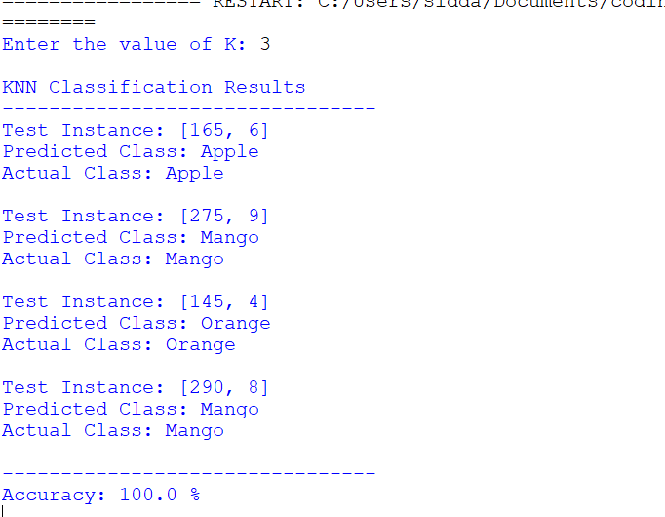

2. import math

# -----------------------------------------
# Dataset
# -----------------------------------------
# [Years of Experience, Performance Score]
X = [
[1, 50],
[2, 55],
[2, 60],
[3, 65],
[4, 70],
[4, 75],
[5, 80],
[6, 85],
[7, 90],
[8, 95]
]

# 0 = Not Promoted
# 1 = Promoted
y = [0, 0, 0, 0, 1, 1, 1, 1, 1, 1]

# -----------------------------------------
# Sigmoid Function
# -----------------------------------------
def sigmoid(z):
return 1 / (1 + math.exp(-z))

# -----------------------------------------
# Logistic Regression using Gradient Descent
# -----------------------------------------
def train_model(X, y, learning_rate, epochs):

w1 = 0
w2 = 0
bias = 0

n = len(X)

for epoch in range(epochs):

dw1 = 0
dw2 = 0
db = 0

for i in range(n):

# Linear equation
z = w1 * X[i][0] + w2 * X[i][1] + bias

# Sigmoid output
prediction = sigmoid(z)

# Error
error = prediction - y[i]

# Gradients
dw1 += error * X[i][0]
dw2 += error * X[i][1]
db += error

# Average gradients
dw1 = dw1 / n
dw2 = dw2 / n
db = db / n

# Update weights
w1 = w1 - learning_rate * dw1
w2 = w2 - learning_rate * dw2
bias = bias - learning_rate * db

return w1, w2, bias

# -----------------------------------------
# User Input
# -----------------------------------------
learning_rate = float(input("Enter learning rate: "))
epochs = int(input("Enter number of epochs: "))

# Train the model
w1, w2, bias = train_model(
X, y, learning_rate, epochs
)

# -----------------------------------------
# Test Data
# -----------------------------------------
test_data = [
[3, 62],
[5, 72],
[6, 88],
[2, 58]
]

actual_labels = [0, 1, 1, 0]

# -----------------------------------------
# Prediction
# -----------------------------------------
predicted_labels = []

print("\nPrediction Results")
print("-----------------------------")

for i in range(len(test_data)):

years = test_data[i][0]
performance = test_data[i][1]

# Calculate z
z = w1 * years + w2 * performance + bias

# Sigmoid probability
probability = sigmoid(z)

# Classification
if probability >= 0.5:
predicted = 1
else:
predicted = 0

predicted_labels.append(predicted)

print("Employee:", test_data[i])
print("Sigmoid Output:", round(probability, 4))
print("Predicted Class:", predicted)
print("Actual Class:", actual_labels[i])
print()

# -----------------------------------------
# Accuracy
# -----------------------------------------
correct = 0

for i in range(len(actual_labels)):
if predicted_labels[i] == actual_labels[i]:
correct += 1

accuracy = (correct / len(actual_labels)) * 100

print("Accuracy:", accuracy, "%")
