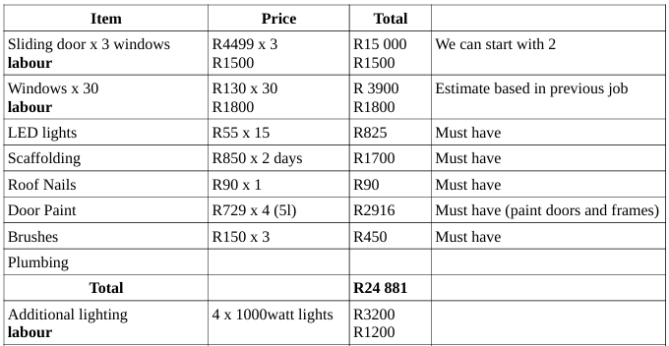
Ceiling  Labour | 6 x R250  R1200 | R1500  R1200 | Side hall ceiling
Door repairs  Labour | R2500  R1000 (rough estimate) | R2500 | The doors are R6000 cheapest ones, we can repair the existing
1.5mm Copper Cable  Labour | R2200  R1500 | R2200  R1200 | Light the remaining parts of the building  Jose will do both jobs of additional lighting and lighting the remaing parts and changing the dead lights for R2400
New Total |  | R39 681 | I am going to subtract the one sliding door for now
 |  | R34 682

