MVC APP

MVC application using VS 2012, entity frame work, MSSQL 2012, bootstrap and JQuery

I used the Repository pattern.

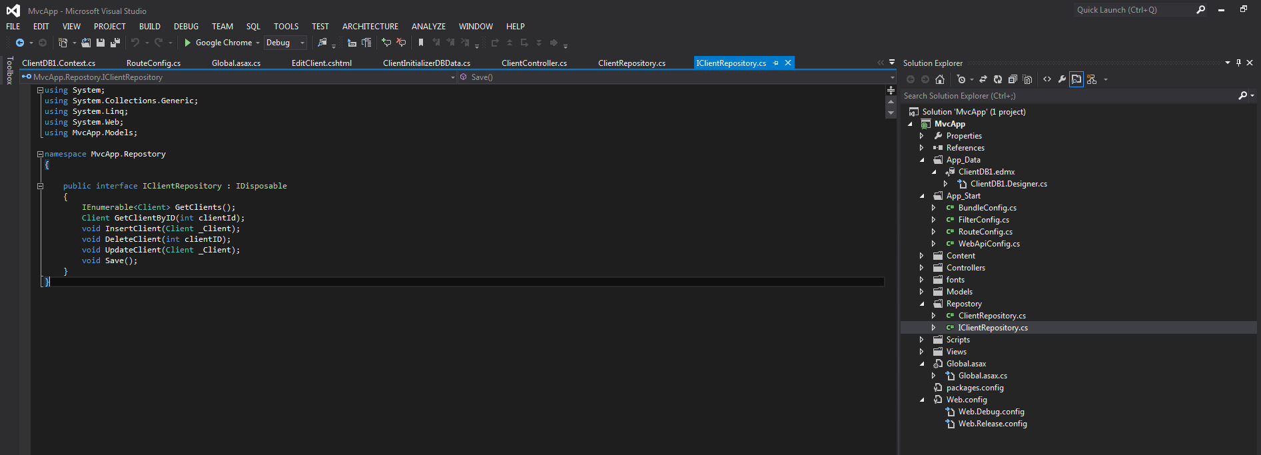

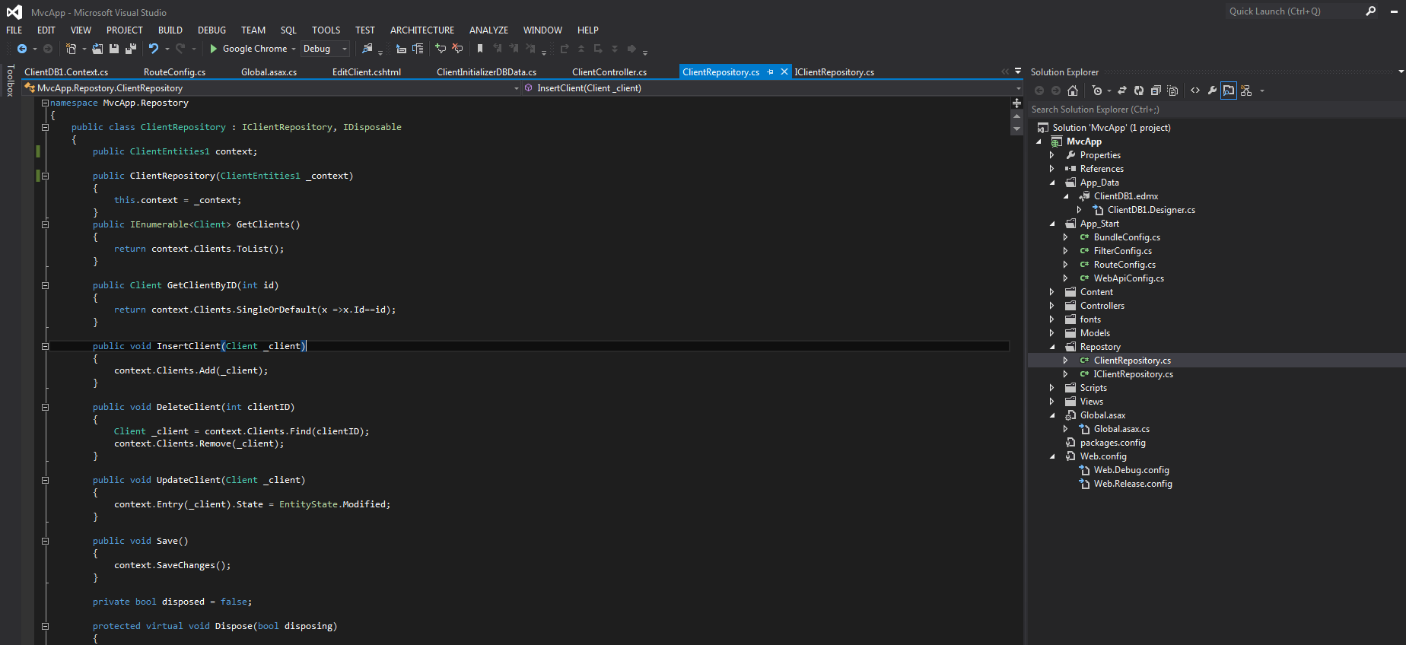

Script to create the Client DB and Client table

USE [master]

GO

CREATE DATABASE [Client]

GO

USE [Client]

GO

CREATE TABLE [dbo].[Client](

[Id] [int] IDENTITY(1,1) NOT NULL,

[Surname] [nvarchar](100) NOT NULL,

[FirstNames] [nvarchar](100) NOT NULL,

[IdentityType] [nvarchar](50) NOT NULL,

[IdentityNumber] [nvarchar](50) NOT NULL,

[DateOfBirth] [date] NOT NULL,

CONSTRAINT [PK_Client] PRIMARY KEY CLUSTERED

(

[Id] ASC

))

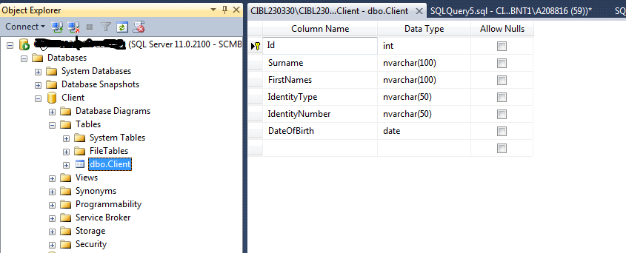

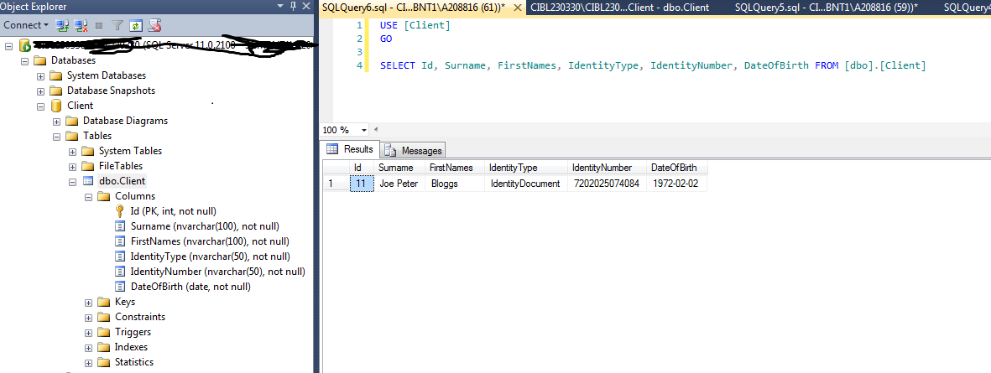

View Client screen

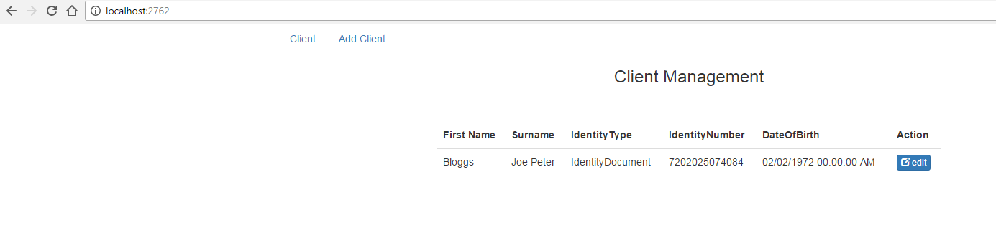

Add New Client screen

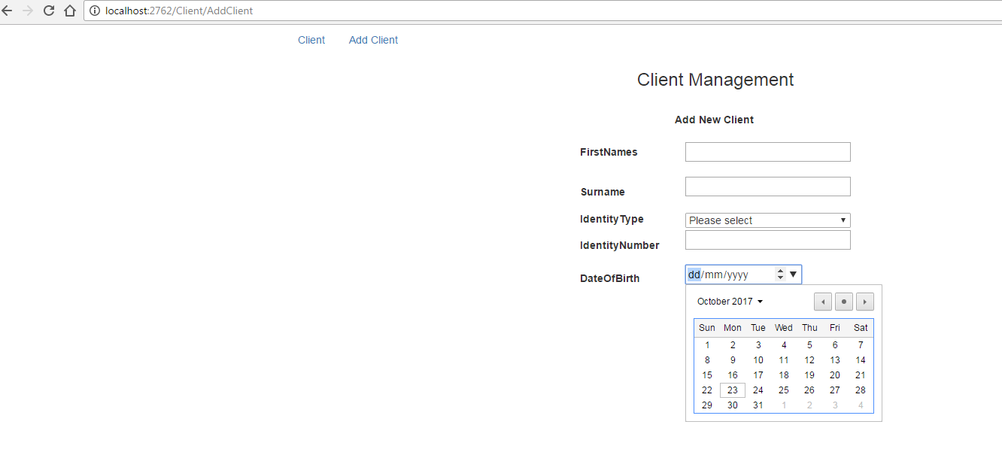

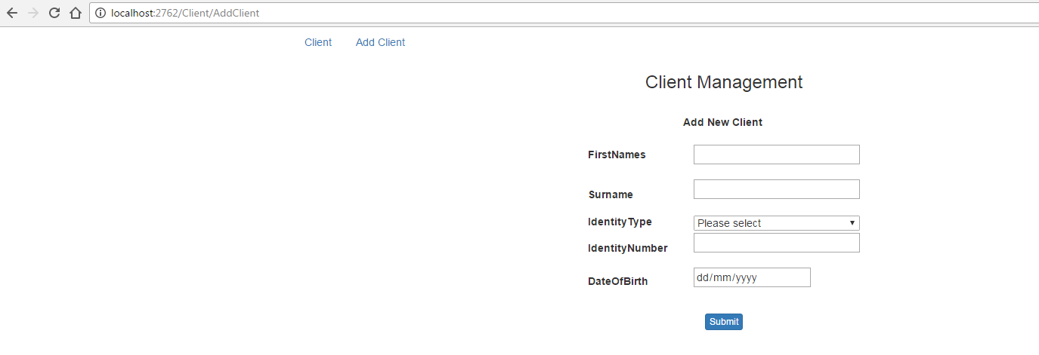

Update Client screen