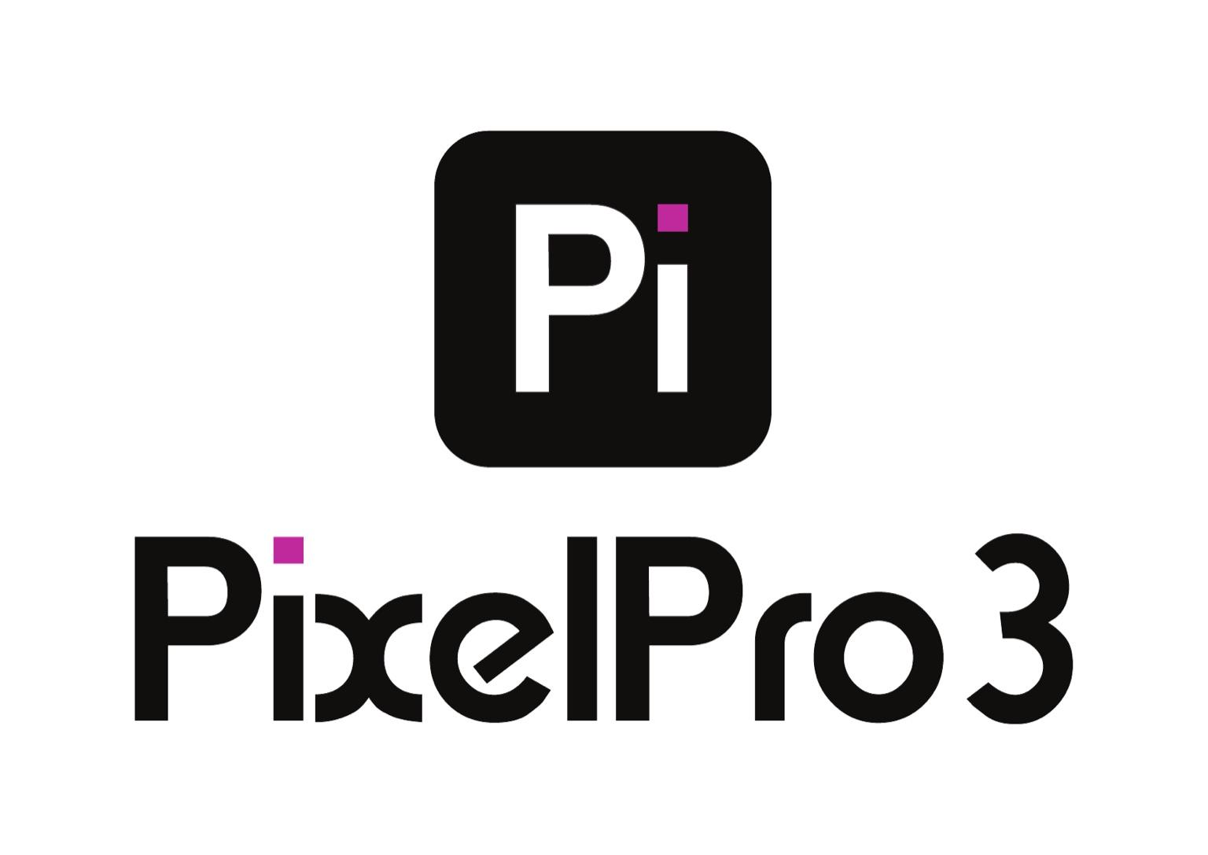 | PIXEL PRO 3 LLC  5550 Wild Rose Lane, Suite 400  West Des Moines, IA 50266  EIN: 99-2598141  contact@pixelpro3.com  (833) 412-3327
-----------------------------------------------------------------------------------------------------------------
MASTER SERVICE AGREEMENT
This Master Service Agreement ("Agreement") is made and entered into on {StartDate}, by and between:
Pixel Pro 3 LLC, a limited liability company organized and existing under the laws of the State of Iowa, United States of America, with its principal place of business at 5550 Wild Rose Lane, Suite 400, West Des Moines, IA 50266, EIN 99-2598141, herein referred to as the "Provider",
and
{ClientName}, located at {ClientAddress}, herein referred to as the "Client".
1. PURPOSE AND SCOPE
This Agreement governs the delivery of the services described below, in accordance with the applicable provisions of the Uniform Commercial Code (UCC), the Iowa Code, and federal laws governing commercial transactions in the United States.
- Service Type: {ServiceType}
- Project Summary: {ProjectDescription}
This Agreement may also cover additional services as mutually agreed in writing and documented via addendums.
2. TERM AND DURATION
- Effective Date: {StartDate}
- Completion Date: {DeliveryDate}
- The term may be extended by mutual written agreement.
3. FEES AND PAYMENT
- Total Project Value: ${TotalValue}
- Payment Method: {PaymentMethod}
- Payment Terms: {PaymentTerms}
All fees shall be paid in U.S. Dollars. Invoices are due within the agreed term, and subject to a 2% late fee per month in case of delay, as permitted under Iowa Code § 535.2(3)(a).
4. WARRANTIES AND SUPPORT
Provider warrants that the services shall be performed in a professional and workmanlike manner in accordance with industry standards and Iowa Code Chapter 554, and agrees to offer a warranty of {Warranty} for the work delivered, starting on the date of handover.
5. INTELLECTUAL PROPERTY RIGHTS
Unless otherwise agreed in writing:
- All final deliverables shall become the sole property of the Client upon full payment.
- The Provider retains rights to non-exclusive background tools or libraries, unless otherwise agreed.
- This clause complies with U.S. Copyright Law - Title 17, U.S. Code.
6. CONFIDENTIALITY
Both parties agree to maintain strict confidentiality of all business, technical, and financial information disclosed, pursuant to Iowa Code § 550 and common law principles of trade secrecy.
7. TERMINATION
Either party may terminate this agreement with 7 days' written notice, in accordance with Iowa Code § 554.2610, provided that:
- Work completed up to termination must be compensated
- Deliverables up to that point shall be delivered to the Client
8. INDEMNIFICATION AND LIMITATION OF LIABILITY
Each party agrees to indemnify and hold the other harmless against third-party claims arising from gross negligence or willful misconduct.
The Provider's total liability shall not exceed the total amount paid under this Agreement, in accordance with UCC § 2-719.
9. GOVERNING LAW AND DISPUTE RESOLUTION
This Agreement shall be governed by and construed under the laws of the State of Iowa, including but not limited to:
- Iowa Code - Title XIII (Commerce)
- Uniform Commercial Code as adopted by Iowa
- Any dispute arising from this Agreement shall be subject to the exclusive jurisdiction of the Polk County District Court, or, if applicable, the U.S. District Court for the Southern District of Iowa.
10. ENTIRE AGREEMENT
This Agreement, including attachments and addendums, constitutes the entire understanding between the parties and supersedes all previous agreements, whether oral or written.
11. SIGNATURES
IN WITNESS WHEREOF, the parties hereto have executed this Agreement on the date first written above.
Client:
Name: {ClientName}
Signature: ____________________________
Date: _____________________
Sales Representative (Pixel Pro 3):
Name: {SalesRepName}
Signature: ____________________________
Date: _____________________
Executive Representative (Pixel Pro 3 LLC):
Name: Vinicius Assad de Magalhães
Title: CEO
Signature: ____________________________
Date: _____________________

