PCB Portal

1. Luồng dữ liệu PCB

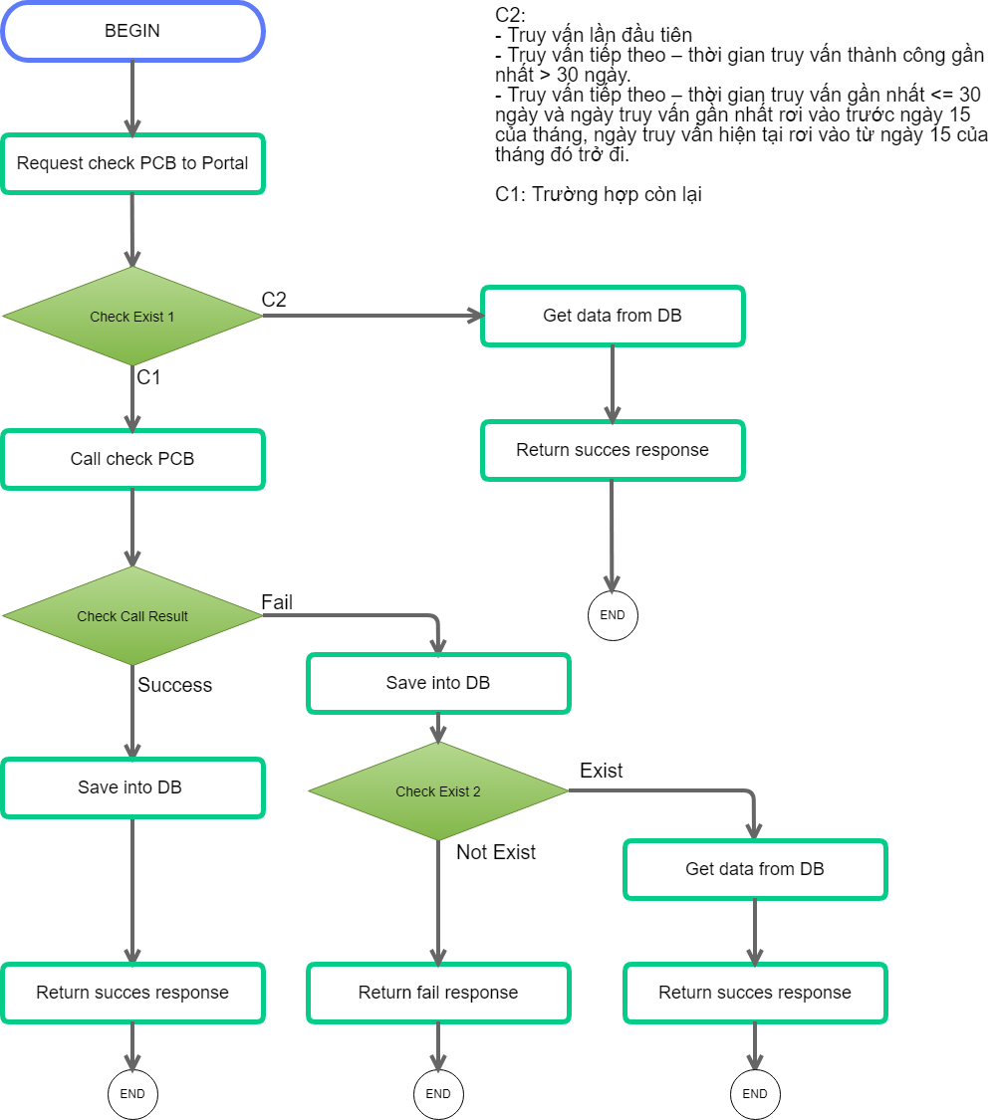

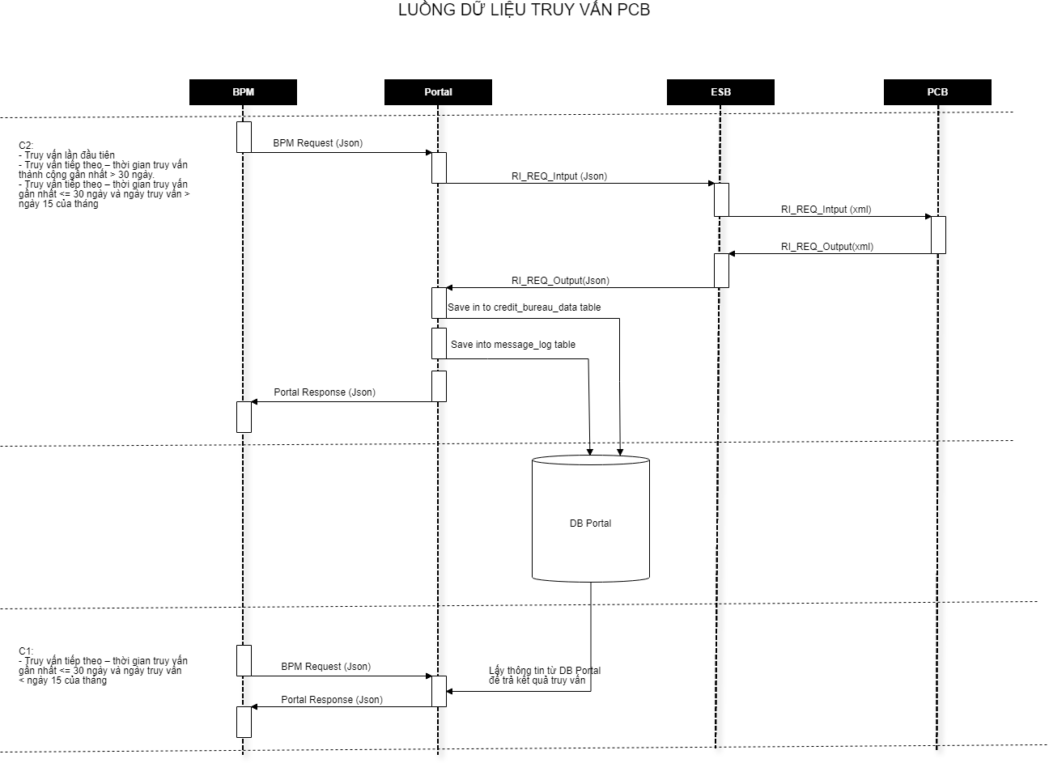

1. Data model

CREDIT_BUREAU_DATA table : Lưu lại thông tin PCB của khách hàng.

|  |  |  |  |
| --- | --- | --- | --- |
| COLUM_NAME | DATA_TYPE | NULLABLE | DATA_DEFAULT |
| ID | NUMBER(15,0) | No |  |
| RECORD_STATUS | VARCHAR2(1 BYTE) | No | 'A' |
| CREATED_DATE | DATE | No | sysdate |
| LAST_UPDATED_DATE | DATE | No | sysdate |
| CUST_ID | NUMBER(13,0) | Yes |  |
| CB_SOURCE | VARCHAR2(1 BYTE) | No | 'P' |
| CB_TYPE | VARCHAR2(1 BYTE) | No | 'C' |
| CB_KEY | VARCHAR2(30 BYTE) | Yes |  |
| CB_DATA_DETAIL | CLOB | Yes |  |
| CUST_IDENTITY_NUMBER | VARCHAR2(30 BYTE) | Yes |  |

MESSAGE_LOG table : Lưu lại lịch sử call PCB (Case C2) để làm đối soát (chi tiết trong file PaymentFlowNote) :

Call success:

|  |  |
| --- | --- |
| **MESSAGE_LOG** | **call PCB** |
| RELATION_ID | BPM app ID |
| TRANS_ID | CREDIT_BUREAU_DATA.ID |
| TRANS_TYPE | pcbSuccessCheck |
| FROM_CHANNEL | MCP |
| TO_CHANNEL | PCB |
| REQUEST_TIME | Time when insert record to Message log |
| MSG_REQUEST | Payload send to PCB |
| MSG_RESPONSE | Response from PCB |

Call fail:

|  |  |
| --- | --- |
| **MESSAGE_LOG** | **call PCB** |
| RELATION_ID | BPM app ID |
| TRANS_ID |  |
| TRANS_TYPE | pcbFailCheck |
| FROM_CHANNEL | MCP |
| TO_CHANNEL | PCB |
| REQUEST_TIME | Time when insert record to Message log |
| MSG_REQUEST | Payload send to PCB |
| MSG_RESPONSE | Response from PCB |