Context : when perform git remote add origin

Problem : “fatal: unsafe repository“

Solution proposed by git : git config --global --add safe.directory 'E:/random documentation of my coding life' doesn’t work

The dir is successfully added to the safe.directory

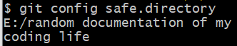

However, git remote add origin still failed miserably

The way to do this on window is to directly update to .gitconfig file at C:\Users\<username>\.gitconfig (for Windows)

(for Ubuntu)