## Programming-Intermediate Project

## Part I. Design, implement and document database

### 1.1. Draw ER Diagram

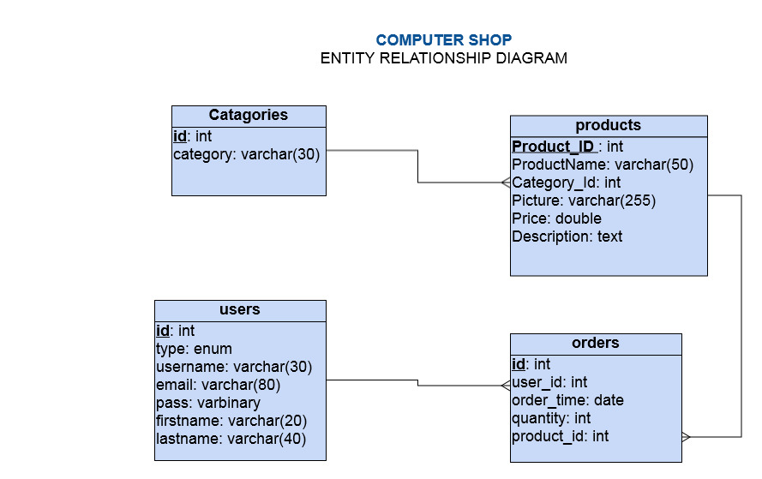

### 1.2. Data dictionary

**Catagories Table (id**, category**)**

|  |  |  |  |  |  |
| --- | --- | --- | --- | --- | --- |
| **Index** | **Field name** | **Caption** | **Data type** | **Field size** | **Notes** |
| 1 | **id** | catagory id | int |  | primary key |
| 2 | category | catagory name | varchar | 30 |  |

**Products Table (ProductID**, ProductName, Category_Id, Picture, Price, Description**)**

|  |  |  |  |  |  |
| --- | --- | --- | --- | --- | --- |
| **Index** | **Field name** | **Caption** | **Data type** | **Field size** | **Notes** |
| 1 | ProductID | Product Id | int |  | Primary key |
| 2 | Product Name | Product Name | varchar | 50 |  |
| 3 | Category_Id | Category ID | int |  | Foreign key( references to catagories table) |
| 4 | Picture | Product Picture | varchar | 255 |  |
| 5 | Price | Price of product | double |  |  |
| 6 | Description | Product Description | text |  |  |

**Orders Table (id**, user_id, order_time, quantity, product_id**)**

|  |  |  |  |  |  |
| --- | --- | --- | --- | --- | --- |
| **Index** | **Field name** | **Caption** | **Data type** | **Field size** | **Notes** |
| 1 | id | Order Id | int |  | Primary key |
| 2 | user_id | User ID | int |  | Foreign key( references to users table) |
| 3 | order_time | Order time | date |  |  |
| 4 | quantity | Product Quantity | int |  |  |
| 5 | product_id | Product ID | int |  | Foreign key(references to products table) |

**Users Table (id**, type, username, email, pass, firstname, lastname**)**

| **Index** | **Field name** | **Caption** | **Data type** | **Field size** | **Notes** |
| --- | --- | --- | --- | --- | --- |
| 1 | id | User ID | int |  | Primary key |
| 2 | type | Type User | enum |  |  |
| 3 | username | Username of user | varchar | 30 |  |
| 4 | email | Email of user | varchar | 80 |  |
| 5 | pass | Password of user | varbinary | 32 |  |
| 6 | firstname | First Name of user | varchar | 20 |  |
| 7 | lastname | Last Name of user | varchar | 40 |  |

### 1.3. Report backup and restore planning

Backup and restore on the whole database and the administrator will perform this work every week. The steps to perform backup and restore database includes:

a. Backup database

Step 1: Access Phpmyadmin from browser will appear:

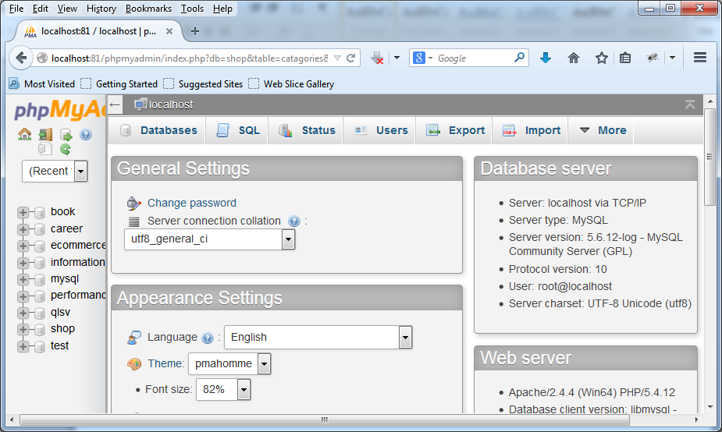

Step 2: Select Export will appear the window:

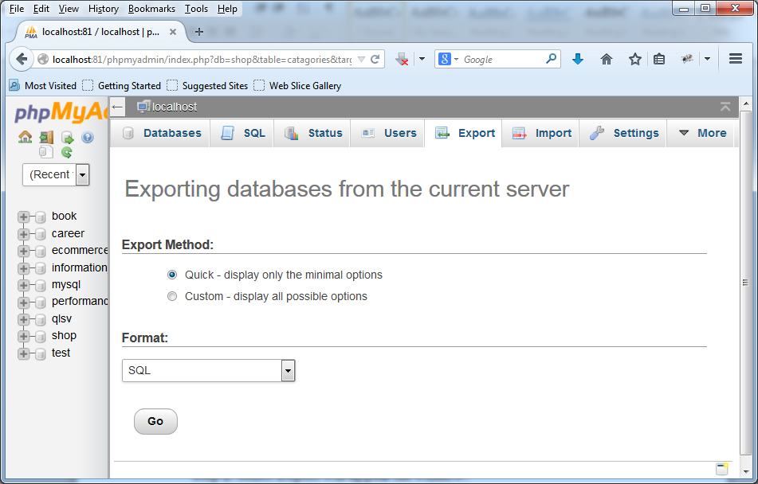

Step 3: Select Custom – display all possible options

Step 4: Select database need to backup

Step 5: Enter name file name need to backup then select go

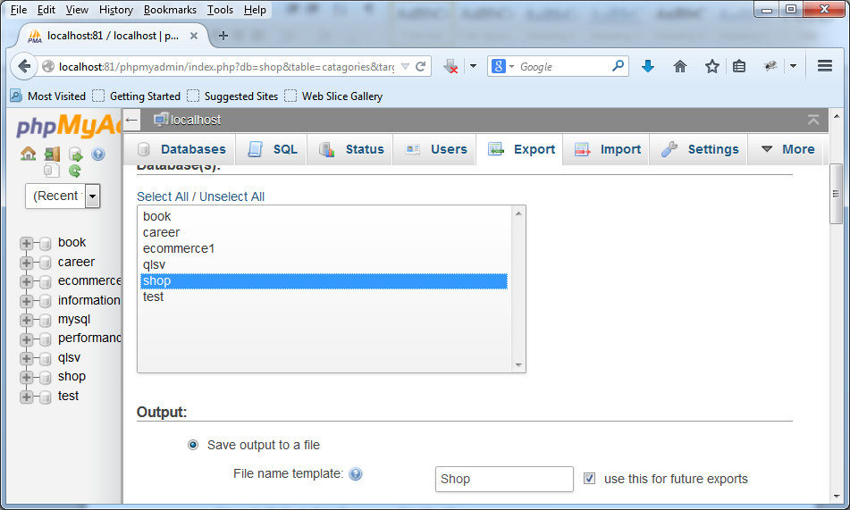

b. Restore database

The progress to restore databse it occurs according to following steps:

Step 1: Access Phpmyadmin from browser will appear:



Step 2: Select Import will appear the window:

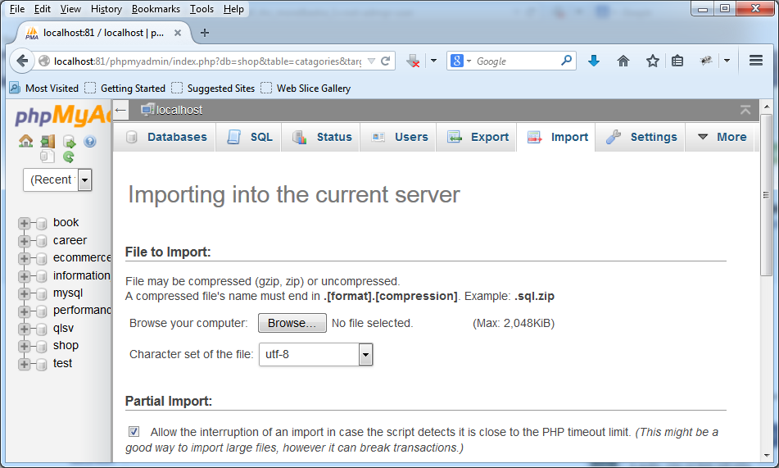

Step 3: Press browse button then select the path to file database need restore

Step 4: Press go to finish

## Part II. Design and document website

### 2.1. User case

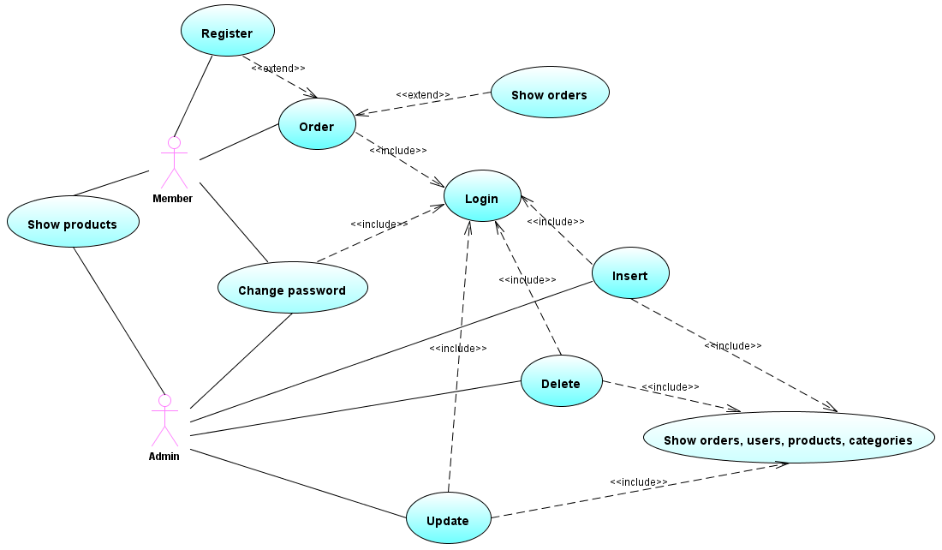

### 2.2. WireFrame

a. Front Page

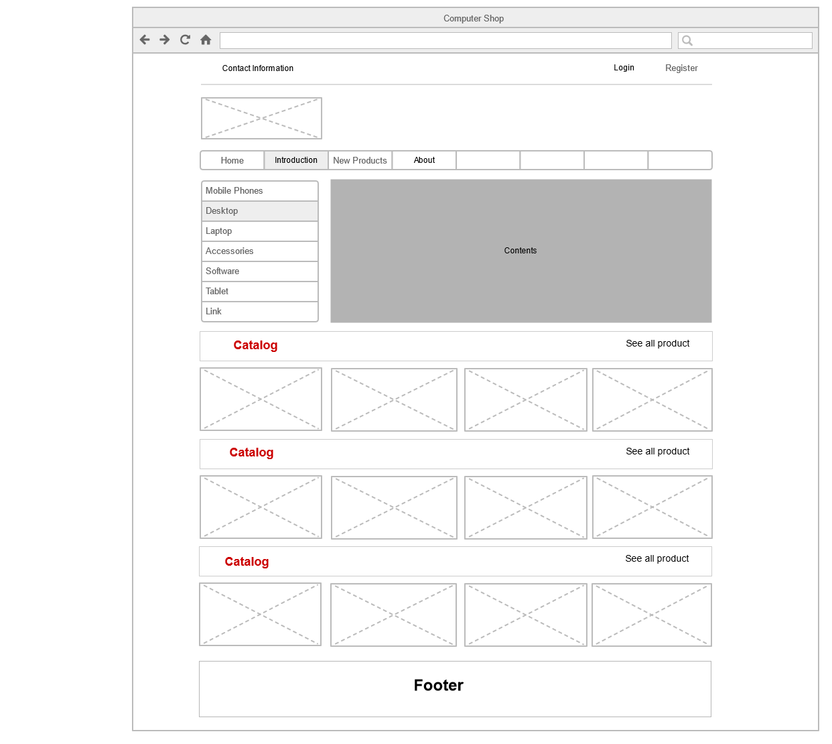

b. Back Page

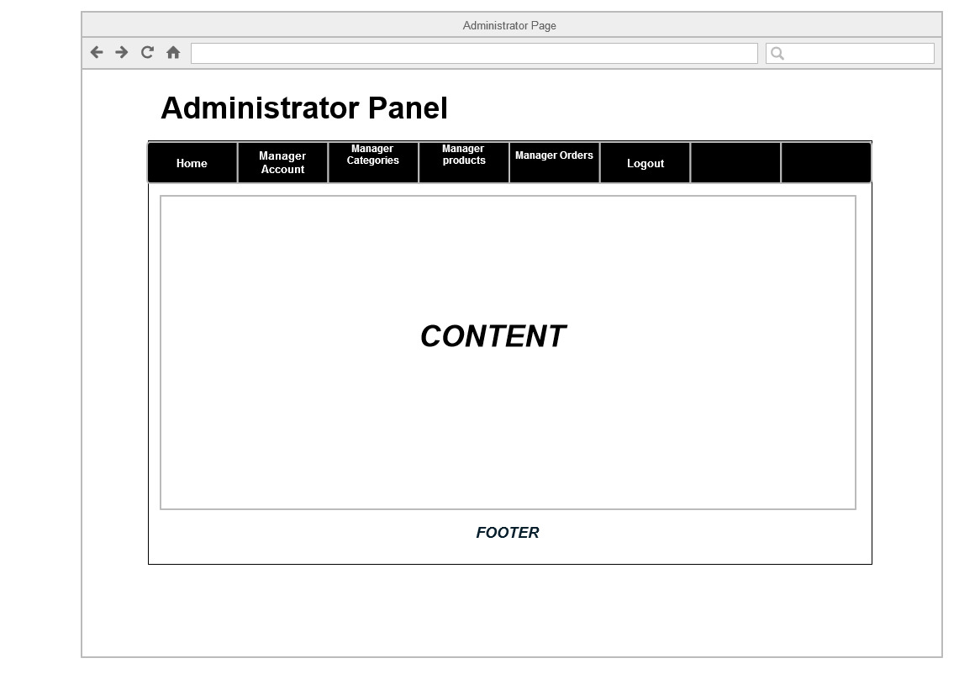

### 2.3. Extended Sitemap

a. Sitemap

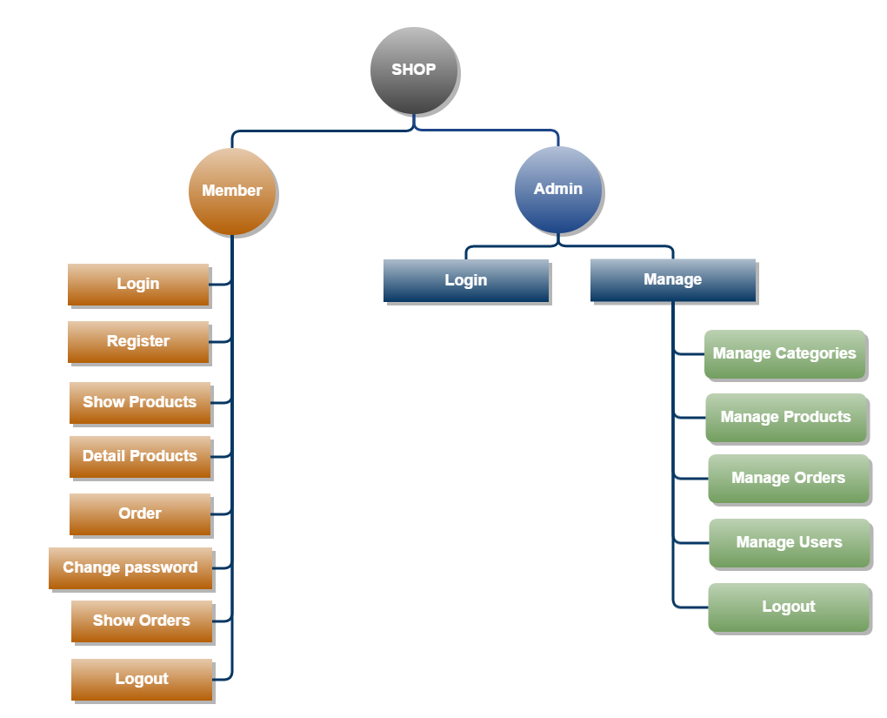

b. Extended Sitemap (File image: [Extended map.png](Extended%20map.png))

***Home Page***

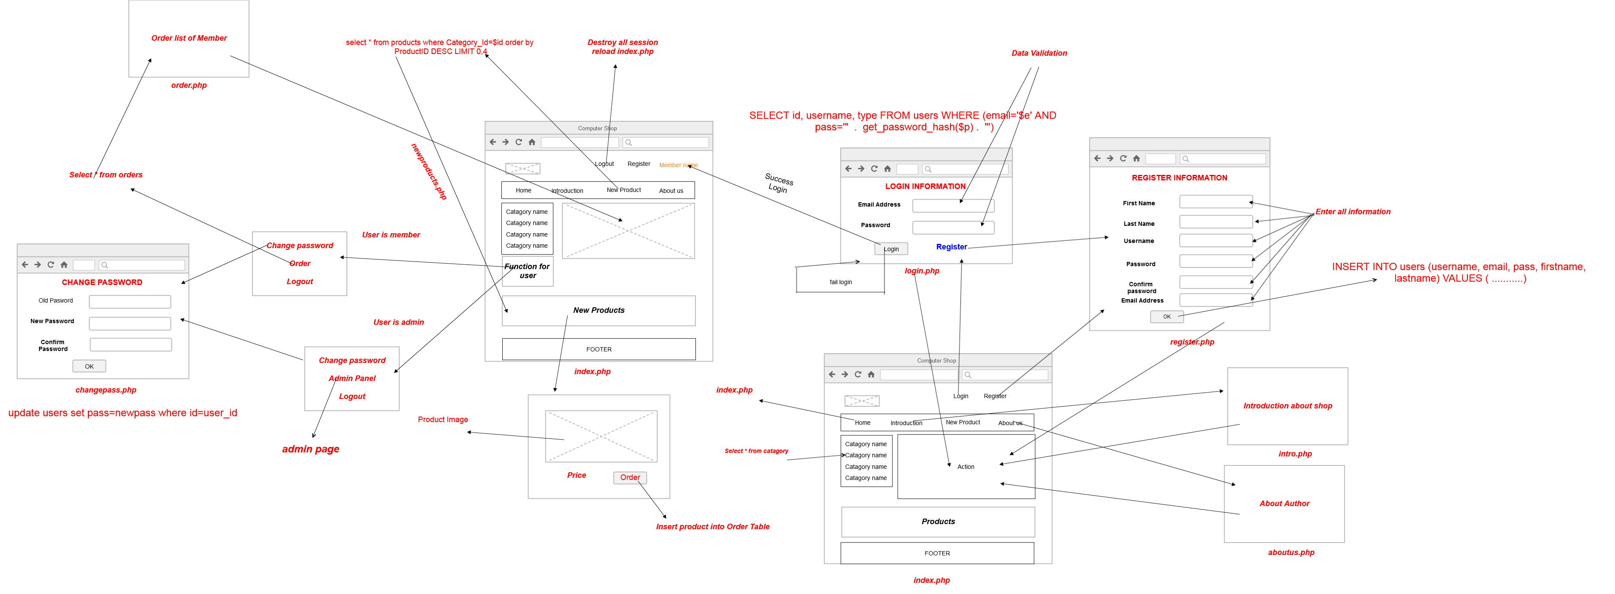

***Admin page ([AdminExtended](extended_map%20(2).png))***

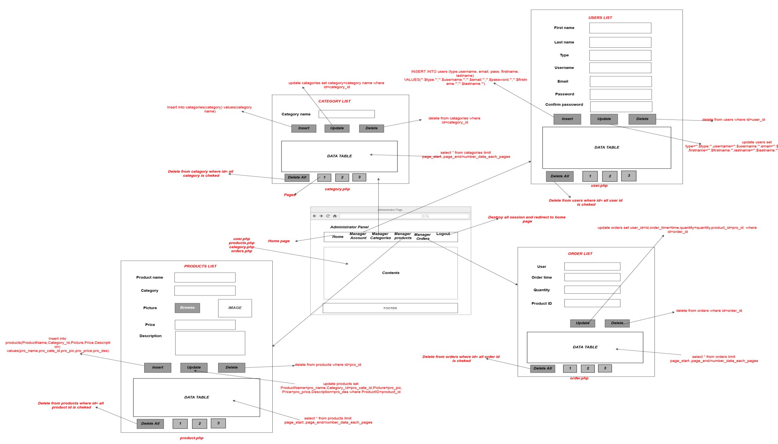

### 2.4. Checklist

|  |  |  |
| --- | --- | --- |
| **Index** | **Requirement** | **Yes/No** |
|  | Design database includes: User table, category, product, order | Yes |
|  | Database include least 3 categories and two products in each category | Yes |
|  | Write report on what backup and restore procedure would required for database | Yes |
|  | The site must be dynamic | Yes |
|  | The site have use mutiple languages | No |
|  | The site include an home page and backpage | Yes |
|  | New user can register account and see a message if they registered successful | Yes |
|  | User can login with a account to order and see a message if login successful | Yes |
|  | User can see error message if login fail | Yes |
|  | The password must not be stored as plain text | Yes |
|  | User can not order unless logged in | Yes |
|  | User can change password and logout | Yes |
|  | User can see their order and can delete some product in the order | Yes |
|  | When user logged in success then they can see their firtname and lastname on right top corner | Yes |
|  | The user include a second type of user and admin | Yes |
|  | Admin can add, update, delete user, category, product, order in database | Yes |
|  | Create a use case diagram to show the functionality of website | Yes |
|  | Create an extended site map | Yes |
|  | Clearly comment all source code | Yes |
|  | Code and debug all functionality of website | Yes |
|  | Testing data | Yes |

### 2.5. Website is required in a specific country

Website is supported two languages: Vietnamese, English. If user is in Vietnam then they will select Vietnamese languages and if user in other country then they will select English.

The solution for website two languages,it builts by each column in table will have a column the same properties but it’s difference about languages

Eg:

**Product Table (ProductID**, ProductName, ProductName_VN, CategoryID, Picture, Price, Desctiption,Description_VN**)**

In that:

**ProductName**: use English

**ProductName_VN**: use VietNamese

**Price**:

if user’s in VietName then Price=Price*21000 (following current dollar rate)

if user’s in other country then price don’t change

## Part III. Implement and document website

3.1.

3.2.

3.3. Testing code use Rips-sourceforget

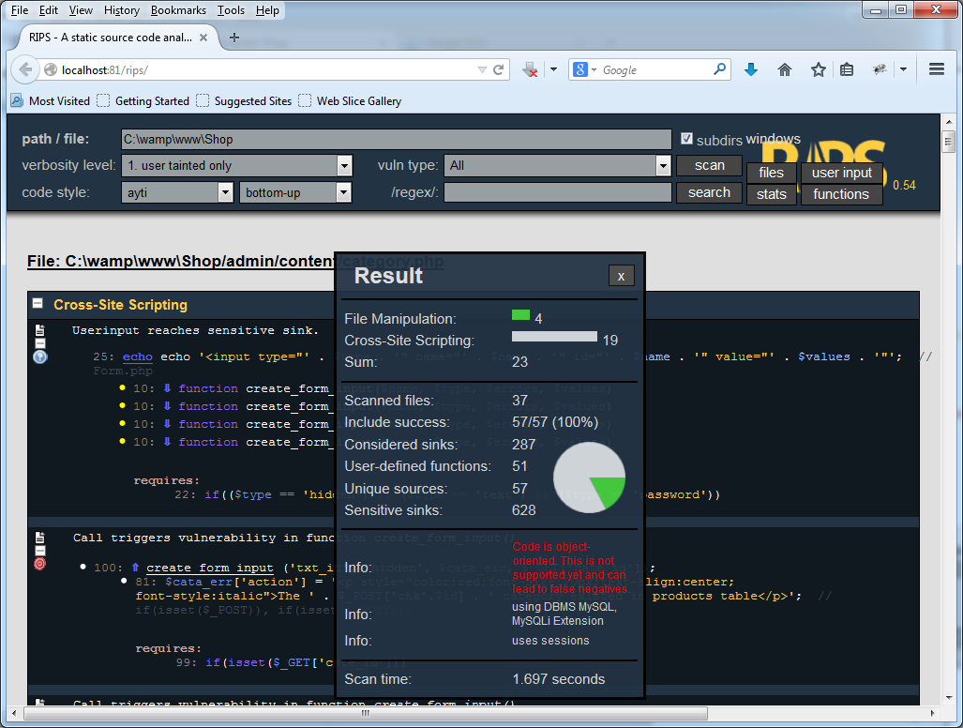

Scan file and includes

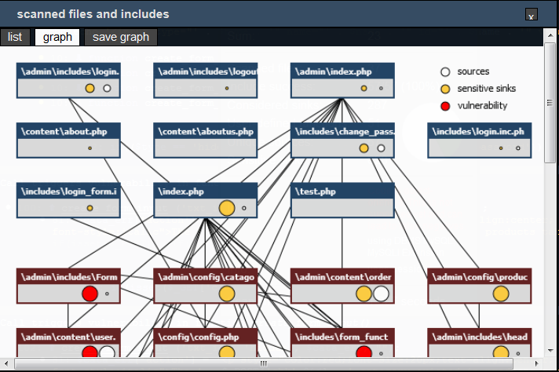

## Part IV. Test and document website