**Teacher active**

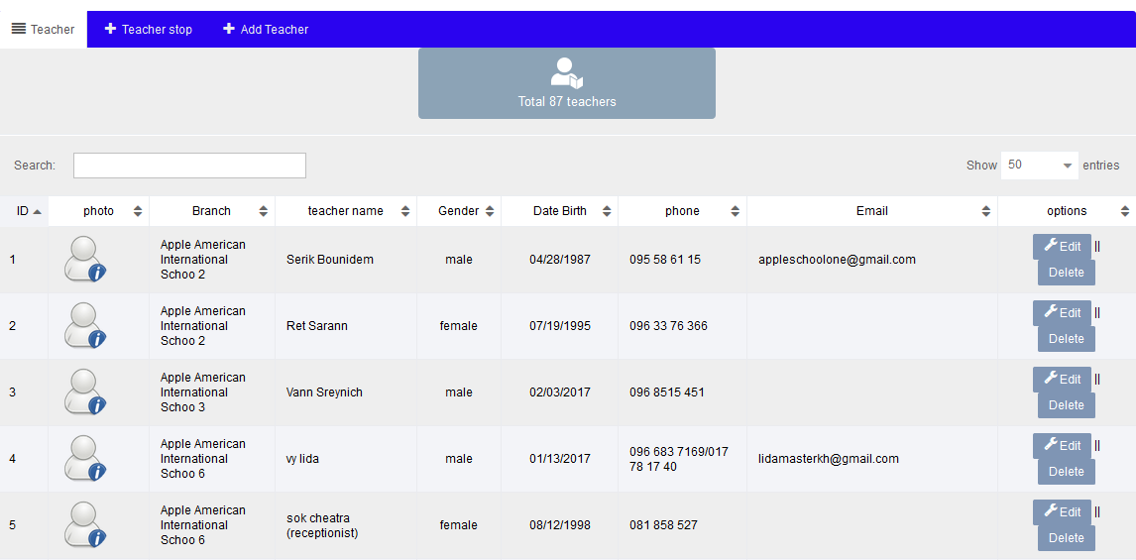

**Teacher inactive**



**New Teacher**

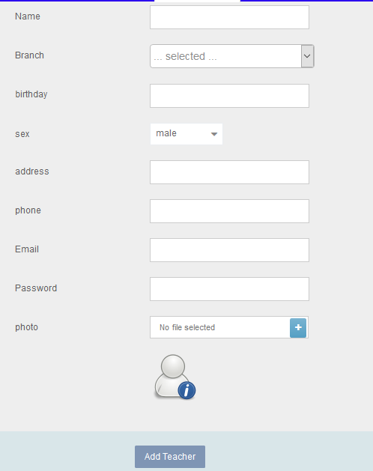

Note: add branch as combo box

Function

1. Create new/ edit / delete

Permission

1. Based on user assigned by admin