**Branch list**

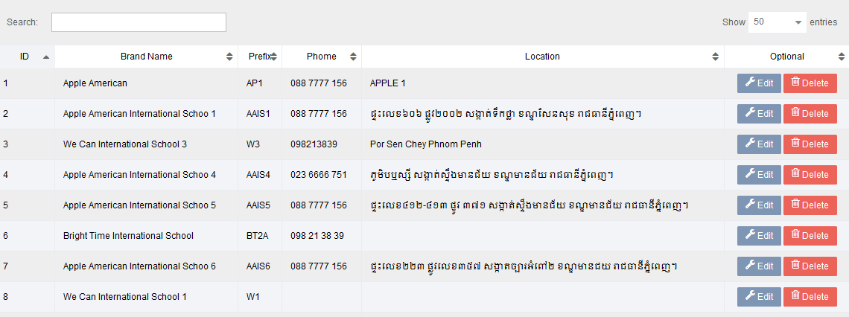

**New Branch**

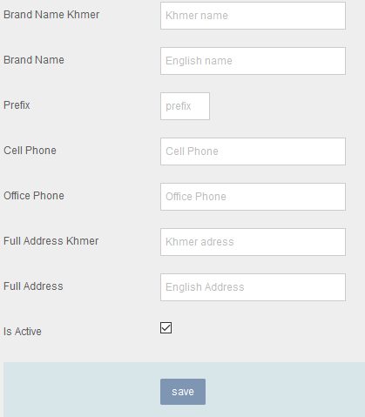

Function

1. Create new/ edit / delete

Permission

1. Based on user assigned by admin