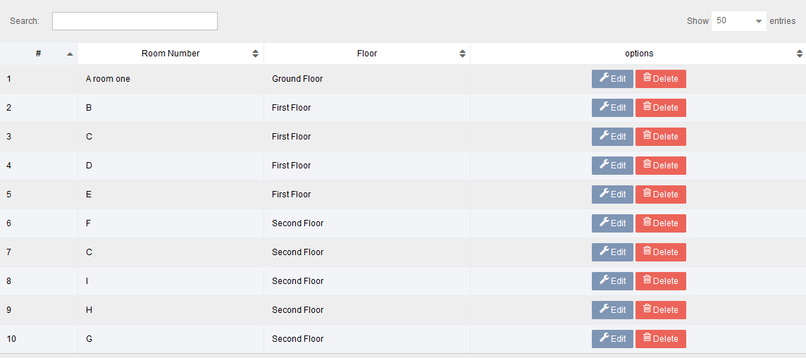**Room list**

**New room**

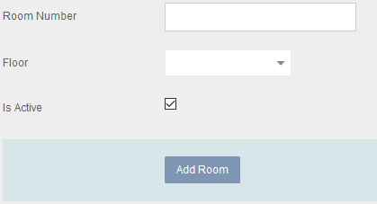

Note: add new room using modal popup. And interface add floor.

Function

1. Create new/ edit / delete

Permission

1. Based on user assigned by admin