**Comparision of SQL and NoSQL**

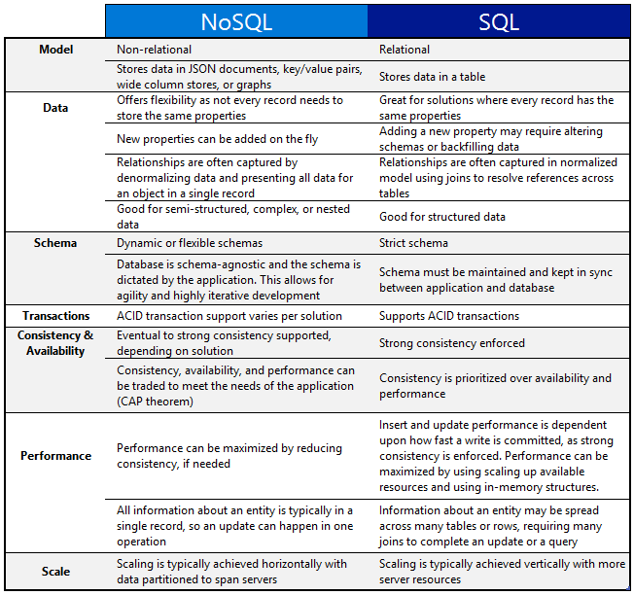

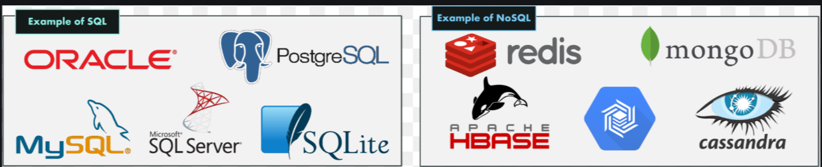

* **Pros and Cons of SQL and NoSQL**

**SQL Pros:**

* It is highly suitable for relational databases.
* Normalization can be greatly used here, thus it also helps in removing redundancy and organizing data in a better way.
* Transactions in SQL databases are ACID compliant, thereby guarantees security and stability.
* Follows well-defined standards like ISI and ANSI which are accepted worldwide.
* Uses single standardized language i.e. SQL across different RDBMS.

**SQL Cons:**

* The process of interfacing is complex.
* As SQL is an object, it occupies space.
* Handling Big data is very costly as we will have to increase the hardware for scaling.

**NoSQL Pros:**

* Capable of handling big data.
* As it is schema-less and table free, it offers a high level of flexibility with data models.
* It is a low-cost database and the open source NoSQL databases provide very affordable solutions to small enterprises.
* Easier and low-cost scalability. We don’t need to increase the hardware for scaling. We just need to add more servers to the pool as NoSQL is schema-free and built on distributed systems.
* We can work with it fast with database details

**NoSQL Cons:**

* The benefits of NoSQL come at the cost of relaxing ACID properties. NoSQL offers only eventual consistency.
* Relatively less community support.
* Lacks standardization, unlike SQL, which in turn creates some issues during migration.
* Inter-operability is also a concern in the case of NoSQL databases.

**List of NoSQL Database available other then MongoDB**

* **This is the Top list of NoSQL Database in 2020**
* Redis
* Couchbase
* MongoDB
* Amazon DynamoDB
* IBM Cloudant
* Cassandra
* HBase
* CouchDB
* And more …

**JSON Documents MongoDB**

* **What is JSON?**
* JSON is stand for JavaScript Object Notation
* JSON is a lightweight format storing and transporting data
* JSON is often used when data is sent from server to front-end page

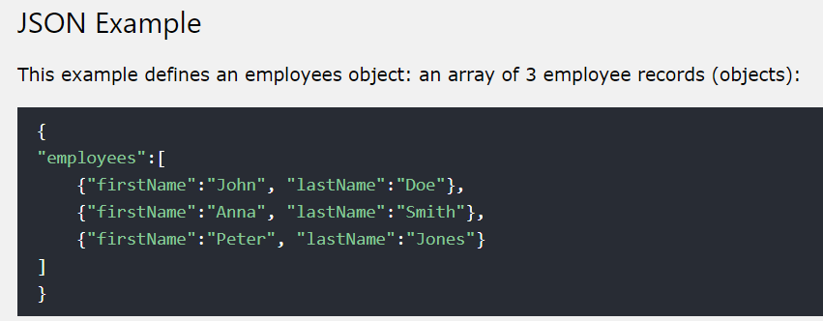

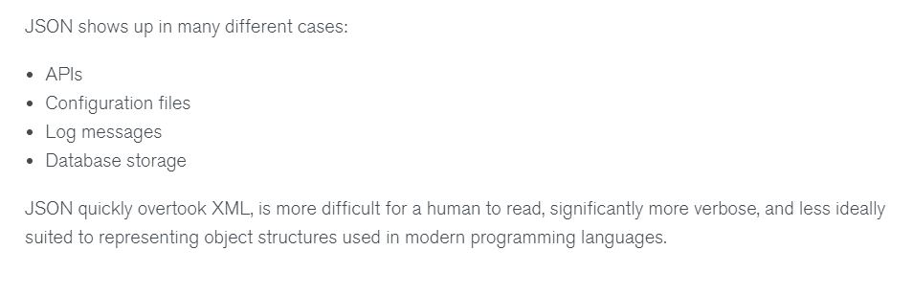

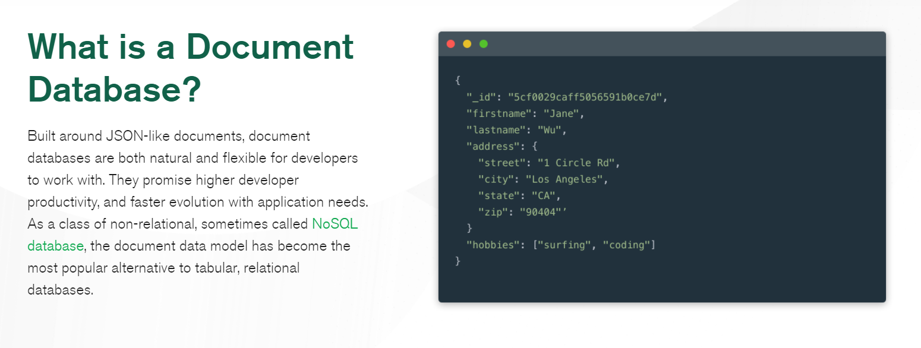

References:

* <https://www.softwaretestinghelp.com/sql-vs-nosql/> **(SQL vs NoSQL)**
* <https://www.trustradius.com/nosql-databases> **(List of Top NoSQL Database)**
* <https://www.w3schools.com/whatis/whatis_json.asp> **(JSON Definition)**
* <https://www.mongodb.com/document-databases> **(Doc Database)**