Create Database **employee** with collection **‘records’** and with data:

Id: 123

Name: “Vuthy Sreang”

Phone: “+85598820725”

Current_date: Date()

* **Step 1:**
* I show all databases in my MongoDB to know how many databases in my MongoDB

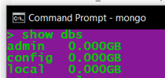

* **Step 2:**
* I create databases name **employee** with collection name **records** and has data

Id: 123

Name: “Vuthy Sreang”

Phone: “+85598820725”

Current_date: my_currentDate

That show in image below in CMD:

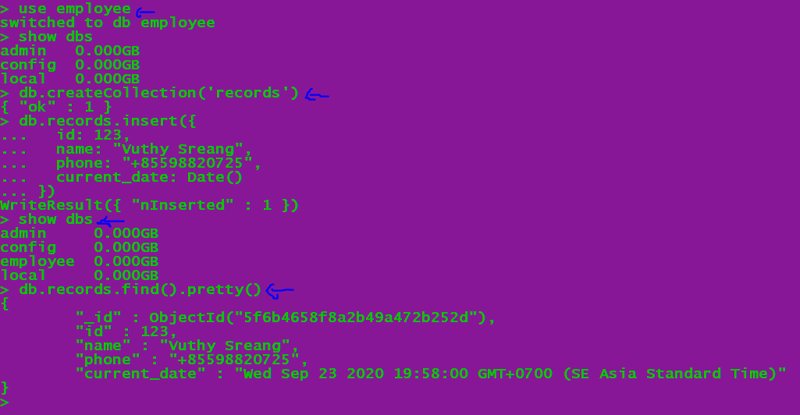

* **All output in one Image below:**

