**Create many data documents into a collection of Database MongoDB in a single operation using CMD**

* **Step 1:**
* I create data to be insert in vscode first.

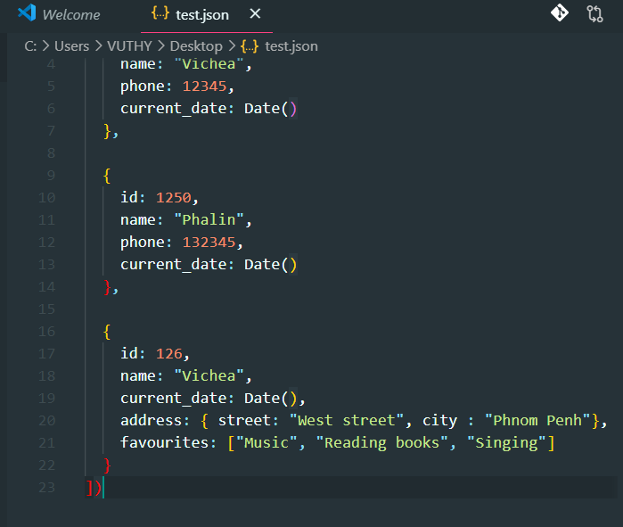

Because it hard to type in CMD in a single operation. So have to do like to make me easy than use only CMD.

* Then I copy it into my MongoDB CMD and hit ENTER.
* Then data are inserted into my **records** collection of **employee** Database

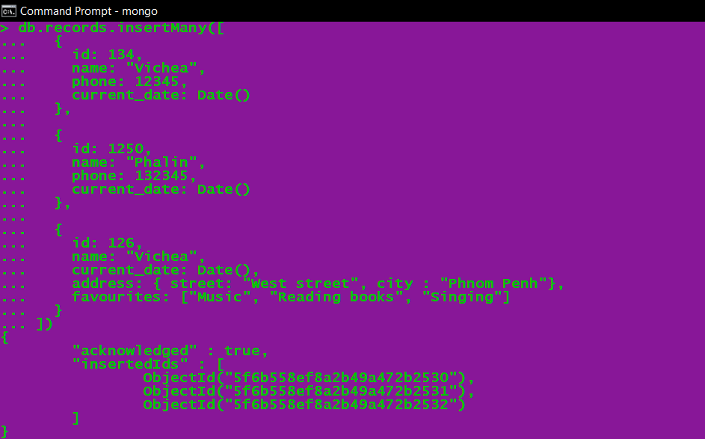

* **Step 2:**
* I find data in my MongoDB that I inserted already by CMD: **db.records.find().pretty()**
* 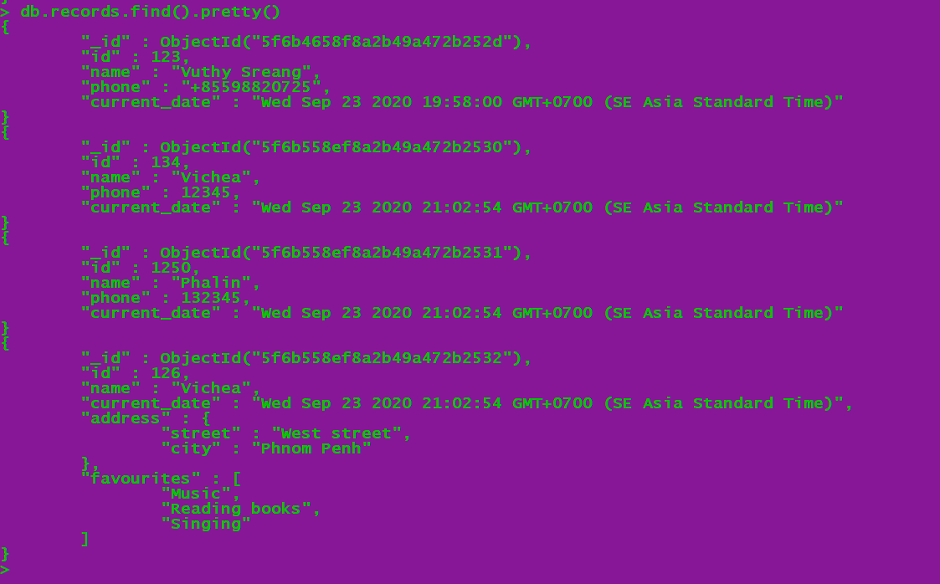

We can see output data in MongoDB compass:

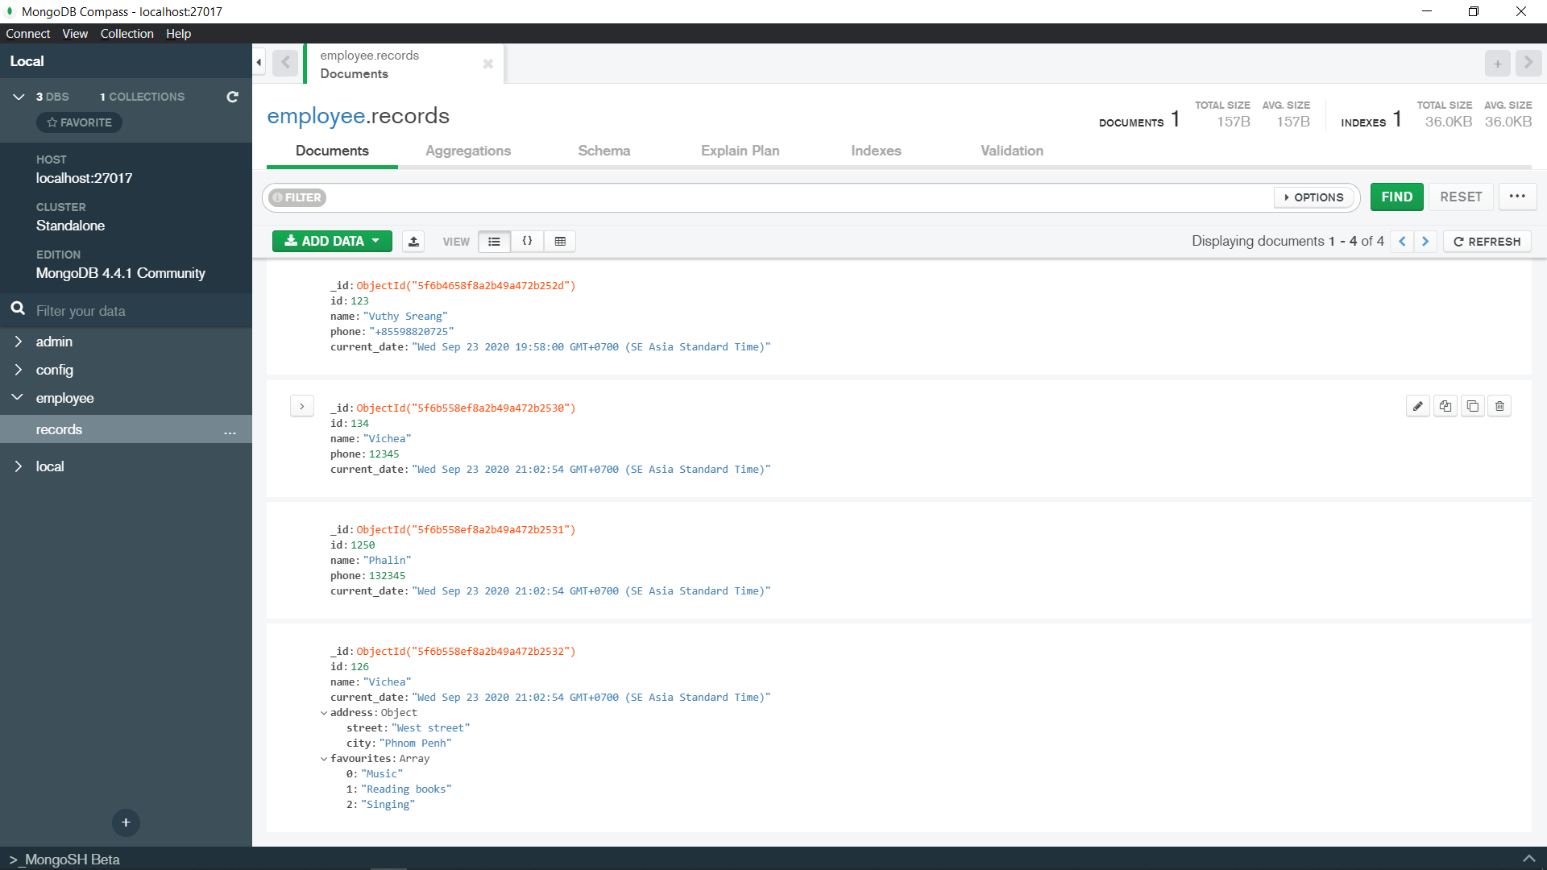

================================= **END** =================================