* Read and display all the records from the “records” collection of the “employee” database as a single operation using command prompt.

**db.records.find().pretty()**

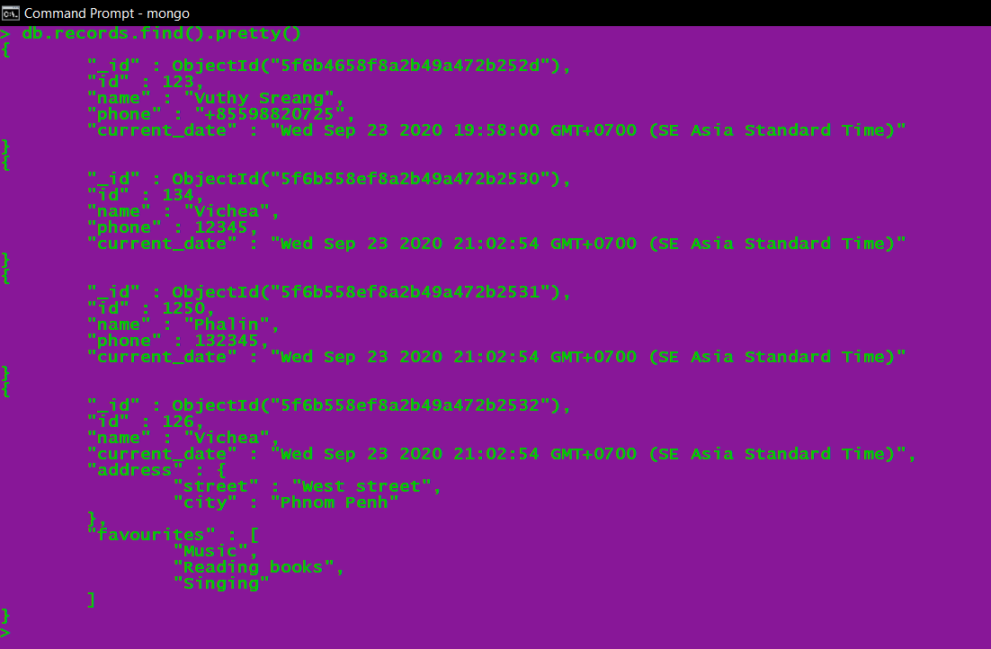

+ Sort and display the records in ascending order of the “id” property.

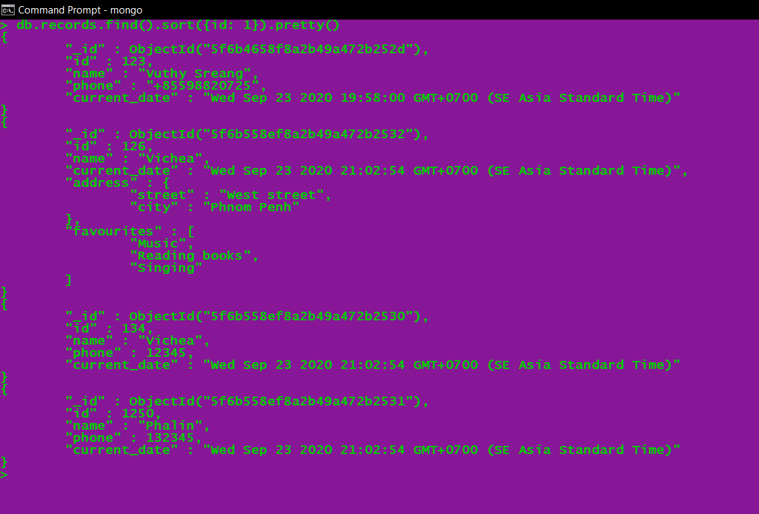

+ Sort and display the records in descending order of the “id” property.

