* This is the data before I increment the salary in {name: “Chan Phalin”}

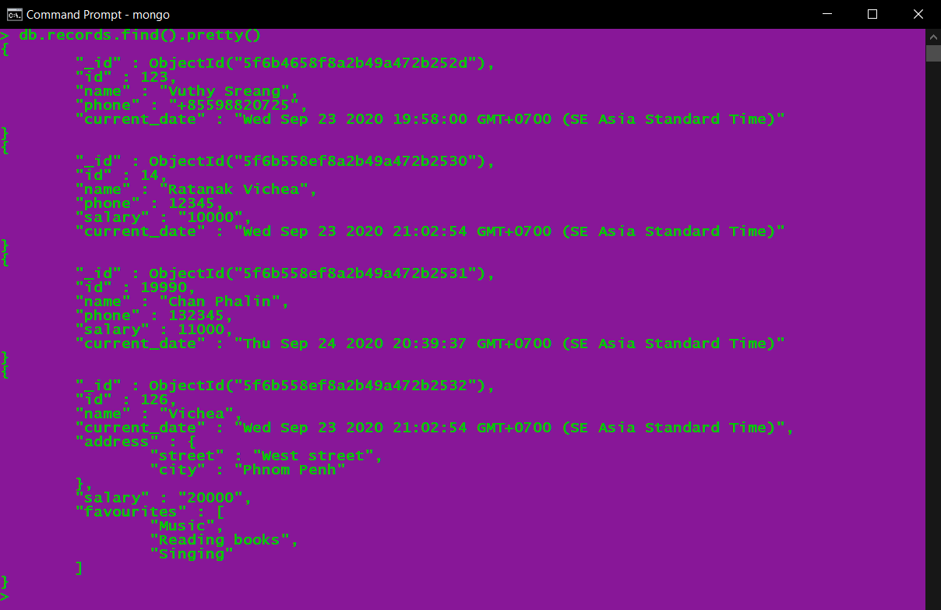

* **Update the existing records and increment “salary” by 1000 for the records whose “name” is “Phalin”.**
* **Display all the records in a proper format after update.**

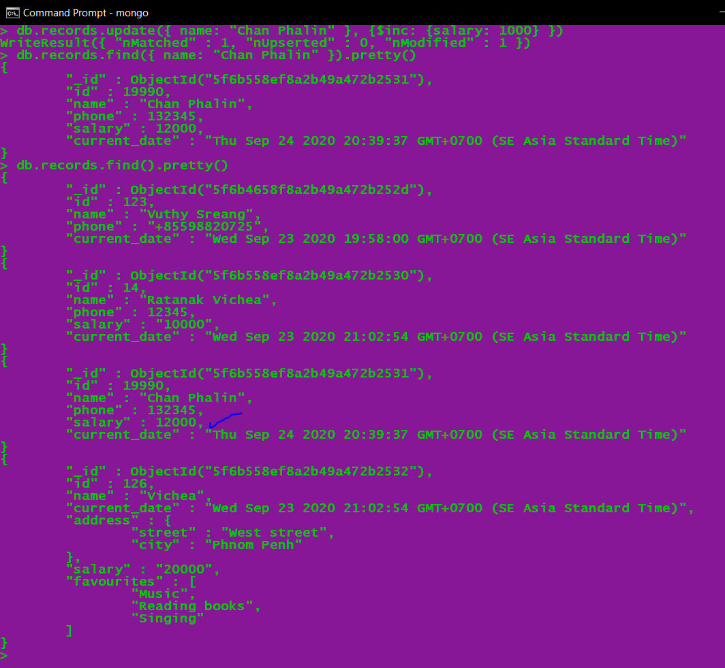

**Or we can see in the MongoDB Compass**

