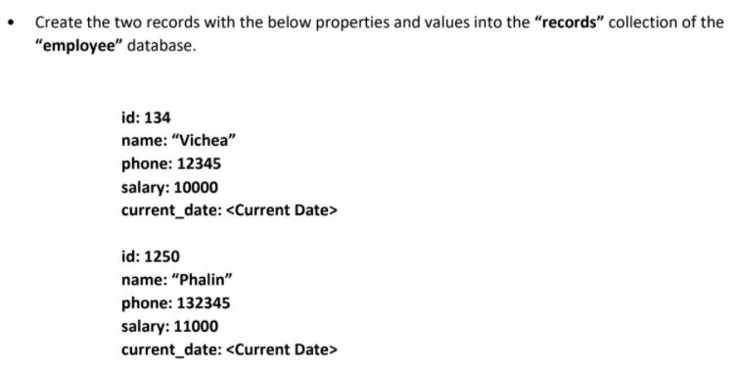

* **ANSWER**

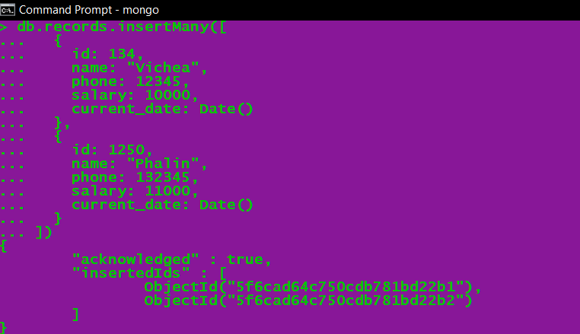

**Output in MongoDB Compass:**

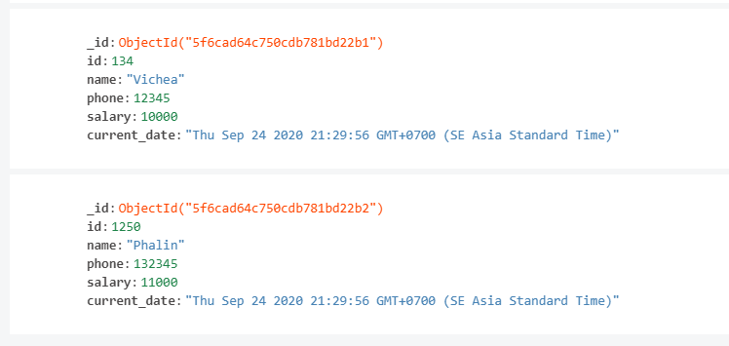

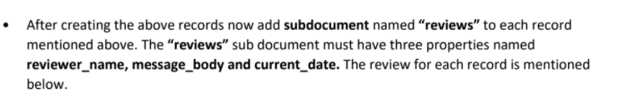

**ANSWER:**

* For {name: “Vichea”}

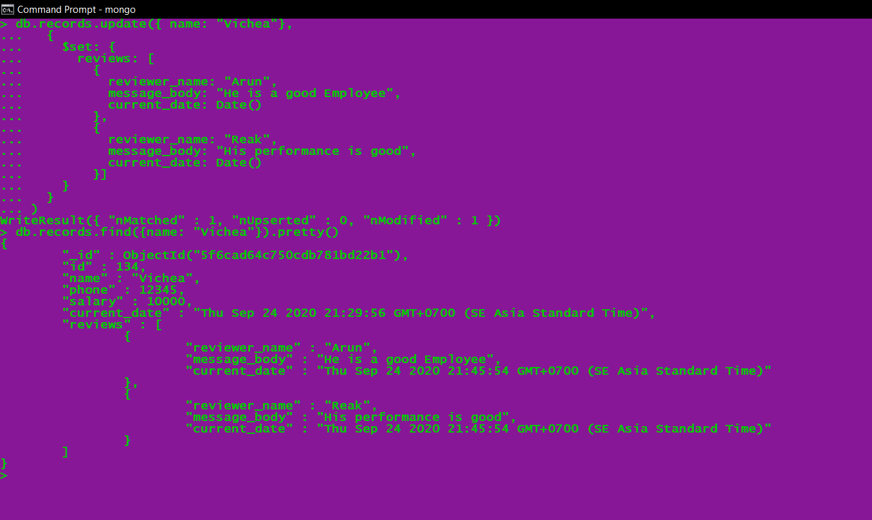

**Output in MongoDB Compass:**

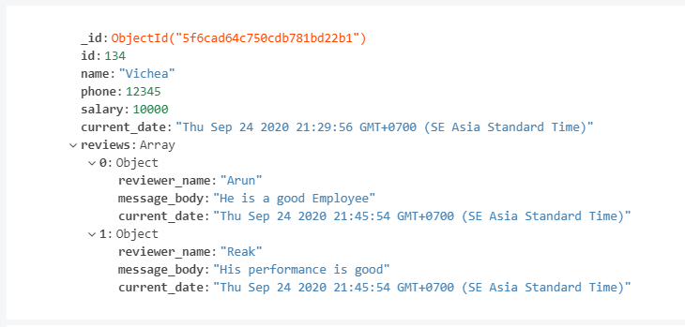

* for {name: “Phalin”}

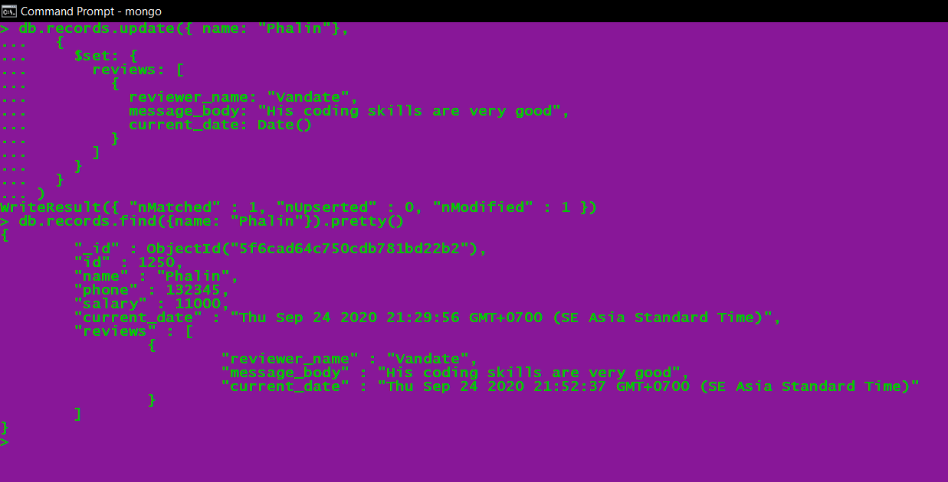

**Output in MongoDB Compass:**

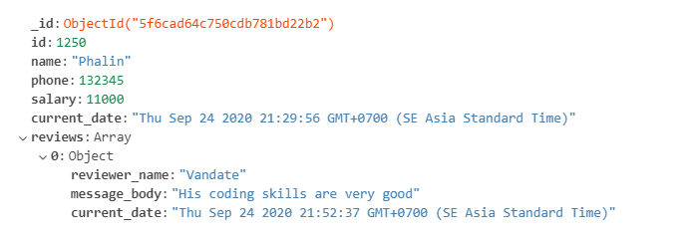

* **This is the final output for subDocument of these two {name: “Vichea”} and {name: “Phalin”} in MongoDB Compass:**

