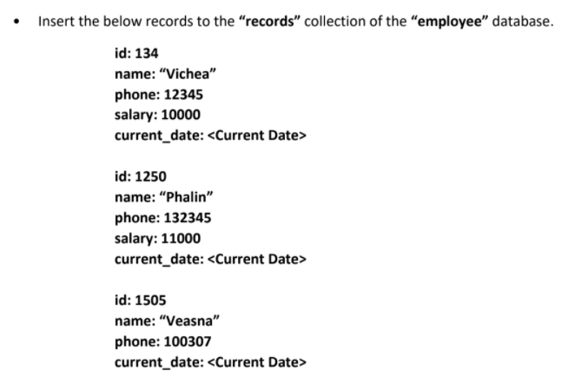

**ANSWER:**

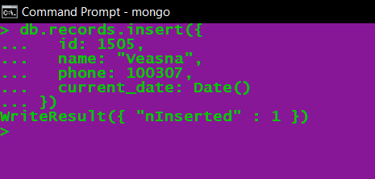

**Output in MongoDB Compass:**

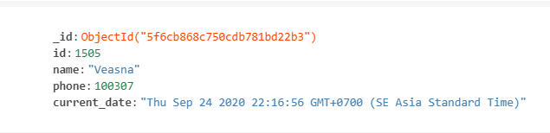



**ANSWER:**

* **Create indexing**

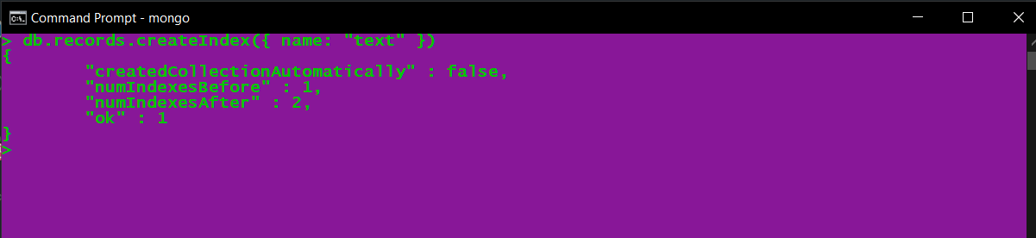

* **Use $search**

