* **Find and display the records where salary is greater than 5000**

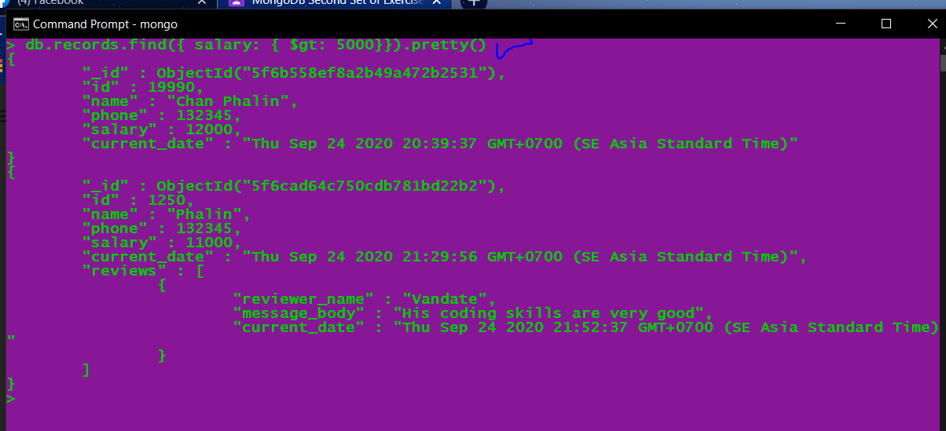

* **Find and display the records where salary is less than or equal to 9000**

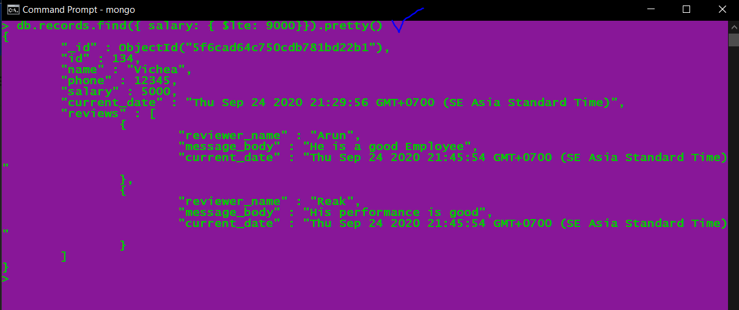

* **Find and display the records where salary is between 8000 and 11000**



**Or we can** 8000 <= salary <= 11000. just test it.

