* Start Free with MongoDB Atlas

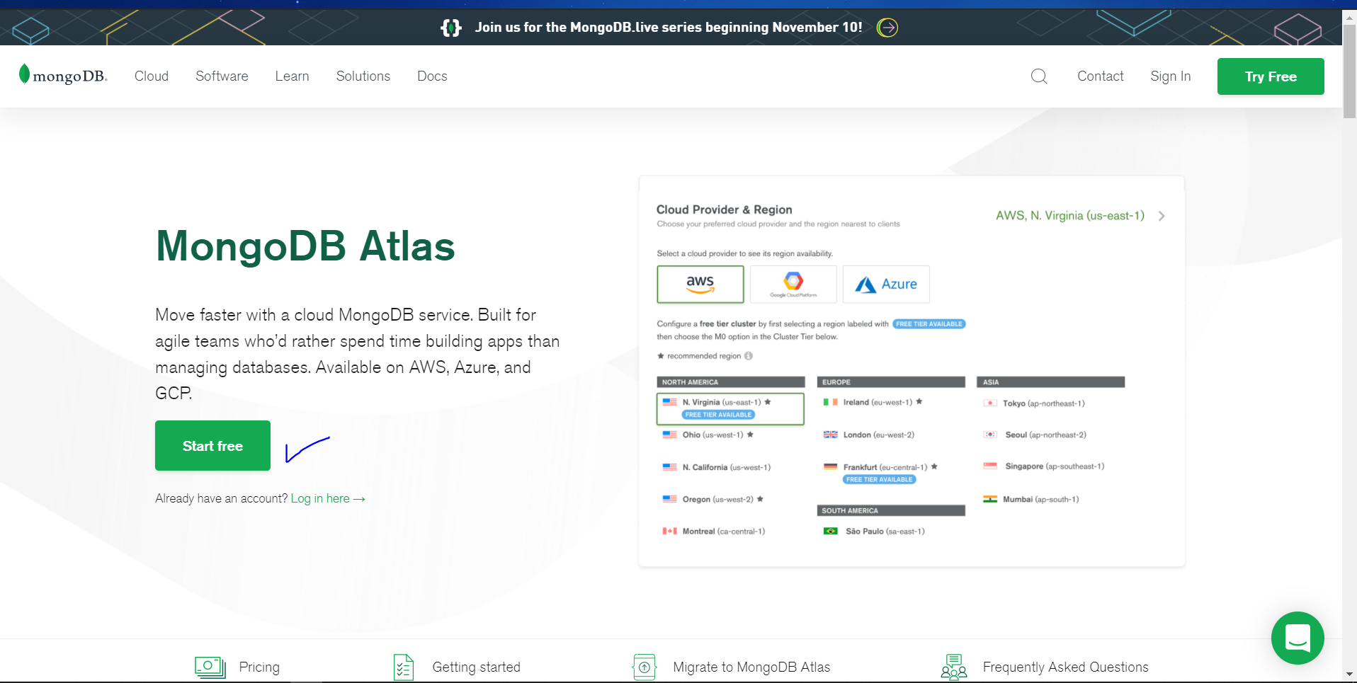

* + - Login with KIT Gmail

🡪 Create Organization (I have created name: KIT FullStack)

🡪 Create Project (I have created name: First Project)

* + - Then it shows the screen to create cluster and follow:

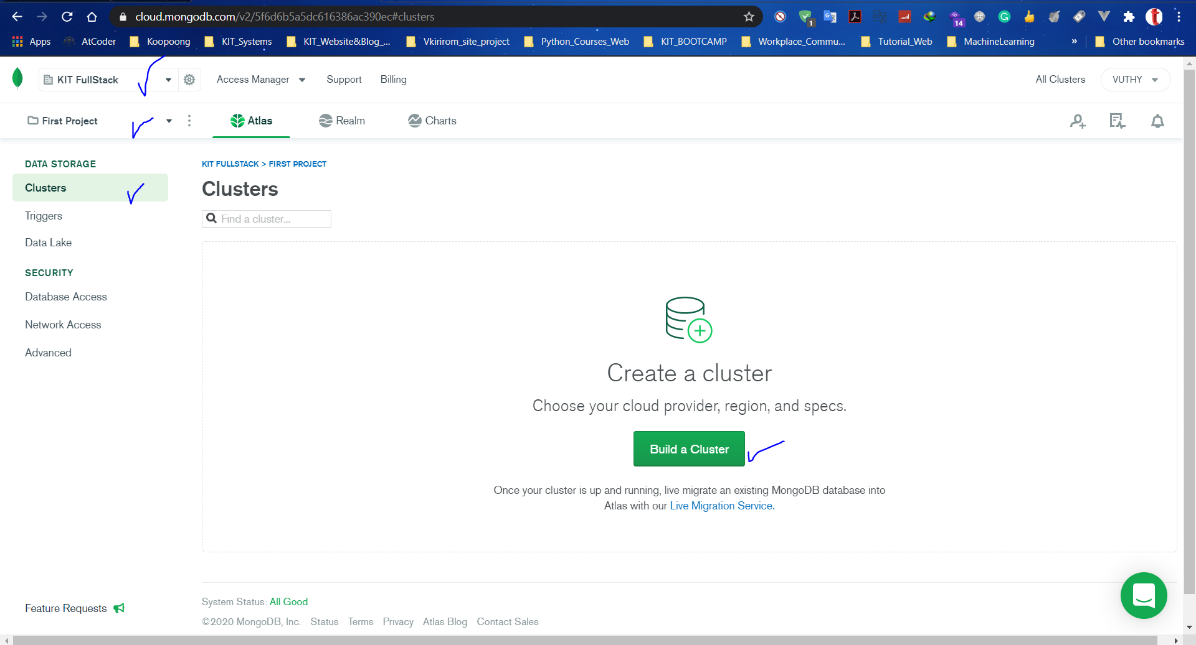

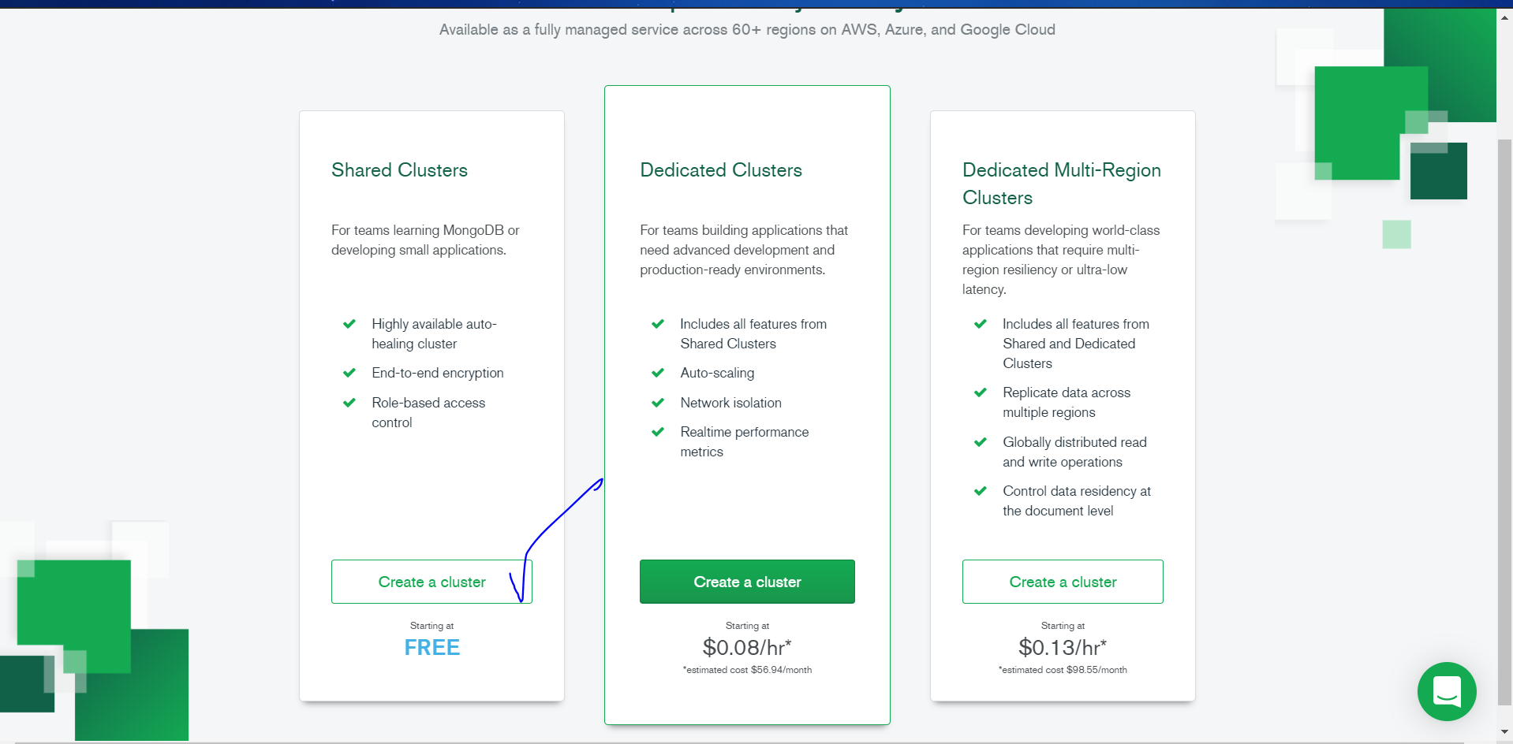

- I chose AWS

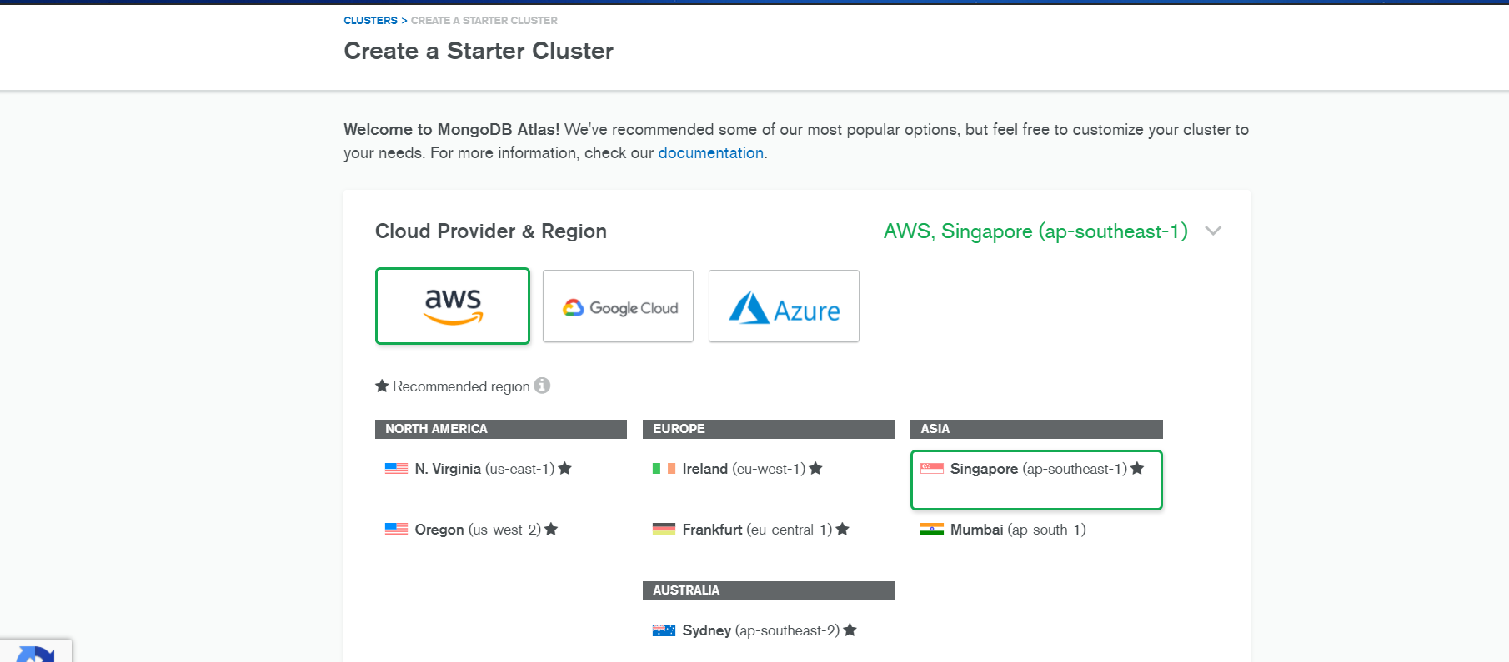

- Chose M0 Sandox

- Cluster name: **VuthyCloudDB**

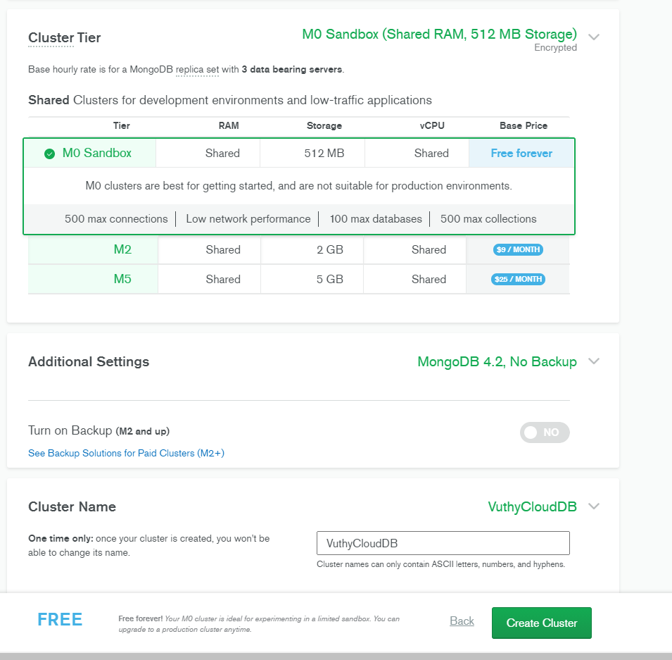

- Under database Access option -> Create user with the name :<Your name> and give read and write permission.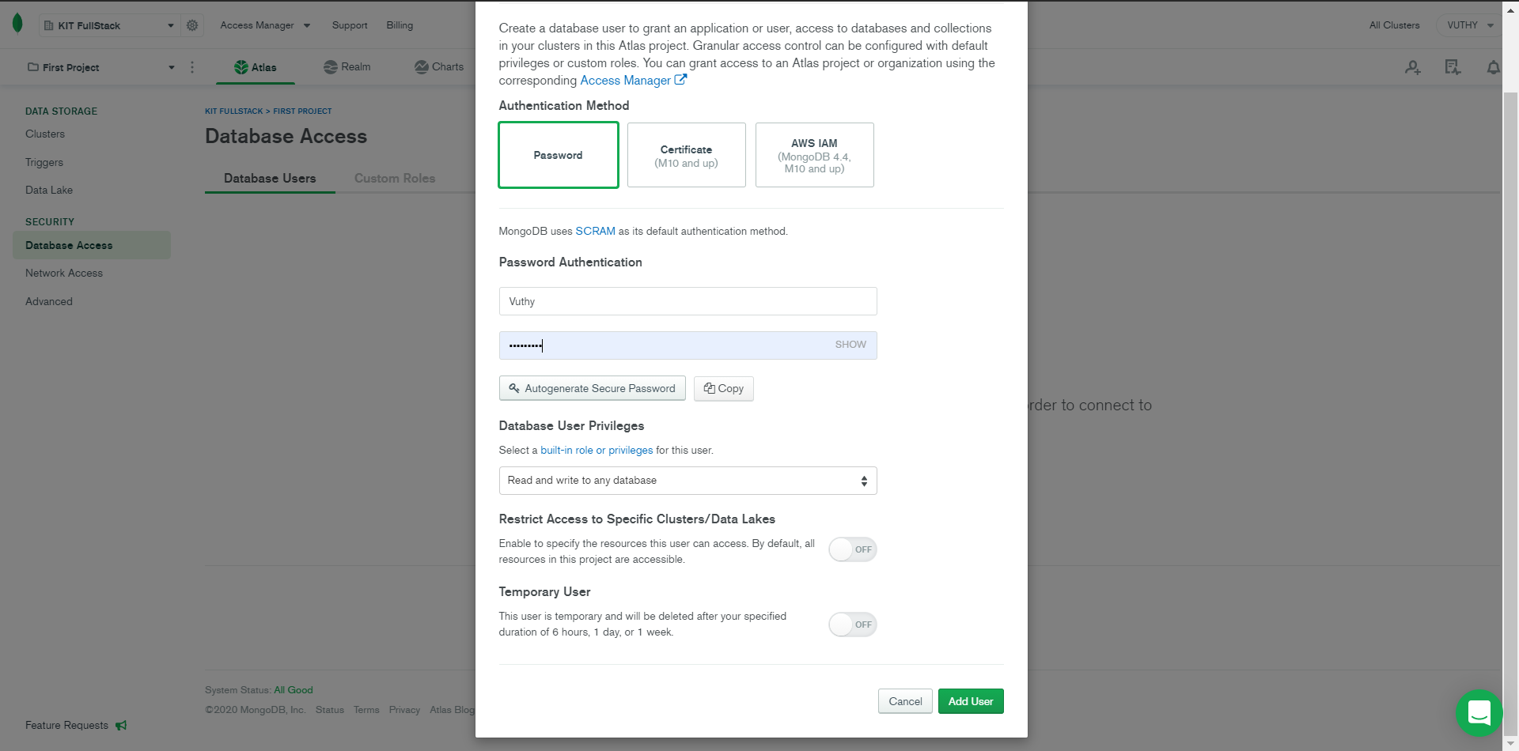

* Under Network Access option -> Provide IPWhitelist option the permission to access from anywhere.

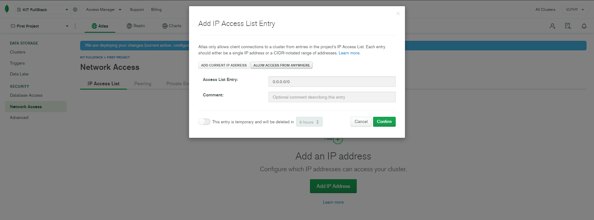

- Under Clusters option -> Choose connect -> Choose connect with the Mongo Shell and copy the connection string paste it in the mongo shell and enter.

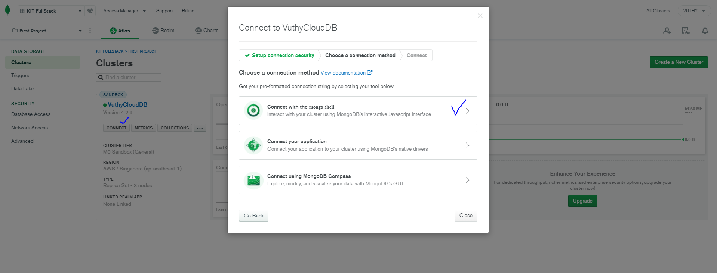

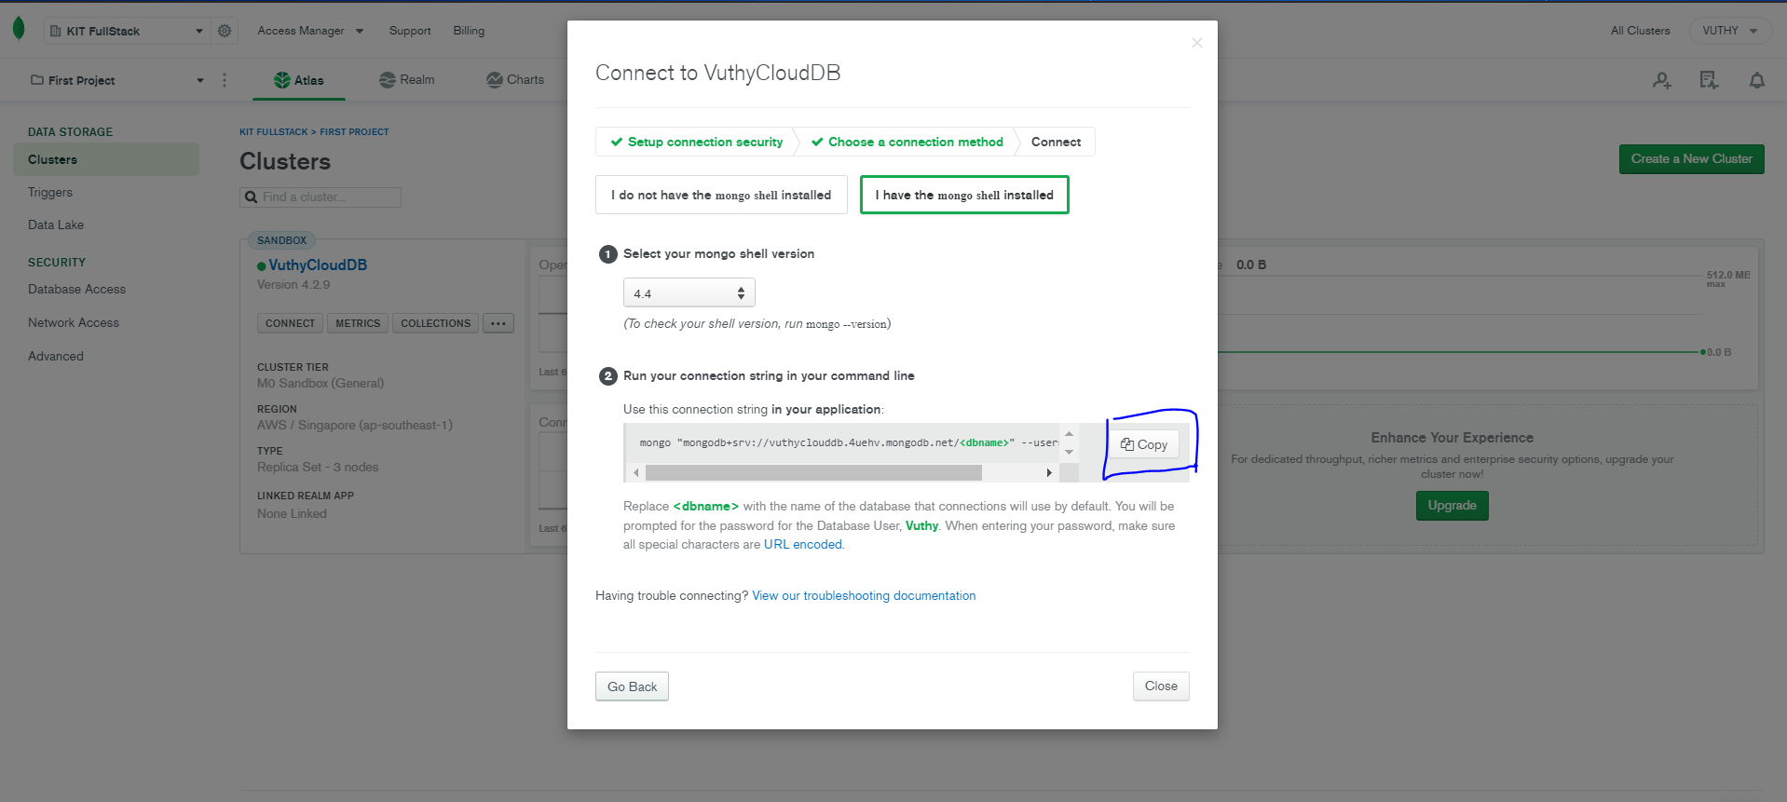

- paste into mongoSHell

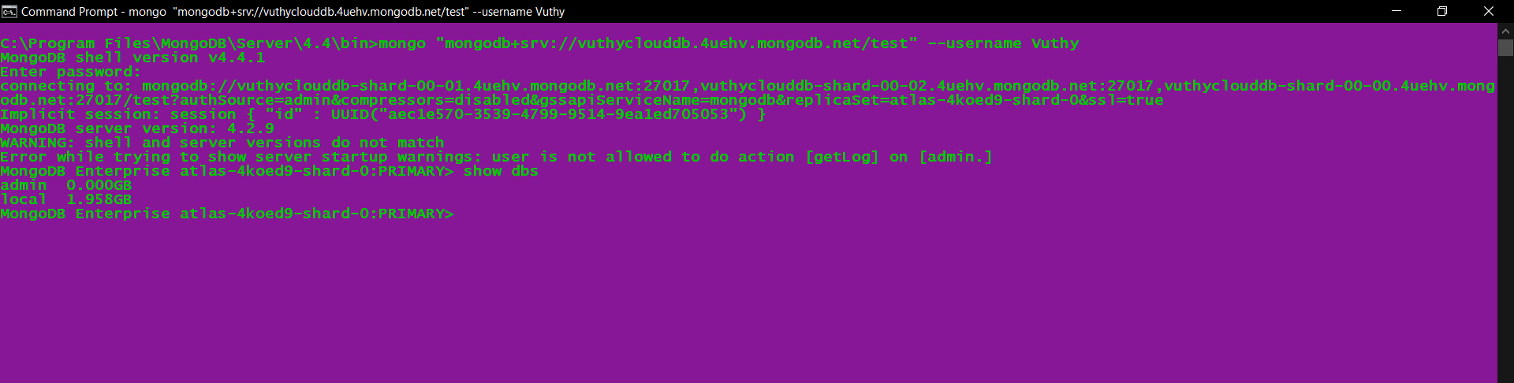

- After connecting your mongo shell with the cloud. Now create a database or use any of the existing databases and create a collection named “**test**” from your Mongo shell (Command Prompt).

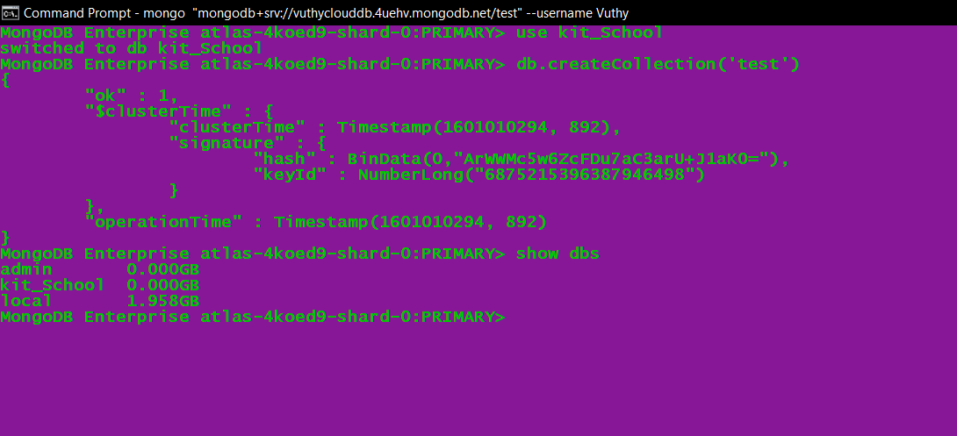

- Insert a record into the collection from command prompt.

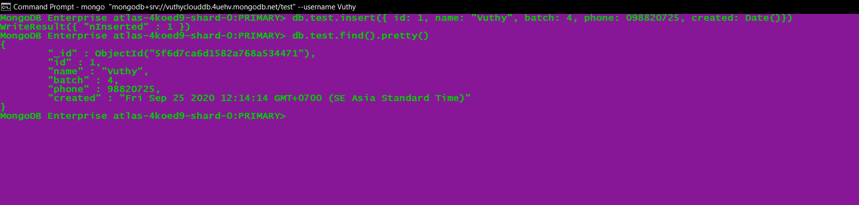

Or we can see in MongoDB Atlas

