**Vue.js Introduction**

* **What is Vue and its advantages?**
  + **Definition of Vue**

**Vue** (pronounced /vjuː/, like **view**) is a **progressive framework** for building user interfaces.  It is one of the most popular frameworks for simplifying web development. Vue mostly works with presentation layer. Vue is focus on view part. Vue.js development is also capable of powering Single Page Application (SPA) when used in combination with the modern tooling and support libraries. It is easy to integrate with big projects for frontend development.

* + **Advantages of Vue**

#### 1) Very Small Size

The success of JavaScript framework is depending on its size. The smaller the size is, the more it will be used. One of the greatest advantages of Vue.js is its small size. The size of this framework is 18-21KB and it takes no time for user to download and use it. This does not mean that it has a low speed because of its small size. Instead, it beat all bulky frameworks like React.js, Angular.js and Ember.js.

**2) Flexibility**

A deal with flexibility is another advantage of Vue.js. It allows the user to write template in HTML file, JavaScript file and pure JavaScript file using virtual nodes. This flexibility also makes it easy to understand for the developer of React.js and Angular.js and any new other JavaScript frameworks.

**3) Simplistic approach**

One of the reasons for the popularity of this framework is easy to understand. The user can easily add Vue.js in an existing project because of its simple structure. They don’t even need to know much about JSX, ES2015. Those who are familiar with HTML and JavaScript can fetch a lot about the framework and get started quickly. This is what makes Vue.js more advantageous for a fast-paced development environment and makes it very easy to make it shift.

**4) Detailed documentation**

Developers always like to use the framework with detailed documentation because it is always easy for them to write their first application. The documentation with Vue.js is so comprehensive that any user who knows a little about JavaScript and HTML can develop his own application or web page.

**5) Reactivity**

It means at every point, when the variables change, it will automatically inform their peers. This is where variables in Vue.js are reactive.

**6) Two-way Communication**

Vue.js facilitates two-way communication because of its Model–view–view-model (MVVM) architecture which makes it quite easy to handle HTML blocks. In this respect, it seems very close to Angular.js which also speed up HTML blocks.

* **What is the role of Vue as a front-end framework?**
  + **Vue.js framework** is used for building User Interface of web application. And it enables easy creation of powerful single page applications (**SPA**) and progressive web application (**PWA**).
* **What is the difference between Vue.js and Bootstrap?**
  + **Vue.js**

Vue.js is a progressive framework used to develop frontend applications with heavy user interaction, like adding validations in form, complex business logic etc. It has more to do with JS than CSS.

* + **Bootstrap**

Bootstrap is a CSS framework, it is used for styling and designing the application. It will be used within a Vue.js application to provide the layout and styling for components and in some instances some plugin functionality for things like date pickers and dialog boxes

* **What is the progressive web framework?**
  + **Progressive Web Framework** is the front-end framework such as Vue.js, React.js, Angular.js, etc. that used for building single page application (**SPA**) and progressive web application (**PWA**), is a type of application software delivered through the web, built using common web technologies including HTML, CSS and JavaScript. It is intended to work on any platform. Functionality includes working offline, push notifications, and device hardware access, enabling creating user experiences similar to **native applications**on desktop and mobile devices. Since a progressive web app is a type of webpage or website known as a web application, there is no requirement for developers or users to install the web apps via digital distribution systems like **Apple App Store** or **Google Play.**
* **What are Single File Applications?**
  + Single File Applications are the applications that built by used single file component such as Vue.js that has Vue Component file includes HTML, CSS, and JAVASCRIPT in a single file.
    - EXAMPLE:

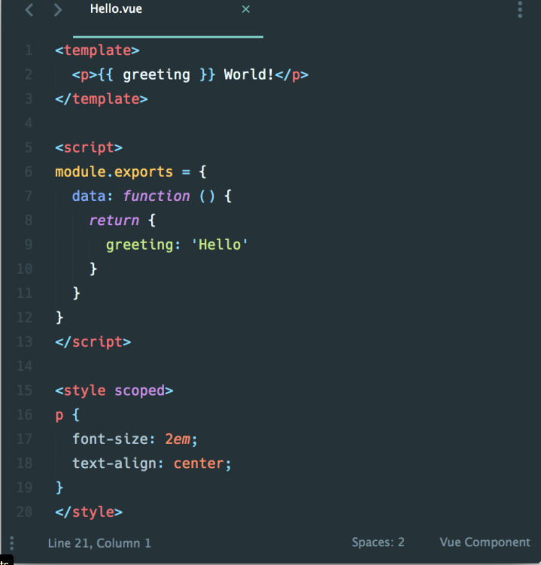

* + A **single**-**page application** is an app that works inside a browser and does not require page reloading during use.
* **What are the three parts of a component?**
  + The three parts of a component are: **Template**, **Script**, and **Style**.
    - **EXAMPLE:**



* **What are the differences between Vue CDN and Vue CLI?**
  + **Vue CDN**
    - CDN or Content delivery network refer to geographically distribute group of servers which work together provide fast delivery of internet content. So, we can install vue through Vue CDN.
    - For example:

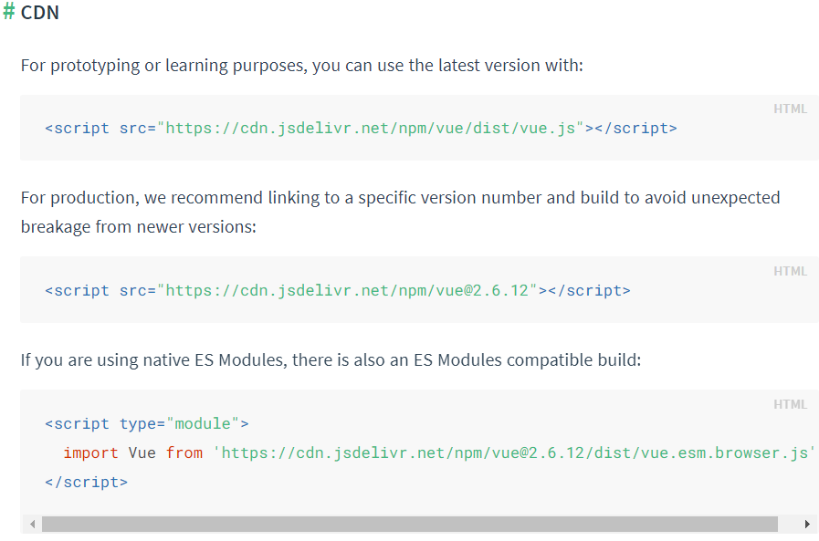

we can browse the source of the NPM package at [**cdn.jsdelivr.net/npm/vue**](https://cdn.jsdelivr.net/npm/vue/).

* + **Vue CLI**
    - Vue **CLI** is stand for Vue Command Line Interface (@**vue**/**cli**) is a globally installed NPM package and provides the **Vue** command in

terminal. It provides the ability to quickly scaffold a new project via **Vue** create, or instantly prototype new ideas via **Vue** serve. We can also manage our projects using a graphical user interface via **Vue** UI.