**HOW TO INSTALL VUE APP PROJECT USING VUECLI/NPM**

* First, We need to install **Node, NPM, and VueCLI** into our computer/machine.
  + I already installed **node**, and **NPM**. So picture below just show how to intall **Vue CLI** in cmd.

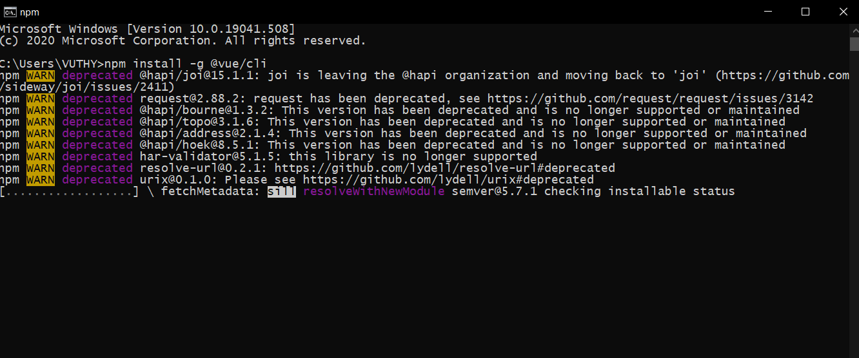

* Check Version (node, npm, vue)

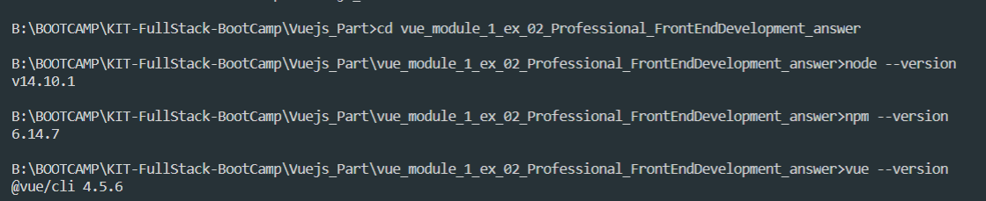

* Go into directory that we want to create Vue Project. Then follow this:
* **Step 1**: command: vue create {{project_name}} (create Vue App Project)
  + Pick preset: {{ I picked Manually select features }}
  + Then the next step is followed.

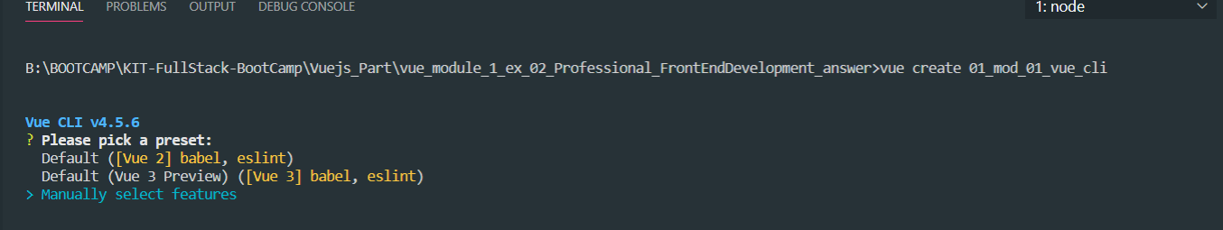

* Step 2: Check the features needed for our project
  + Then the next step is followed.

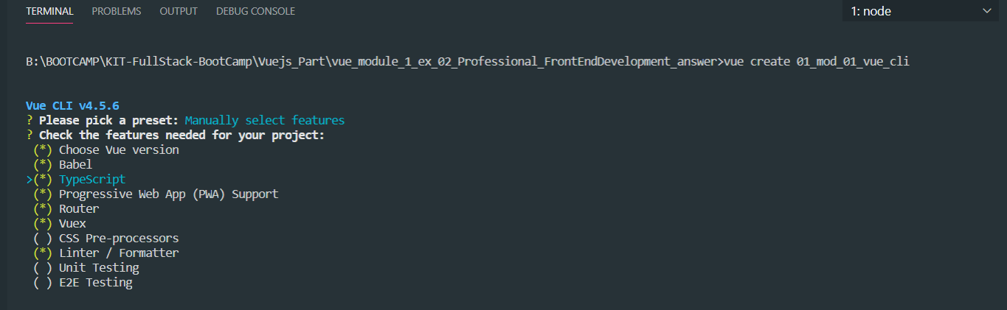

* Step 3: Choose a version of vue.js that want to start the project with

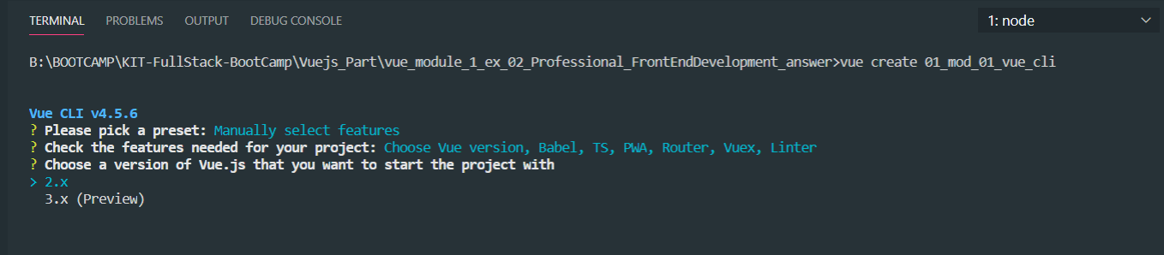

* Step 4: Use class-style component syntax or not?
  + I chose YES

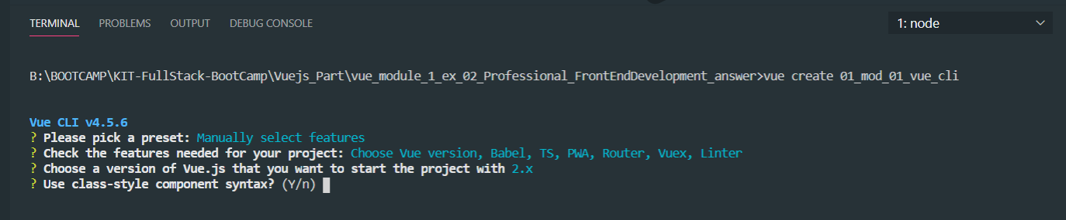

* Step 5: Choose TypeScript, and use history mode for router?
  + I chose YES.

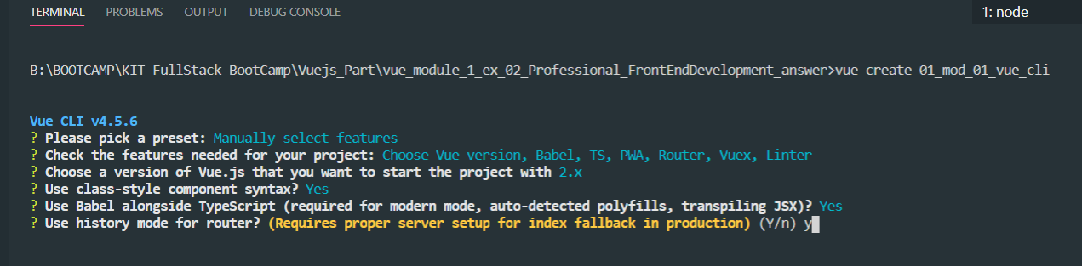

* Step 6: Pick a linter / formatter config
  + I picked {{EsLint + Prettier}}

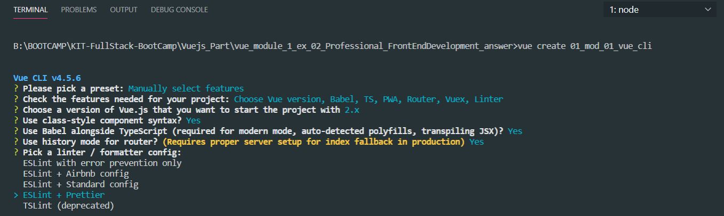

* Step 7: Pick additional lint features
  + I picked all (*)

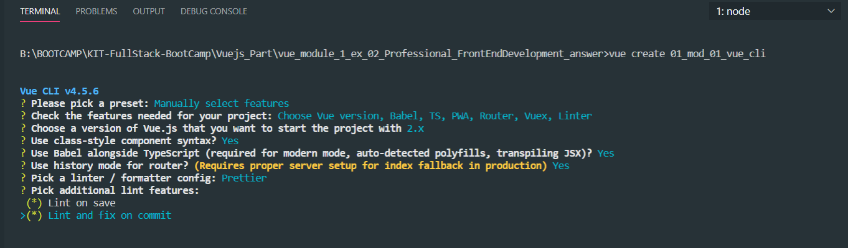

* Step 8: Where do you prefer placing config for Babel, ESLint, etc.?
  + I choose {{package.json}}

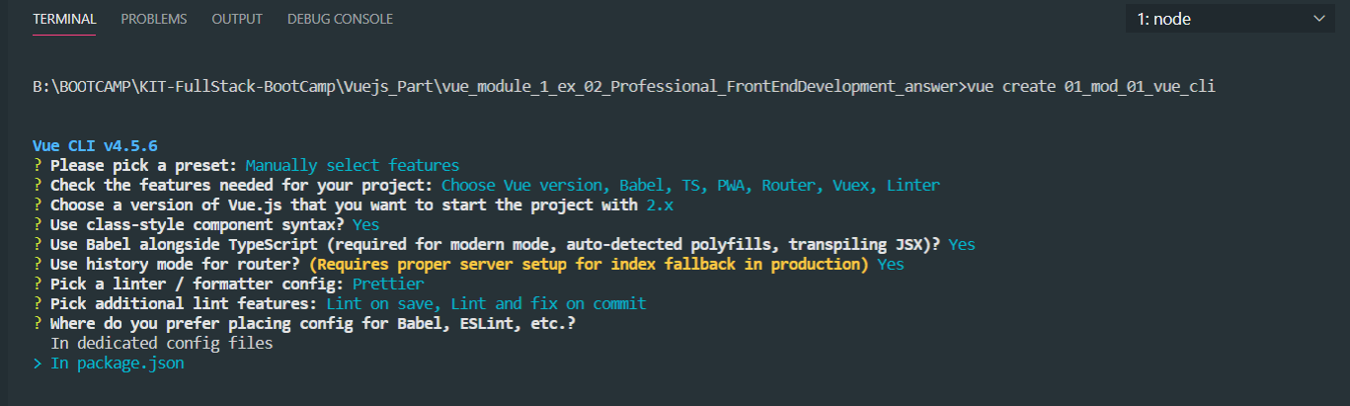

* Step 9: Save this as a preset for future project or not?
  + I choose YES. But I recommend that do not choose YES if we don’t want to use for future project.

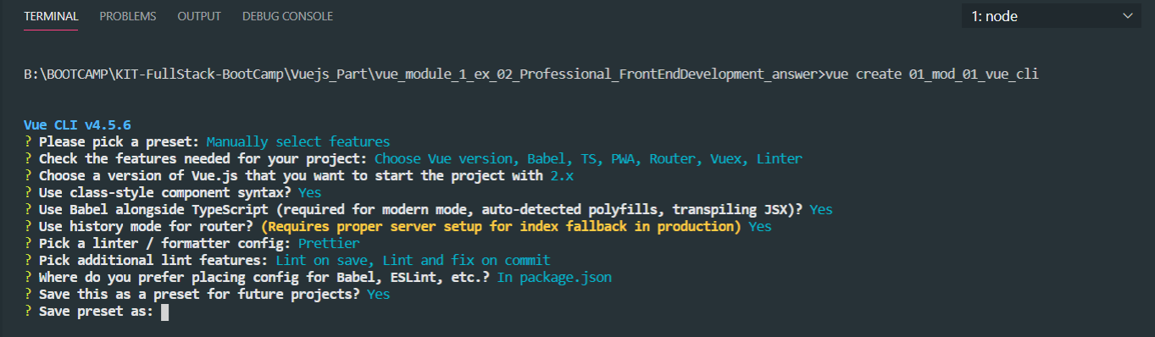

* Step 10: After above steps already it will be installing Vue Cli plugin into our project.

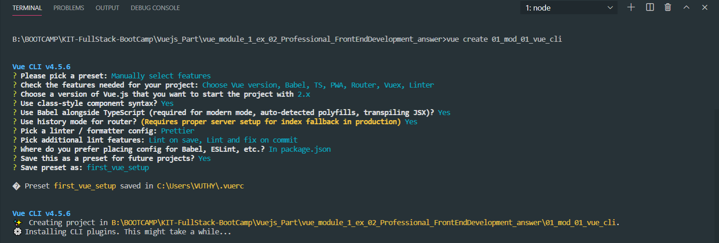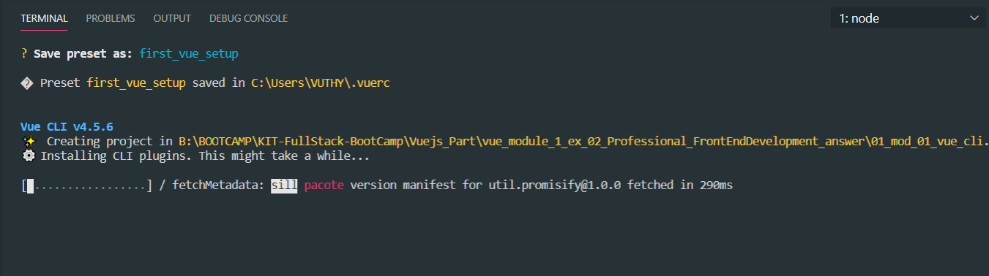

* After installed already we can see the directory in our project.

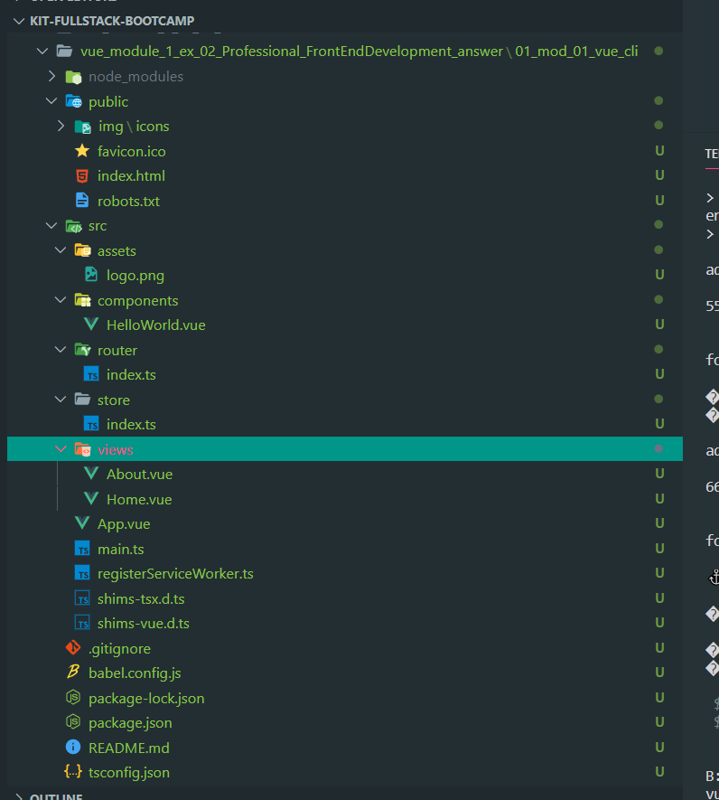

* Then go to project directory that has installed already.
  + cd <directory_name>

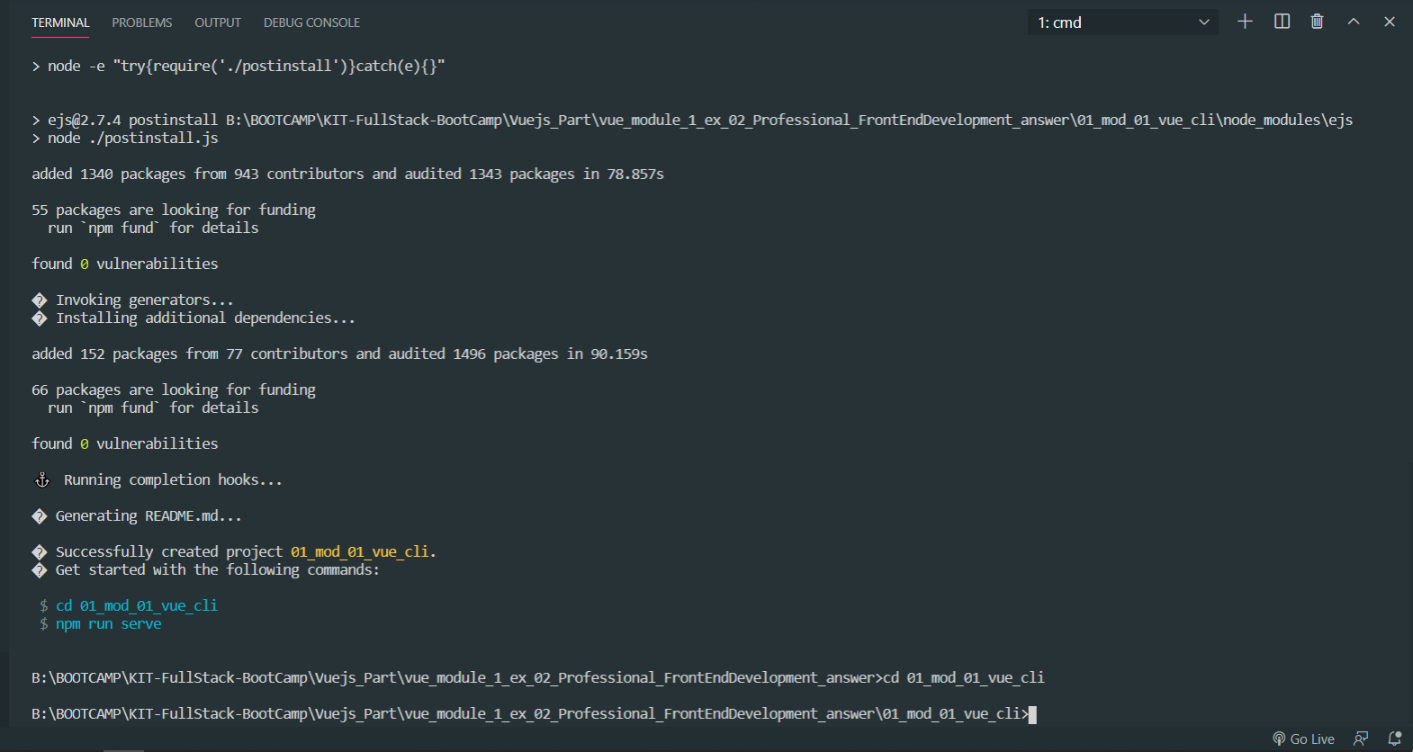

* Then We can run the project into browser
  + Command: npm run serve

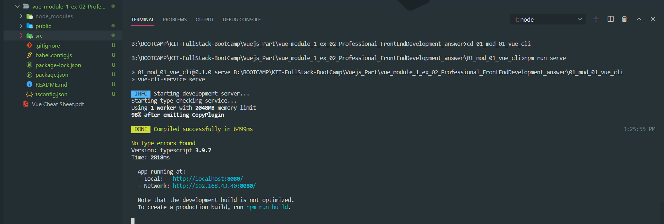

* This is the output of our first Vue App.

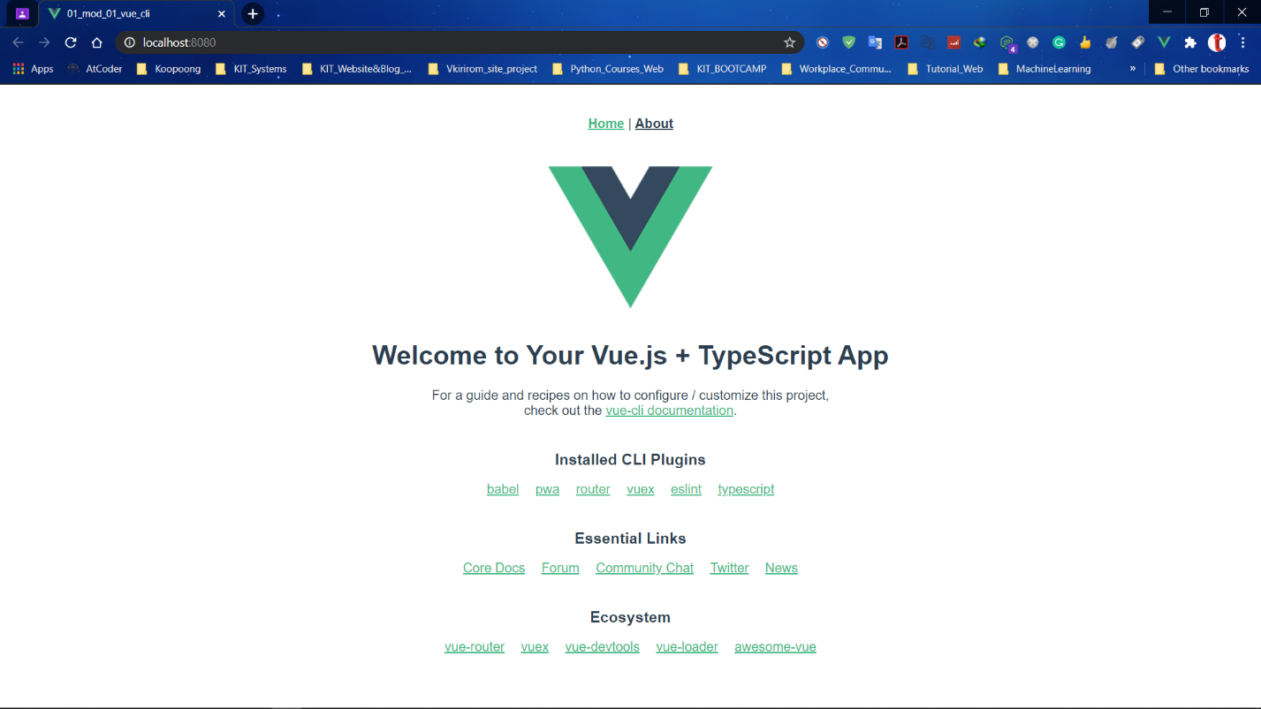

====================== **END** =======================