What does your web server do?
- A web server takes a client request and gives something back to the client.
What does the web client do?
- A web client lets the user request something on the server, and shows the user the result of the request.
Clients and servers know HTML and HTTP
- HTML tells the browser how to display the content to the user.
- HTTP is the protocol clients and servers use on the web to communicate.
- The server uses HTTP to send HTML to the client.
What is the HTTP protocol ?
- HTTP runs on top of TCP/IP.
- Key elements of the request stream:
+ HTTP method (the action to be performed)
+ The page to access (a URL)
+ Form parameters (like arguments to a method)
- Key elements of the response stream:
+ A status code (for whether the request was successful)
+ Content-type (text, picture, HTML, etc.)
+ The content (the actual HTML, image, etc.)
HTML is part of the HTTP response:
- An HTTP response can contain HTML. HTTP adds header information to the top of whatever content is in the response (in other words, the thing coming back from the server). An HTML browser uses that header info to help process the HTML page. Think of the HTML content as data pasted inside an HTTP response.
HTTP methods:
- GET method is a simple request, POST can send user data (to make complex requests).
- EAD, TRACE, PUT, DELETE, OPTIONS, and CONNECT.
Anatomy of an HTTP GET request :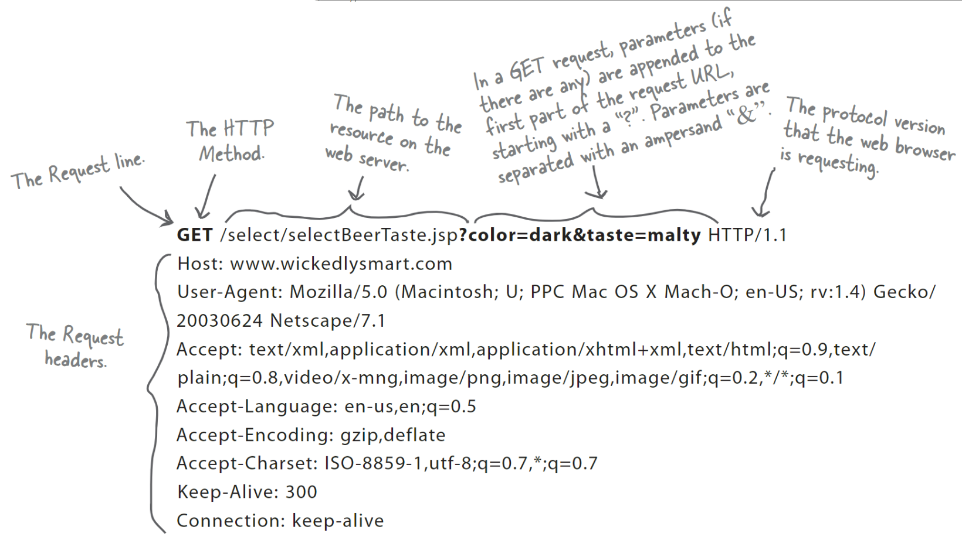
Anatomy of an HTTP POST request:
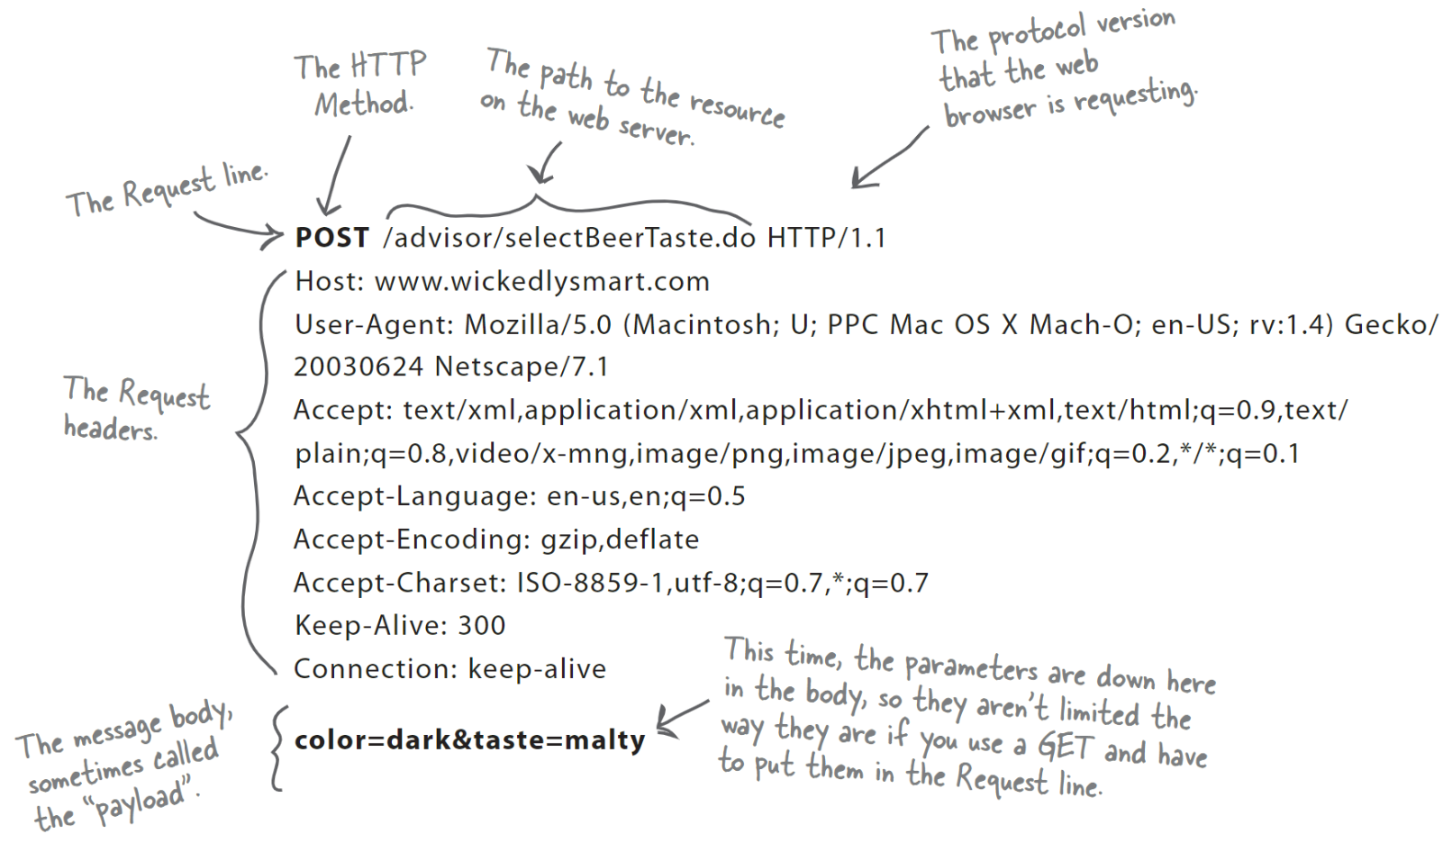
Anatomy of an HTTP response:
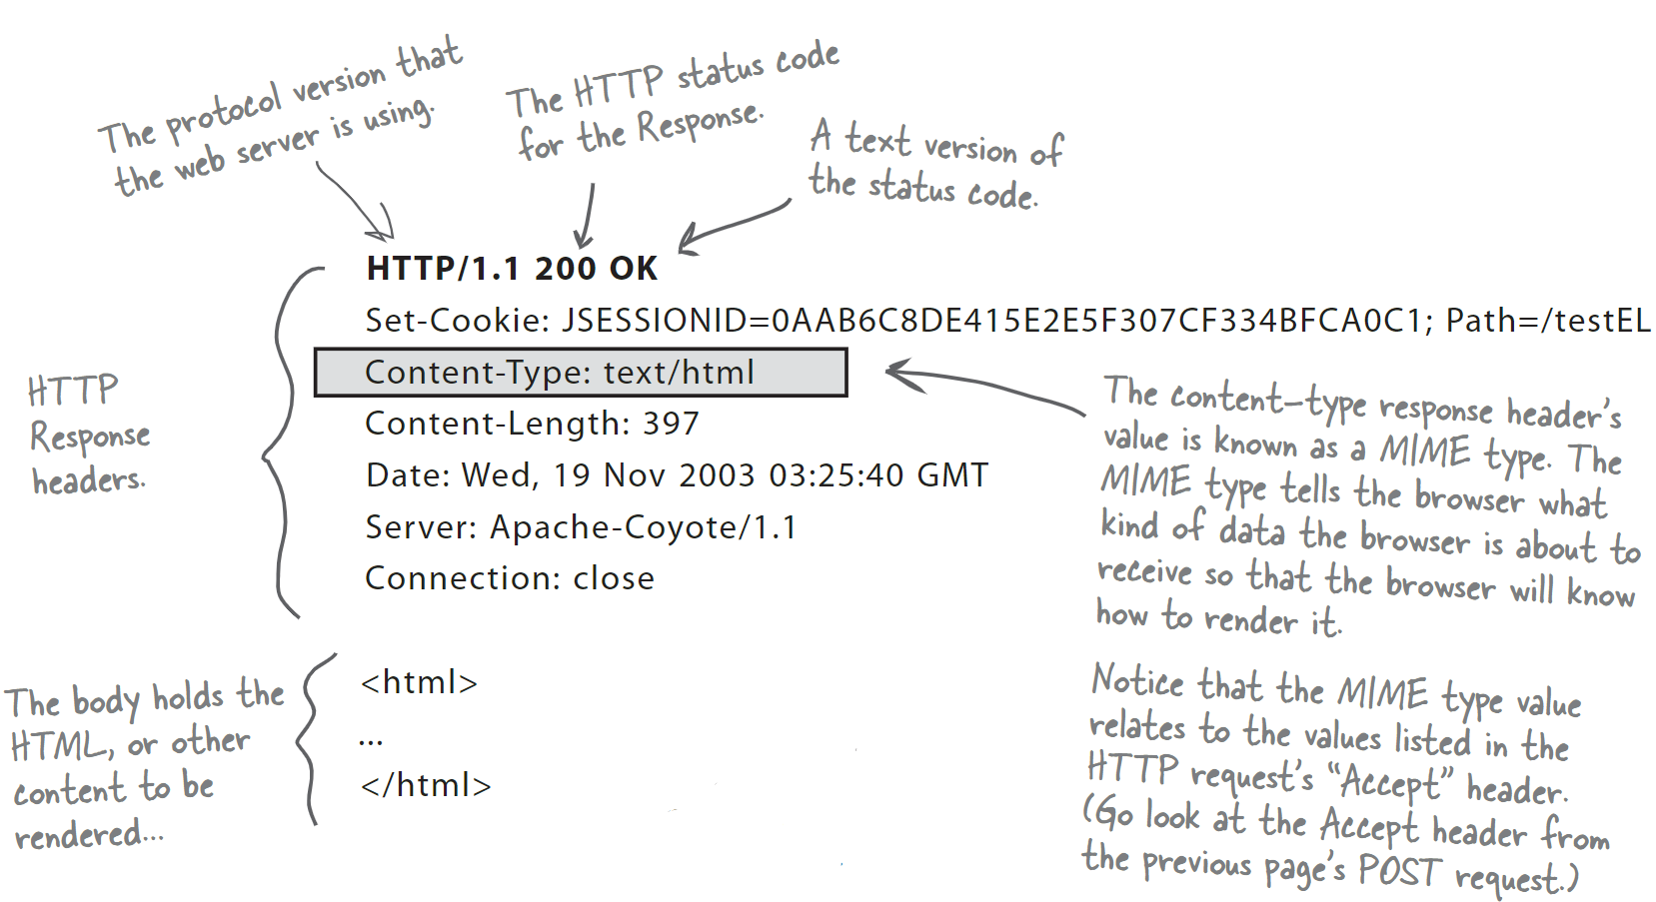
All the pieces on one page:
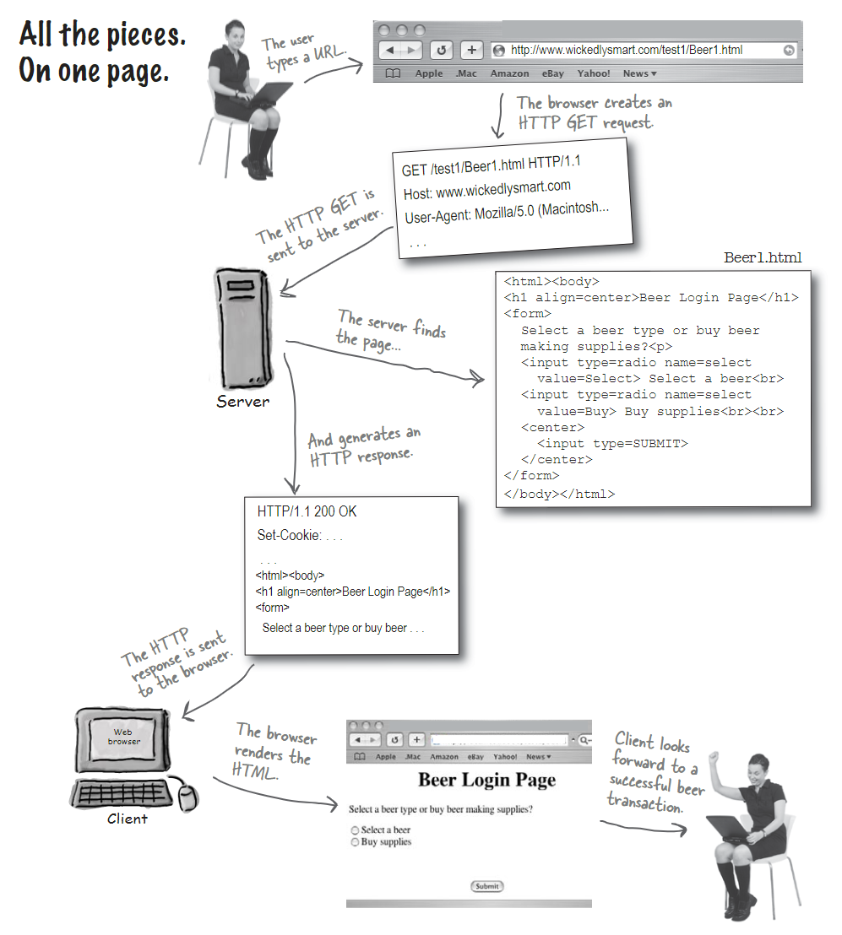
URL (Uniform Resource Locators):
Every resource on the web has its own unique address, in the URL format.
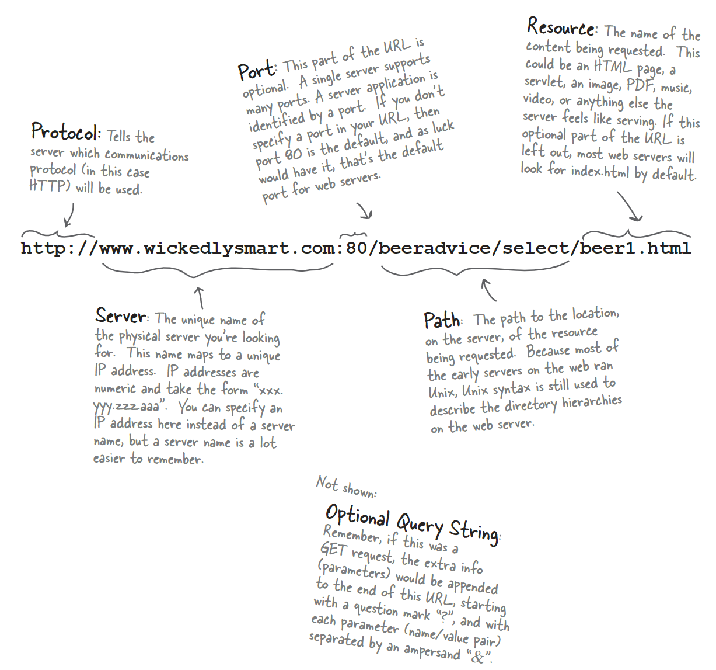
- A TCP port is just a 16-bit number that identifies a specific software program on the server hardware.
Static web pages:
- A static page just sits there in a directory. The server finds it and hands it back to the client as is. Every client sees the same thing.
Two things the web server alone won’t do:
- 1. Dynamic content
- 2. Saving data on the server
CGI program (Common Gateway Interface):
- Program for a web server helper app.
- Servlets and CGI both play the role of a helper app in the web server.
Servlets Demystified (write, deploy, run):
- 1. Build this directory tree (somewhere not under tomcat). 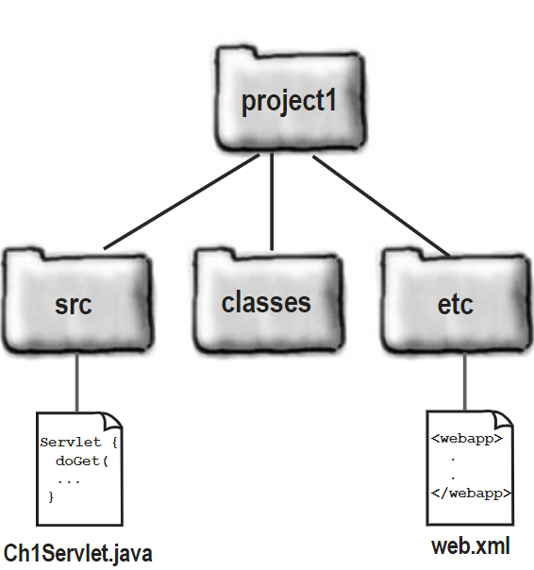
- 2. Write a servlet.
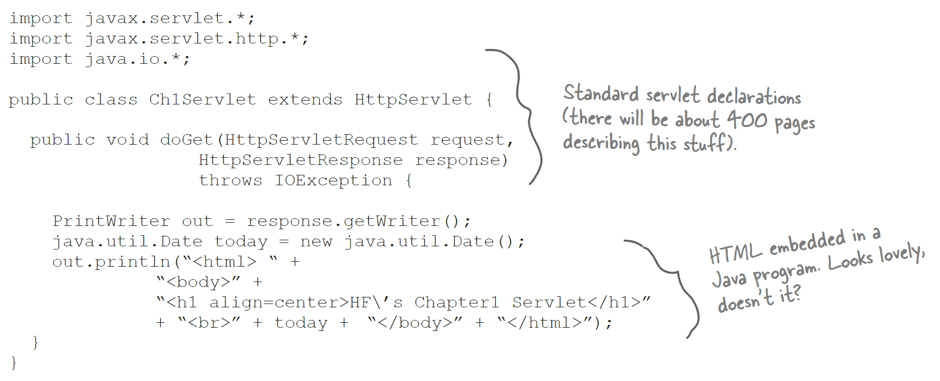
- 3. Create a deployment descriptor (DD) named web.xml
