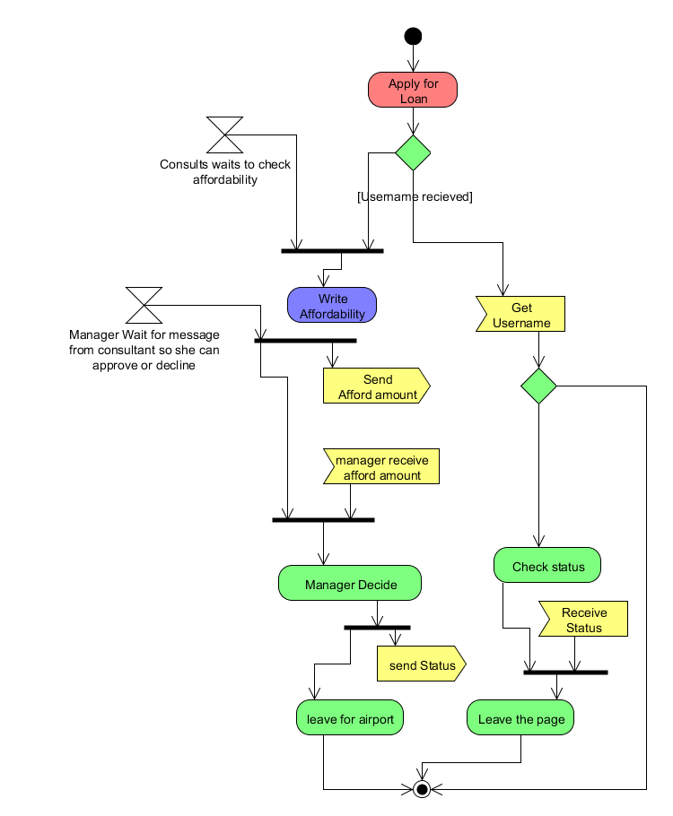

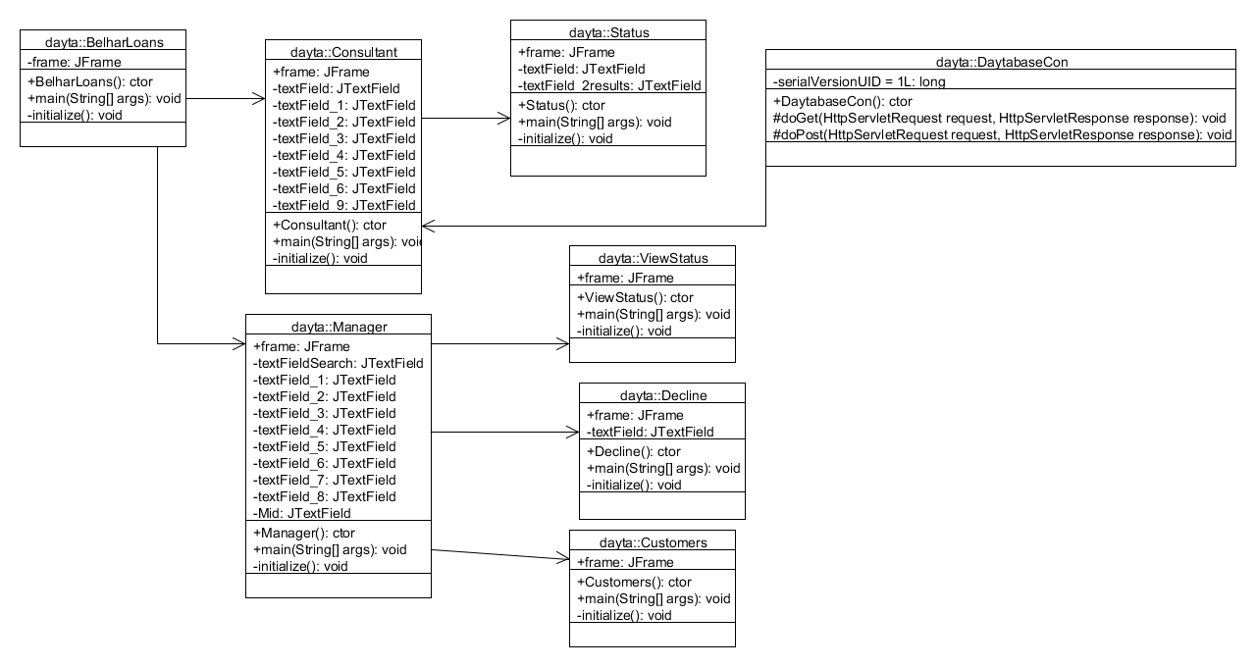

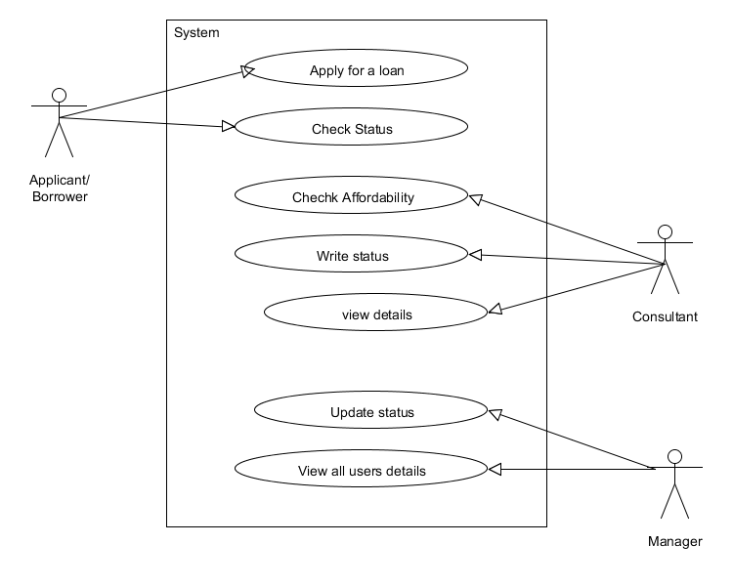

Step 1: Apply for load

The client will go into a website (<http://localhost:8080/217135994/Register.html>) and register their details

Step 2: Check Affordability

The Consultant will then check if the applicant is suitable for the loan then she will send a message to the manager.

Step 3:

The manager will view all of the clients who have sent loans requests

Step 4:

The manager will check the status of affordability which was sent by the consultant

Step 5: Decision

The manager will then decide if she will issue the to the client or not then the message will be sent to the client

Step 6: Check Status

The client will then Login in to the system and view their status in this link : <http://localhost:8080/217135994/CheckStatus.html>

consultant

manager

Password

Username

status

Back

send

Back

Decline

username

reason

status

username

afford

clear

status

exit

Deposableame

salaryame

nameame

titleame

usernameame

Search

Search

view

SA_ID

clear

decline

decline

all

View all

suburb

deposable

salary

surname

name

title

username

State diagram

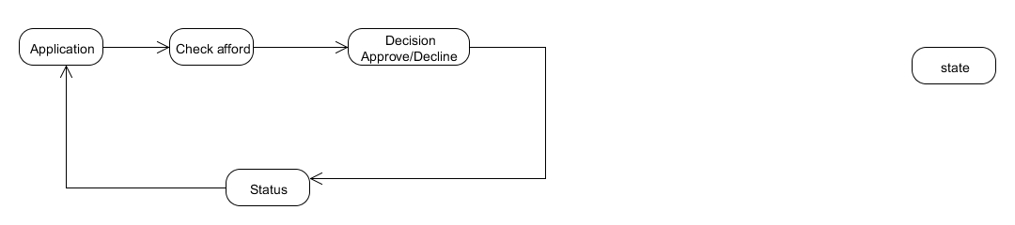

Sequence Diagram

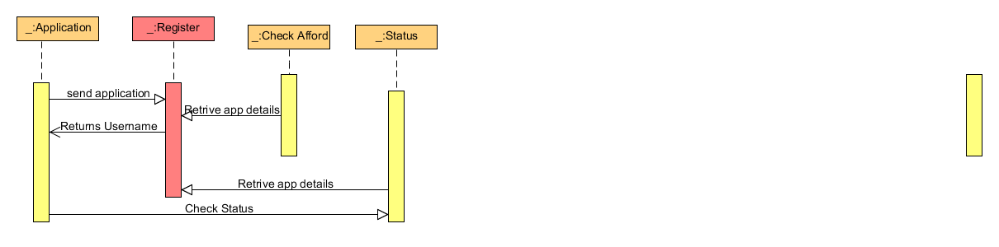

TESTS

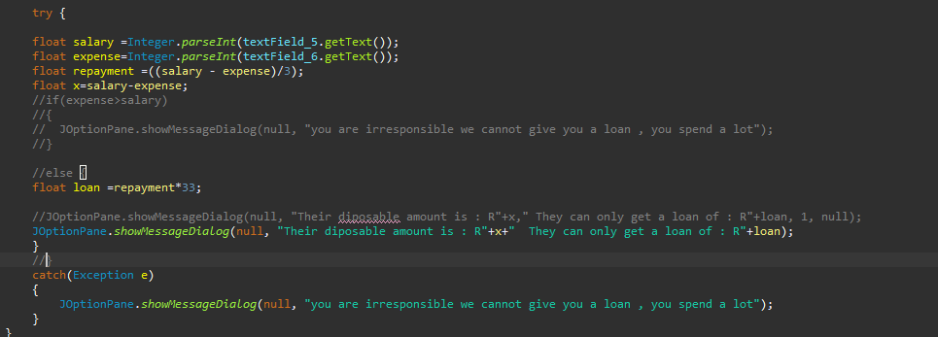

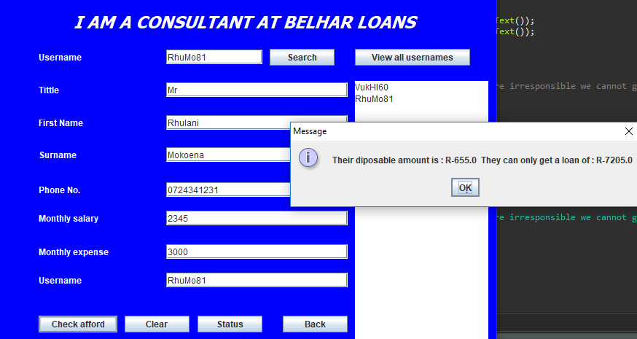

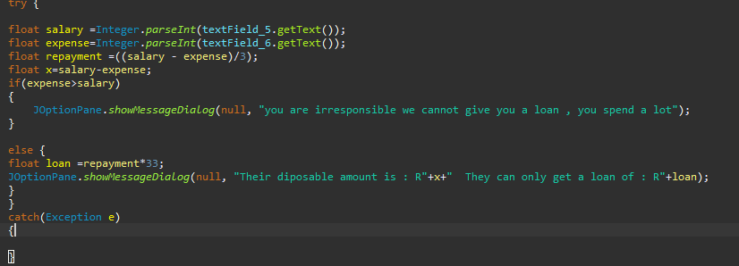

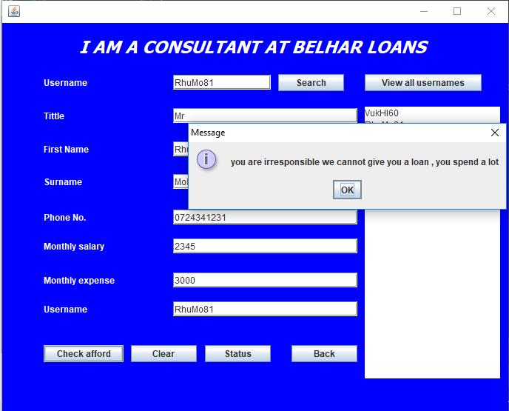

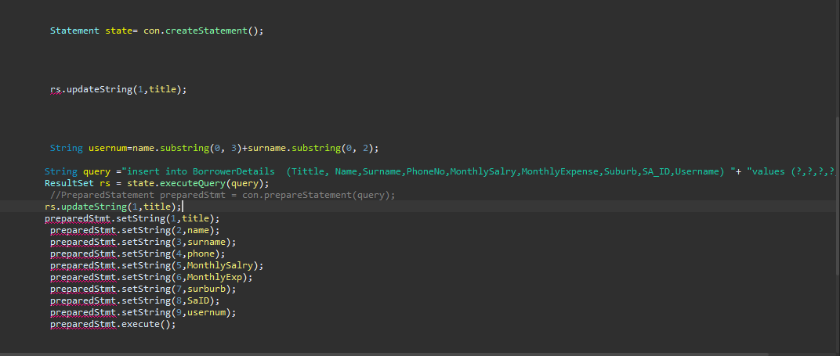

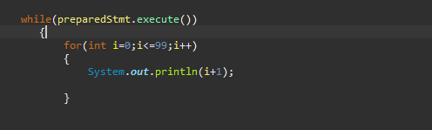Trying to get the right username

User Manual

For someone who wants to run the software they must first start-up tomcat or if they don’t want to do that they must just follow this link <http://localhost:8080/217135994/Register.html>. They will be directed to the webpage that ask if they are South African citizen or not then they will be redirected to a webpage where they will register or apply for a loan. The on the other side of the manager they must make sure that they have java JDK 8 installed on their system. Then they can just click the jar file

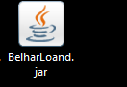

After opening this software the user will be required to login as manager or a consultant hence they must make sure that they MYSQL installed so that the can create a data base by simply clicking on the script files which will automatically create a data base for them.