A Hybrid Information Extraction and Retrieval‑Augmented Generation Framework for Legal Compliance Checking in Vietnamese and International Sports Governance

Executive Summary
This report develops a rigorous, paper-ready blueprint for a hybrid compliance-checking system that targets Vietnamese and international sports governance regimes (e.g., match rules, disciplinary norms, anti‑doping, arbitration procedures). The core challenge is to deliver (i) an actionable compliance verdict and (ii) a defensible explanation grounded in authoritative text—while handling multilingual drafting/translation artifacts, cross‑jurisdiction conflicts, and frequent rule updates (effective dates, superseding amendments). The legal/sports setting makes hallucination, uncited claims, and version mistakes unacceptable. [1]
The proposed solution is a hybrid “IE → retrieval → constrained generation → verification” pipeline:
- Information Extraction (IE) converts both (a) user scenarios and (b) governance documents into structured representations: entities/roles, actions, conditions, temporal constraints, and norm types (obligation/prohibition/permission/sanction). Legal‑style extraction is non-trivial but well-studied in domains like obligations/prohibitions detection. [2]
- Retrieval‑Augmented Generation (RAG) retrieves the controlling provisions and generates explanations only from retrieved evidence, leveraging the foundational RAG approach for knowledge-intensive tasks. [3]
- Hallucination controls use verification-style methods (e.g., Chain‑of‑Verification) and automated faithfulness metrics (RAGAS, FActScore-like atomic checks) to measure and reduce unsupported claims. [4]
- Parameter‑efficient adaptation (LoRA/PEFT) enables domain tuning without full fine-tuning costs, supporting multilingual legal compliance tasks at feasible compute budgets. [5]
The starting point is a GitHub prototype (private) that already encodes key compliance-system instincts: structural chunking, citation-first JSON outputs, hybrid indexing, and scenario-based rule matching. This report generalizes and strengthens that prototype into a cross‑jurisdiction, version‑aware, multilingual compliance framework, and proposes an evaluation protocol against baselines (pure rules, pure LLM, pure RAG) using metrics including Precision/Recall/F1, Exact Match, and Hallucination Rate (plus retrieval metrics and abstention quality). [6]

Research Approach and Evidence Base

Key information needs guiding the research
This deep research was structured around six information needs:
- What a working baseline system already implements (from the GitHub prototype): ingestion, structural parsing, indexing, prompt conventions, and evaluation scaffolding.
- How to formalize cross‑jurisdiction sports governance (norm hierarchy, appeals/arbitration forum, effective dates, language precedence). [7]
- Which peer‑reviewed methods best support legal IE + RAG (retrieval, obligation extraction, legal benchmarks, multilingual legal evaluation). [8]
- How to train/adapt models responsibly in multilingual legal settings (Vietnamese NLP toolchain, LoRA, legal domain pretraining). [9]
- How to evaluate correctness and hallucination in a compliance context (RAGAS, FActScore, NoMIRACL for non‑relevant retrieval). [10]
- What ethical/legal implications dominate (privacy, liability, jurisdictional risk, governance). [11]

Sources consulted and connectors used
Enabled connectors explicitly used: GitHub (private repository inspection of bomxp/nlp-football-chatbot).
External literature and primary/official materials were gathered via web search, prioritizing peer‑reviewed venues and official governance documents (e.g., anti-doping codes, arbitration procedures, laws-of-the-game updates). [12]
Practical limitation note: an attempt to use file-based search indicated that some previously uploaded files had expired, so this report does not rely on those uploads for evidence and instead uses the GitHub connector and web-cited sources.

Problem Statement and Cross‑Jurisdiction Challenges

Problem statement
Given a user query (a question or scenario) and a corpus of governance texts, the task is to determine compliance status—e.g., compliant / non‑compliant / conditional / insufficient evidence—and produce a traceable justification, consisting of controlling provisions, applicability conditions, and citations. In sports governance this spans multiple normative layers:
- Domestic legal rules and implementing regulations (e.g., Vietnamese legislation governing sports organizations, tournaments, athlete rights/obligations). [13]
- Sport‑specific rules and federation regulations (e.g., national federation laws/rulebooks). [14]
- International regulatory regimes (e.g., anti‑doping codes, disciplinary codes, eligibility frameworks). [15]
- Dispute resolution and appellate procedures (e.g., CAS procedural rules, amendments, effective dates). [16]
Compliance automation is difficult because the system must simultaneously be accurate, version‑correct, and evidence‑bounded.

Multilingual and cross‑jurisdiction “gotchas” that must be engineered explicitly
Language precedence and translation drift. Even when multiple languages exist, one text may prevail legally. The World Anti‑Doping Code specifies the Code is published in English and French and that the English version prevails in conflicts. [17]
Vietnamese federation materials may be translations or adapted editions of international rules; translation nuances can shift thresholds, definitions, or exceptions—making purely semantic similarity search risky.
Effective dates and version conflicts. Sports rules update on seasonal cycles. For example, the 2025/26 Laws of the Game explicitly state an effective date (“Effective from 1st July 2025”), requiring time‑scoped retrieval and reasoning. [18]
Similarly, the CAS Code changes via amendments (e.g., amendments effective 1 July 2025) and has in‑force versions (e.g., a 2023 code “In force as from 1 February 2023”). [19]
A compliance system must treat “what rule applies?” as a first-class decision.
Forum and hierarchy complexity. Sports disputes often route through specialized bodies and arbitration. FIFA’s public materials emphasize that CAS plays a central role in football-related disputes and that appellate review routes to CAS. [20]
This implies compliance checking may require not only substantive norms (e.g., doping, integrity) but also procedural compliance (deadlines, appeal requirements), which are time- and forum-sensitive. [16]
Vietnamese NLP constraints. Vietnamese text processing requires reliable word segmentation and NER; off-the-shelf English tokenizers degrade significantly. VnCoreNLP provides Vietnamese segmentation/POS/NER/parse; PhoBERT improves Vietnamese NER and other tasks compared to multilingual baselines like XLM-R. [21]
Benchmark evidence that “legal multilingual is hard.” LEXTREME (multilingual legal benchmark) reports modest results even for strong baselines and notes that ChatGPT struggles with multiple tasks—supporting the assumption that “just prompt a general LLM” is not sufficient for cross‑jurisdiction compliance. [22]

Framework Design and Architecture

Design principles
- Structure first, generate last. Extract structured facts/norms before generation to reduce ambiguity and improve determinism. [2]
- Citations are required for every material claim. RAG is used to bind explanations to evidence; abstain when evidence is missing. [23]
- Version- and jurisdiction-aware retrieval. Always filter by effective dates, issuer, and jurisdiction before generating. [24]
- Measure hallucination explicitly. Faithfulness must be a tracked metric, not an assumption. [10]

System architecture
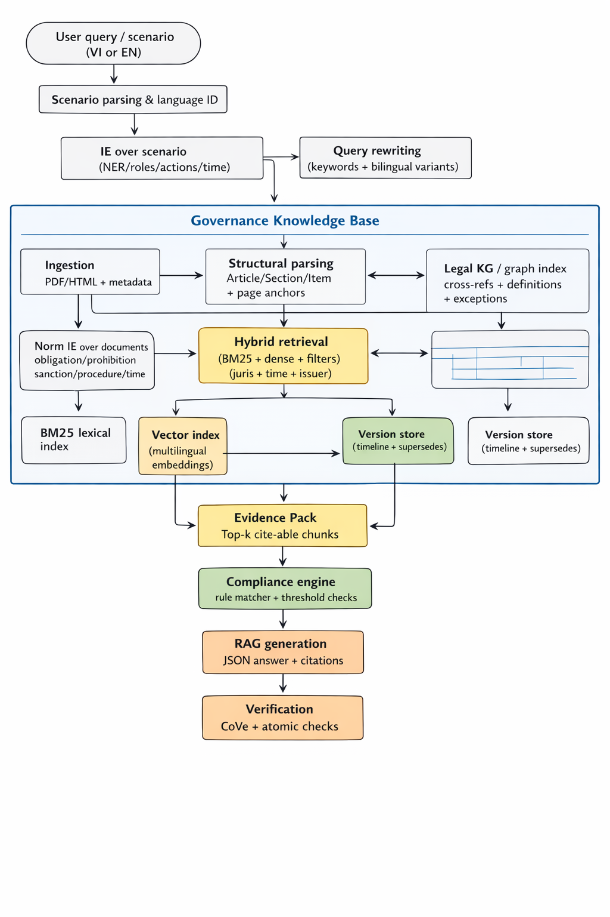
This architecture combines (i) classic legal IE and rule checks with (ii) RAG-style evidence-grounded generation, as originally formulated for knowledge-intensive tasks. [25]
Graph-based augmentation is optional but valuable for corpus-level “global” questions (themes, overarching obligations). GraphRAG proposes extracting an entity graph and generating community summaries to answer global questions at scale. [26]

What the GitHub prototype already demonstrates (repo-driven insights)
Inspection of the private GitHub prototype (via the GitHub connector) shows several strong patterns that should be preserved and generalized:
- Structural parsing and citation objects: the prototype emphasizes citation-ready segmentation (law → section) and fixed IDs for chunks, enabling auditability.
- Hybrid indexing: BM25 + dense embeddings (FAISS) and Vietnamese tokenization dependencies.
- Citation-first JSON prompting: answer format enforces citations; abstention behavior is encouraged.
- Scenario compliance mode: a fact-extraction step produces structured scenario fields, followed by deterministic rule matching.
These patterns align with the consensus in RAG evaluation research: retrieval + grounded generation must be evaluated together, and abstention behavior matters when documents are non-relevant or missing. [27]
Because the repository is private, its file-level details are not web-citable here; nevertheless, its design strongly matches the evidence-grounded approach recommended by RAG and hallucination-control literature. [28]

Workflow diagram focusing on compliance checking
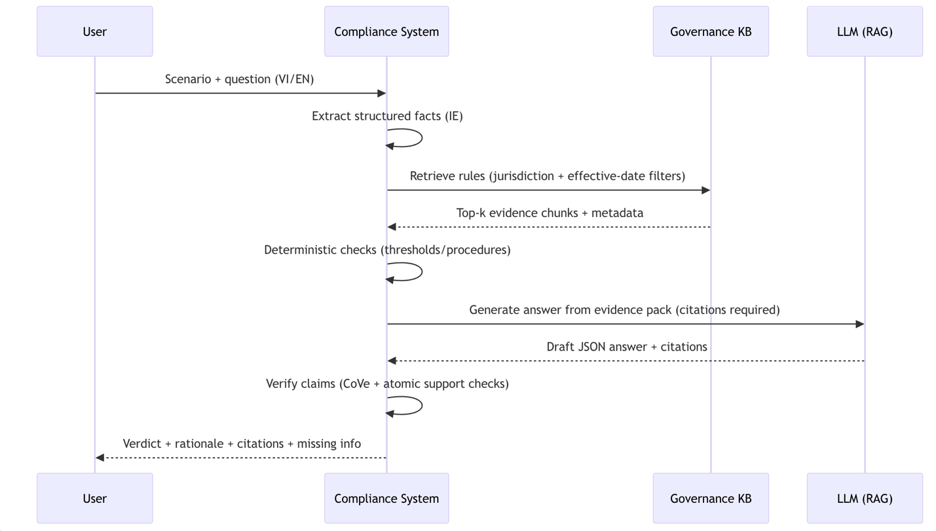
Verification follows the principle of Chain-of-Verification: draft → verification questions → independent answers → revised response, which has been shown to reduce hallucinations. [29]

Training, Prompting, and Knowledge Base Construction

Hybrid approach: IE + rules + RAG (why each layer exists)
IE layer (structuring). Legal and governance text often encodes conditions, exceptions, and sanctions in ways that benefit from explicit extraction. Obligation/prohibition extraction has established methods and confirms that discourse context and self-attention can improve performance. [2]
For Vietnamese inputs and Vietnamese governance texts, Vietnamese toolkits and pretrained models materially improve core NLP stages (segmentation, NER). [30]
Rule-based modules (determinism and auditability). Certain compliance checks are naturally formalizable: deadlines (“within X days”), minimum thresholds, eligibility constraints, sanction tables. Arbitration rules and procedural codes are especially amenable to rule-like validation (e.g., “in force as from…” or “effective date” constraints). [16]
RAG layer (grounded explanation). RAG couples retrieval with generation so answers can be updated by changing the corpus rather than retraining, and supports provenance. [3]
Verification layer (hallucination reduction and measurement). Use CoVe-style verification and atomic fact scoring (FActScore) to identify unsupported statements, alongside RAGAS-style faithfulness and relevance metrics. [31]

Knowledge base construction and versioning
A compliance KB must be engineered like a legal database, not like a generic document dump.
Document acquisition (primary-first). Recommended primary/official sources include:
- Vietnamese federation rulebooks such as a 2022 Vietnamese football laws PDF published by the Vietnam Football Federation[32]. [14]
- Laws of the Game editions with explicit effective dates (e.g., 2025/26 effective from 1 July 2025), associated with The IFAB[33] rulemaking. [18]
- The World Anti‑Doping Code (effective 1 January 2021) maintained by World Anti-Doping Agency[34], including language precedence and transitional provisions. [35]
- The Code of Sports‑related Arbitration maintained by Court of Arbitration for Sport[36] (in-force notices) and subsequent amendment notices. [16]
- Olympic Charter editions (in force dates and governance structure) from International Olympic Committee[37] channels (e.g., Olympic World Library records or official PDFs). [38]
- Domestic legal layer for Vietnam[39] (e.g., amendments to the Law on Physical Training and Sports, describing governance/tournament authority and obligations). [13]
Metadata schema (minimum viable legal provenance). Each document should carry:
- issuer (e.g., federation, international body)
- jurisdiction (VN / international / mixed)
- language and language_precedence rules (where applicable) [17]
- effective_date, published_date, supersedes, amends [40]
- document_type (statute, regulation, code, guideline, case summary)
- stable doc_id, plus page anchors for PDFs.
Version resolution logic. A practical hierarchy is:
- Filter by jurisdiction + forum (e.g., doping question → WADA regime) [41]
- Filter by time: only norms effective at scenario time. [42]
- Apply supersedes links; if conflicts remain, return both with a warning and ask for missing facts.

Training and fine-tuning strategy
A pragmatic training plan splits into (A) IE models and (B) LLM behavior models.
IE training (Vietnamese + legal norms).
- For Vietnamese NER/segmentation baselines: VnCoreNLP; for stronger modeling: PhoBERT-based sequence labeling. [30]
- For legal-domain adaptation (especially English): LEGAL‑BERT shows that legal-domain pretraining and broader hyperparameter search can materially change outcomes and provide legal-specialized encoders. [43]
- For multilingual transfer across Vietnamese/English: XLM‑R is a strong multilingual baseline for cross‑lingual representations and can be used for cross-lingual retrieval embeddings or IE baselines. [44]
LLM adaptation via LoRA/PEFT.
LoRA freezes base weights and trains low-rank matrices, reducing trainable parameters and memory footprint while achieving competitive results versus full fine‑tuning. [5]
For this domain, apply LoRA to two supervised tasks:
- Scenario → structured facts (JSON schema with roles/actions/time/jurisdiction hints).
- Question + retrieved context → verdict + structured rationale + citations (strict JSON output).

Prompt engineering (examples) and RAG retrieval illustration
Below are prompts aligned with best practices: constrain the model to the retrieved context, enforce citations, and provide abstention pathways—consistent with RAG evaluation and hallucination mitigation insights. [45]

Example prompt: scenario fact extraction (Vietnamese/English)
SYSTEM: You extract structured compliance facts from a sports governance scenario.
Rules:
- Output ONLY valid JSON.
- Do NOT infer missing dates/jurisdictions.
- If critical facts are missing, list them in missing_info.
USER SCENARIO:
{scenario_text}
OUTPUT JSON SCHEMA:
{
"actors": [{"entity": "...", "role": "..."}],
"governing_context": {"sport": "...", "body_hint": "...", "jurisdiction_hint": "VN|INTL|BOTH|null"},
"event_time": {"date": "YYYY-MM-DD|null", "time_phrase": "..." },
"actions": [{"action": "...", "object": "...", "intent": "intentional|negligent|unknown"}],
"keywords": ["..."],
"missing_info": ["..."]
}

Example prompt: citation-first compliance answer (RAG)
SYSTEM: Sports governance compliance assistant (Vietnamese + international).
Hard constraints:
- Use ONLY the retrieved context as evidence.
- Every non-trivial claim MUST cite >=1 context unit_id.
- If evidence is missing/conflicting, output verdict=INSUFFICIENT_EVIDENCE.
- Output ONLY JSON.
USER QUESTION:
{question}
SCENARIO FACTS (JSON):
{facts_json}
RETRIEVED CONTEXT UNITS:
Each unit has: unit_id, doc_id, issuer, effective_date, language, text
{context_units}
OUTPUT JSON:
{
"verdict": "COMPLIANT|NON_COMPLIANT|CONDITIONAL|INSUFFICIENT_EVIDENCE",
"decision_basis": [{"claim": "...", "supports": ["unit_id1","unit_id2"]}],
"answer": "...",
"missing_info": ["..."],
"confidence": 0.0-1.0
}

RAG retrieval example (illustrative)
Assume a scenario: “An athlete files an appeal after a deadline; which procedural rules apply and what is the likely consequence?”
The retrieval layer should return time-scoped procedural provisions (e.g., CAS Code sections; FIFA/CAS procedural summaries if included in corpus). CAS documents explicitly emphasize in-force versions and amendment dates, motivating time filters. [16]
Example evidence pack structure (what the system should construct before generation):
[
{
"unit_id": "CAS_CODE_2023::RXX",
"doc_id": "CAS_CODE_2023_EN",
"issuer": "CAS",
"effective_date": "2023-02-01",
"language": "en",
"snippet": "Procedural deadline clause excerpt..."
},
{
"unit_id": "CAS_NEWS_2025_AMEND::SUMMARY",
"doc_id": "CAS_AMENDMENTS_2025",
"issuer": "CAS",
"effective_date": "2025-07-01",
"language": "en",
"snippet": "Amendments in force from 1 July 2025..."
}
]
This evidence packaging enables later computation of hallucination metrics (supported vs unsupported claims) and is also compatible with RAGAS-style faithfulness evaluation. [46]

Evaluation, Baselines, and Experimental Protocol

Baselines (required for a credible paper)
A rigorous evaluation must compare to at least three baselines:
System | Core idea | Strength | Common failure mode
Pure rule-based | Regex + hand rules + templates | High precision on narrow checks | Low coverage; brittle to paraphrase
Pure LLM | Prompt-only generation | Fluent; broad | Hallucination; weak version discipline [47]
Pure RAG | Retrieve + generate | Better grounding than pure LLM | Retrieval miss → wrong answer; still may hallucinate [23]
Hybrid (IE + RAG + rules + verify) | Structured facts + filtered retrieval + constrained generation + verification | Best balance of auditability + coverage | Complexity/latency; needs annotation for IE and evaluation [48]

Metrics: what to measure and where
A compliance system should be evaluated as a pipeline, not only by final text quality.
Component | Metrics | Why it matters
IE (scenario + norms) | Precision/Recall/F1 on entities/relations/events/time | Ensures extracted “facts” and “tests” are correct [49]
Retrieval | Recall@K, MRR@K, nDCG@K | Must retrieve controlling provisions (COLIEE tasks motivate this) [50]
Verdict | Accuracy, Macro-F1; Exact Match (template) | Compliance outcome must be correct and structured
Citation quality | Citation precision/recall; evidence coverage | Legal-grade trust requires accurate citations [51]
Hallucination | Hallucination rate; RAGAS faithfulness; FActScore-style atomic support | Detect unsupported claims and quantify risk [46]
Abstention robustness | Non-relevant robustness (NoMIRACL subsets) | System must refuse when evidence is non-relevant [52]

Datasets: what exists and what must be built
Existing peer-reviewed legal benchmarks (not sports-specific, but useful):
- LexGLUE: English legal language understanding benchmark. [53]
- LEXTREME: multilingual legal benchmark emphasizing difficulty and model limitations. [22]
- COLIEE: legal retrieval and entailment tasks (statute retrieval / entailment), strongly relevant to retrieval evaluation design. [54]
- LegalBench: broad legal reasoning tasks to probe LLM legal reasoning behaviors. [55]
- CUAD: expert-annotated legal contract review dataset (useful for clause/obligation extraction patterns). [56]
Vietnamese legal corpora (useful for domain adaptation and retrieval corpora):
- Underthesea Vietnamese Legal Corpus (UTS_VLC) provides Vietnamese legal documents across years (dataset; not itself peer‑reviewed). [57]
Sports governance corpora (primary domain corpus; must be curated):
- Federation rulebooks (Vietnam PDFs). [14]
- IFAB Laws of the Game (time/version explicit). [18]
- World Anti‑Doping Code (language precedence and effective date explicit). [35]
- CAS Code and amendments (procedural compliance). [16]
- Olympic Charter editions (governance layer). [38]
Not relevant: MELD (emotion/sentiment conversation dataset) is unrelated to legal compliance and should not be used.
Key missing asset (your main research contribution): a sports governance compliance dataset with scenario → verdict + gold citations across Vietnamese and international regimes.

Multilingual data sourcing and annotation strategy
A credible annotation plan should include:
- Scenario templates seeded from real governance questions (eligibility, disciplinary sanctions, match rules, doping, appeals).
- Annotation schema aligned with legal norms: obligation/prohibition/permission, condition triggers, sanction types, deadlines, forum. Obligation/prohibition extraction literature provides precedent for norm classification. [2]
- Bilingual annotation: Vietnamese + English scenarios with linked supporting provisions; include explicit jurisdiction tags and temporal applicability fields.
- Active learning: prioritize examples where models disagree (rule-based vs RAG vs hybrid).
- Adversarial “non-relevant” sets: evaluate abstention using non-relevant contexts (NoMIRACL-like principle). [52]

Experimental setup (paper-ready)
A reproducible setup should report:
- Hardware: e.g., 1–4 GPUs (≥24GB VRAM each) for fine-tuning; CPU-only acceptable for indexing and BM25. (LoRA reduces requirements versus full fine-tuning.) [5]
- Retrieval: BM25 + multilingual dense embeddings (XLM‑R / SBERT family), FAISS/Qdrant; reranker optional. [44]
- Generation: instruction-tuned LLM with constrained decoding (low temperature) + JSON schema enforcement; verification pass (CoVe/atomic checks). [58]
- Hyperparameters for LoRA (example defaults to include in a paper):
- rank r: 8–32
- alpha: 16–64
- dropout: 0.05–0.1
- target modules: attention q,v (or q,k,v)
- LR: 1e‑4 to 2e‑4; epochs: 1–3; batch: 32–128 effective
Justify these choices by LoRA’s parameter-efficiency framing. [5]

Expected results and statistical analysis (hypotheses)
Given known weaknesses of “LLM-only” legal reasoning and multilingual legal benchmarks, the most defensible expected results are:
- Hybrid > pure RAG on Exact Match for structured verdict templates because IE reduces ambiguity and enforces slot completeness. [59]
- Hybrid > pure LLM on Hallucination Rate because retrieval grounding plus verification reduces unsupported claims. [60]
- Graph augmentation improves “global” corpus questions (themes/overview), consistent with GraphRAG’s motivation that vanilla RAG struggles on global sensemaking. [26]
Statistical testing plan (paper-standard):
- Retrieval metrics: paired bootstrap confidence intervals.
- Verdict accuracy/F1: McNemar test (for paired categorical outcomes) and bootstrap for F1.
- Hallucination rate: bootstrap CIs over claims or over questions.

Error Analysis, Limitations, Ethics, and Implementation Recommendations

Error analysis taxonomy (what to include in the paper)
- Jurisdiction errors: wrong regime retrieved (VN statute vs international code).
- Version errors: citing outdated provisions (missing effective-date filters). [40]
- Language drift errors: Vietnamese translation differs from controlling English text; language precedence not enforced. [17]
- Retrieval misses: correct rule exists but not retrieved (chunking too coarse, embedding mismatch). [61]
- Generation overreach: answer adds sanctions or thresholds not in evidence; measured via faithfulness/atomic checks. [62]
- Abstention failures: system answers confidently even when context is non-relevant (NoMIRACL-like scenarios). [52]

Limitations (to state explicitly)
- No off-the-shelf sports governance compliance dataset: the main bottleneck is domain-accurate scenarios with gold citations.
- Private/blocked sources: some official portals may rate-limit automated access; corpus acquisition must prioritize stable PDFs and ensure terms-of-use compliance.
- Legal reasoning vs legal advice: system outputs should be framed as informational and evidence-backed; real legal liability remains. [47]

Ethical/legal implications and risk controls
Privacy and sensitive data. Sports compliance scenarios can include medical and disciplinary data (particularly in anti‑doping contexts); data minimization, access control, and secure logging are required. The anti‑doping code’s governance scope implies that mishandling such data is high-risk. [63]
Liability and “over‑reliance.” Legal-system surveys warn that LLM usage in legal contexts spans drafting, analysis, and compliance monitoring, but reliability and governance remain key concerns. [47]
Jurisdictional risk. Failing to respect language precedence (e.g., English prevailing in WADA conflicts) can invert outcomes and expose organizations to sanctions. [17]
Hallucination mitigation as a compliance requirement. Adopt hard policies: “no citation → no definitive answer,” and enforce verification stages (CoVe) plus automated faithfulness scoring (RAGAS, atomic checks). [4]

Novelty claims (paper positioning)
A defensible novelty claim for IEEE Access / ESWA / IP&M is:
- A cross‑jurisdiction, version-aware hybrid architecture for sports governance compliance combining structured IE (norm templates, time/event normalization) with filtered RAG and verification—explicitly engineered for Vietnamese + international regimes. [64]
- A dataset + evaluation protocol that includes gold citations and non‑relevant robustness tests (abstention), aligning with modern RAG evaluation (RAGAS, NoMIRACL) and factuality metrics (FActScore). [65]
- A governance KB methodology detailing versioning, effective-date filtering, language precedence, and forum/hierarchy metadata—grounded in real primary documents. [66]

Concise actionable recommendations
- Build the governance KB first: ingest stable PDFs, add document metadata (issuer/jurisdiction/effective date/language precedence), and implement strict version filtering. [67]
- Implement IE for scenario + norms: start with Vietnamese segmentation/NER (VnCoreNLP/PhoBERT) and add obligation/prohibition extraction templates for norms. [68]
- Adopt hybrid retrieval: BM25 + dense multilingual embeddings; evaluate retrieval with COLIEE-inspired metrics and your own gold citations. [69]
- Make citations mandatory and enforce abstention: follow RAGAS/NoMIRACL principles and explicitly test non‑relevant scenarios. [27]
- Use LoRA to adapt the fact extractor and the citation-grounded answer generator; keep a verification stage (CoVe + atomic checks). [70]
- Publish a baseline suite: pure rules, pure LLM, pure RAG, hybrid; report statistical significance and error taxonomy.

Recommended primary sources to cite (starter set)
Below is a starter set of primary documents to ingest and cite (URLs included in code form; the report above cites these sources individually):
Vietnam federation rulebook PDFs:
- VFF "Luật thi đấu Bóng đá (final 2022)" PDF (vff.org.vn)
International sport governance:
- IFAB / Laws of the Game 2025/26 PDF (Effective 1 July 2025) (thefa.com or theifab.com references)
- WADA World Anti-Doping Code 2021 PDF (wada-ama.org)
- CAS Code of Sports-related Arbitration PDF + amendment notices (tas-cas.org)
- Olympic Charter (in force as from 30 January 2025) (IOC-related distribution channels / Olympic World Library)
Vietnam domestic legal layer:
- Law amending the Law on Physical Training and Sports (Law No. 26/2018/QH14), English translation (luatvietnam.vn)

[1] [7] [15] [17] [35] [39] [66] World Anti-Doping Code
https://www.wada-ama.org/sites/default/files/resources/files/2021_wada_code.pdf?utm_source=chatgpt.com
[2] [59] Obligation and Prohibition Extraction Using Hierarchical RNNs - ACL Anthology
https://aclanthology.org/P18-2041/?utm_source=chatgpt.com
[3] [8] [12] [23] [25] [28] [61] https://proceedings.neurips.cc/paper/2020/hash/6b493230205f780e1bc26945df7481e5-Abstract.html
https://proceedings.neurips.cc/paper/2020/hash/6b493230205f780e1bc26945df7481e5-Abstract.html
[4] [29] [31] [34] [48] [58] [60] https://aclanthology.org/2024.findings-acl.212/
https://aclanthology.org/2024.findings-acl.212/
[5] [70] https://arxiv.gg/abs/2106.09685
https://arxiv.gg/abs/2106.09685
[6] [52] “Knowing When You Don’t Know”: A Multilingual Relevance Assessment Dataset for Robust Retrieval-Augmented Generation - ACL Anthology
https://aclanthology.org/2024.findings-emnlp.730/?utm_source=chatgpt.com
[9] [21] [30] [32] [49] [68] VnCoreNLP: A Vietnamese Natural Language Processing Toolkit - ACL Anthology
https://aclanthology.org/N18-5012/?utm_source=chatgpt.com
[10] [27] [33] [37] [45] [46] [51] [65] https://arxiv.gg/abs/2309.15217
https://arxiv.gg/abs/2309.15217
[11] [47] Large Language Models in Legal Systems: A Survey | Humanities and Social Sciences Communications
https://www.nature.com/articles/s41599-025-05924-3?utm_source=chatgpt.com
[13] Law amending Law on Physical Training and Sports, Law No. 26/2018/QH14
https://english.luatvietnam.vn/law-no-26-2018-qh14-dated-26-2018-qh14-on-amending-physical-training-and-sports-164909-doc1.html?utm_source=chatgpt.com
[14] LIÊN ĐOÀN BÓNG ĐÁ VIỆT NAM
https://vff.org.vn/wp-content/uploads/2022/06/Lu%E1%BA%ADt-thi-%C4%91%E1%BA%A5u-B%C3%B3ng-%C4%91%C3%A1-final-2022.pdf?utm_source=chatgpt.com
[16] Code of Sports-related Arbitration
https://www.tas-cas.org/fileadmin/user_upload/CAS_Code_2023__EN_.pdf?utm_source=chatgpt.com
[18] [24] [36] [40] [42] [64] [67] 1 Laws of the Game 25/26
https://www.thefa.com/-/media/files/thefaportal/governance-docs/laws-of-the-game/2025-26/laws-of-the-game-2025-26.ashx?utm_source=chatgpt.com
[19] Amendments to the CAS code, in force from 1 July 2025 - Tribunal Arbitral du Sport / Court of Arbitration for Sport
https://www.tas-cas.org/en/general-information/news-detail/article/amendments-to-the-cas-code-in-force-from-july-1?utm_source=chatgpt.com
[20] FIFA publishes CAS & Football Annual Report 2024
https://inside.fifa.com/legal/court-of-arbitration-for-sport/news/cas-football-annual-report-2024-published?utm_source=chatgpt.com
[22] LEXTREME: A Multi-Lingual and Multi-Task Benchmark for the Legal Domain - ACL Anthology
https://aclanthology.org/2023.findings-emnlp.200/?utm_source=chatgpt.com
[26] From Local to Global: A Graph RAG Approach to Query-Focused Summarization | GraphRAG
https://graphrag.com/appendices/research/2404.16130/?utm_source=chatgpt.com
[38] Olympic charter : in force as from 30 January 2025 / International Olympic Committee - Olympic World Library
https://library.olympics.com/Default/doc/SYRACUSE/3525972/olympic-charter-in-force-as-from-30-january-2025-international-olympic-committee%3F_lg%3Den-GB?utm_source=chatgpt.com
[41] [63] World Anti-Doping Code | World Anti Doping Agency
https://www.wada-ama.org/en/resources/world-anti-doping-code-and-international-standards/world-anti-doping-code?utm_source=chatgpt.com
[43] LEGAL-BERT: The Muppets straight out of Law School - ACL Anthology
https://aclanthology.org/2020.findings-emnlp.261/?utm_source=chatgpt.com
[44] Unsupervised Cross-lingual Representation Learning at Scale - ACL Anthology
https://aclanthology.org/2020.acl-main.747/?utm_source=chatgpt.com
[50] [54] [69] COLIEE 2025 – COLIEE
https://coliee.org/overview?utm_source=chatgpt.com
[53] LexGLUE: A Benchmark Dataset for Legal Language Understanding in English - ACL Anthology
https://aclanthology.org/2022.acl-long.297/?utm_source=chatgpt.com
[55] "LegalBench: A Collaboratively Built Benchmark for Measuring Legal Reas" by Spencer Williams
https://scholarlycommons.law.cwsl.edu/fs/455/?utm_source=chatgpt.com
[56] CUAD: An Expert-Annotated NLP Dataset for Legal Contract Review
https://datasets-benchmarks-proceedings.neurips.cc/paper_files/paper/2021/hash/6ea9ab1baa0efb9e19094440c317e21b-Abstract-round1.html?utm_source=chatgpt.com
[57] undertheseanlp/UTS_VLC · Datasets at Hugging Face
https://huggingface.co/datasets/undertheseanlp/UTS_VLC?utm_source=chatgpt.com
[62] https://aclanthology.org/2023.emnlp-main.741/
https://aclanthology.org/2023.emnlp-main.741/

