Flight Delay Prediction Using Machine Learning Algorithms
V. KARTHIK
241FA18158
Department of ACSE
Vignan’s Foundation for Science,Technology and Research

- INTRODUCTION
Air transportation is a time-sensitive system in which delays can propagate across aircraft rotations, crew assignments, airport resources, and connecting passengers. A useful prediction system should therefore identify the likelihood of delay before departure, when operational decisions can still be made. Machine learning is suitable for this task because flight delay behavior depends on interacting categorical, temporal, route, and schedule variables rather than a single deterministic rule.
This research develops an end-to-end flight-delay classification workflow using the assigned flight-delay dataset. The implementation was performed in a VS Code notebook and was designed to avoid target leakage by restricting predictive variables to information that can reasonably be known before departure. The study compares five algorithms and extends the comparison with targeted hyperparameter tuning.
- PROBLEM STATEMENT
The problem is to classify a scheduled flight as delayed or not delayed, where a delayed flight is defined as one whose arrival delay exceeds 15 minutes. The prediction must be made using predeparture information such as month, day, day of week, airline, origin, destination, scheduled duration, distance, and scheduled departure time. Variables that become available only during or after a flight are excluded from the predictive feature set.
- RESEARCH OBJECTIVES
The objectives of the study are: (1) understand the structure and quality of the flight-delay data; (2) perform exploratory analysis and data cleaning; (3) construct a leakage-safe target and feature set; (4) engineer useful temporal and categorical features; (5) develop and compare five classification algorithms; (6) apply crossvalidation and hyperparameter tuning where beneficial;
(7) select the best model using performance metrics; and (8) demonstrate reusable model serialization and prediction on unseen flight data.
- RESEARCH QUESTIONS
RQ1: Which pre-departure flight characteristics are useful for predicting arrival delay? RQ2: Which of the five evaluated machine learning algorithms provides the strongest classification performance? RQ3: Does targeted hyperparameter tuning improve the selected models? RQ4: Can the final model be reused successfully for prediction on an unseen flight after serialization?
- LITERATURE REVIEW / RELATED WORK
Classical decision-tree methods established a practical approach to learning classification rules from structured data. Ensemble methods subsequently improved predictive robustness by combining multiple weak or diverse learners. Random Forest aggregates randomized decision trees, while gradient boosting builds an additive model by sequentially correcting errors. XGBoost extends gradient boosting with regularization and efficient optimization. Logistic Regression remains an important baseline because it provides a simple, interpretable linear decision boundary.
Flight-delay research commonly combines historical operational variables, weather information, airport characteristics, temporal patterns, and airline effects. The present work differs in emphasis by implementing a complete leakagecontrolled predeparture pipeline on a large sample and by comparing several widely used classifiers under a common evaluation framework.
- RESEARCH GAP
A practical gap remains between isolated model demonstrations and reproducible pre-departure prediction workflows. Some approaches may use variables such as actual departure delay, arrival time, or post-flight delay components, which can produce artificially optimistic results because these variables are unavailable at prediction time. This study addresses that gap by explicitly excluding postdeparture variables, using a pipeline for preprocessing and modeling, and testing the saved model again on an unseen flight record.
- DATASET DESCRIPTION
The assigned dataset is the U.S. Department of Transportation flight-delay dataset distributed through Kaggle. The working sample contains 500,000 flight records and 31 columns. The three related files are flights.csv, airlines.csv, and airports.csv; the modeling workflow primarily uses the flights table because the required airline and airport codes are already represented in the flight records.
TABLE 1. DATASET AND TARGET CHARACTERISTICS.
Property | Value
Working sample | 500,000 flights
Original columns used for inspection | 31
Target | DELAYED
Delay threshold | Arrival delay > 15 minutes
Modeling features | 11 pre-departure features
Delayed class | 98,565 (20.45%)
Not-delayed class | 383,487 (79.55%)
- METHODOLOGY
The methodology follows a sequential machine learning workflow: dataset loading, structural inspection, data-quality analysis, cleaning, target construction, exploratory analysis, feature engineering, leakage-safe feature selection, train-test splitting, preprocessing pipelines, model training, validation, tuning, evaluation, model comparison, final selection, unseen prediction, and model serialization.
- SYSTEM / ML WORKFLOW
The system can be represented as: Raw CSV files > data inspection -> cleaning -> target construction -> EDA -> feature engineering -> leakage control -> traintest split -> preprocessing pipeline -> five classifiers -> cross-validation and tuning -> evaluation -> model selection -> serialization -> unseen prediction. The pipeline design keeps transformations associated with the model so that the same preprocessing logic is applied during training and inference.
- DATA PREPROCESSING
Data quality checks identified substantial missingness in several operational columns.
Cancellation reason was missing for most observations, while delay-component variables were unavailable for many flights because those components do not exist for every flight. Duplicate analysis found zero duplicate rows in the 500,000record working sample. Cancelled flights were removed because they do not have meaningful arrivaldelay outcomes for this classification
task, leaving
483,176 records. Rows with missing
ARRIVAL_DELAY were then removed, leaving 482,052 records for target construction.
Outlier analysis was performed using the interquartile range. Potential outliers were observed in arrival delay, distance, and scheduled time. These observations were treated as legitimate extreme operational values rather than automatically deleted, because unusually long delays and long routes can be genuine flight events. This avoids discarding meaningful examples.
- EXPLORATORY DATA ANALYSIS (EDA)
The target distribution shows a class imbalance:
79.55% of usable flights were not delayed and 20.45% were delayed. Airline-level analysis showed variation in delay rates, with MQ having the highest observed rate in the analyzed sample and HA, DL, and AS among the lower-rate carriers. Day-of-week analysis also showed variation, with Monday and Sunday exhibiting relatively higher delay rates in the available sample.
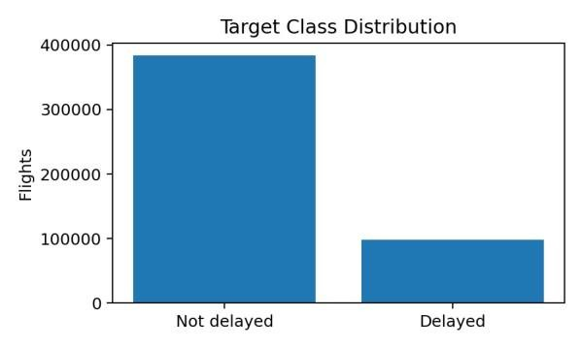
FIGURE 1. TARGET CLASS DISTRIBUTION. THE DATASET IS IMBALANCED TOWARD FLIGHTS THAT ARE NOT DELAYED.
- FEATURE ENGINEERING / FEATURE
SELECTION
Scheduled departure time was transformed into departure hour and departure minute. A categorical departure-period feature was also created to distinguish morning, afternoon, evening, and night. The final feature set contained MONTH, DAY, DAY_OF_WEEK, AIRLINE, ORIGIN_AIRPORT, DESTINATION_AIRPORT, SCHEDULED_TIME, DISTANCE, DEP_HOUR, DEP_MINUTE, and DEP_PERIOD.
Leakage prevention was a central feature-selection rule. DEPARTURE_DELAY and
ARRIVAL_DELAY were excluded because they are outcomes or near-outcomes. WHEELS_OFF, WHEELS_ON, AIR_TIME, ELAPSED_TIME,
ARRIVAL_TIME, and post-flight delay-component variables were also excluded because they are unavailable before departure. This design makes the experiment closer to a real pre-flight prediction problem.
- MODEL DEVELOPMENT
Five classification algorithms were developed under comparable preprocessing conditions. Logistic Regression served as a linear baseline. Decision Tree captured nonlinear decision rules. Random Forest used an ensemble of randomized trees. Gradient Boosting built an additive ensemble of weak learners. XGBoost provided a regularized gradient-boosting implementation. Class weighting was used where appropriate to reduce the effect of class imbalance.
- EXPERIMENTAL SETUP
The working dataset was split into training and test partitions using a stratified split so that the target-class proportions were preserved. Categorical variables were one-hot encoded and numerical variables were imputed and scaled where required. The transformations were placed inside scikit-learn pipelines to prevent preprocessing leakage from the test set into model training.
TABLE 2. MACHINE LEARNING ALGORITHMS EVALUATED.
Algorithm | Purpose
Logistic Regression | Linear baseline classifier
Decision Tree | Nonlinear rule-based classifier
Random Forest | Bagged tree ensemble
Gradient Boosting | Sequential boosting ensemble
XGBoost | Regularized gradient boosting
- MODEL VALIDATION
Model validation used stratified cross-validation for the tuning stages. F1-score was selected as the primary optimization metric because the delayed class is the operationally important minority class and a useful system should balance precision and recall rather than maximize accuracy alone. ROC-AUC was also reported to assess ranking ability across thresholds.
- HYPERPARAMETER TUNING
Targeted randomized search was applied to Random Forest and XGBoost. To control computational cost in the VS Code environment, the search spaces and number of sampled combinations were intentionally limited. For the faster Random Forest search, two-fold crossvalidation and three sampled parameter combinations were used. This practical design provided tuning evidence without allowing hyperparameter search to dominate the complete experiment.
- MODEL EVALUATION
The evaluation used accuracy, precision, recall, F1score, and ROC-AUC. Accuracy measures overall correctness, while precision measures how many predicted delays were actually delayed. Recall measures how many actual delayed flights were detected. F1-score is the harmonic mean of precision and recall and was used as the primary selection criterion. ROC-AUC summarizes discrimination over different thresholds.
- MODEL COMPARISON
TABLE 3. TEST-SET PERFORMANCE COMPARISON.
Model | Accura  cy | Precisi on | Reca  ll | F1 | ROC  -  AUC
Decision Tree | 0.7174 | 0.3820 | 0.61  85 | 0.47  23 | 0.73  74
Random  Forest | 0.6927 | 0.3543 | 0.61  15 | 0.44  86 | 0.72  24
Tuned  Random  Forest | 0.6926 | 0.3540 | 0.61  04 | 0.44  82 | 0.72  17
Logistic Regressi on | 0.6360 | 0.3131 | 0.65  36 | 0.42  34 | 0.69  46
XGBoos  t | 0.8185 | 0.7070 | 0.19  17 | 0.30  16 | 0.76  48
Gradient Boostin g | 0.8159 | 0.6948 | 0.17  74 | 0.28  26 | 0.75  49
Tuned XGBoos  t | 0.8108 | 0.7231 | 0.12  09 | 0.20  72 | 0.73  68
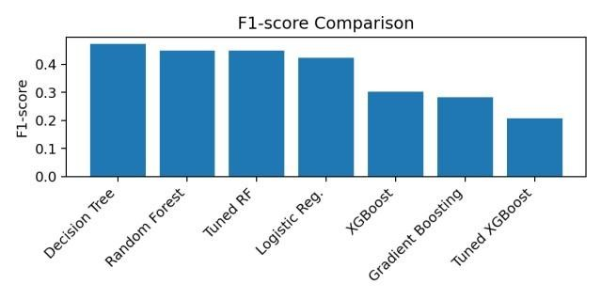
FIGURE 2. F1-SCORE COMPARISON OF EVALUATED MODELS.
ADDITIONAL TABLES AND FIGURES FROM NOTEBOOK
The following material is aligned directly with the executed notebook. It expands the original report with the complete test-set comparison, model-specific scenarios, validation/tuning evidence, and the principal diagnostic graphs. The classification problem is imbalanced, so F1-score is treated as the primary

extremely low recall and lowest F1 among the boosting variants.
Model | Accur acy | Preci sion | Rec all | F1 | RO  C-  AU  C | Scenario
Logisti c  Regres sion | 0.636 0 | 0.313 1 | 0.65 36 | 0.42 34 | 0.69 46 | Weak  baseline; highest  recall  among the main models but  low precision and F1.
Decisi on Tree | 0.717 4 | 0.382 0 | 0.61 85 | 0.47 23 | 0.73 74 | Best F1; strongest balance between  precision and recall for delayed flights.
Rando m  Forest | 0.692 7 | 0.354 3 | 0.61 15 | 0.44 86 | 0.72 24 | Strong second-best  F1 among the main  models; balanced but below Decision Tree.
Gradie nt  Boosti ng | 0.815 9 | 0.694 8 | 0.17 74 | 0.28 26 | 0.75 49 | High accuracy/pr ecision, but very low recall causes weak F1 for delayed flights.
XGBo ost | 0.818 5 | 0.707 0 | 0.19 17 | 0.30 16 | 0.76 48 | Highest accuracy  and ROCAUC, but low recall makes it  unsuitable  under the  F1-first objective.
Tuned Rando m  Forest | 0.692 6 | 0.354 0 | 0.61 04 | 0.44 82 | 0.72 17 | Tuning  slightly reduced test performanc  e relative to  baseline  Random  Forest.
Tuned  XGBo  ost | 0.810 8 | 0.723 1 | 0.12 09 | 0.20 72 | 0.73 68 | Highest precision, but
Model | Accurac y | Precisio n | Recall | F1 | ROC-  AUC
Random Forest (baseline  ) | 0.6927 | 0.3543 | 0.611 5 | 0.448 6 | 0.722 4
Random  Forest  (tuned) | 0.6926 | 0.3540 | 0.610 4 | 0.448 2 | 0.721 7
XGBoost  (baseline  ) | 0.8185 | 0.7070 | 0.191 7 | 0.301 6 | 0.764 8
XGBoost  (tuned) | 0.8108 | 0.7231 | 0.120 9 | 0.207 2 | 0.736 8
Tuned Model | Best CV F1 | Best Parameters
Random Forest | 0.4443 | n_estimators=100;  max_depth=15; min_samples_split=5
XGBoost | 0.2113 | subsample=1.0; n_estimators=50; max_depth=6; learning_rate=0.05
selection metric while accuracy, precision, recall, and ROC-AUC are reported as supporting measures.

Complete Model Comparison and Scenario

Model-selection scenario: Decision Tree is selected because it has the highest F1-score (0.4723). XGBoost has the highest accuracy (0.8185) and ROC-AUC
(0.7648), but its recall for delayed flights is only 0.1917, so it misses most delayed flights. The Decision Tree therefore gives the best balance for the minority delayed class under the project objective.

Hyperparameter Tuning Comparison

Tuning scenario: neither tuned model improves the corresponding baseline on the held-out test set. Random Forest tuning produces a small decline in F1 from 0.4486 to 0.4482, while XGBoost tuning reduces F1 from 0.3016 to 0.2072. Therefore, tuning does not change the final model selection.

Cross-Validation and Tuning Evidence

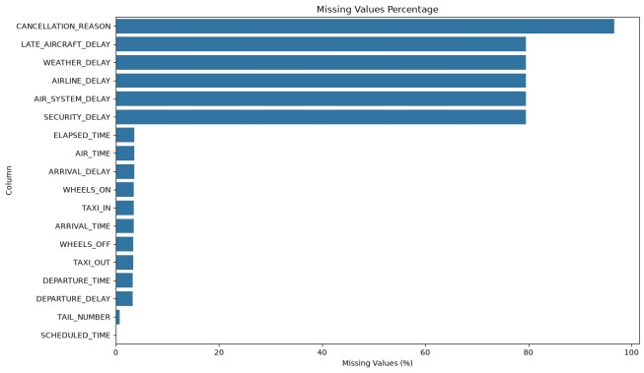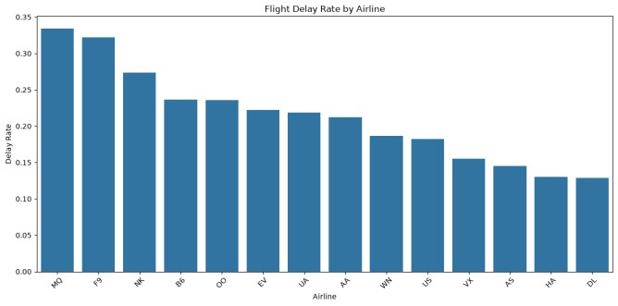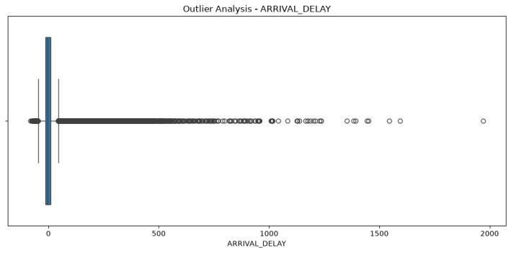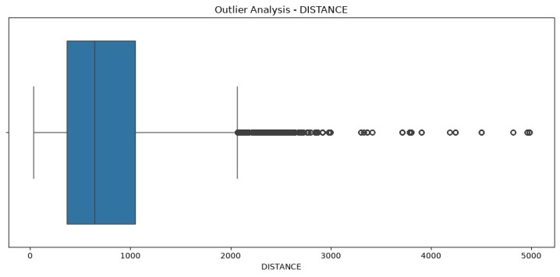

FIGURE A. Missing
-
value percentage by column.

FIGURE E. Outlier analysis for arrival delay.

FIGURE B. Flight delay rate by airline. FIGURE F. Outlier analysis for distance.
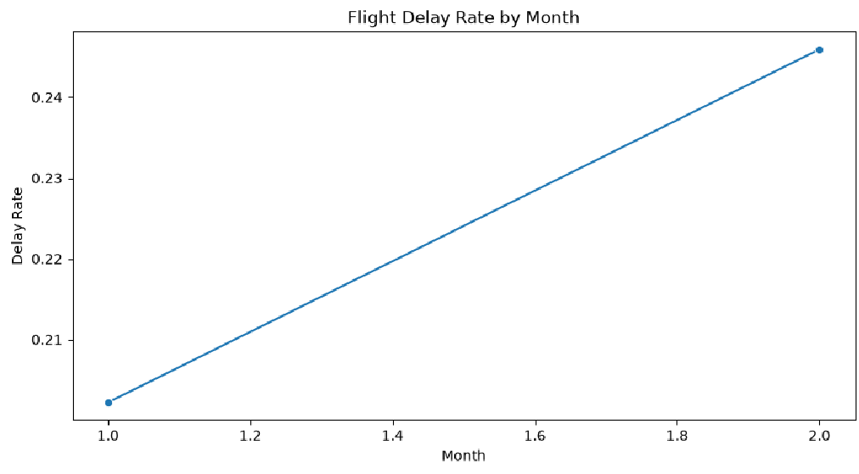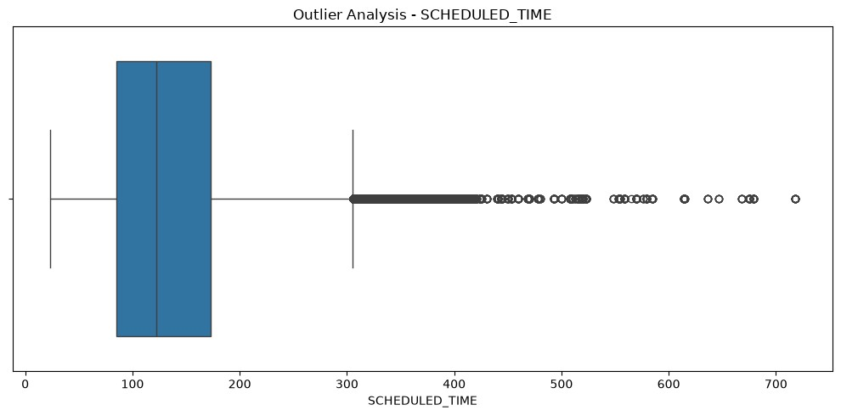

FIGURE C. Flight delay rate by month. FIGURE G. Outlier analysis for scheduled time.
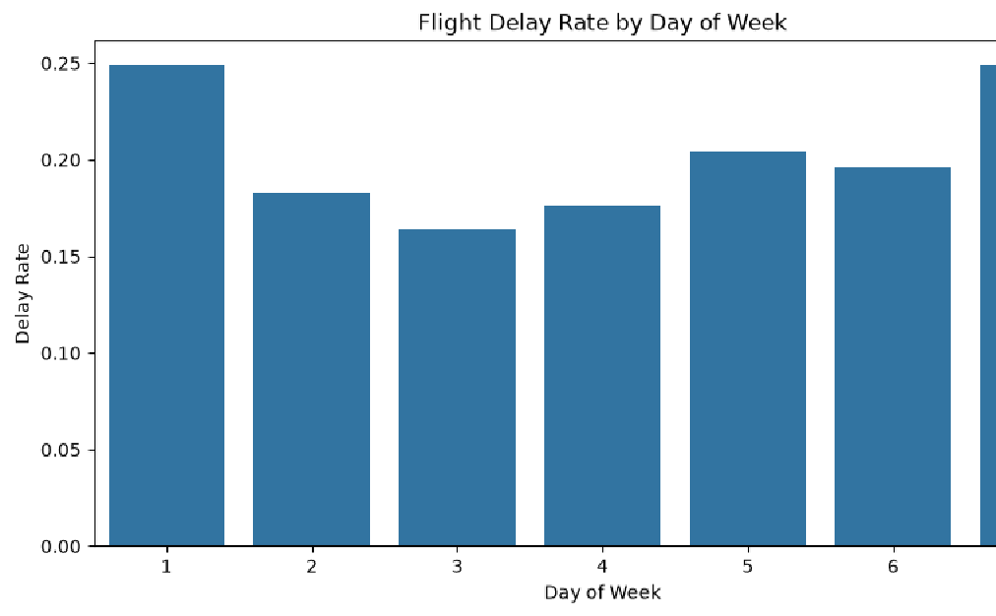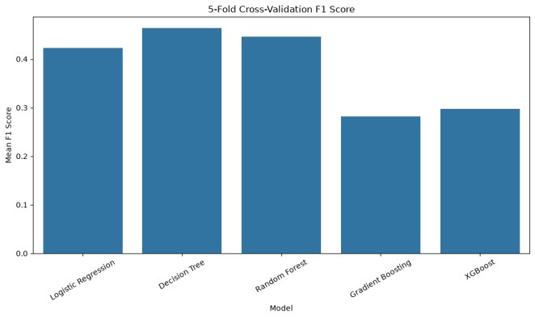

FIGURE H. Five
-
fold cross
-
validation F1
-
score comparison.

FIGURE D. Flight delay rate by day of week.

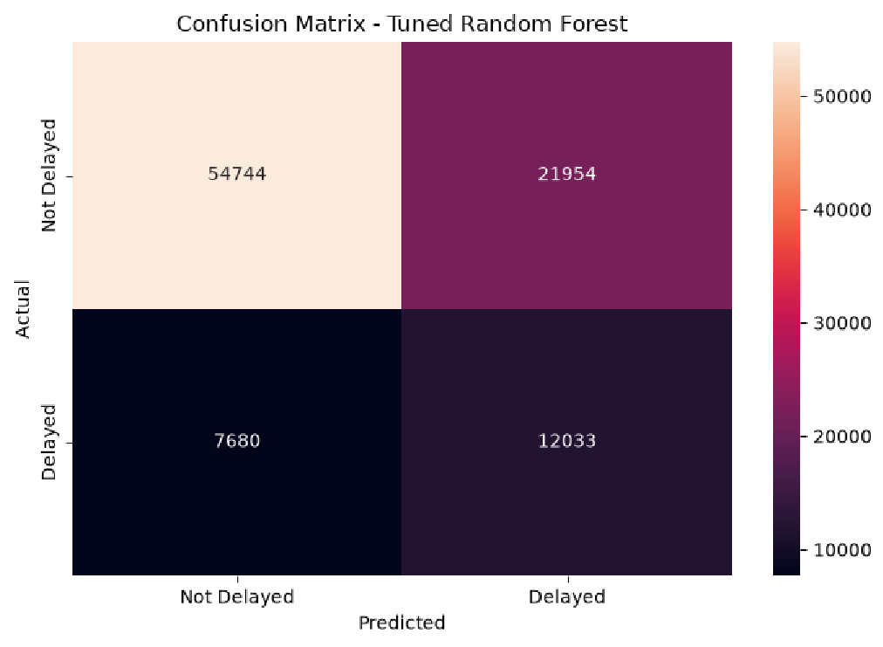
FIGURE I. Confusion matrix for tuned Random Forest.
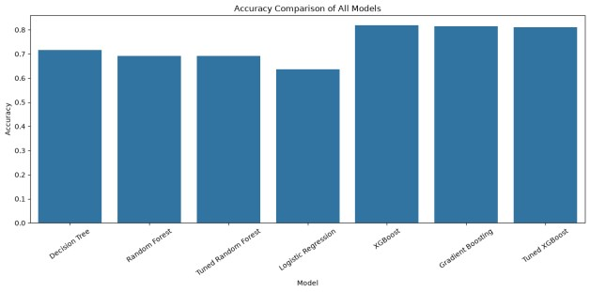
FIGURE J. Accuracy comparison of all evaluated models.
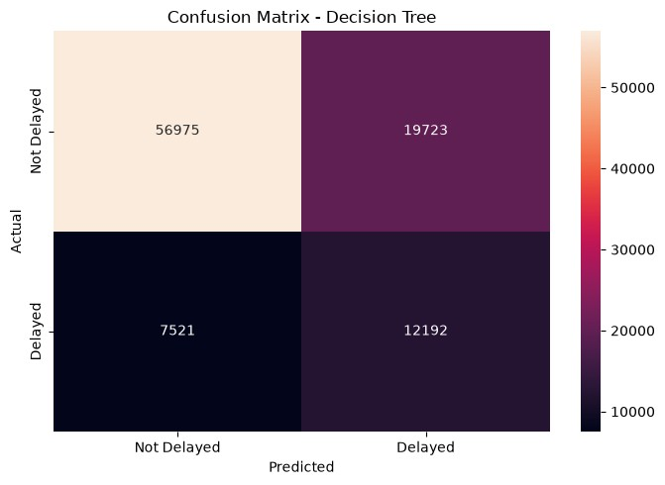
FIGURE K. Confusion matrix for the final Decision Tree.
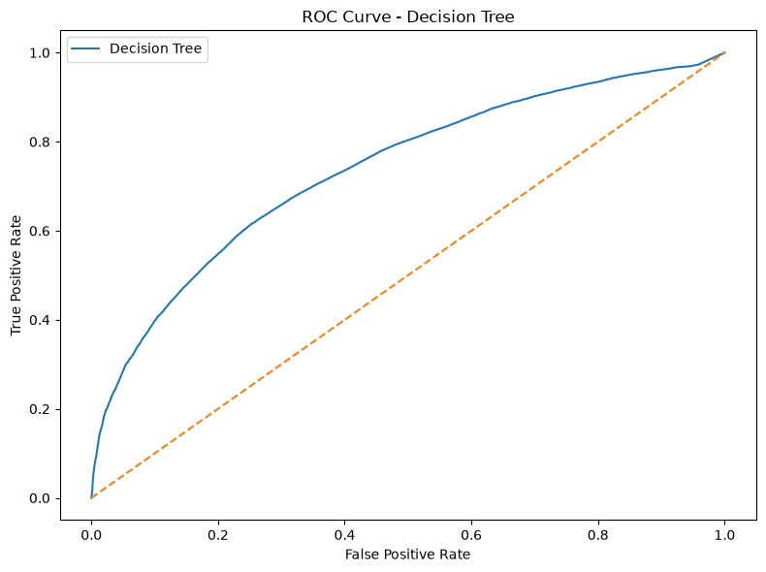
FIGURE L. ROC curve for the final Decision Tree.

Metric-wise Interpretation
Metric | Best model | Value | Scenario
Accuracy | XGBoost | 0.8185 | Highest overall correctness, but does not adequately detect delayed flights.
Precision | Tuned XGBoost | 0.7231 | When it predicts delay, it is most often correct; however, it flags very few actual delays.
Recall | Logistic Regression | 0.6536 | Detects the largest share of delayed flights among the main baseline models.
F1-score | Decision Tree | 0.4723 | Best balance of precision and recall; primary selection criterion.
ROC-AUC | XGBoost | 0.7648 | Best ranking/discrimination across thresholds, but not enough recall for the operational objective.

This comparison shows why accuracy alone should not determine the final model in an imbalanced delayprediction problem. The selected Decision Tree sacrifices some overall accuracy in exchange for substantially better delayed-class balance, as reflected by its highest F1-score.

P-value / R² Note
This notebook is a binary classification workflow and does not calculate regression R² or OLS p-values. Therefore, p-value and R² should not be inserted into the classifier comparison. The appropriate classification metrics here are Accuracy, Precision, Recall, F1-score, and ROC-AUC. F1-score is the primary criterion used by the notebook.
- FINAL MODEL SELECTION
The Decision Tree was selected as the final model because it achieved the highest F1-score among the evaluated final models: 0.4723. Although XGBoost achieved higher accuracy (0.8185) and ROC-AUC (0.7648), its recall for delayed flights was only 0.1917, resulting in a lower F1-score of 0.3016. The Decision Tree provided a substantially better balance between detecting delayed flights and limiting false delay predictions.
- SAMPLE / UNSEEN DATA PREDICTION
A synthetic unseen flight record was constructed using only pre-departure variables: an American Airlines flight from JFK to LAX, scheduled for 18:30, with a scheduled duration of 360 minutes and a distance of 2,475 miles. The final Decision Tree predicted that the flight would not be delayed, with an estimated delay probability of 35.32%. The same prediction was reproduced after reloading the serialized model.
- RESULTS
The final Decision Tree achieved 71.74% accuracy,
38.20% precision, 61.85% recall, 47.23% F1-score, and 73.74% ROC-AUC. The classification report showed an F1-score of 0.81 for the not-delayed class and 0.47 for the delayed class. These results indicate that the model identifies a meaningful portion of delayed flights but still produces false positives, which is expected in an imbalanced operational prediction problem.
- DISCUSSION
The results demonstrate the importance of choosing an evaluation metric that matches the application objective. The highest-accuracy models were not the best models for balanced delay detection. XGBoost and Gradient Boosting classified the majority class effectively, but their relatively low recall for delayed flights reduced F1-score. The Decision Tree, despite lower accuracy, detected a larger fraction of delayed flights and therefore achieved the strongest F1-score. This trade-off is important for operational deployment because missing a delayed flight may have a different cost from incorrectly flagging a flight.
The leakage-safe feature set also makes the results more realistic. A model that uses actual departure delay or arrival delay can appear highly accurate while providing no useful advance warning. Restricting inputs to pre-departure information creates a more meaningful test of predictive usefulness.
- LIMITATIONS
The experiment uses a 500,000-record working sample rather than the complete historical dataset. Weather information was not integrated as an external feature source, and the model does not explicitly model airport congestion, aircraft rotation, crew scheduling, or network propagation. The target is binary, so it does not estimate the number of minutes of delay. The class imbalance also makes accuracy alone insufficient for judging performance. Finally, the experiment was performed as an offline notebook workflow rather than a continuously monitored production service.
- CONCLUSION
This research presented an end-to-end machine learning approach for pre-departure flight delay prediction. The workflow covered dataset understanding, data-quality analysis, preprocessing, exploratory analysis, feature engineering, leakage prevention, five-model development, validation, hyperparameter tuning, model comparison, final selection, unseen prediction, and model serialization. The Decision Tree achieved the best F1-score of 0.4723 and was therefore selected as the final model. The successful save-and-reload test demonstrates that the trained pipeline can be reused for inference.
- FUTURE SCOPE
Future work can incorporate weather forecasts, airport-level congestion, aircraft tail history, routelevel historical delay rates, holiday calendars, and network connectivity. Additional work can evaluate calibrated probabilities, cost-sensitive learning, threshold optimization, temporal validation, and more extensive hyperparameter optimization. A production MLOps extension could include experiment tracking, model versioning, automated data validation, scheduled retraining, drift monitoring, API deployment, and dashboard-based operational alerts.
- REFERENCES
- L. Breiman, “Random forests,” Machine
Learning, vol. 45, no. 1, pp. 5–32, 2001.
- J. R. Quinlan, C4.5: Programs for Machine Learning. San Mateo, CA, USA: Morgan Kaufmann, 1993. [3] J. H. Friedman, “Greedy function approximation: A gradient boosting machine,” Annals of Statistics, vol. 29, no. 5, pp. 1189–1232, 2001.
- T. Chen and C. Guestrin, “XGBoost: A scalable tree boosting system,” in Proc. 22nd ACM SIGKDD Int. Conf. Knowledge Discovery and Data Mining, 2016, pp. 785– 794.
- C. M. Bishop, Pattern Recognition and
Machine Learning. New York, NY, USA: Springer,
2006. [6] U.S. Department of Transportation, “Flight Delays,” Kaggle dataset, available through Kaggle, accessed 2026.
[7] F. Pedregosa et al., “Scikit-learn: Machine learning in Python,” Journal of Machine Learning Research, vol. 12, pp. 2825–2830, 2011.

