* When do I use for loops?

*For* loops are traditionally used when you have a piece of code which you want to repeat *n* number of times. for example -

string = "Hello World"

for x in string:

print x

Another example

for letter in **'Python':** # First Example

print 'Current Letter :', letter

fruits = ['banana', 'apple', 'mango']

for fruit in **fruits**: # Second Example

print 'Current fruit :', fruit

print "Good bye!"

When the above code is executed, it produces the following result −

Current Letter : P

Current Letter : y

Current Letter : t

Current Letter : h

Current Letter : o

Current Letter : n

Current fruit : banana

Current fruit : apple

Current fruit : mango

Good bye!

**Python break statement**

The break statement terminates the loop containing it. Control of the program flows to the statement immediately after the body of the loop.

If break statement is inside a nested loop (loop inside another loop), break will terminate the innermost loop.

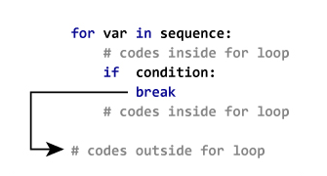

# Use of break statement inside loop

for val in "string":

if val == "i":

break

print val

print "The end"